TNBC Multi-Omics Report

### Functional Enrichment Results
SNF cluster contrast shows enrichment for genes UP in the cluster (note: logFC sign inverted by design; DOWN set treated as cluster-upregulated). Top GO BP terms:
• axonogenesis (adj.P=1.4e-16, n=427)
• positive regulation of cell adhesion (adj.P=1.5e-15, n=459)
• cell-substrate adhesion (adj.P=2.6e-14, n=338)
• regulation of neuron projection development (adj.P=5.5e-14, n=412)
• embryonic organ development (adj.P=1e-13, n=419)
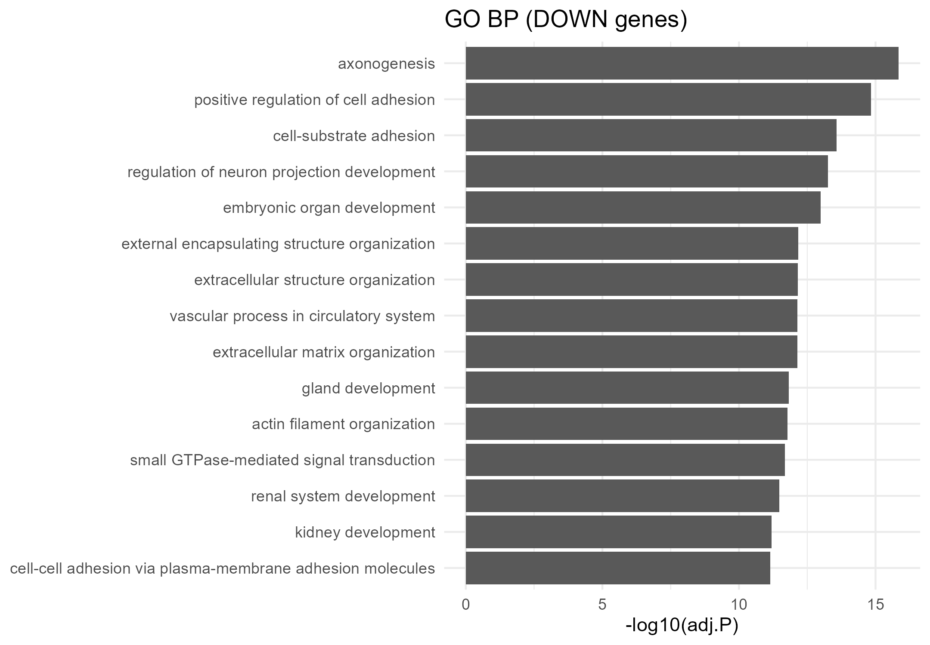

SNF clustering — cluster size distribution
SNF clustering (estimated K) produced 6 clusters.
Sizes (n): 1=32, 4=27, 6=23, 2=20, 5=17, 3=16.
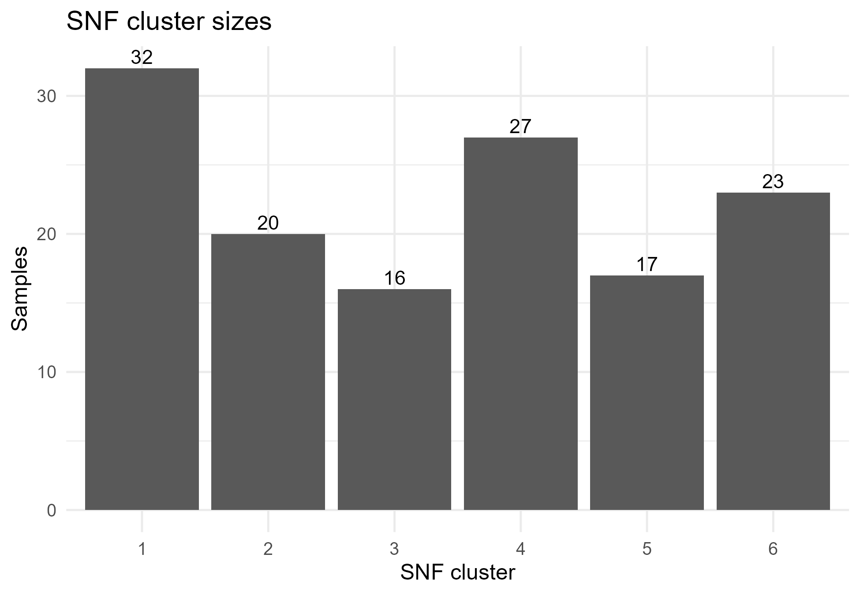

Overall survival — Cox model (unadjusted)
Cox (OS ~ cluster): no clusters reached p<0.05.
See forest for full HRs.
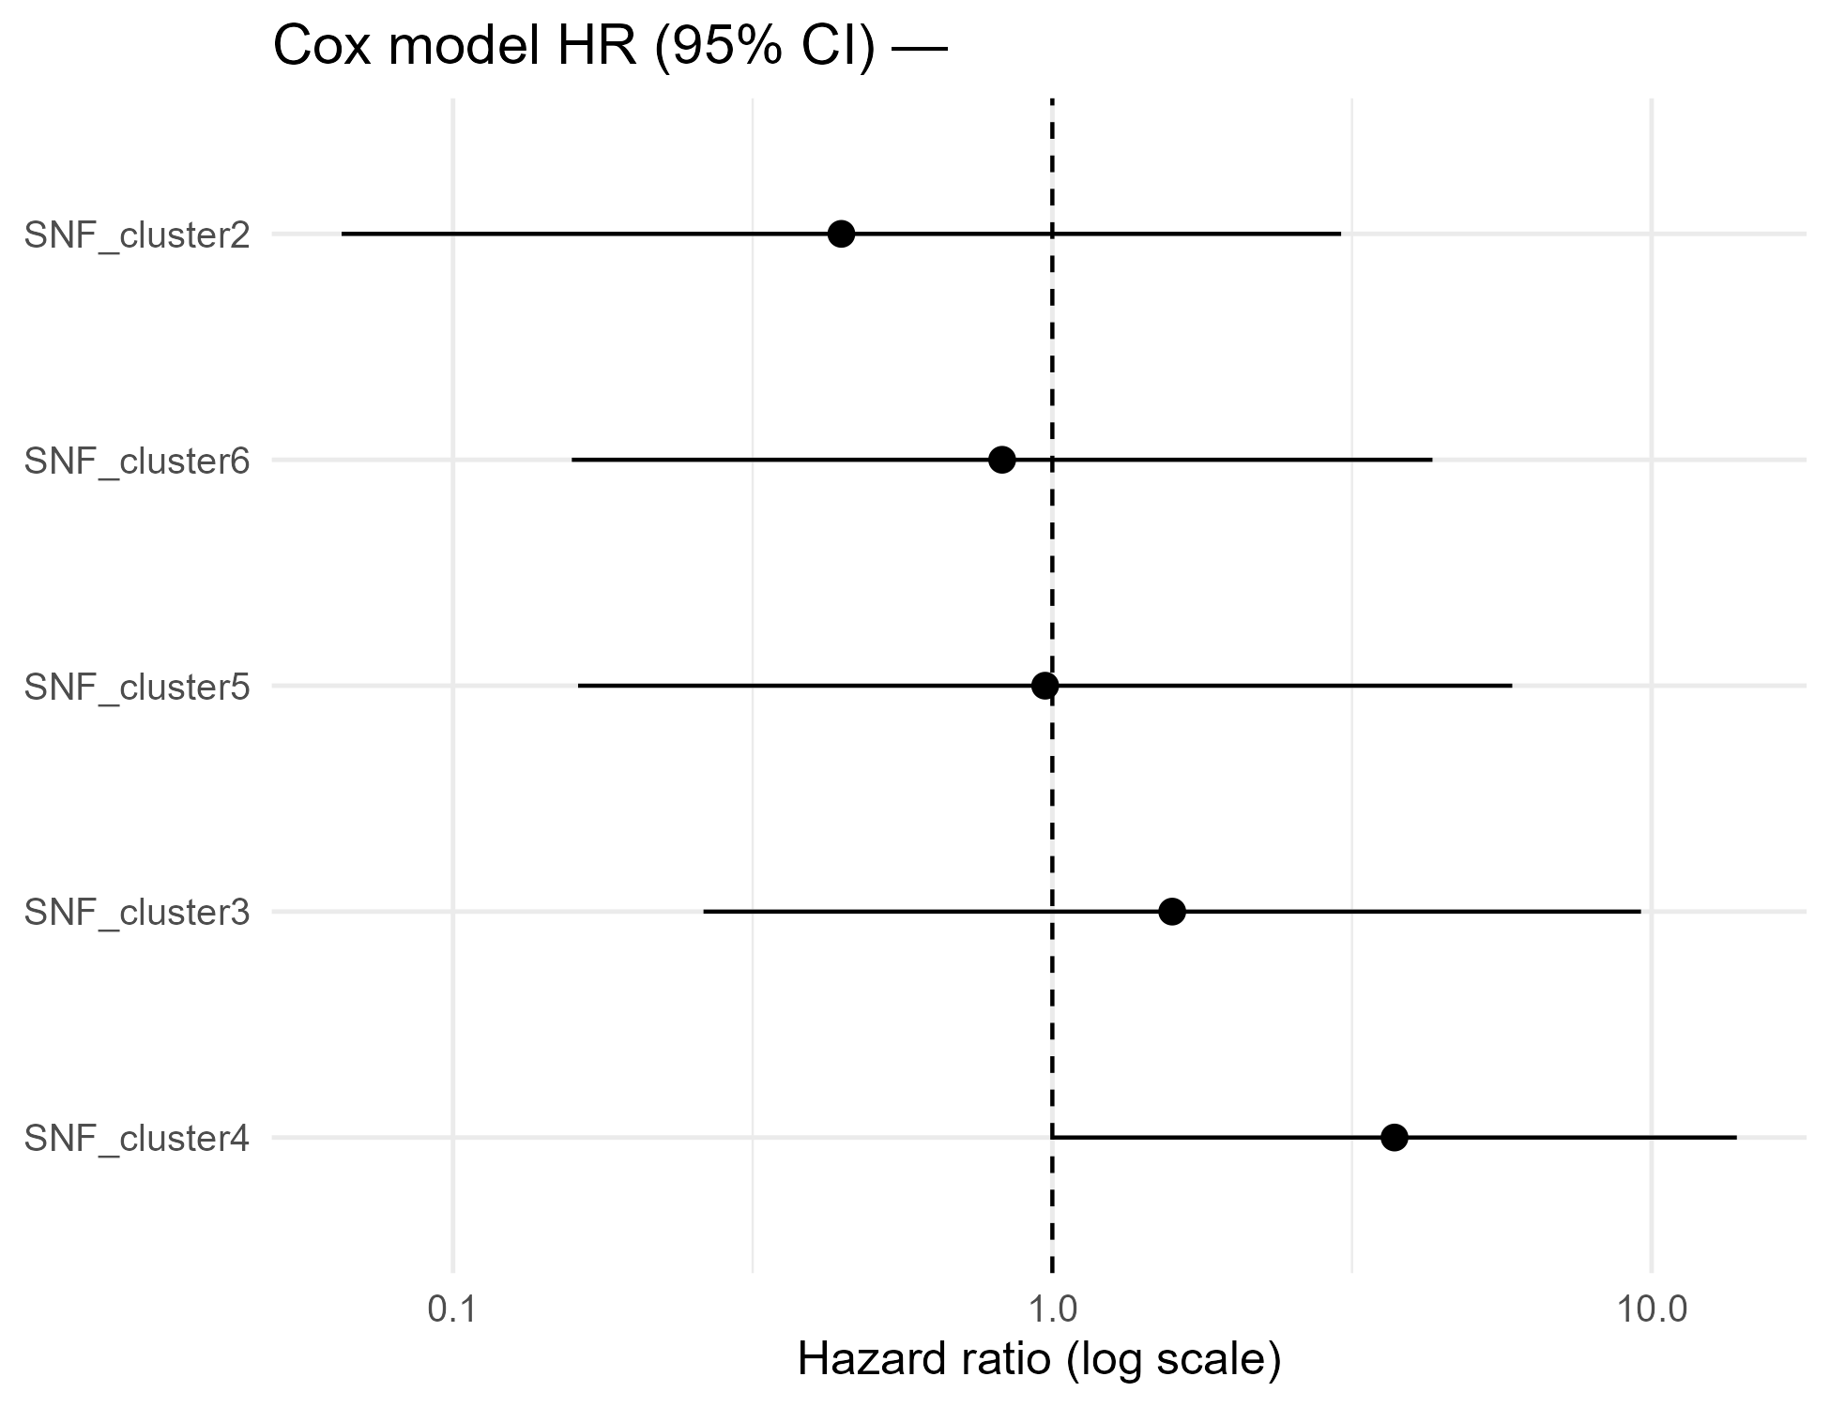

Overall survival — Cox model (age-adjusted)
Cox (OS ~ cluster + age): no clusters retained significance after age adjustment.
Forest shows all clusters.
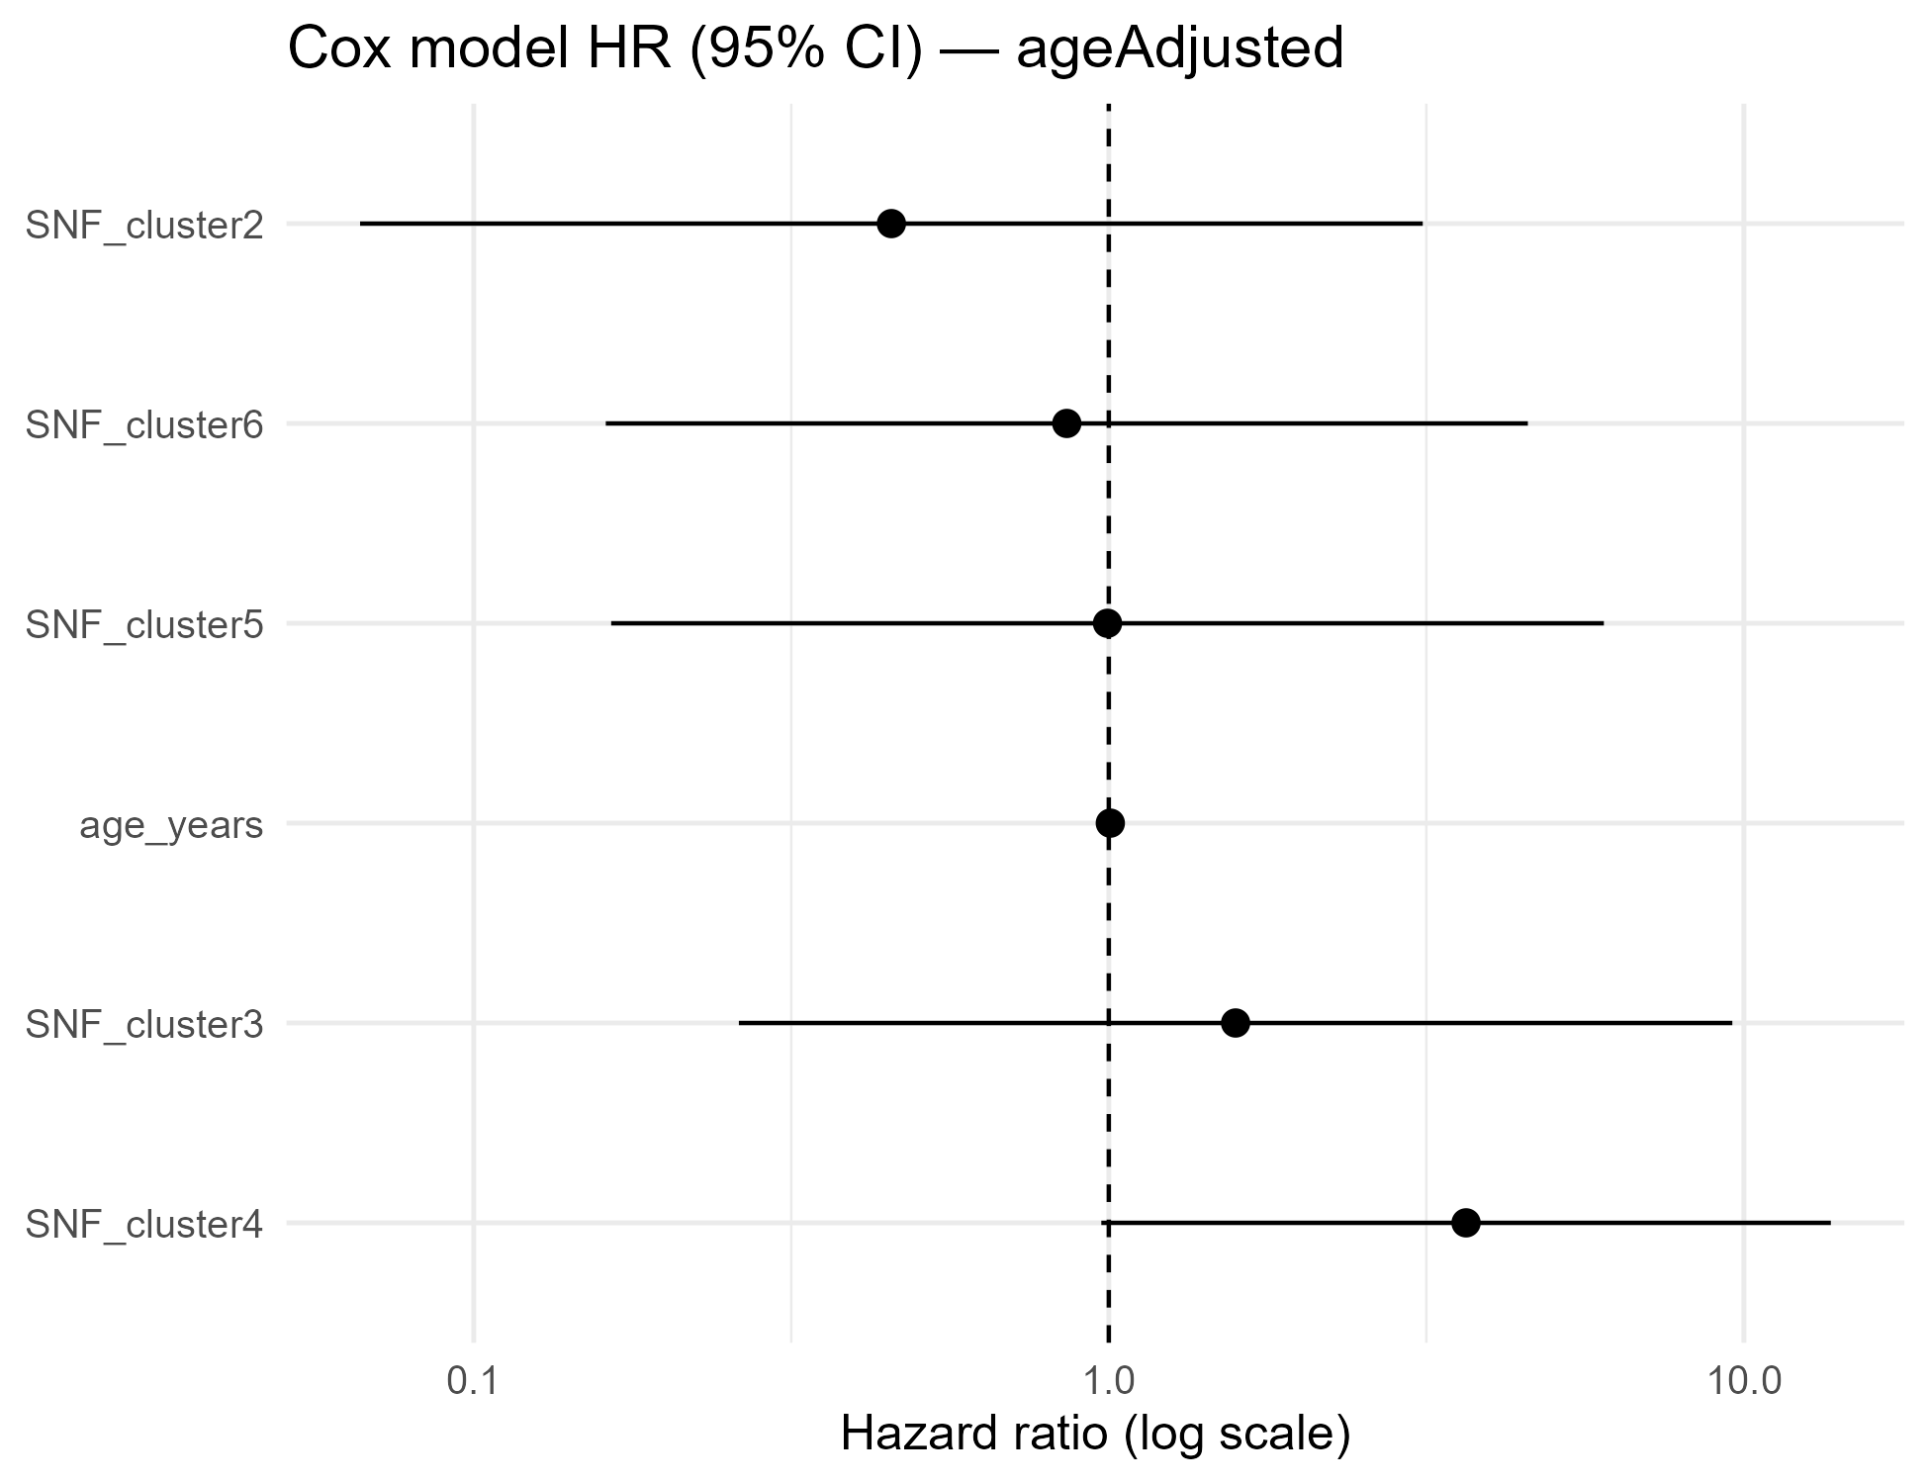

Functional enrichment — GO biological process
Functional enrichment (GO:BP) for cluster-upregulated gene set (by design, from DOWN list). See bar plot for top terms.

Functional enrichment — GO biological process
Functional enrichment (GO: Biological Process). Top terms:
• ribonucleoprotein complex biogenesis (adj.P=1.9e-35, n=294)
• ribosome biogenesis (adj.P=1.4e-32, n=207)
• viral process (adj.P=6.4e-29, n=248)
• cytoplasmic translation (adj.P=1.1e-28, n=127)
• rRNA metabolic process (adj.P=3.2e-27, n=173)
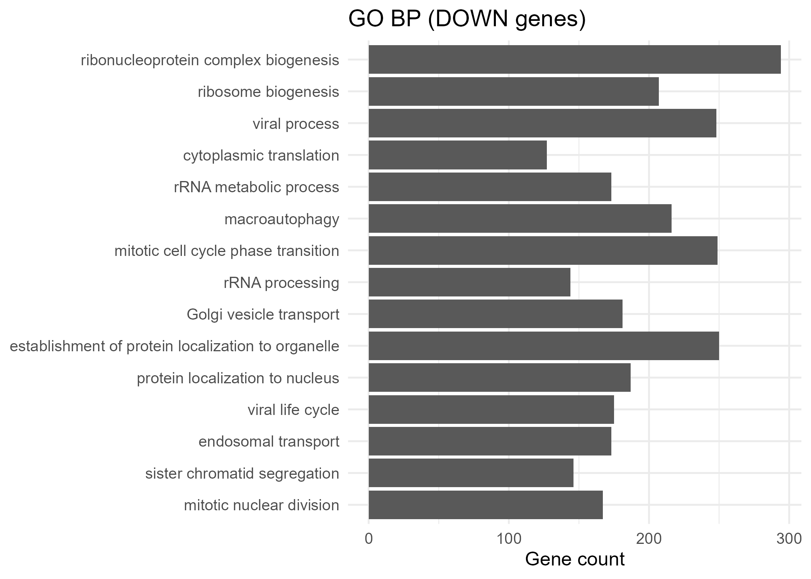

Age–cluster composition
Proportions of SNF clusters within each age group (stacked bars).
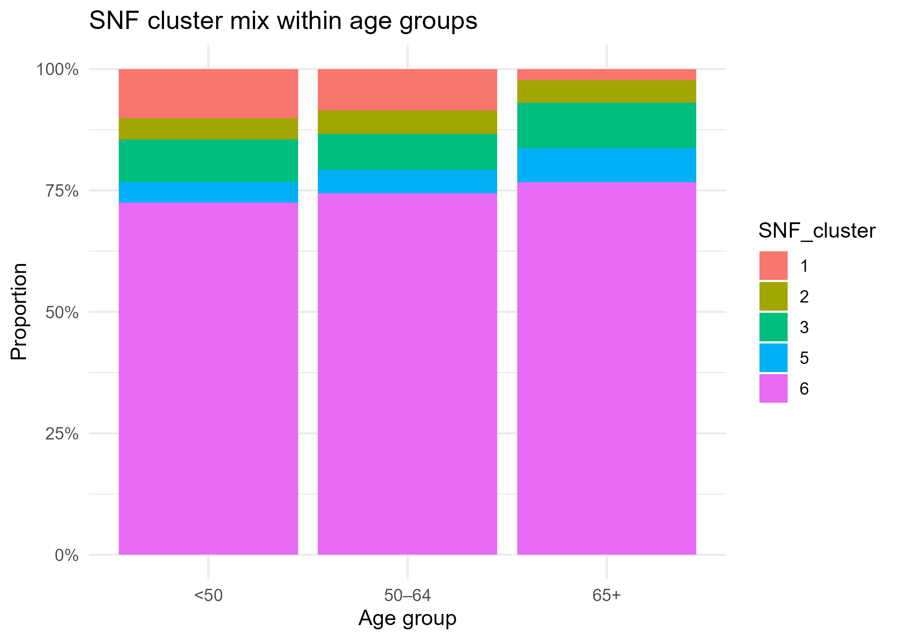

Overall survival — Cox models
We fitted Cox models with SNF clusters as predictors. The unadjusted model and an age-adjusted model give broadly similar hazard ratios (HRs). Forest plots below show HRs with 95% CIs for each cluster vs the reference.
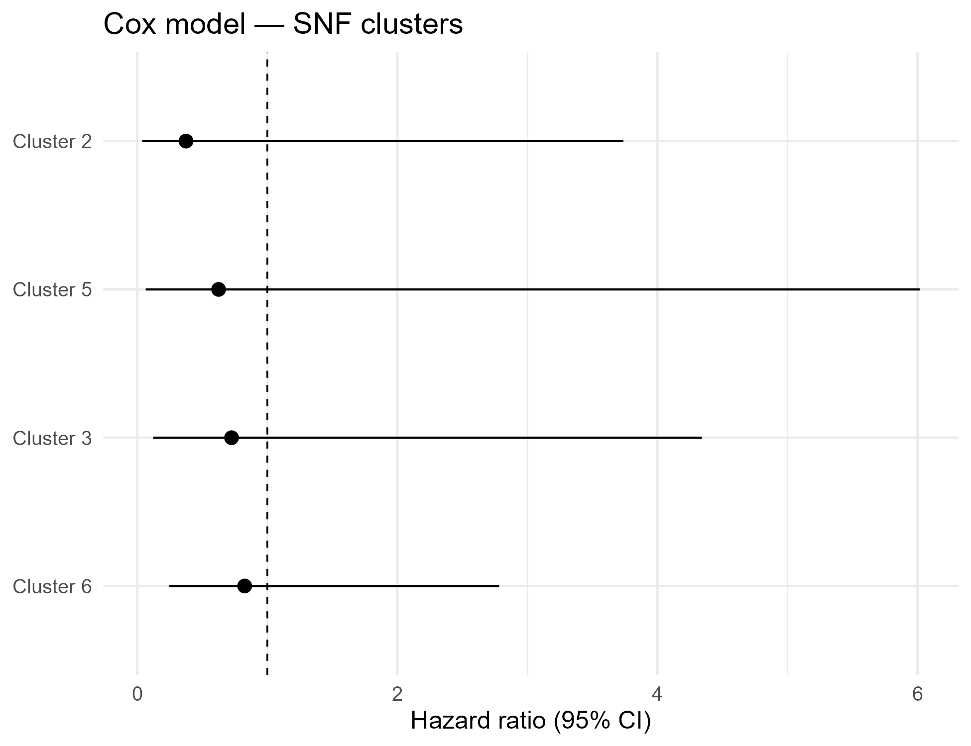

Age-adjusted:
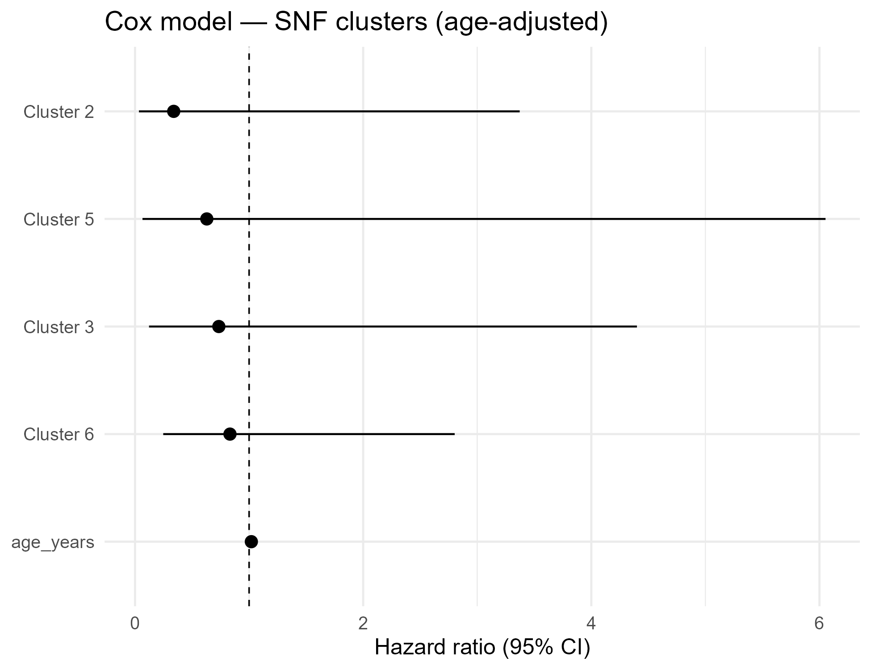

KM by SNF cluster — stratified by age group
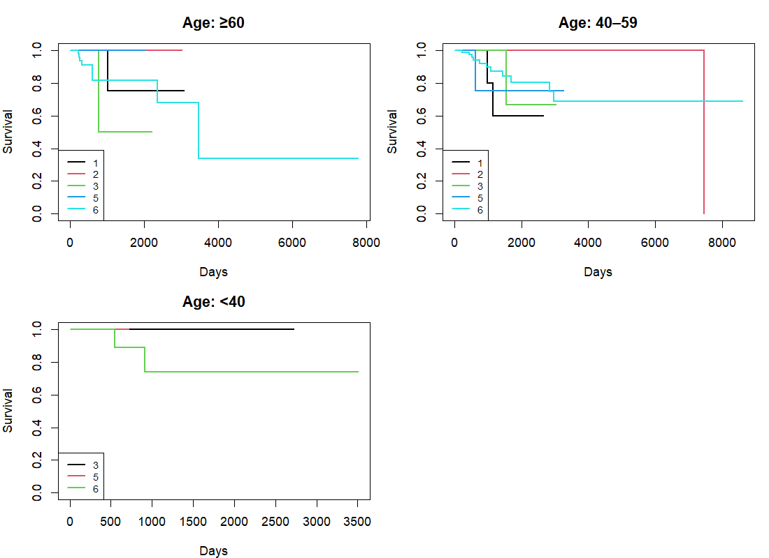

Overall survival — Cox model (unadjusted)
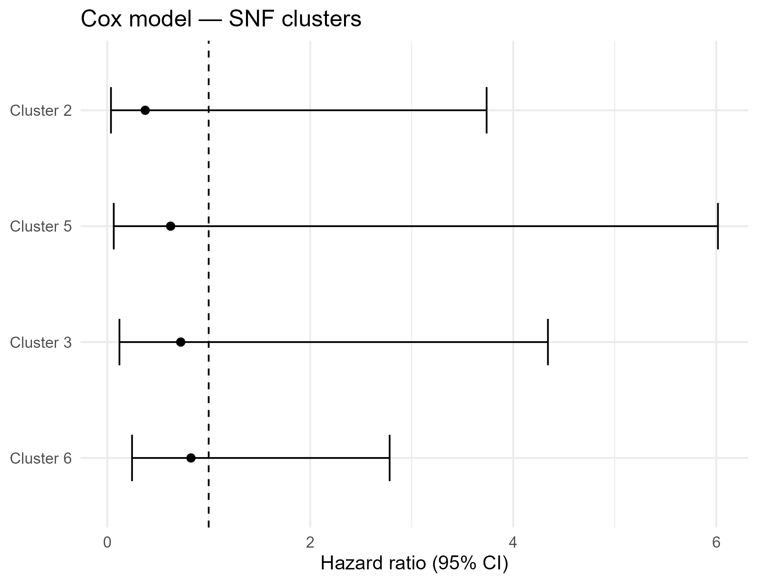

Overall survival — Cox model (age-adjusted)
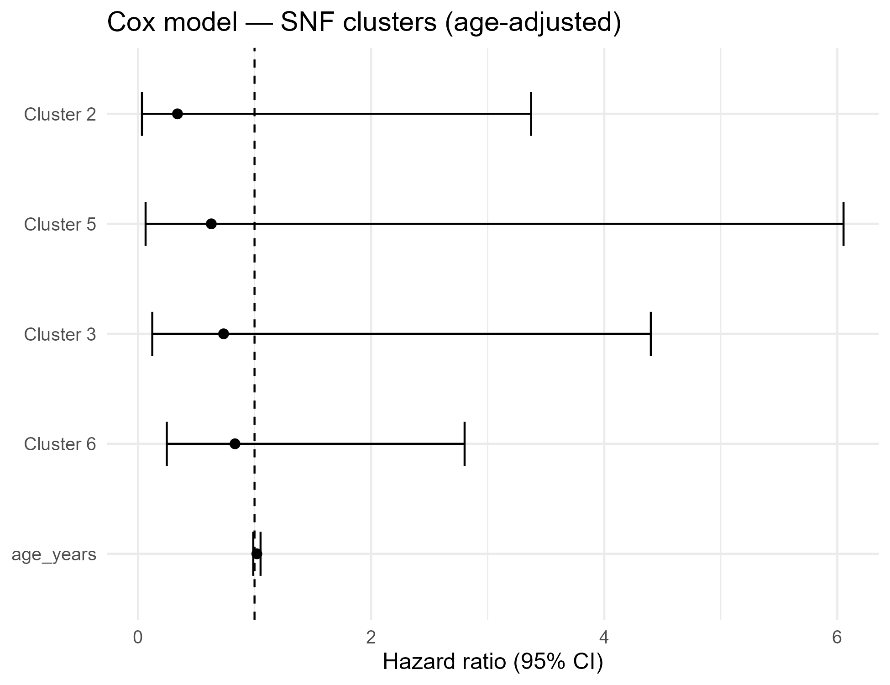

Kaplan–Meier by SNF cluster
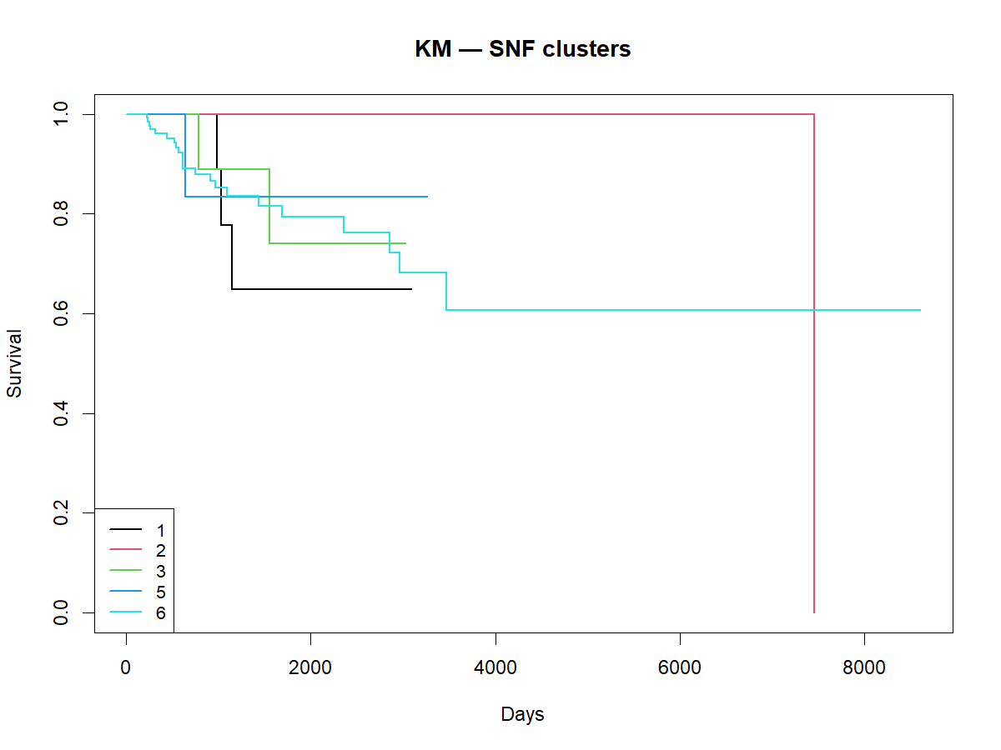

KM stratified by age group
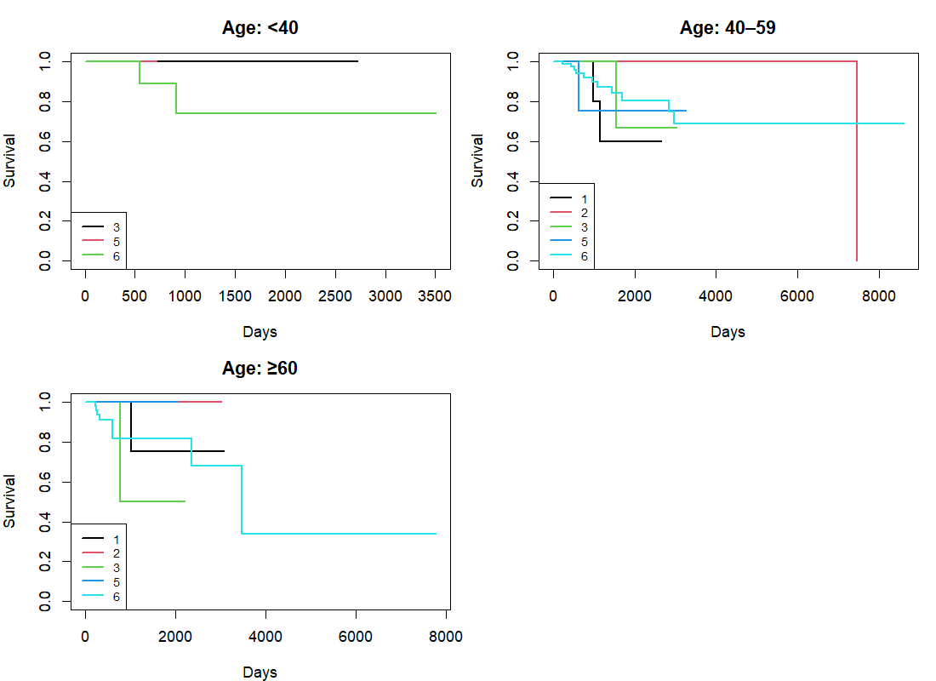

Overall survival — Cox model (unadjusted)
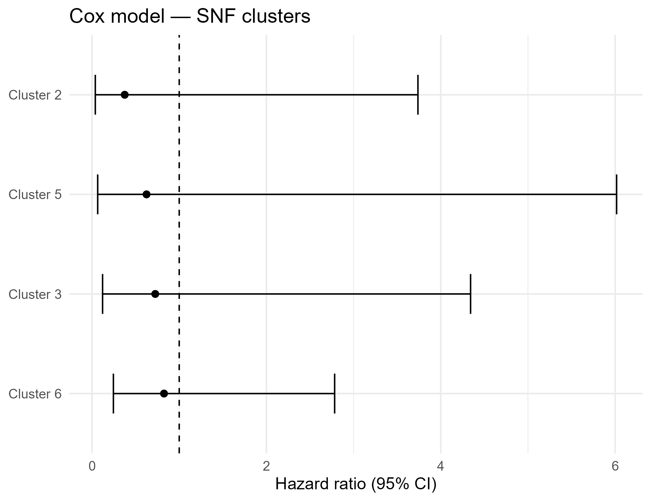

Overall survival — Cox model (age-adjusted)
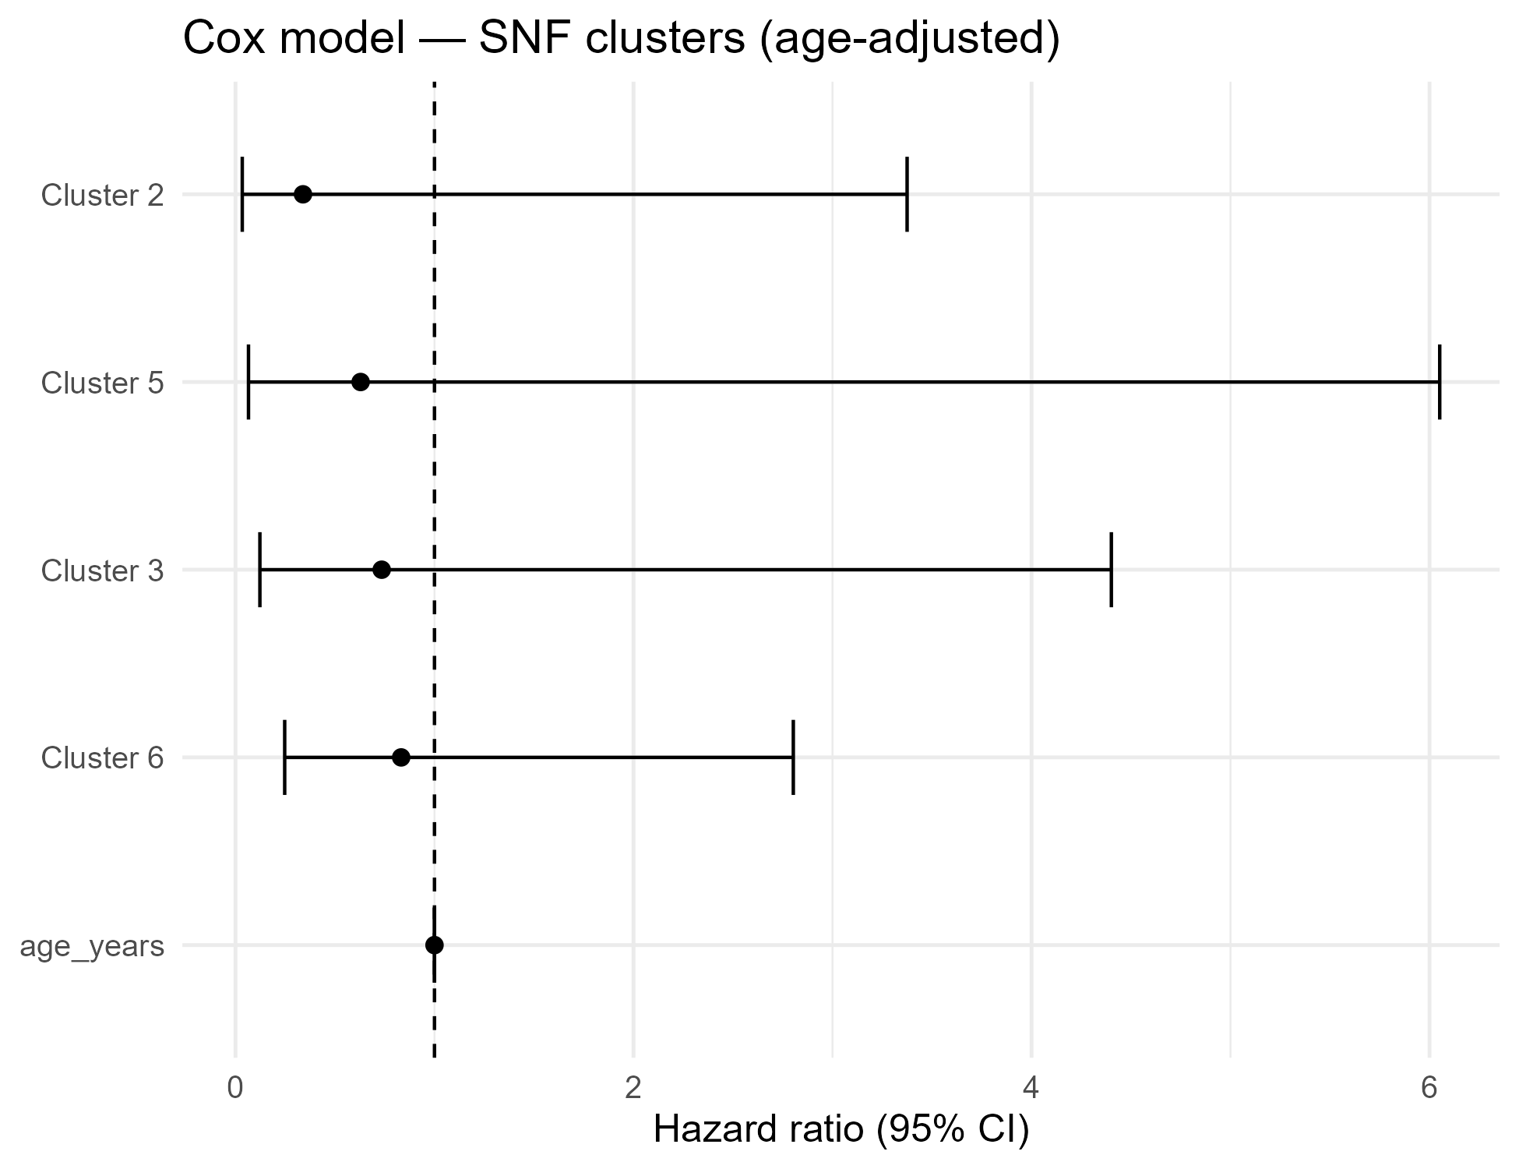

Kaplan–Meier by SNF cluster
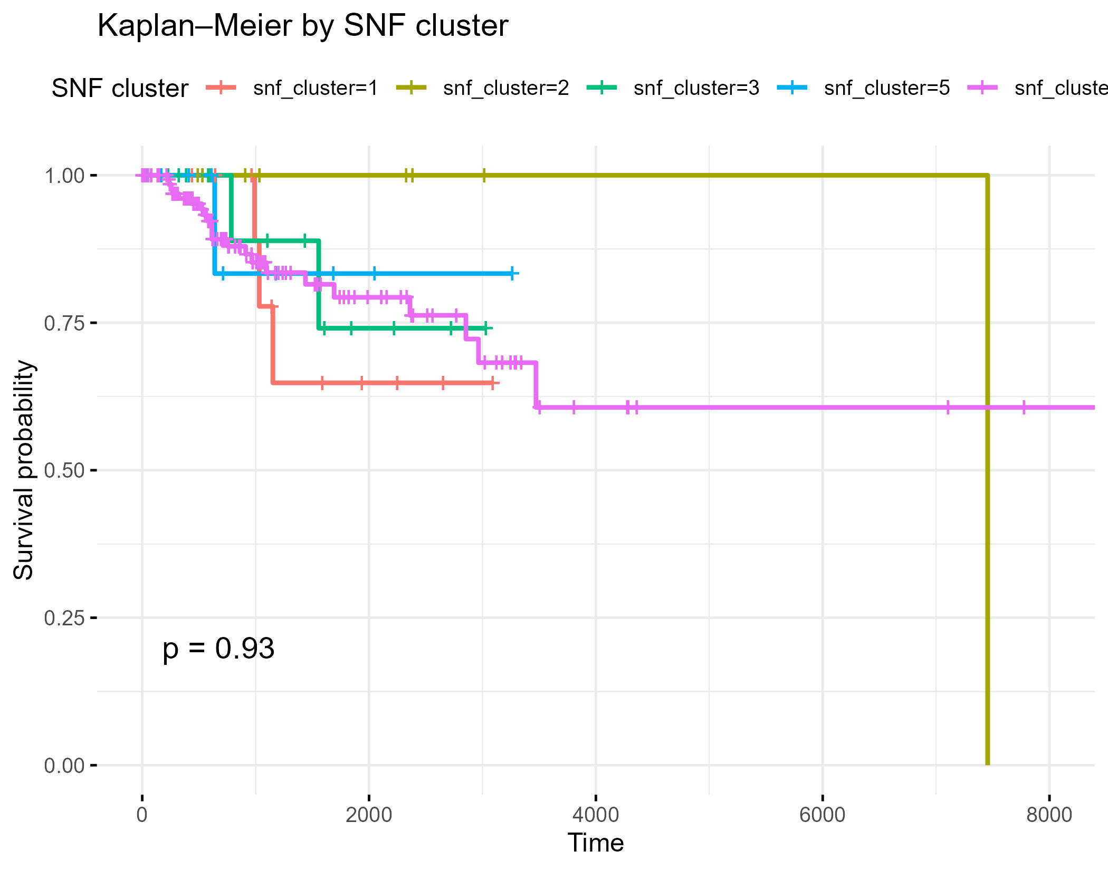

KM by SNF cluster — stratified by age group
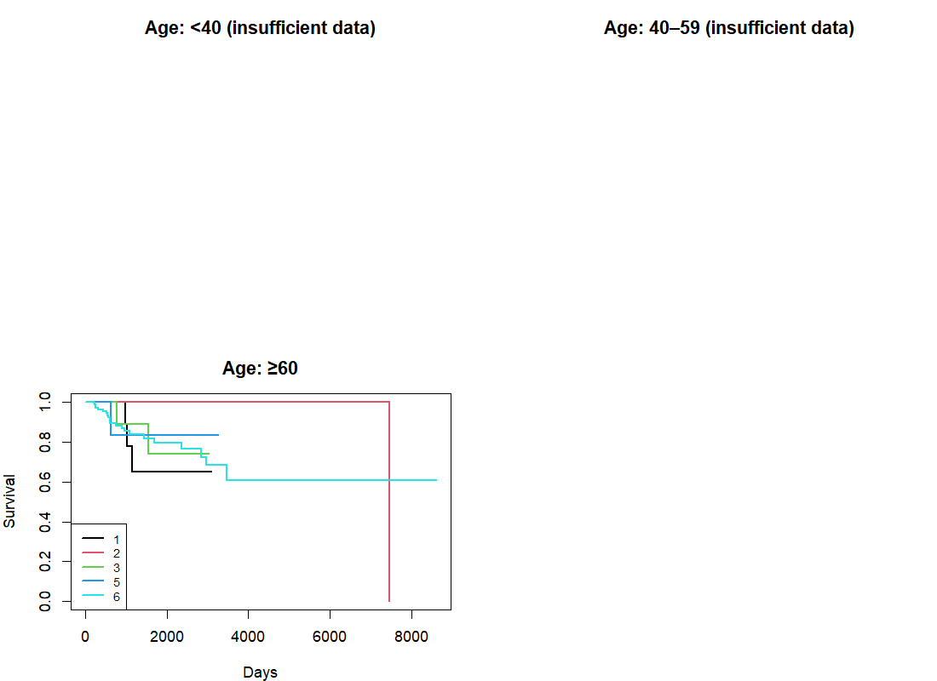

Clinical summary
N | Clusters | N per cluster | Age mean ± SD
194 | 1, 2, 3, 5, 6 | 15, 9, 16, 10, 144 | 20312.5 ± 4304.6

Age group × SNF cluster (counts + %)
Age group | 1 | 2 | 3 | 5 | 6
≥60 | 15 (7.7%) | 9 (4.6%) | 16 (8.2%) | 10 (5.2%) | 144 (74.2%)

