TNBC quick report
Generated: 2025-08-19 17:37

QC & clustering

PCA (VST)
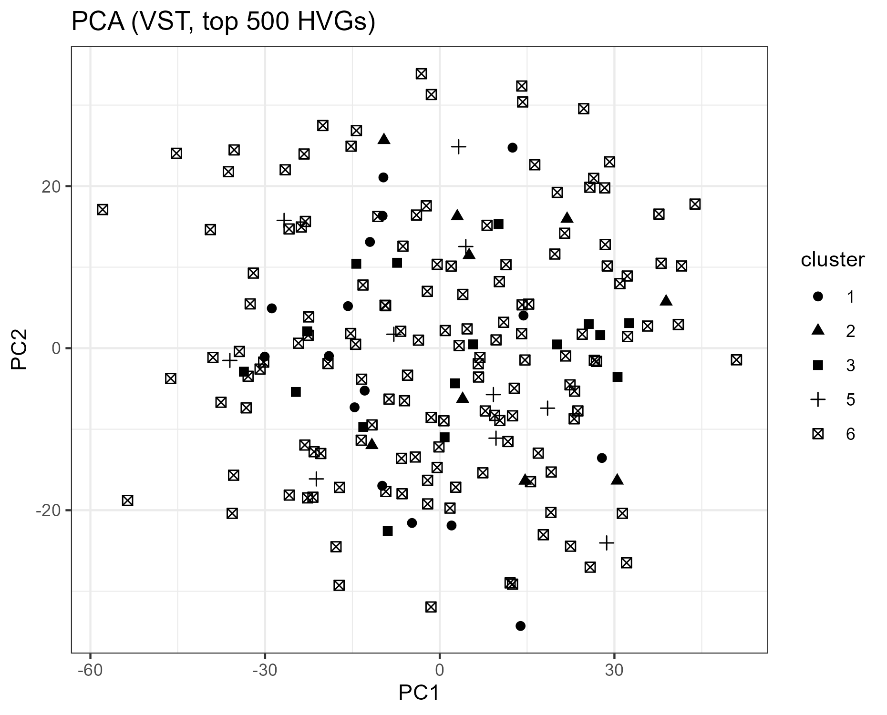

Markers heatmap (strict)
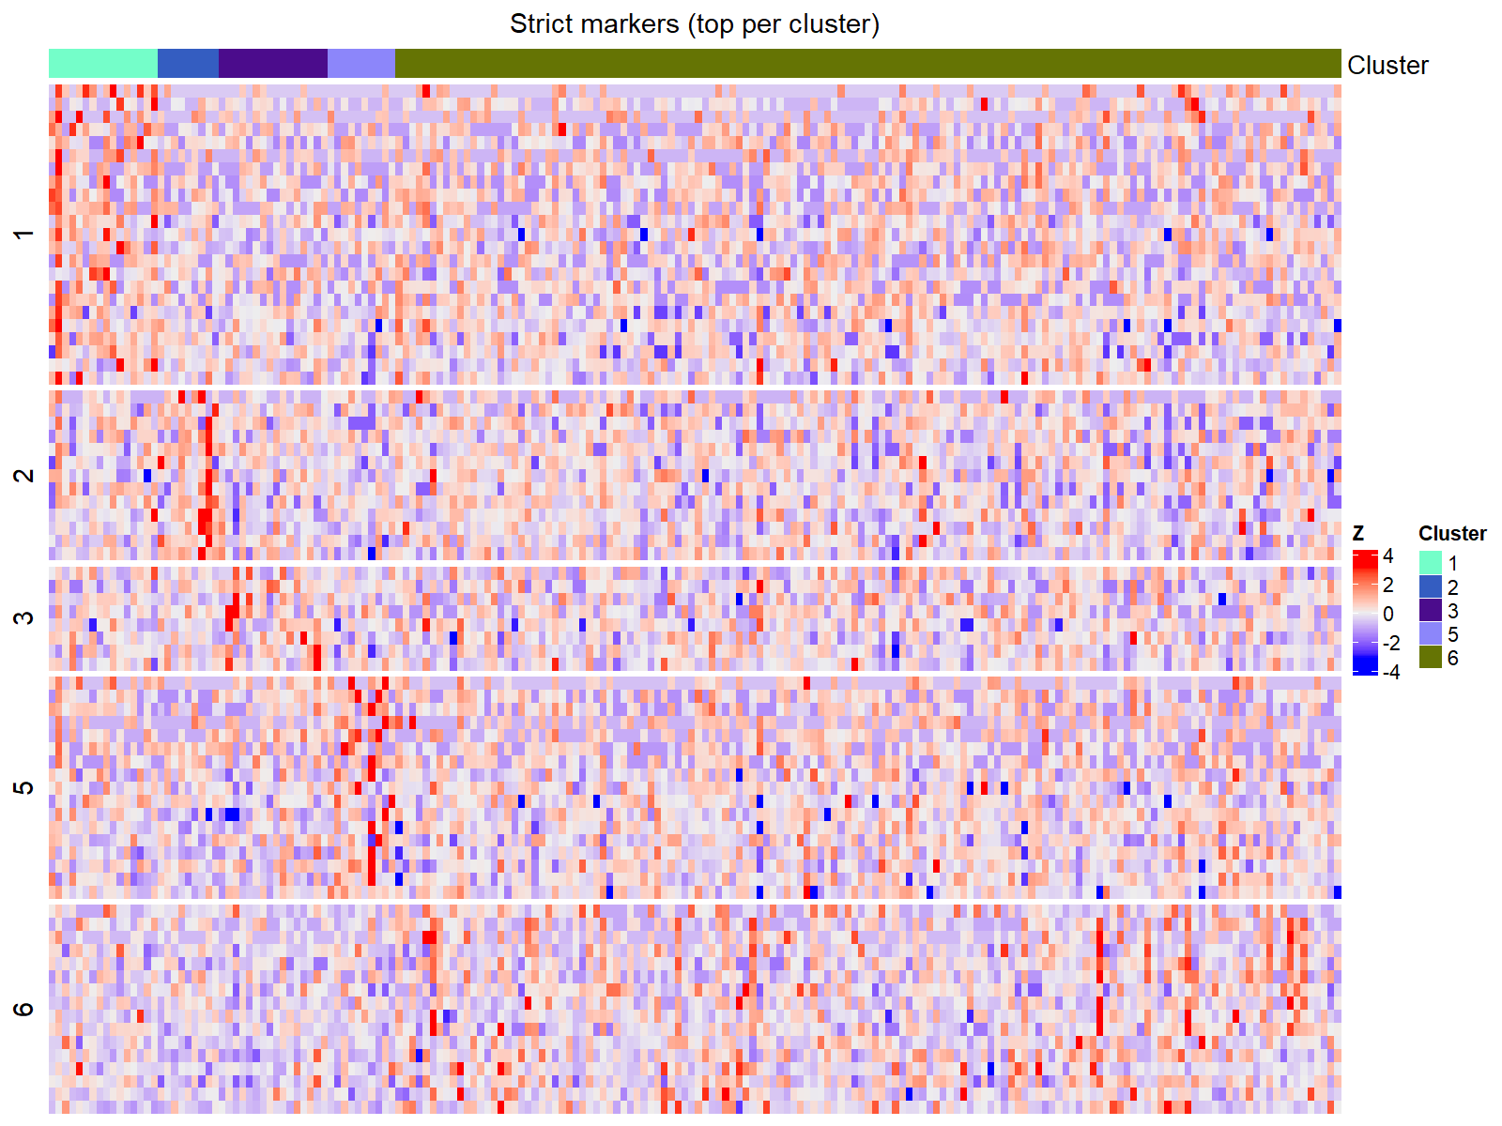

Differential expression

Volcano: cluster C:/TNBC_project/results/deseq2_percluster/plots/Volcano1vsREST.png vs REST
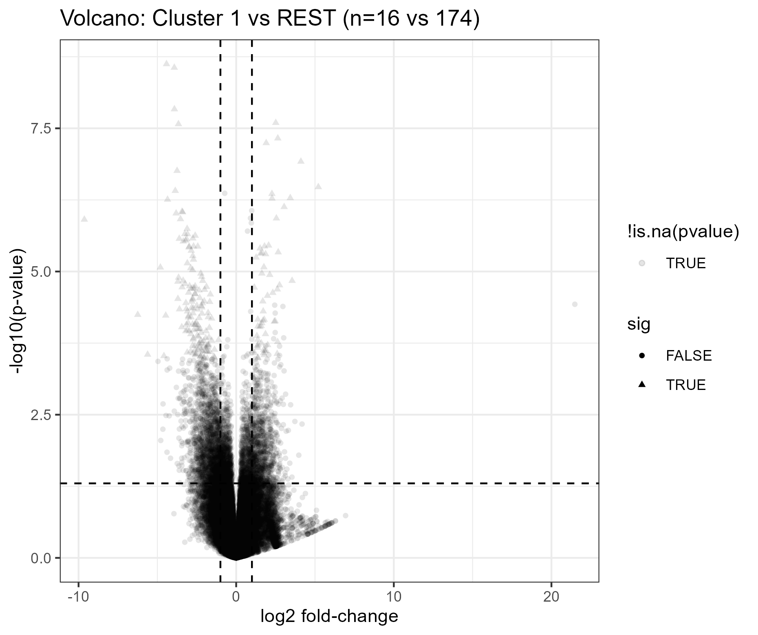

Volcano: cluster C:/TNBC_project/results/deseq2_percluster/plots/Volcano2vsREST.png vs REST
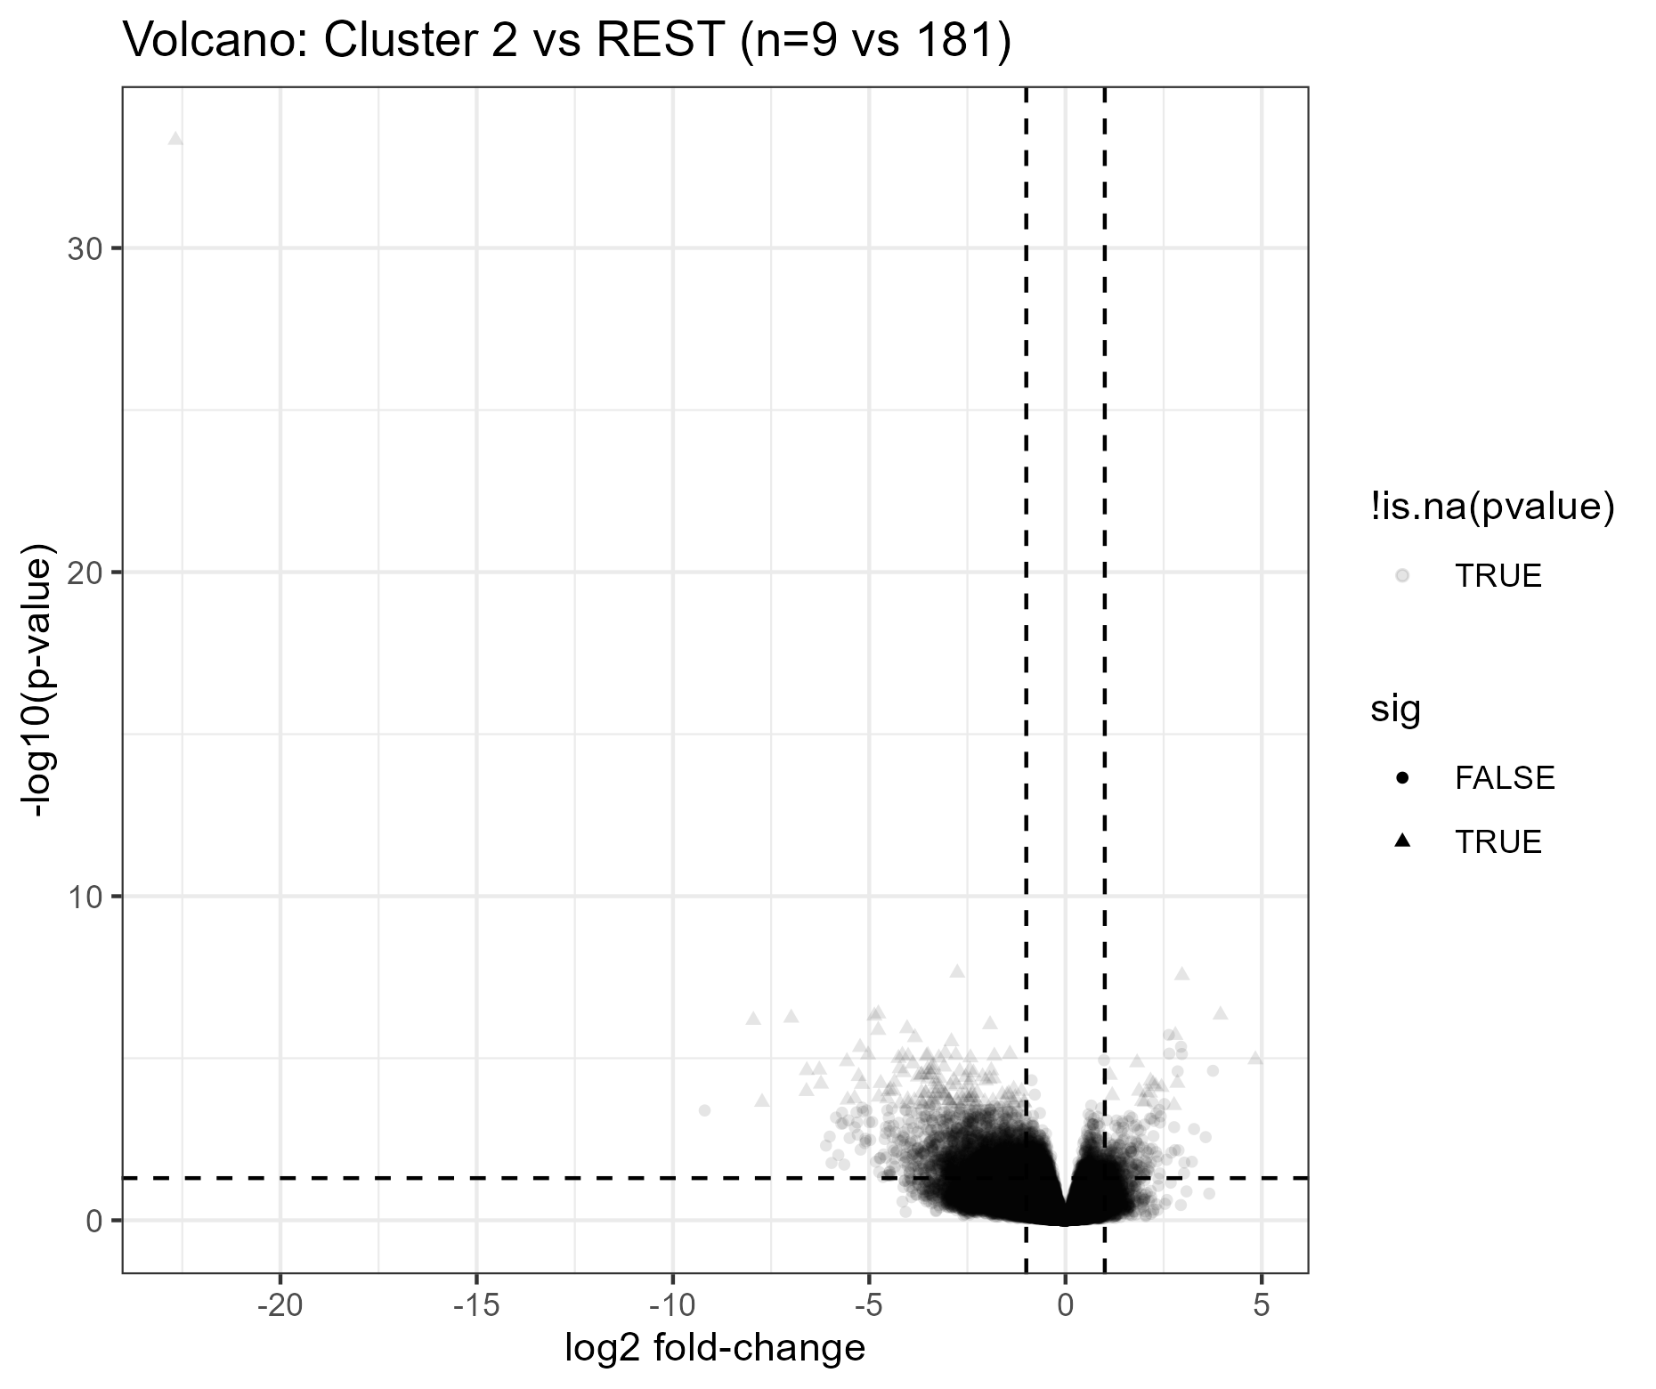

Volcano: cluster C:/TNBC_project/results/deseq2_percluster/plots/Volcano3vsREST.png vs REST
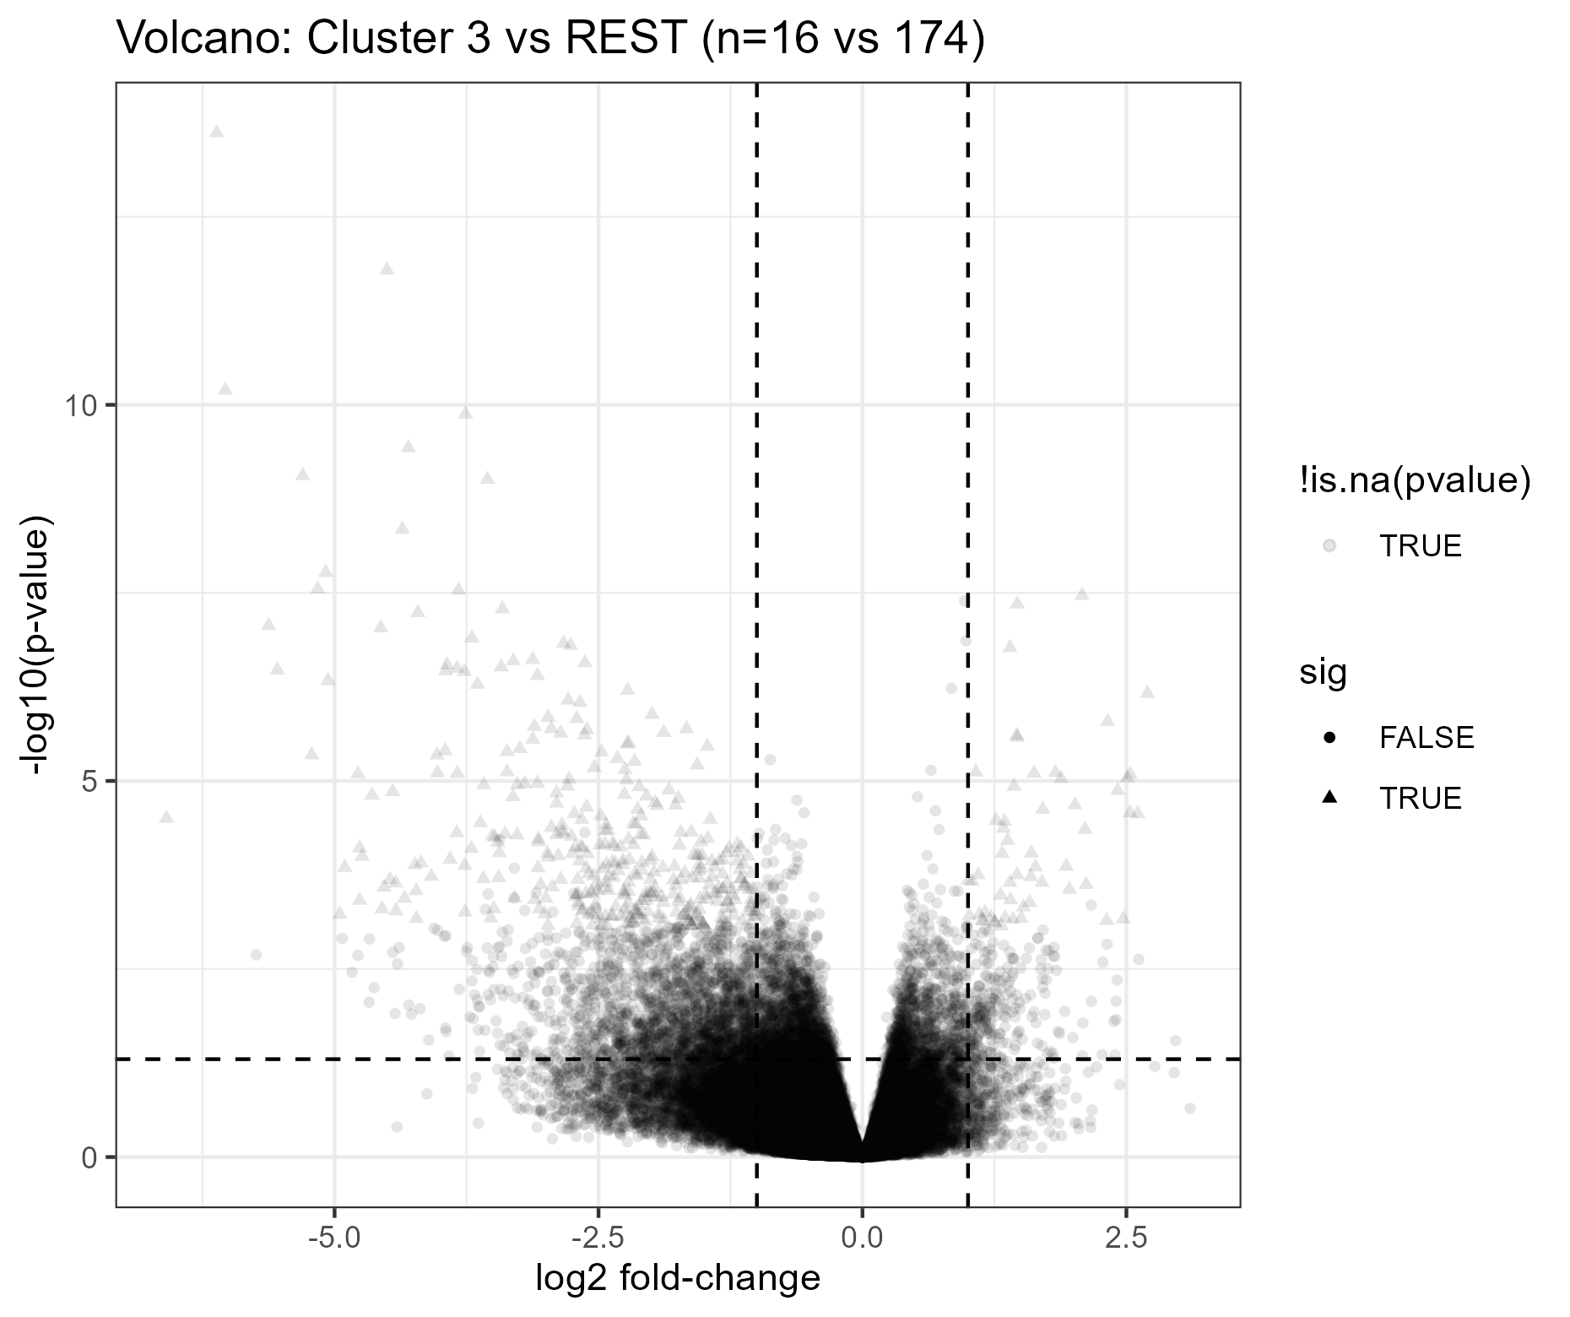

Volcano: cluster C:/TNBC_project/results/deseq2_percluster/plots/Volcano5vsREST.png vs REST
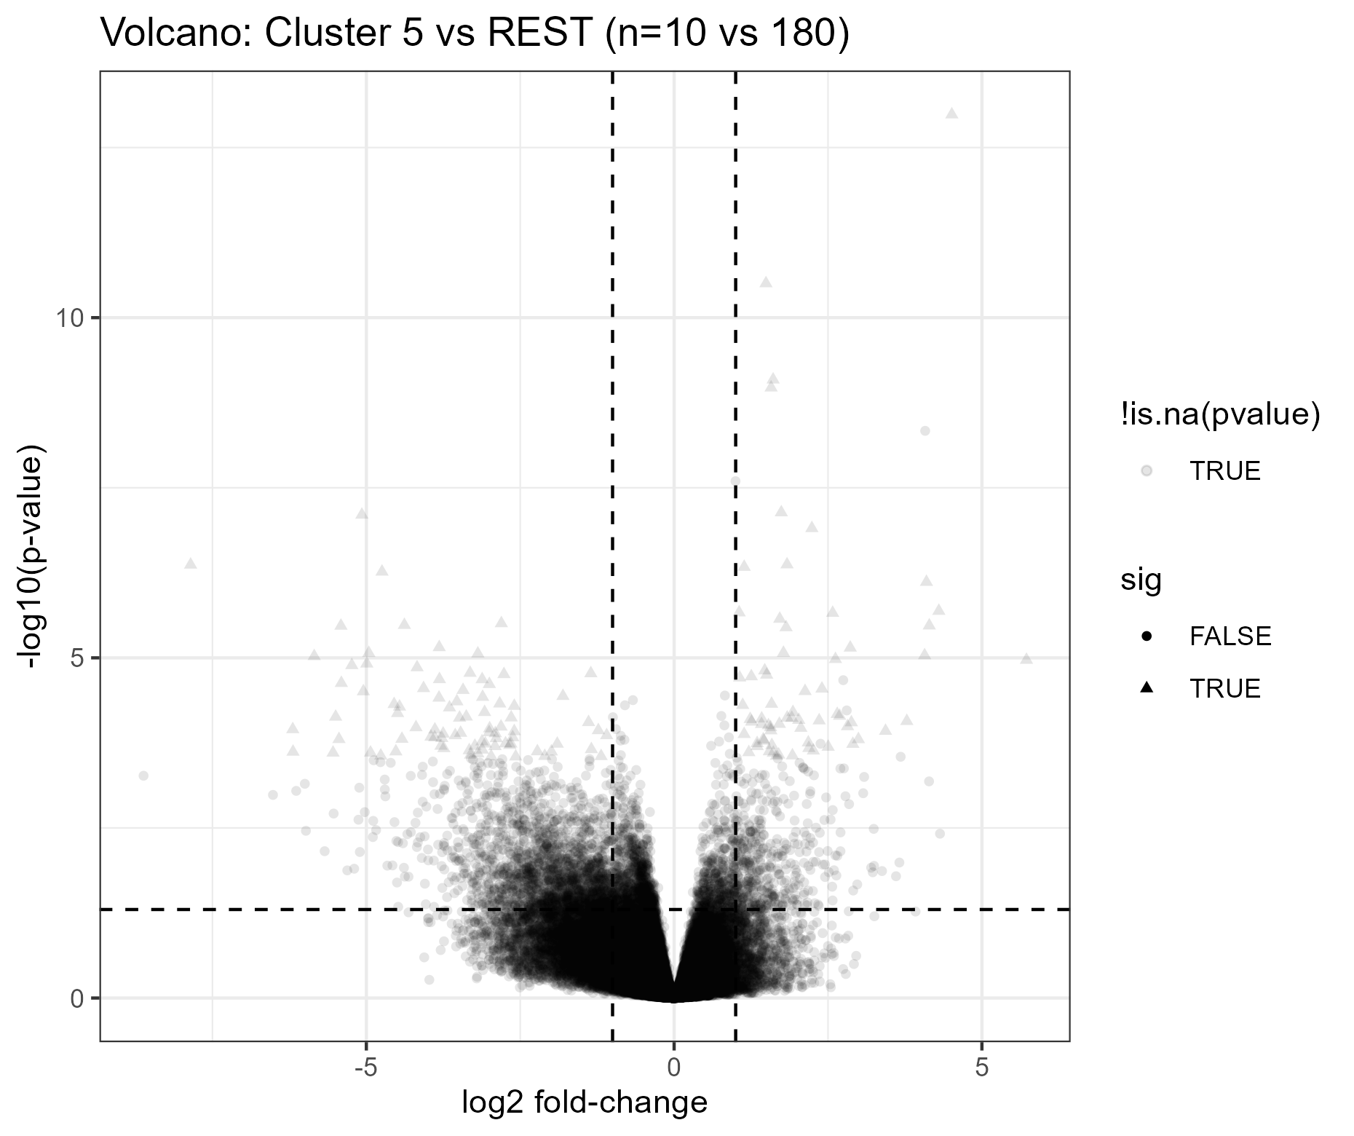

Volcano: cluster C:/TNBC_project/results/deseq2_percluster/plots/Volcano6vsREST.png vs REST
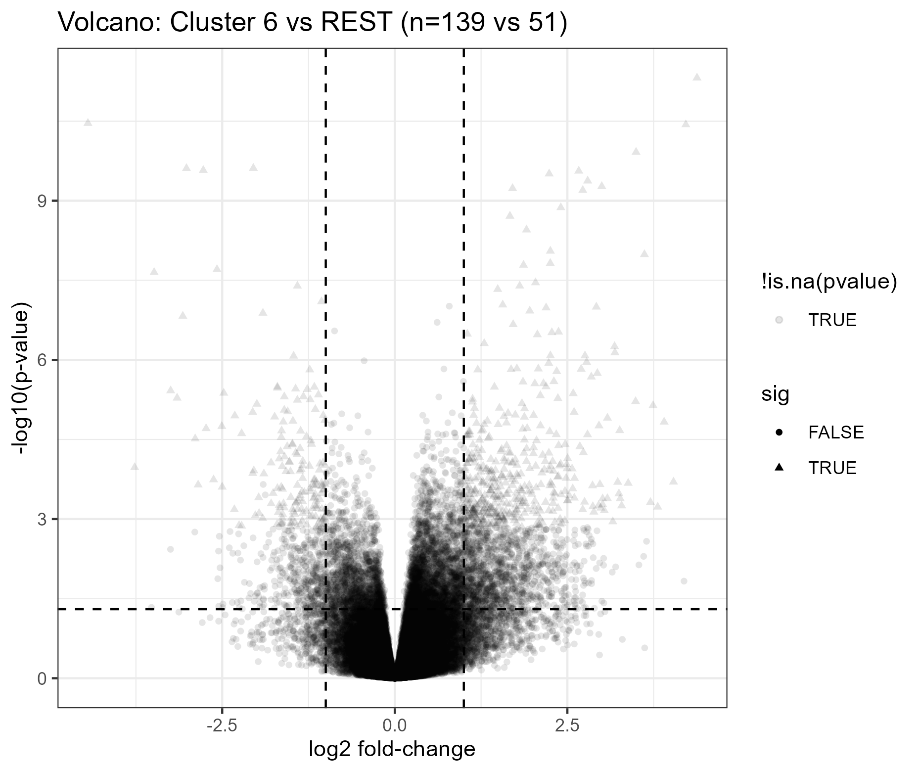

DE summary (head)
OK: 1
OK: 2
OK: 3
OK: 5
OK: 6

Enrichment

Reactome heatmap
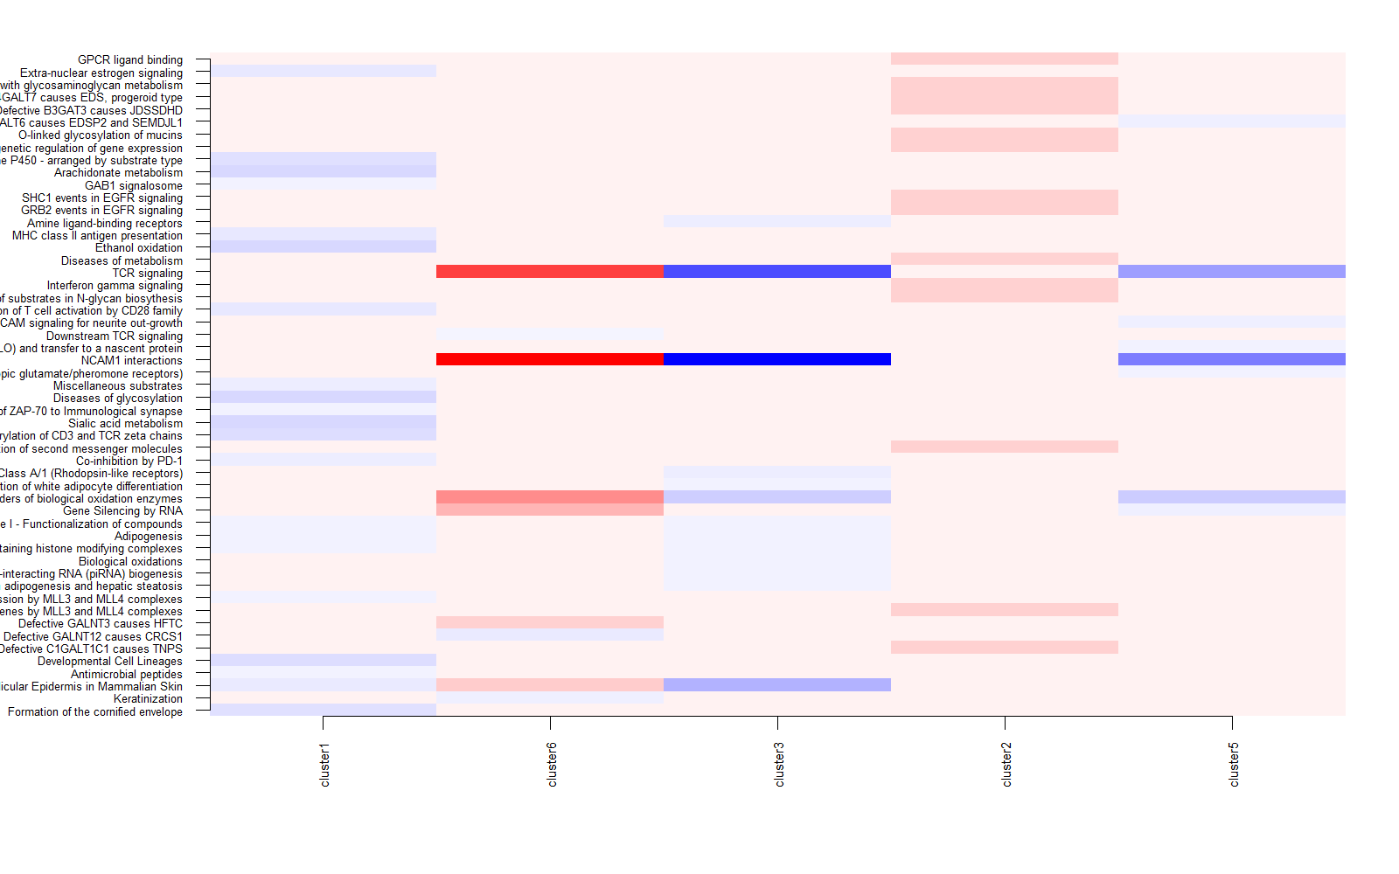

GSVA (Hallmark + Reactome compact)

GSVA top-50 heatmap
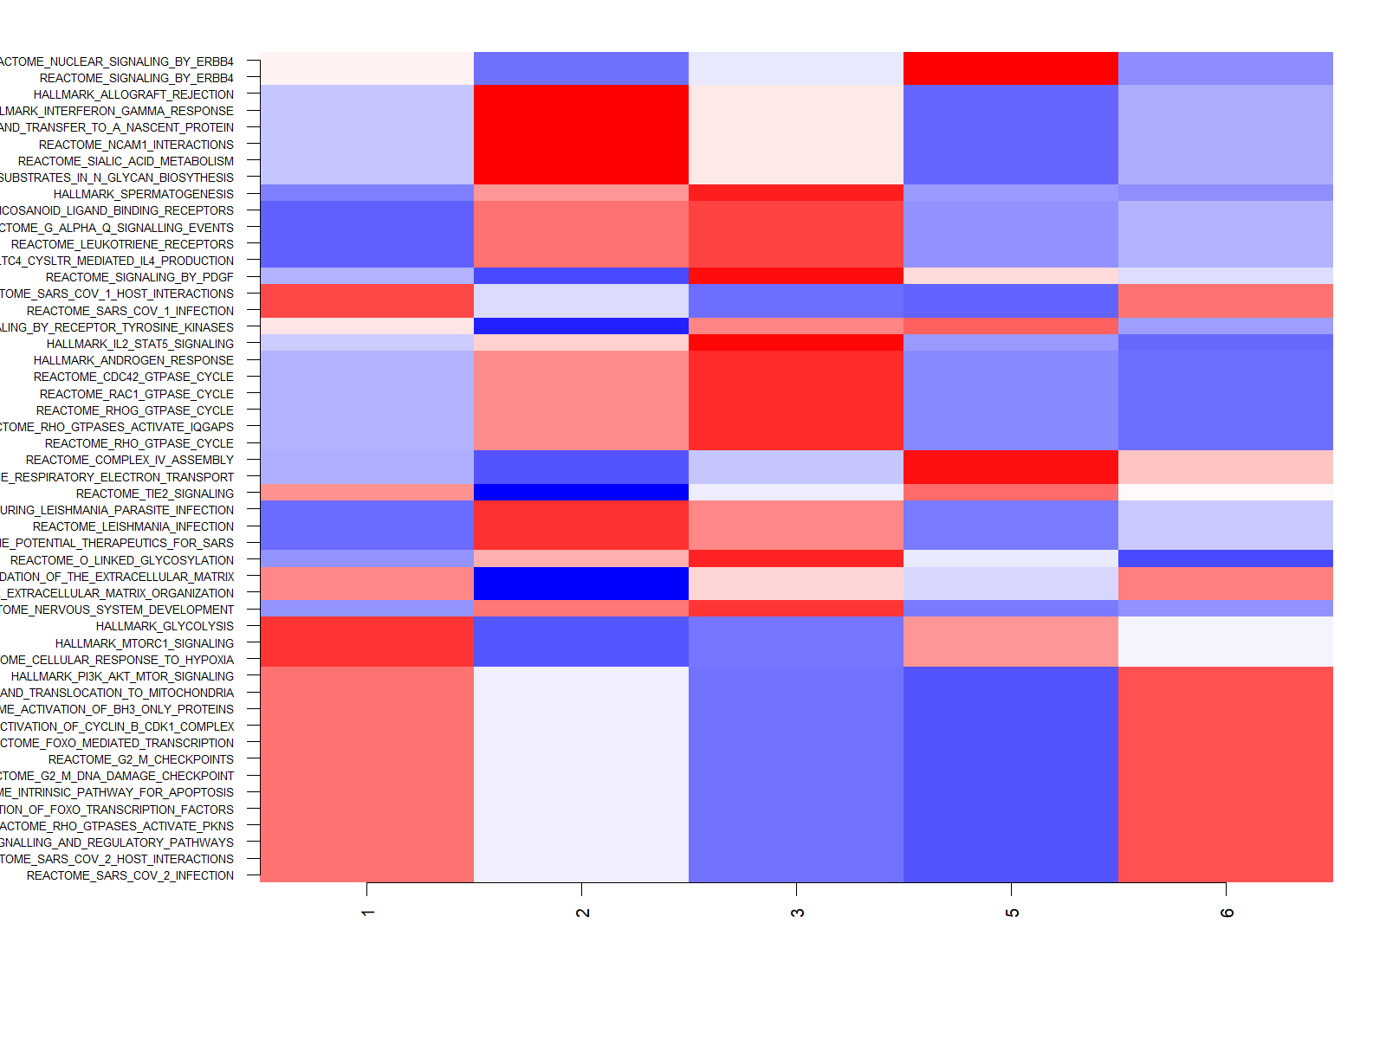

Top pathways (KW)
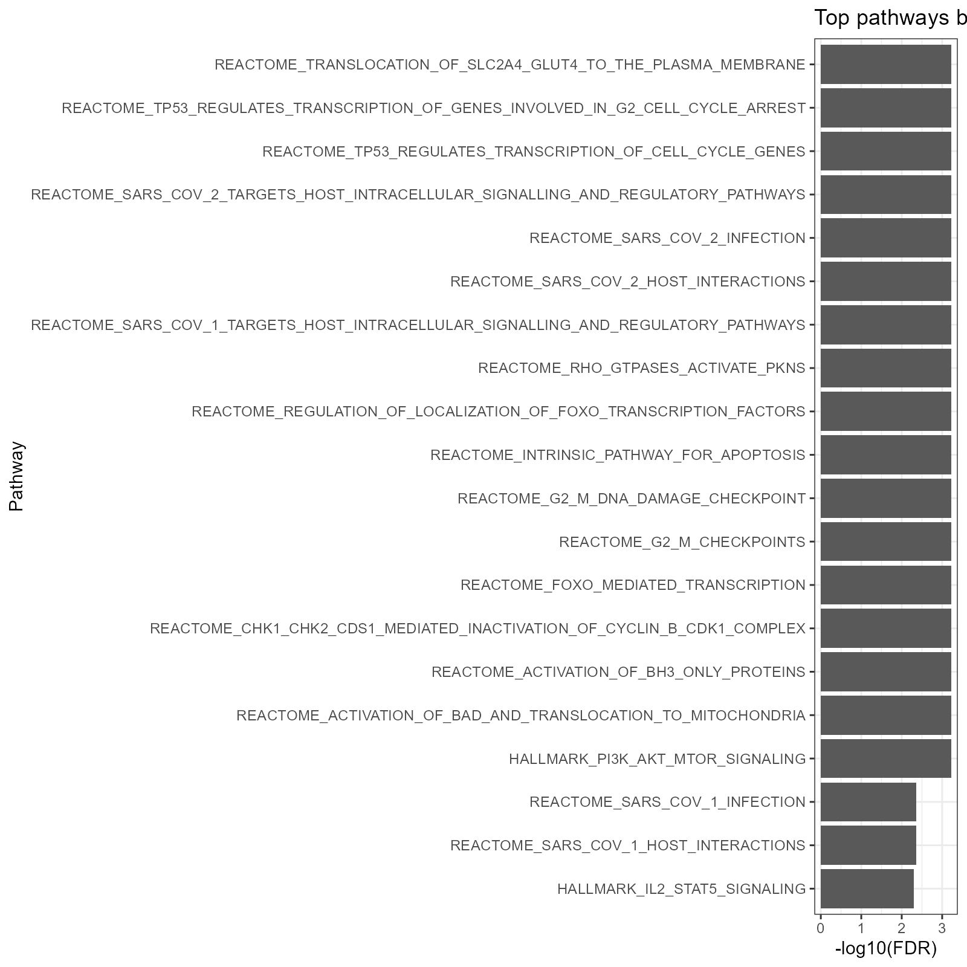

KW table (head)
pathway | kw_p | kw_fdr
HALLMARK_PI3K_AKT_MTOR_SIGNALING | 0.00004370215 | 0.0008226286
REACTOME_ACTIVATION_OF_BAD_AND_TRANSLOCATION_TO_MITOCHONDRIA | 0.00004370215 | 0.0008226286
REACTOME_ACTIVATION_OF_BH3_ONLY_PROTEINS | 0.00004370215 | 0.0008226286
REACTOME_CHK1_CHK2_CDS1_MEDIATED_INACTIVATION_OF_CYCLIN_B_CDK1_COMPLEX | 0.00004370215 | 0.0008226286
REACTOME_FOXO_MEDIATED_TRANSCRIPTION | 0.00004370215 | 0.0008226286
REACTOME_G2_M_CHECKPOINTS | 0.00004370215 | 0.0008226286
REACTOME_G2_M_DNA_DAMAGE_CHECKPOINT | 0.00004370215 | 0.0008226286
REACTOME_INTRINSIC_PATHWAY_FOR_APOPTOSIS | 0.00004370215 | 0.0008226286
REACTOME_REGULATION_OF_LOCALIZATION_OF_FOXO_TRANSCRIPTION_FACTORS | 0.00004370215 | 0.0008226286
REACTOME_RHO_GTPASES_ACTIVATE_PKNS | 0.00004370215 | 0.0008226286
REACTOME_SARS_COV_1_TARGETS_HOST_INTRACELLULAR_SIGNALLING_AND_REGULATORY_PATHWAYS | 0.00004370215 | 0.0008226286
REACTOME_SARS_COV_2_HOST_INTERACTIONS | 0.00004370215 | 0.0008226286
REACTOME_SARS_COV_2_INFECTION | 0.00004370215 | 0.0008226286
REACTOME_SARS_COV_2_TARGETS_HOST_INTRACELLULAR_SIGNALLING_AND_REGULATORY_PATHWAYS | 0.00004370215 | 0.0008226286
REACTOME_TP53_REGULATES_TRANSCRIPTION_OF_CELL_CYCLE_GENES | 0.00004370215 | 0.0008226286

Pairwise Wilcoxon (head)
pathway | p | diff_mean | comp | fdr
HALLMARK_PI3K_AKT_MTOR_SIGNALING | 0.0001672484 | -0.8387026 | 5vs6 | 0.003148205
REACTOME_ACTIVATION_OF_BAD_AND_TRANSLOCATION_TO_MITOCHONDRIA | 0.0001672484 | -0.8387026 | 5vs6 | 0.003148205
REACTOME_ACTIVATION_OF_BH3_ONLY_PROTEINS | 0.0001672484 | -0.8387026 | 5vs6 | 0.003148205
REACTOME_CHK1_CHK2_CDS1_MEDIATED_INACTIVATION_OF_CYCLIN_B_CDK1_COMPLEX | 0.0001672484 | -0.8387026 | 5vs6 | 0.003148205
REACTOME_FOXO_MEDIATED_TRANSCRIPTION | 0.0001672484 | -0.8387026 | 5vs6 | 0.003148205
REACTOME_G2_M_CHECKPOINTS | 0.0001672484 | -0.8387026 | 5vs6 | 0.003148205
REACTOME_G2_M_DNA_DAMAGE_CHECKPOINT | 0.0001672484 | -0.8387026 | 5vs6 | 0.003148205
REACTOME_INTRINSIC_PATHWAY_FOR_APOPTOSIS | 0.0001672484 | -0.8387026 | 5vs6 | 0.003148205
REACTOME_REGULATION_OF_LOCALIZATION_OF_FOXO_TRANSCRIPTION_FACTORS | 0.0001672484 | -0.8387026 | 5vs6 | 0.003148205
REACTOME_RHO_GTPASES_ACTIVATE_PKNS | 0.0001672484 | -0.8387026 | 5vs6 | 0.003148205
REACTOME_SARS_COV_1_TARGETS_HOST_INTRACELLULAR_SIGNALLING_AND_REGULATORY_PATHWAYS | 0.0001672484 | -0.8387026 | 5vs6 | 0.003148205
REACTOME_SARS_COV_2_HOST_INTERACTIONS | 0.0001672484 | -0.8387026 | 5vs6 | 0.003148205
REACTOME_SARS_COV_2_INFECTION | 0.0001672484 | -0.8387026 | 5vs6 | 0.003148205
REACTOME_SARS_COV_2_TARGETS_HOST_INTRACELLULAR_SIGNALLING_AND_REGULATORY_PATHWAYS | 0.0001672484 | -0.8387026 | 5vs6 | 0.003148205
REACTOME_TP53_REGULATES_TRANSCRIPTION_OF_CELL_CYCLE_GENES | 0.0001672484 | -0.8387026 | 5vs6 | 0.003148205

Cluster labels

Samples per label
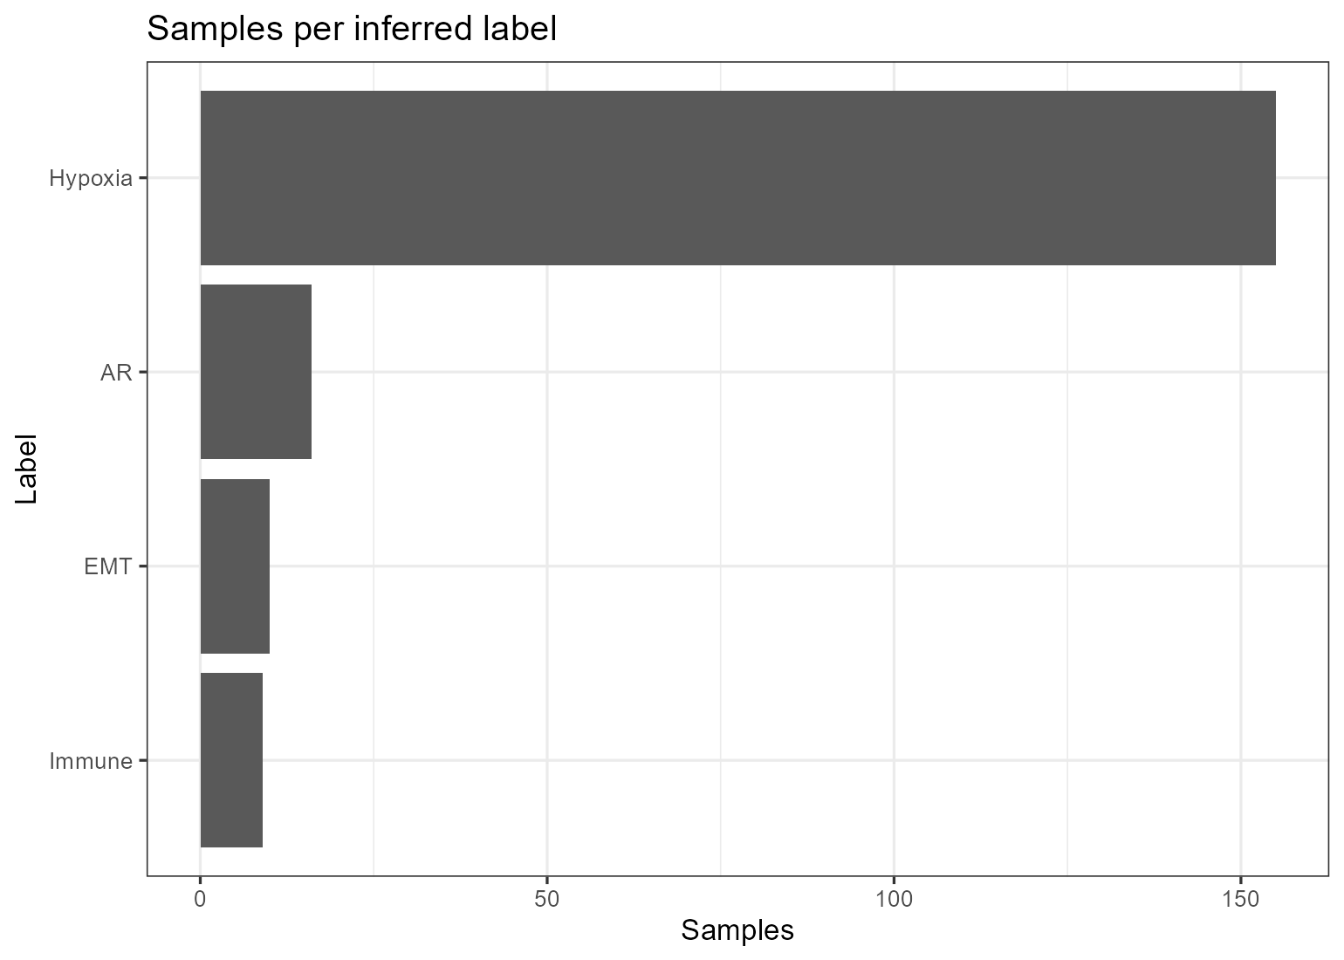

Label composition per cluster
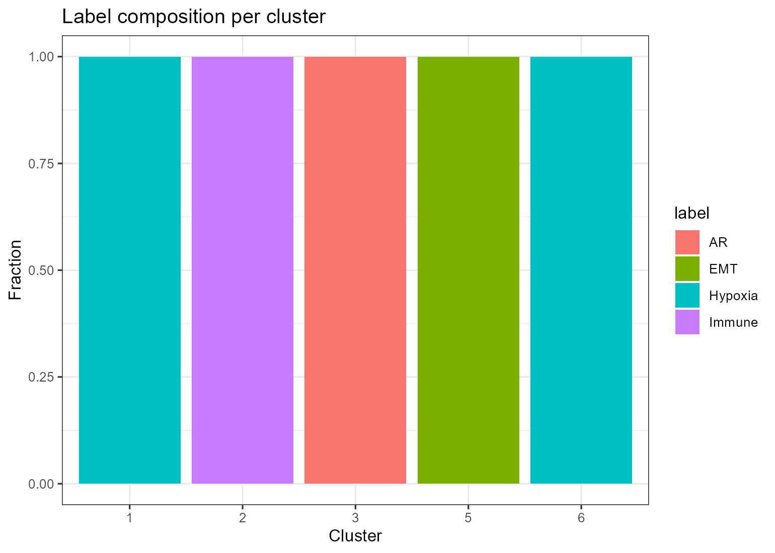

Cluster ↔ label summary
cluster | dominant_label | n_samples | frac_in_cluster
1 | Hypoxia | 16 | 1
2 | Immune | 9 | 1
3 | AR | 16 | 1
5 | EMT | 10 | 1
6 | Hypoxia | 139 | 1

Survival

Kaplan–Meier by cluster
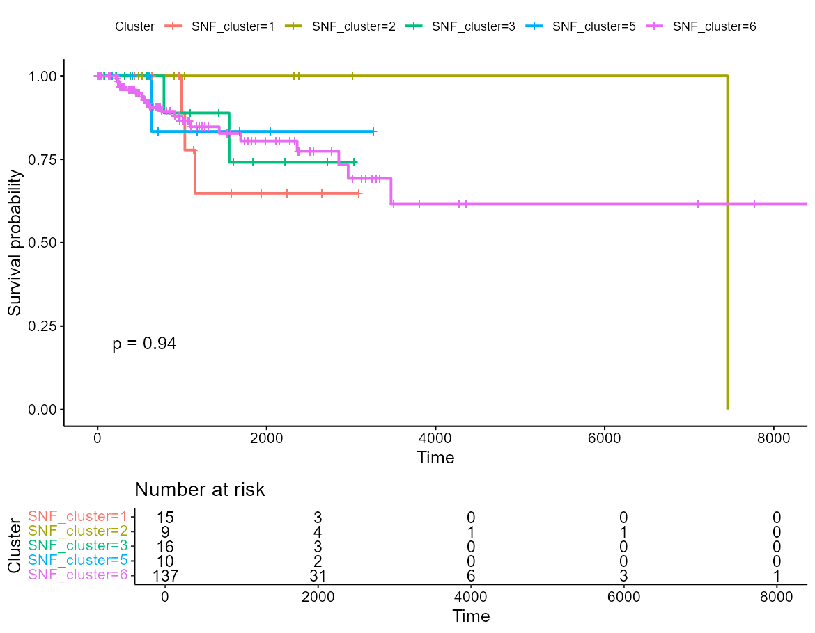

Cox multivariable forest
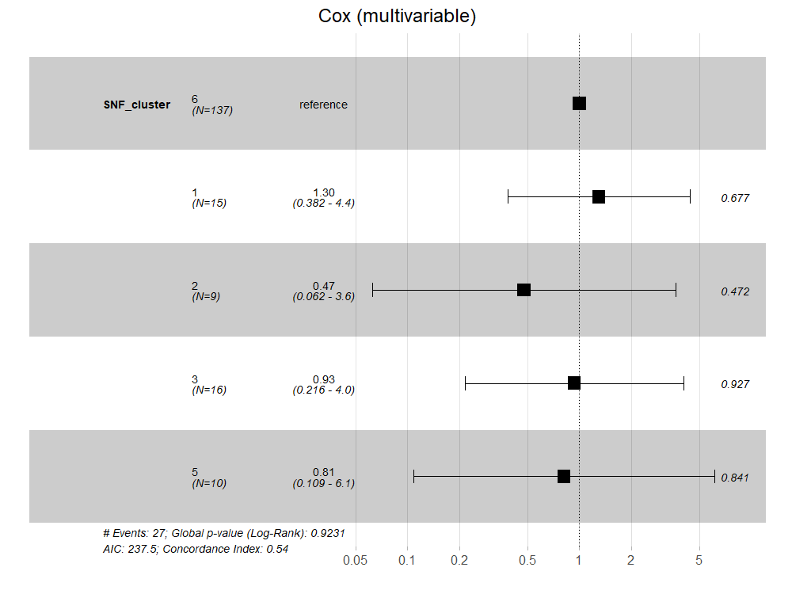

Cox volcano (pathways)
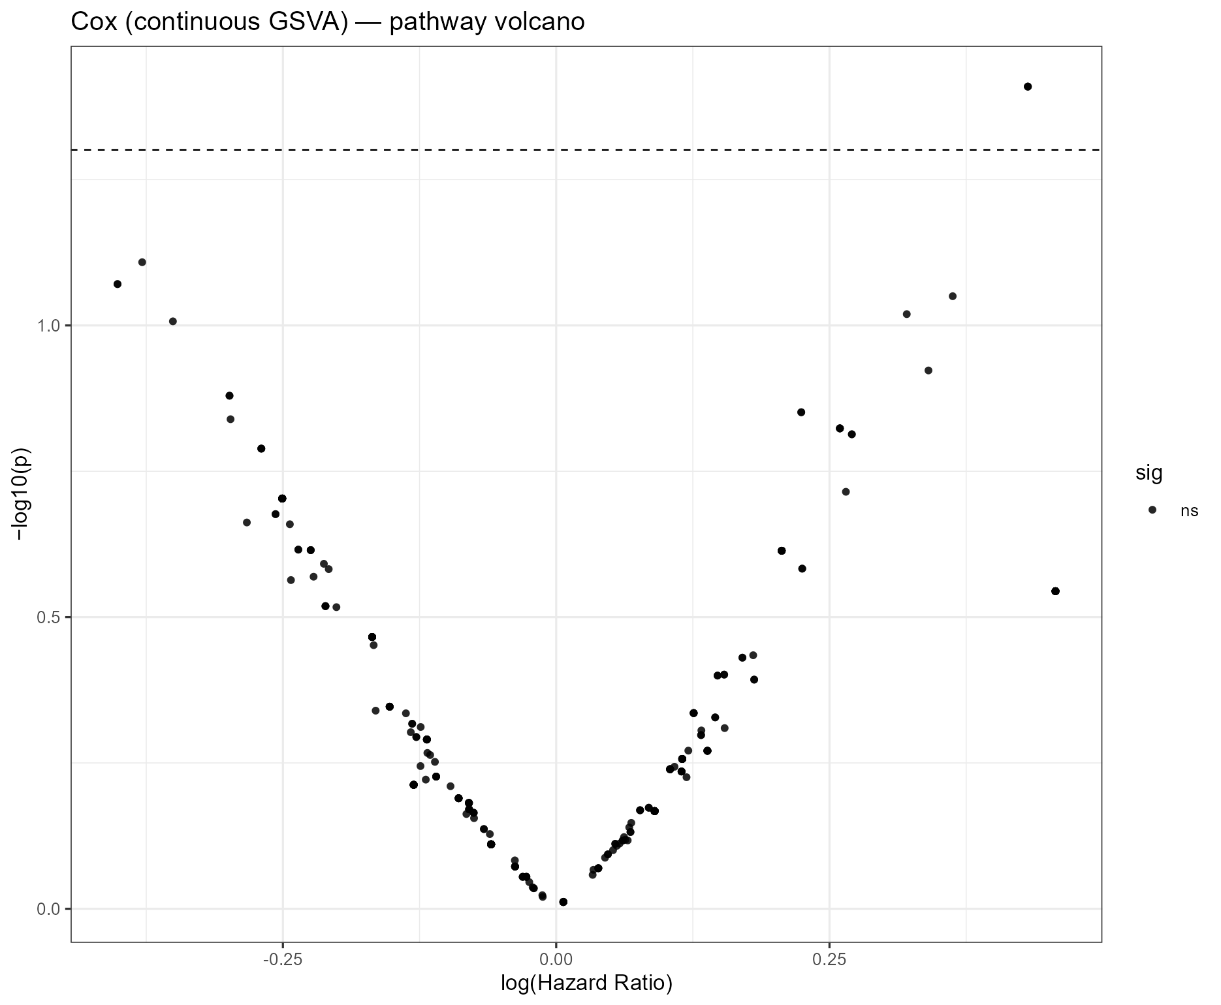

Cox (multivariable) table
term | coef | exp_coef | se | z | p | ci_lower | ci_upper
SNF_cluster1 | 0.26025341 | 1.2972588 | 0.6244175 | 0.41679389 | 0.6768292 | -0.9635824 | 1.484089
SNF_cluster2 | -0.74539483 | 0.4745469 | 1.0369534 | -0.71883159 | 0.4722447 | -2.7777861 | 1.286996
SNF_cluster3 | -0.06809588 | 0.9341709 | 0.7460462 | -0.09127569 | 0.9272735 | -1.5303197 | 1.394128
SNF_cluster5 | -0.20634923 | 0.8135489 | 1.0273141 | -0.20086285 | 0.8408058 | -2.2198478 | 1.807149

