TNBC – Milestone 1 Summary
Auto-generated on 2025-08-20 17:34

Unsupervised structure

PCA (training)
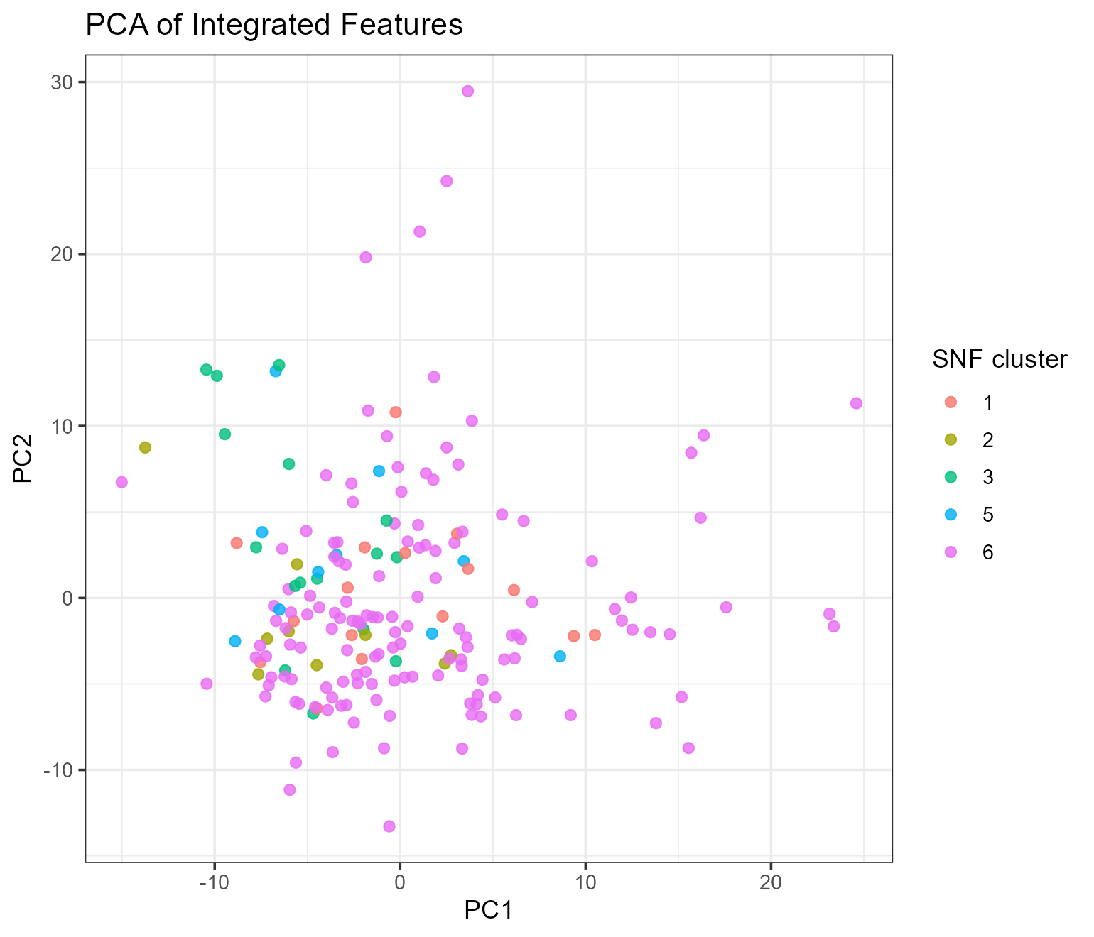

UMAP (training)
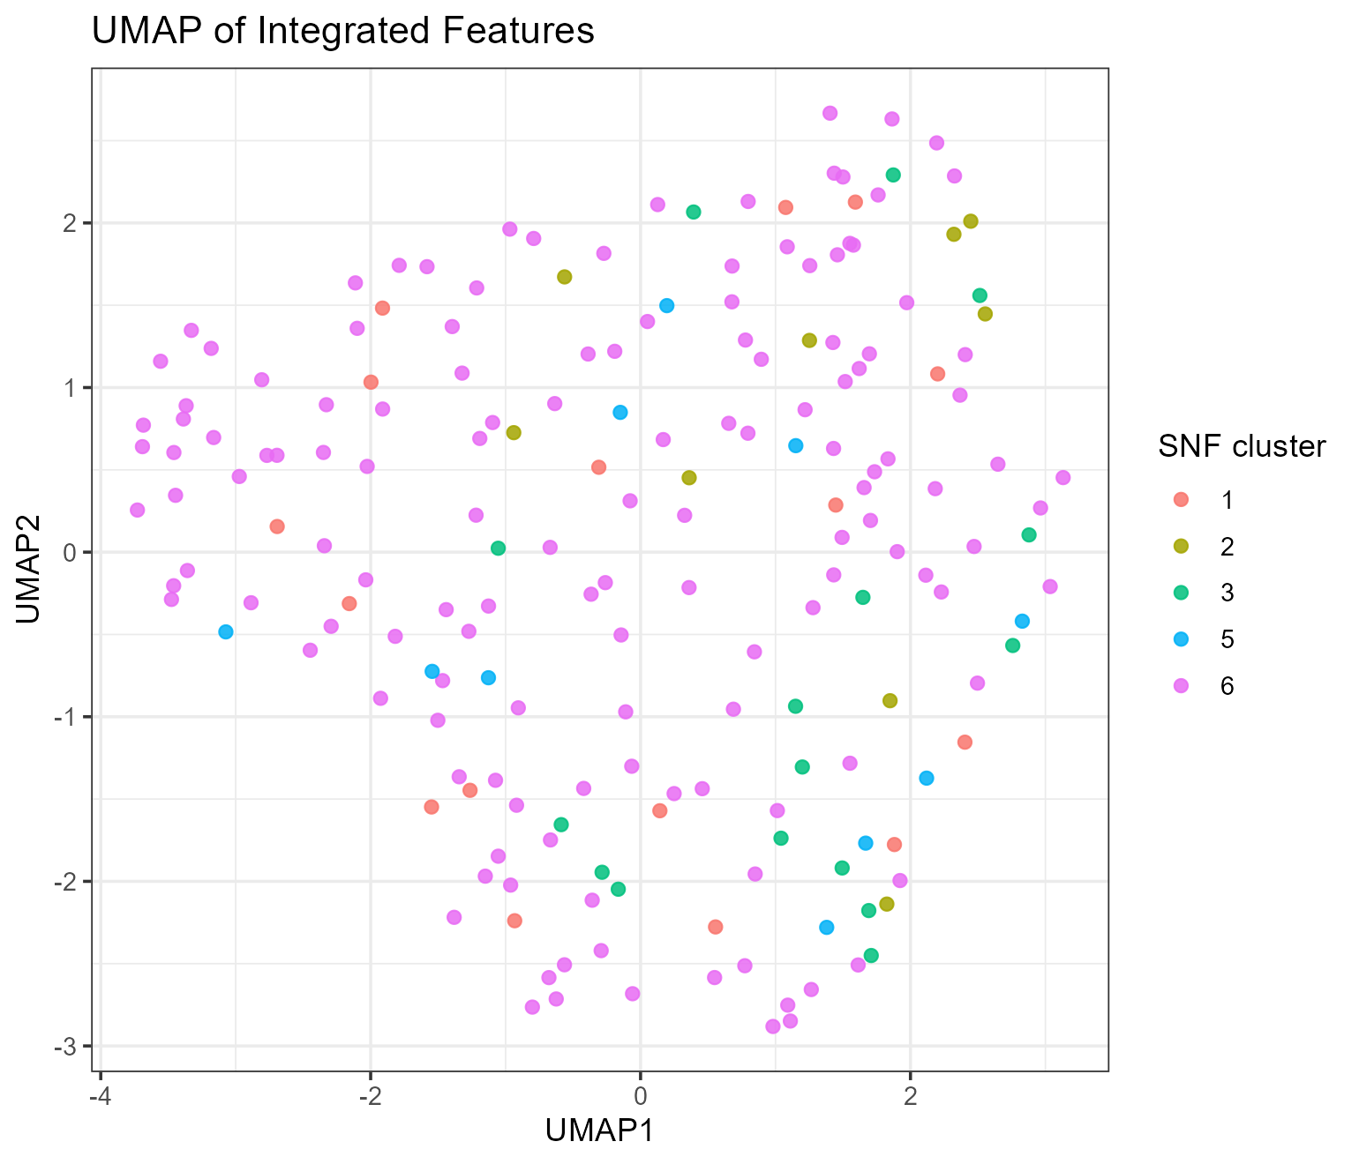

Consensus matrix (K=8)


Silhouette (K=8)
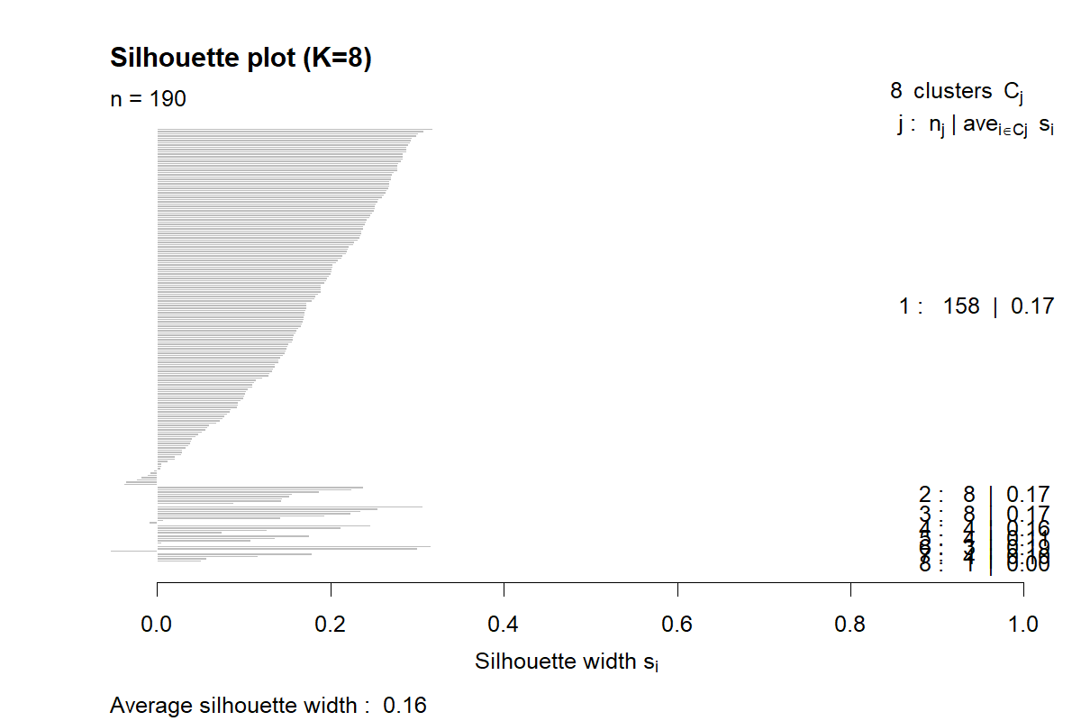

Consensus vs SNF crosstab
CC_cluster | SNF_cluster | n
1 | 1 | 14
2 | 1 | 0
3 | 1 | 0
4 | 1 | 0
5 | 1 | 0
6 | 1 | 2
7 | 1 | 0
8 | 1 | 0
1 | 2 | 8
2 | 2 | 1
…showing first 10 of 40 rows

Agreement metrics
metric | value
ARI_CC_vs_SNF | 0.01032314
ARI_CC_vs_Label | 0.03217932
…showing first 2 of 2 rows

Classifier performance

Confusion (5-fold CV)
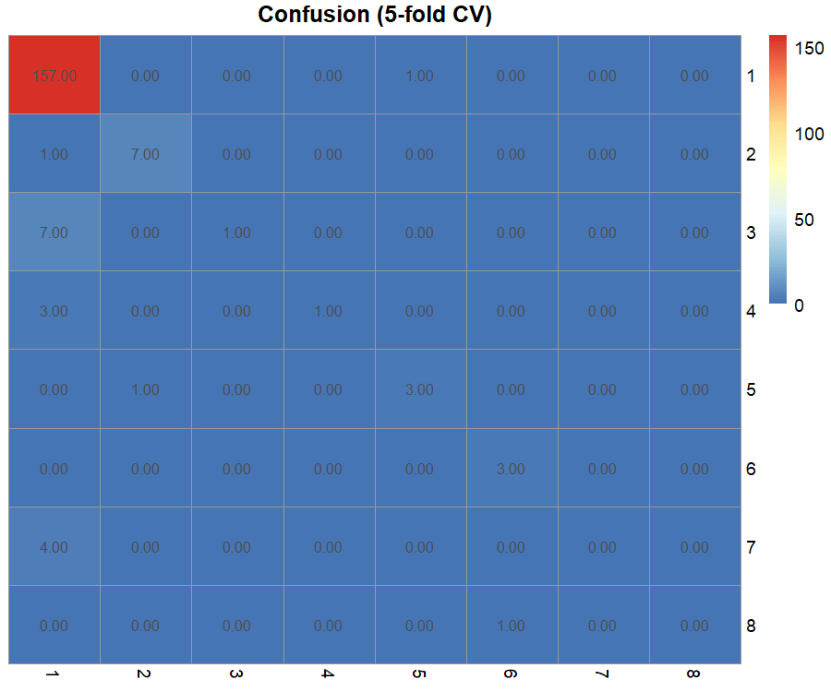

Feature importance (top 25)
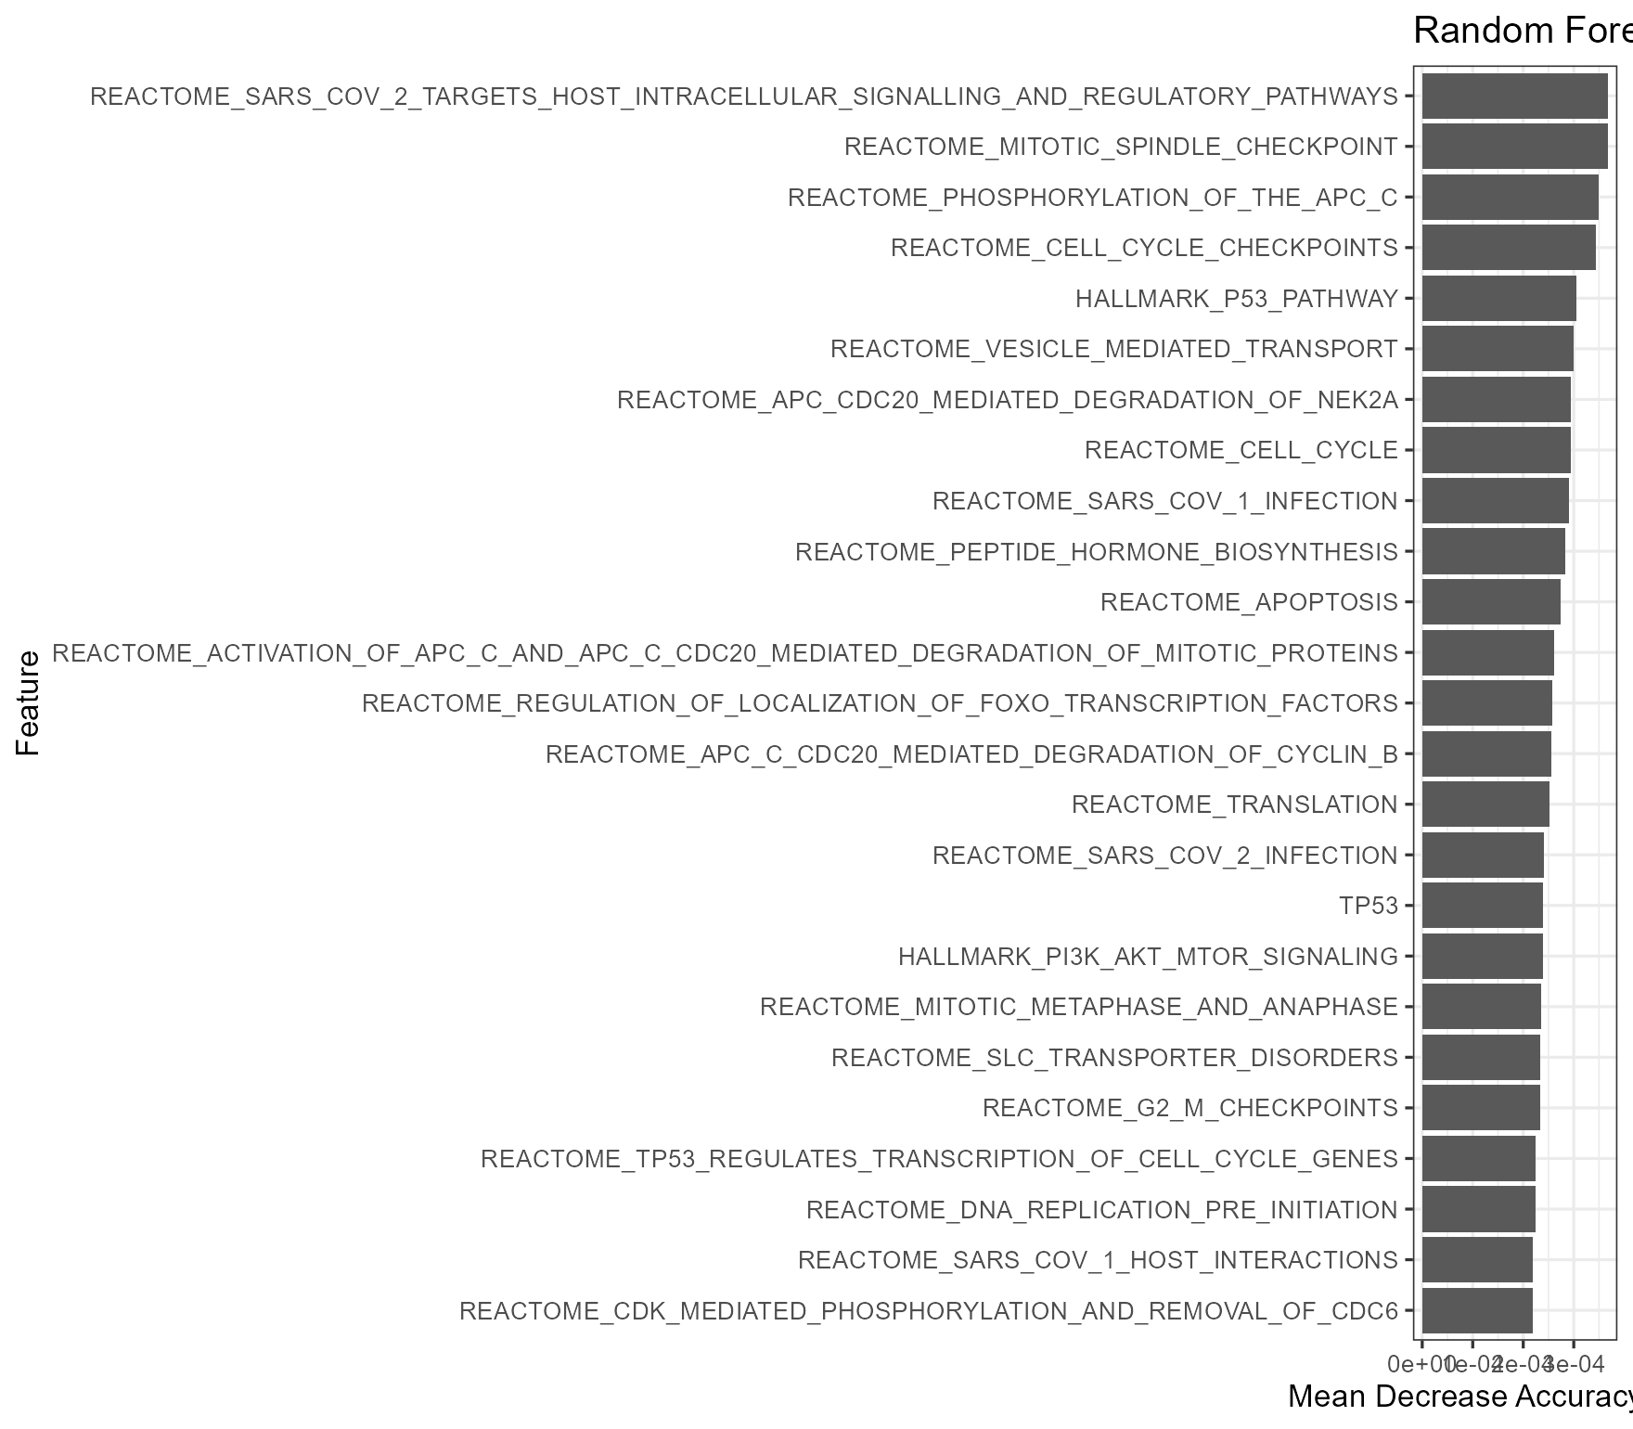

CV metrics
metric | value
CV_accuracy_mean | 0.90503824
CV_accuracy_sd | 0.03072724
…showing first 2 of 2 rows

OOB confusion (tuned RF)
truth | 1 | 2 | 3 | 4 | 5 | 6 | 7 | 8 | class.error
1 | 104 | 7 | 2 | 1 | 5 | 21 | 12 | 6 | 0.3417722
2 | 0 | 8 | 0 | 0 | 0 | 0 | 0 | 0 | 0.0000000
3 | 0 | 0 | 8 | 0 | 0 | 0 | 0 | 0 | 0.0000000
4 | 0 | 0 | 0 | 4 | 0 | 0 | 0 | 0 | 0.0000000
5 | 0 | 0 | 0 | 0 | 4 | 0 | 0 | 0 | 0.0000000
6 | 0 | 0 | 0 | 0 | 0 | 3 | 0 | 0 | 0.0000000
7 | 0 | 0 | 0 | 0 | 0 | 0 | 4 | 0 | 0.0000000
8 | 0 | 0 | 0 | 0 | 0 | 0 | 0 | 0
…showing first 8 of 8 rows

Hold-out accuracy summary
model | accuracy
RF_best | 0.75
GLMNET
Ensemble | 0.75
…showing first 3 of 3 rows

Hold-out confusion (RF best)
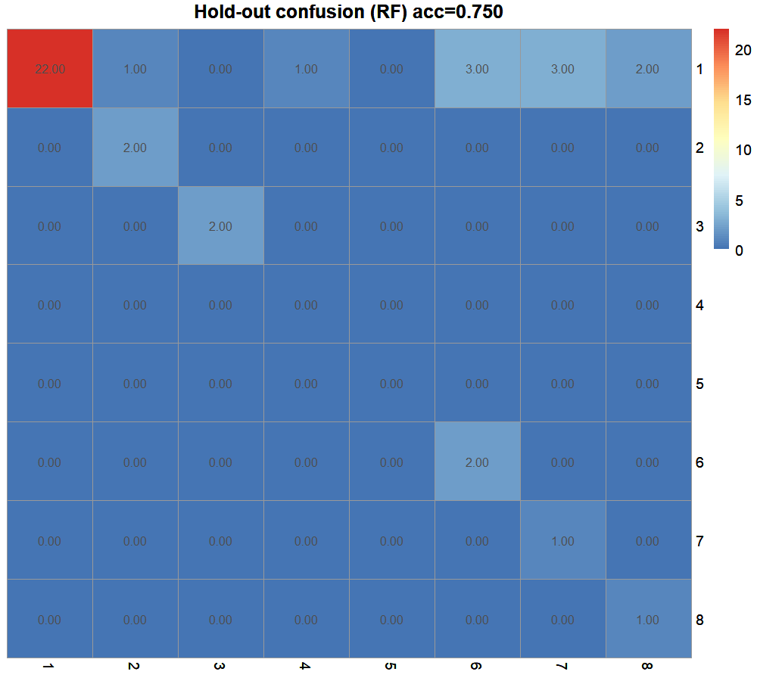

New cohort predictions

Prediction probabilities (heatmap)
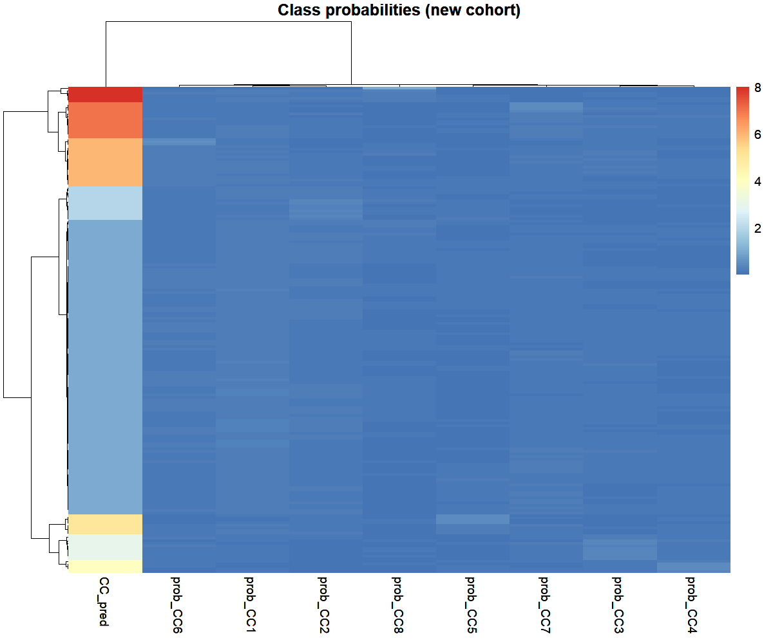

Class counts (bar)
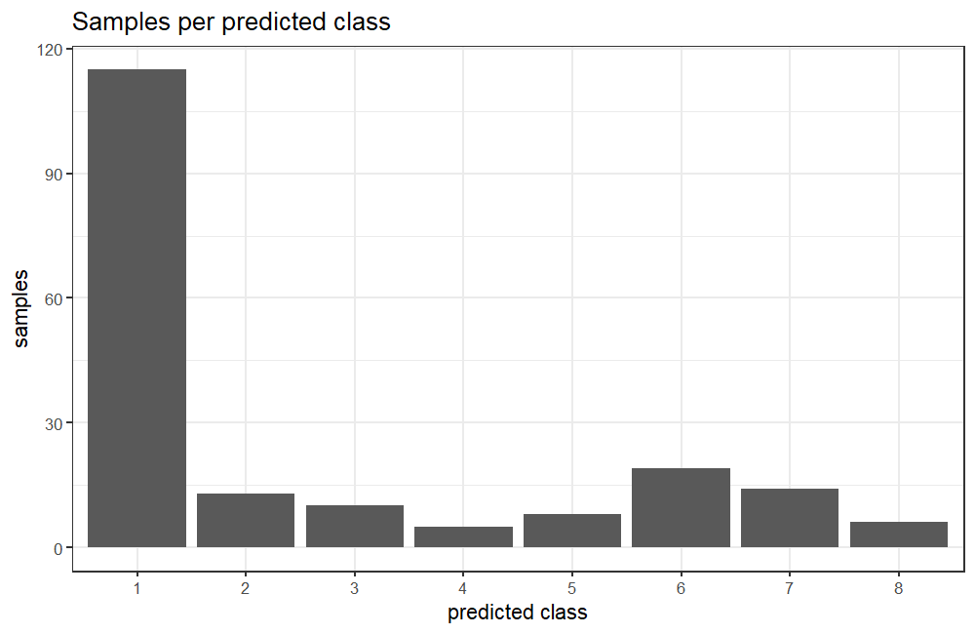

Confidence by class (violin)
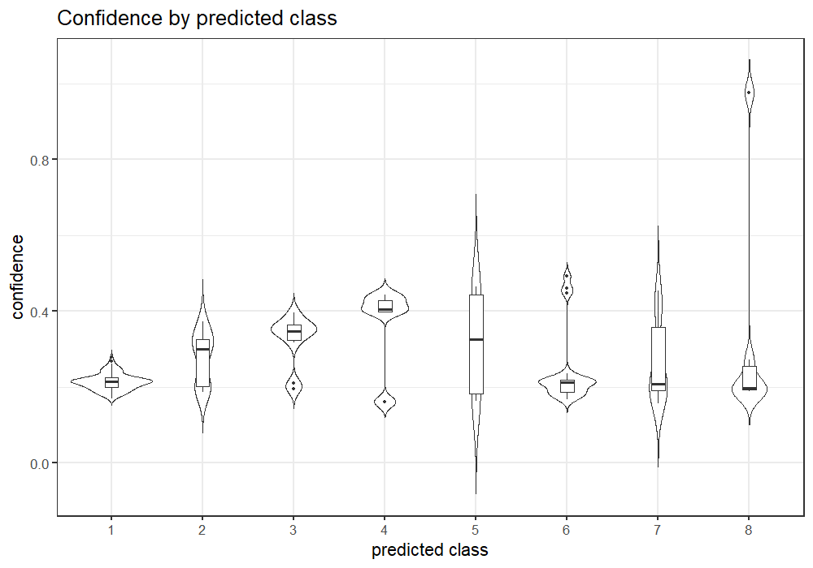

PCA overlay: train vs new
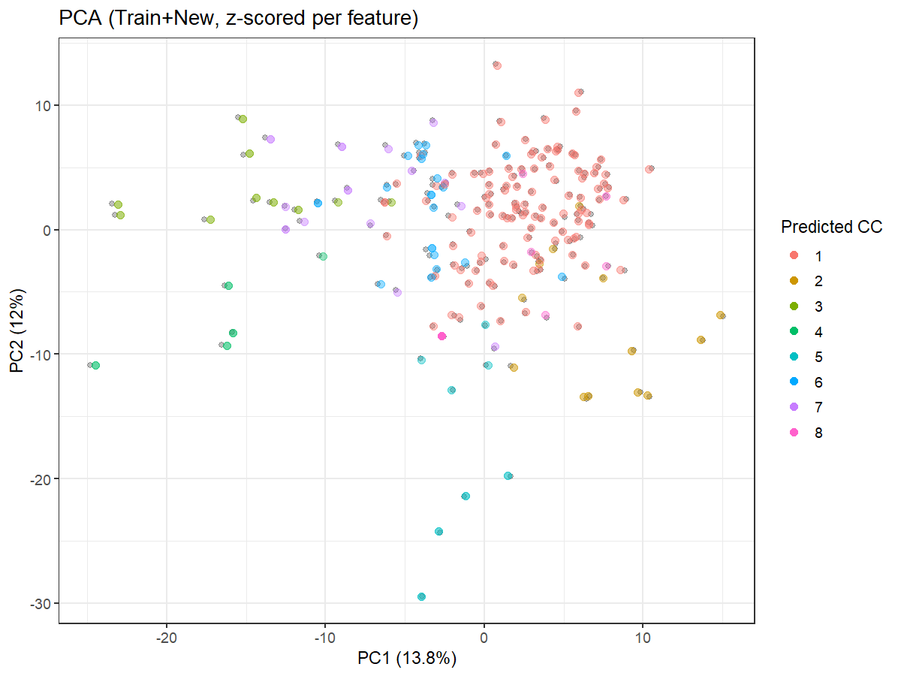

UMAP overlay: train vs new
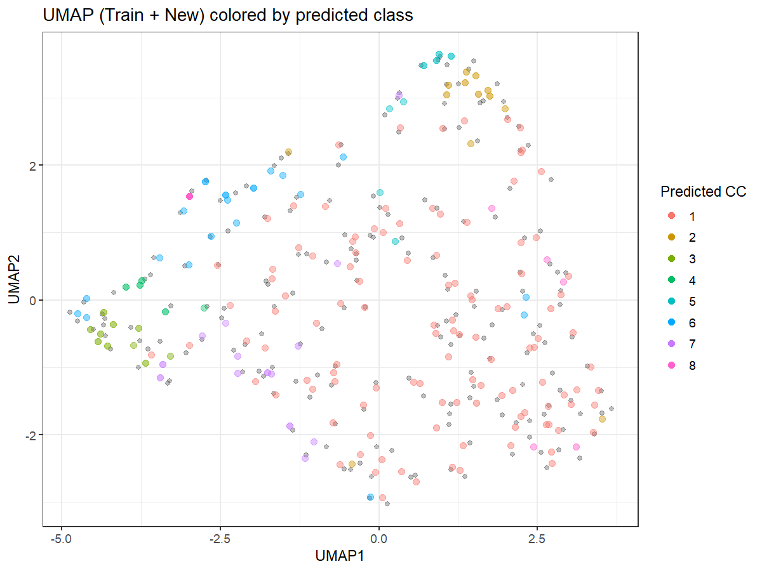

Master predictions (head)
SID | CC_pred | conf | prob_CC1 | prob_CC2 | prob_CC3 | prob_CC4 | prob_CC5 | prob_CC6 | prob_CC7 | prob_CC8
TCGAA2A3XT | 1 | 0.2785 | 0.2785 | 0.1790 | 0.0825 | 0.0680 | 0.0725 | 0.1400 | 0.1070 | 0.0725
TCGAA2A0D2 | 1 | 0.2680 | 0.2680 | 0.1450 | 0.1055 | 0.0920 | 0.0610 | 0.1615 | 0.1010 | 0.0660
TCGAA8A08R | 1 | 0.2610 | 0.2610 | 0.1635 | 0.0845 | 0.0785 | 0.0915 | 0.1160 | 0.0910 | 0.1140
TCGAA2A3XS | 1 | 0.2585 | 0.2585 | 0.1565 | 0.0990 | 0.1110 | 0.0605 | 0.1345 | 0.1340 | 0.0460
TCGAA2A3XX | 1 | 0.2575 | 0.2575 | 0.1675 | 0.0845 | 0.0805 | 0.0585 | 0.1370 | 0.1130 | 0.1015
TCGABHA18Q | 1 | 0.2520 | 0.2520 | 0.1785 | 0.0795 | 0.0940 | 0.0920 | 0.1255 | 0.1040 | 0.0745
TCGAC8A134 | 1 | 0.2505 | 0.2505 | 0.1625 | 0.0925 | 0.0810 | 0.0705 | 0.1820 | 0.1095 | 0.0515
TCGAE2A14R | 1 | 0.2490 | 0.2490 | 0.1540 | 0.0850 | 0.0695 | 0.0640 | 0.1610 | 0.0855 | 0.1320
TCGAA2A0CM | 1 | 0.2480 | 0.2480 | 0.1750 | 0.0755 | 0.0700 | 0.0745 | 0.1735 | 0.1065 | 0.0770
TCGAOLA5D7 | 1 | 0.2470 | 0.2470 | 0.1400 | 0.1060 | 0.0630 | 0.0590 | 0.1465 | 0.1450 | 0.0935
…showing first 10 of 190 rows

Top uncertain (head)
SID | CC_pred | conf | prob_CC1 | prob_CC2 | prob_CC3 | prob_CC4 | prob_CC5 | prob_CC6 | prob_CC7 | prob_CC8
TCGABHA18G | 7 | 0.1570 | 0.1535 | 0.1250 | 0.1410 | 0.1300 | 0.0855 | 0.1275 | 0.1570 | 0.0805
TCGAA2A0T2 | 4 | 0.1610 | 0.1470 | 0.0775 | 0.1465 | 0.1610 | 0.1090 | 0.1345 | 0.1445 | 0.0800
TCGAANA0FJ | 5 | 0.1625 | 0.1490 | 0.1260 | 0.1120 | 0.1370 | 0.1625 | 0.1180 | 0.1395 | 0.0560
TCGAACA62X | 6 | 0.1675 | 0.1500 | 0.1575 | 0.1035 | 0.0910 | 0.1045 | 0.1675 | 0.1390 | 0.0870
TCGABHA0E0 | 1 | 0.1700 | 0.1700 | 0.1150 | 0.1335 | 0.1000 | 0.0735 | 0.1645 | 0.1610 | 0.0825
TCGABHA0WA | 1 | 0.1715 | 0.1715 | 0.1350 | 0.0870 | 0.1455 | 0.1530 | 0.1110 | 0.1370 | 0.0600
TCGAARA2LR | 5 | 0.1715 | 0.1625 | 0.1550 | 0.0630 | 0.1515 | 0.1715 | 0.0885 | 0.1705 | 0.0375
TCGAA2A0T0 | 1 | 0.1720 | 0.1720 | 0.1305 | 0.1395 | 0.1040 | 0.0615 | 0.1540 | 0.1245 | 0.1140
TCGABHA0BL | 6 | 0.1725 | 0.1375 | 0.0860 | 0.1490 | 0.1470 | 0.0880 | 0.1725 | 0.0825 | 0.1375
TCGAD8A27M | 1 | 0.1770 | 0.1770 | 0.1330 | 0.0935 | 0.1530 | 0.1520 | 0.1035 | 0.1025 | 0.0855
…showing first 10 of 190 rows

Biological annotations

Hallmark top-5 union heatmap
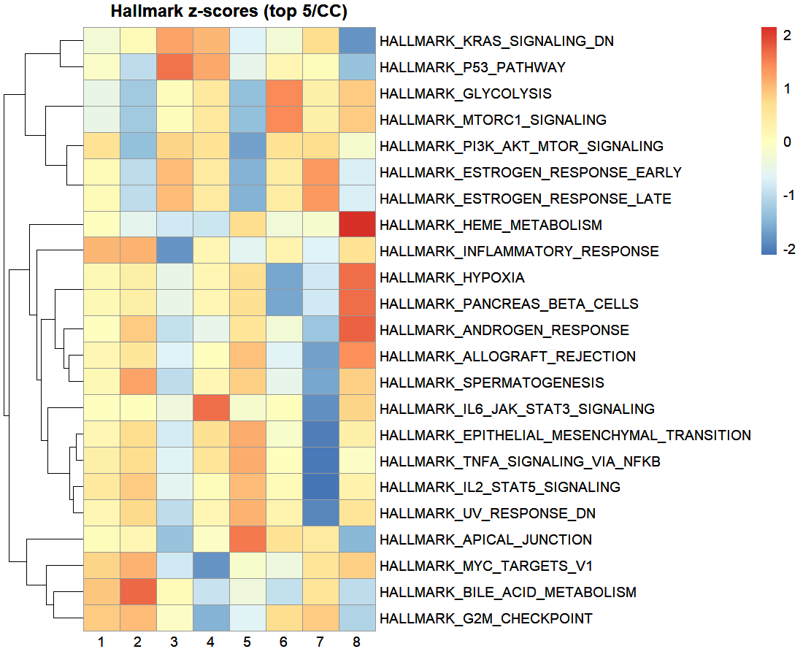

Hallmark top hits per cluster
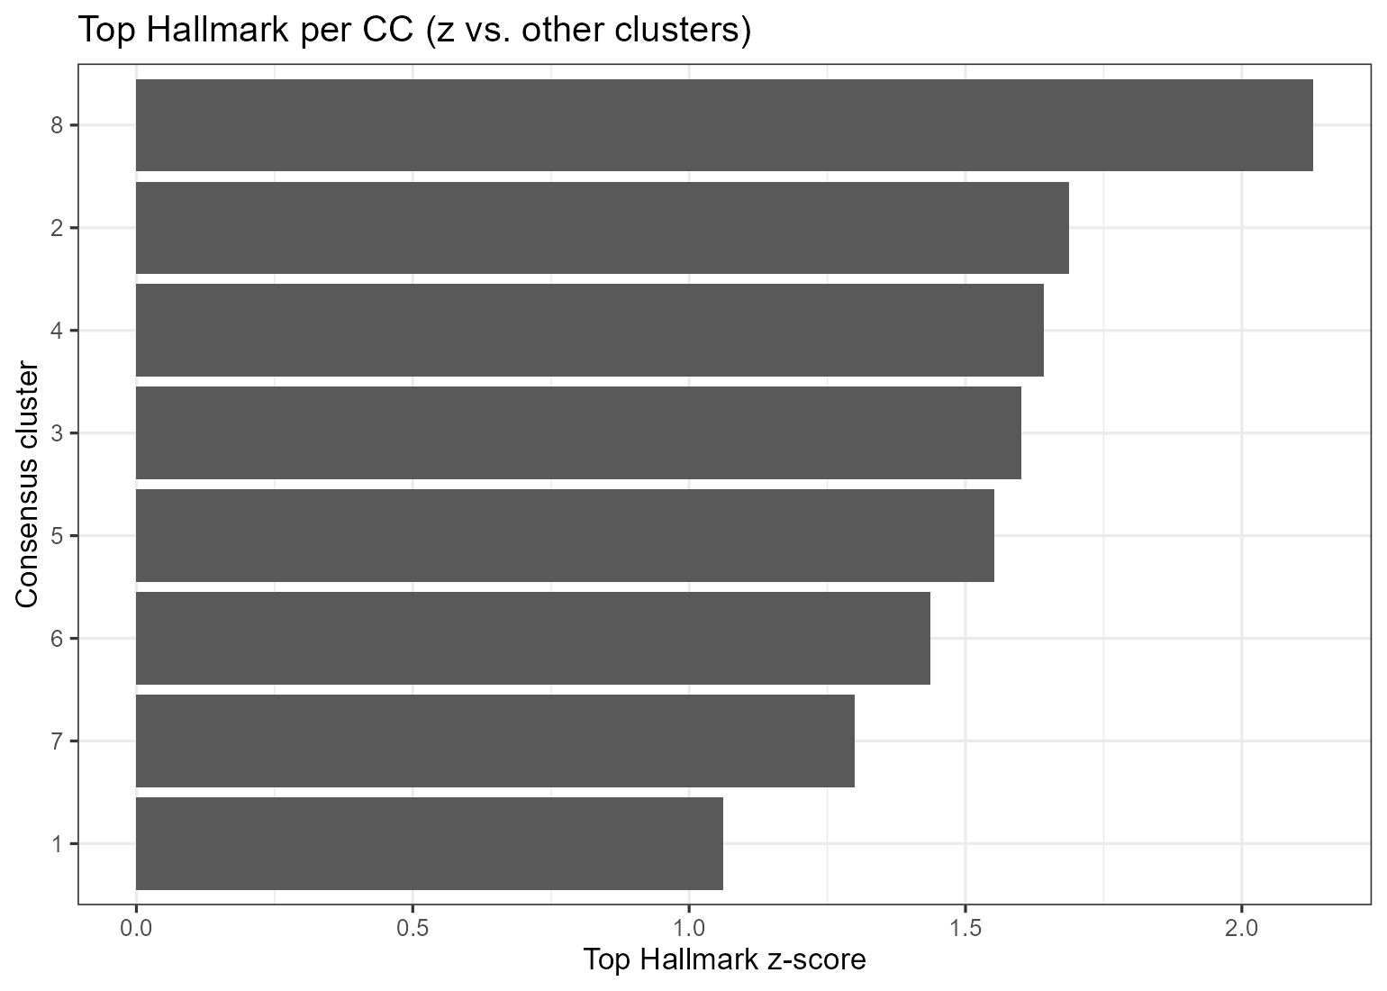

PROGENy snapshot (fallback)
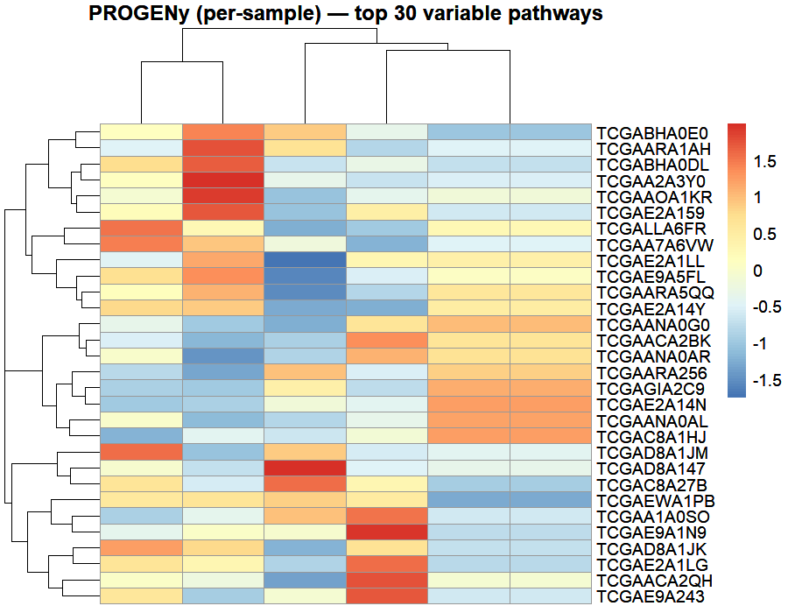

Cluster annotations
CC_cluster | label_primary | z_primary | top_hallmark | label_secondary | z_secondary | label
1 | Inflammatory Response | 1.061148 | HALLMARK_INFLAMMATORY_RESPONSE |  |  | Inflammatory Response
2 | Bile Acid Metabolism | 1.686766 | HALLMARK_BILE_ACID_METABOLISM |  |  | Bile Acid Metabolism
3 | P53 Pathway | 1.601201 | HALLMARK_P53_PATHWAY |  |  | P53 Pathway
4 | Il6 Jak Stat3 Signaling | 1.642512 | HALLMARK_IL6_JAK_STAT3_SIGNALING |  |  | Il6 Jak Stat3 Signaling
5 | Apical Junction | 1.552407 | HALLMARK_APICAL_JUNCTION |  |  | Apical Junction
6 | Glycolysis | 1.436001 | HALLMARK_GLYCOLYSIS |  |  | Glycolysis
7 | Estrogen Response Early | 1.300305 | HALLMARK_ESTROGEN_RESPONSE_EARLY |  |  | Estrogen Response Early
8 | Heme Metabolism | 2.128889 | HALLMARK_HEME_METABOLISM |  |  | Heme Metabolism
…showing first 8 of 8 rows

Cluster assignments (head)
SID | CC_cluster
TCGAA1A0SK | 1
TCGAA1A0SO | 1
TCGAA1A0SP | 1
TCGAA2A04P | 1
TCGAA2A04Q | 1
TCGAA2A04T | 1
TCGAA2A04U | 1
TCGAA2A0CM | 1
TCGAA2A0D0 | 1
TCGAA2A0D2 | 1
…showing first 10 of 190 rows

