| kind | files |
| --- | --- |
| Tables | 80 |
| Images | 105 |

| file | ext | bytes | modified |
| --- | --- | --- | --- |
| results/m3/tables/demo_table.csv | csv | 152.00 B | 2025-08-21 12:17:20 |
| results/integration/consensus_clustering/annotation/cc_cluster_annotations.tsv | tsv | 806.00 B | 2025-08-20 11:09:54 |
| results/integration/consensus_clustering/annotation/cc_sample_annotations.tsv | tsv | 6.38 KB | 2025-08-20 11:09:54 |
| results/integration/consensus_clustering/classifier_cc/classifier_cc/feature_importance.tsv | tsv | 22.91 KB | 2025-08-20 06:30:05 |
| results/integration/consensus_clustering/classifier_cc/classifier_cc/one_vs_rest_auc.tsv | tsv | 59.00 B | 2025-08-20 06:30:06 |
| results/integration/consensus_clustering/classifier_cc/classifier_cc/oob_misclassified.tsv | tsv | 829.00 B | 2025-08-20 06:30:06 |
| results/integration/consensus_clustering/classifier_cc/confusion_matrix_CV.tsv | tsv | 399.00 B | 2025-08-20 05:52:50 |
| results/integration/consensus_clustering/classifier_cc/confusion_OOB.tsv | tsv | 401.00 B | 2025-08-20 06:27:12 |
| results/integration/consensus_clustering/classifier_cc/cv_metrics.tsv | tsv | 84.00 B | 2025-08-20 05:52:50 |
| results/integration/consensus_clustering/classifier_cc/cv_predictions.tsv | tsv | 2.80 KB | 2025-08-20 05:52:51 |
| results/integration/consensus_clustering/classifier_cc/metrics_by_class_OOB.tsv | tsv | 167.00 B | 2025-08-20 06:27:12 |
| results/integration/consensus_clustering/classifier_tuned/glmnet/glmnet_holdout_accuracy.tsv | tsv | 95.00 B | 2025-08-20 06:49:12 |
| results/integration/consensus_clustering/classifier_tuned/holdout_accuracy_summary.tsv | tsv | 52.00 B | 2025-08-20 06:52:10 |
| results/integration/consensus_clustering/classifier_tuned/holdout_predictions_rf_glm_ensemble.tsv | tsv | 836.00 B | 2025-08-20 06:52:10 |
| results/integration/consensus_clustering/classifier_tuned/rf_tuning/feature_importance.tsv | tsv | 20.03 KB | 2025-08-20 06:40:36 |
| results/integration/consensus_clustering/classifier_tuned/rf_tuning/oob_confusion.tsv | tsv | 216.00 B | 2025-08-20 06:40:36 |
| results/integration/consensus_clustering/classifier_tuned/rf_tuning/rf_oob_grid.tsv | tsv | 341.00 B | 2025-08-20 06:40:35 |
| results/integration/consensus_clustering/cluster_assignments.tsv | tsv | 2.43 KB | 2025-08-20 04:00:19 |
| results/integration/consensus_clustering/cluster_assignments_named.tsv | tsv | 4.62 KB | 2025-08-20 04:44:52 |
| results/integration/consensus_clustering/cluster_feature_means.tsv | tsv | 64.67 KB | 2025-08-20 04:19:55 |
| results/integration/consensus_clustering/consensus_agreement_metrics.tsv | tsv | 83.00 B | 2025-08-20 04:05:47 |
| results/integration/consensus_clustering/consensus_vs_label_crosstab.tsv | tsv | 326.00 B | 2025-08-20 04:05:47 |
| results/integration/consensus_clustering/consensus_vs_previous_labels_crosstab.tsv | tsv | 272.00 B | 2025-08-20 03:49:22 |
| results/integration/consensus_clustering/consensus_vs_previous_labels_crosstab_proportions.tsv | tsv | 498.00 B | 2025-08-20 03:49:22 |
| results/integration/consensus_clustering/consensus_vs_SNF_crosstab.tsv | tsv | 269.00 B | 2025-08-20 04:05:46 |
| results/integration/consensus_clustering/cox_by_CC.tsv | tsv | 836.00 B | 2025-08-20 04:10:25 |
| results/integration/consensus_clustering/cox_by_CC_full.tsv | tsv | 892.00 B | 2025-08-20 04:15:58 |
| results/integration/consensus_clustering/cox_by_CC_STABLE.tsv | tsv | 289.00 B | 2025-08-20 04:15:58 |
| results/integration/consensus_clustering/cox_cluster_event_counts_merged.tsv | tsv | 39.00 B | 2025-08-20 04:16:00 |
| results/integration/consensus_clustering/cox_cluster_event_counts_raw.tsv | tsv | 71.00 B | 2025-08-20 04:16:00 |
| results/integration/consensus_clustering/enrichment_manifest.tsv | tsv | 328.00 B | 2025-08-20 05:36:40 |
| results/integration/consensus_clustering/enrichment_top10_per_cluster.tsv | tsv | 6.44 KB | 2025-08-20 04:19:55 |
| results/integration/consensus_clustering/feature_DE/DE_features_CC1_vs_rest.tsv | tsv | 33.07 KB | 2025-08-20 04:48:29 |
| results/integration/consensus_clustering/feature_DE/DE_features_CC2_vs_rest.tsv | tsv | 32.82 KB | 2025-08-20 04:48:31 |
| results/integration/consensus_clustering/feature_DE/DE_features_CC3_vs_rest.tsv | tsv | 33.33 KB | 2025-08-20 04:48:33 |
| results/integration/consensus_clustering/feature_DE/DE_features_CC4_vs_rest.tsv | tsv | 32.97 KB | 2025-08-20 04:48:35 |
| results/integration/consensus_clustering/feature_DE/DE_features_CC5_vs_rest.tsv | tsv | 32.89 KB | 2025-08-20 04:48:36 |
| results/integration/consensus_clustering/feature_DE/DE_features_CC6_vs_rest.tsv | tsv | 32.70 KB | 2025-08-20 04:48:38 |
| results/integration/consensus_clustering/feature_DE/DE_features_CC7_vs_rest.tsv | tsv | 32.80 KB | 2025-08-20 04:48:40 |
| results/integration/consensus_clustering/feature_DE/DE_features_CC8_vs_rest.tsv | tsv | 16.83 KB | 2025-08-20 04:48:41 |
| results/integration/consensus_clustering/feature_DE/enrichment_tables/GO_BP_CC2.tsv | tsv | 78.71 KB | 2025-08-20 05:04:34 |
| results/integration/consensus_clustering/feature_DE/enrichment_tables/GO_BP_CC4.tsv | tsv | 78.71 KB | 2025-08-20 05:04:55 |
| results/integration/consensus_clustering/feature_DE/enrichment_tables/KEGG_CC2.tsv | tsv | 10.69 KB | 2025-08-20 05:05:12 |
| results/integration/consensus_clustering/feature_DE/enrichment_tables/KEGG_CC4.tsv | tsv | 10.69 KB | 2025-08-20 05:05:16 |
| results/integration/consensus_clustering/feature_DE/enrichment_tables/MSIG_HALLMARK_CC2.tsv | tsv | 479.00 B | 2025-08-20 05:06:37 |
| results/integration/consensus_clustering/feature_DE/enrichment_tables/MSIG_HALLMARK_CC4.tsv | tsv | 479.00 B | 2025-08-20 05:06:40 |
| results/integration/consensus_clustering/feature_DE/enrichment_tables/MSIG_REACTOME_CC2.tsv | tsv | 22.04 KB | 2025-08-20 05:06:39 |
| results/integration/consensus_clustering/feature_DE/enrichment_tables/MSIG_REACTOME_CC4.tsv | tsv | 22.04 KB | 2025-08-20 05:06:42 |
| results/integration/consensus_clustering/feature_DE/enrichment_tables_genesOnly/TEST_table.tsv | tsv | 16.00 B | 2025-08-20 05:32:47 |
| results/integration/consensus_clustering/feature_DE/top10_union_signature.tsv | tsv | 7.43 KB | 2025-08-20 04:51:14 |
| results/integration/consensus_clustering/feature_means_by_cluster.tsv | tsv | 271.72 KB | 2025-08-20 04:02:32 |
| results/integration/consensus_clustering/newcohort_predict/confidence_manifest.tsv | tsv | 569.00 B | 2025-08-20 07:11:19 |
| results/integration/consensus_clustering/newcohort_predict/counts_by_confidence.tsv | tsv | 27.00 B | 2025-08-20 07:11:18 |
| results/integration/consensus_clustering/newcohort_predict/counts_by_predicted_class.tsv | tsv | 48.00 B | 2025-08-20 07:11:18 |
| results/integration/consensus_clustering/newcohort_predict/crosstab_pred_vs_previous.tsv | tsv | 165.00 B | 2025-08-20 07:11:19 |
| results/integration/consensus_clustering/newcohort_predict/newcohort_master_table.tsv | tsv | 13.30 KB | 2025-08-20 08:15:04 |
| results/integration/consensus_clustering/newcohort_predict/newcohort_predictions.tsv | tsv | 2.42 KB | 2025-08-20 07:04:01 |
| results/integration/consensus_clustering/newcohort_predict/newcohort_predictions_with_confidence.tsv | tsv | 5.35 KB | 2025-08-20 07:11:18 |
| results/integration/consensus_clustering/newcohort_predict/newcohort_pred_counts.tsv | tsv | 48.00 B | 2025-08-20 07:04:02 |
| results/integration/consensus_clustering/newcohort_predict/newcohort_pred_vs_previous.tsv | tsv | 4.55 KB | 2025-08-20 07:07:51 |
| results/integration/consensus_clustering/newcohort_predict/newcohort_probabilities.tsv | tsv | 11.71 KB | 2025-08-20 07:04:02 |
| results/integration/consensus_clustering/newcohort_predict/newcohort_uncertainty_audit.tsv | tsv | 23.06 KB | 2025-08-20 07:18:42 |
| results/integration/consensus_clustering/newcohort_predict/newcohort_uncertain_samples.tsv | tsv | 18.46 KB | 2025-08-20 07:21:13 |
| results/integration/consensus_clustering/newcohort_predict/per_class_lists/class_1_samples.tsv | tsv | 2.21 KB | 2025-08-20 08:15:06 |
| results/integration/consensus_clustering/newcohort_predict/per_class_lists/class_2_samples.tsv | tsv | 270.00 B | 2025-08-20 08:15:06 |
| results/integration/consensus_clustering/newcohort_predict/per_class_lists/class_3_samples.tsv | tsv | 213.00 B | 2025-08-20 08:15:06 |
| results/integration/consensus_clustering/newcohort_predict/per_class_lists/class_4_samples.tsv | tsv | 115.00 B | 2025-08-20 08:15:06 |
| results/integration/consensus_clustering/newcohort_predict/per_class_lists/class_5_samples.tsv | tsv | 173.00 B | 2025-08-20 08:15:06 |
| results/integration/consensus_clustering/newcohort_predict/per_class_lists/class_6_samples.tsv | tsv | 388.00 B | 2025-08-20 08:15:06 |
| results/integration/consensus_clustering/newcohort_predict/per_class_lists/class_7_samples.tsv | tsv | 292.00 B | 2025-08-20 08:15:06 |
| results/integration/consensus_clustering/newcohort_predict/per_class_lists/class_8_samples.tsv | tsv | 134.00 B | 2025-08-20 08:15:06 |
| results/integration/consensus_clustering/newcohort_predict/summary/assigned_conf_ge_0.60.tsv | tsv | 37.00 B | 2025-08-20 07:49:10 |
| results/integration/consensus_clustering/newcohort_predict/summary/class_counts.tsv | tsv | 48.00 B | 2025-08-20 08:15:06 |
| results/integration/consensus_clustering/newcohort_predict/summary/confidence_counts.tsv | tsv | 27.00 B | 2025-08-20 07:34:38 |
| results/integration/consensus_clustering/newcohort_predict/summary/counts_by_class_and_confband.tsv | tsv | 218.00 B | 2025-08-20 07:49:10 |
| results/integration/consensus_clustering/newcohort_predict/summary/mean_prob_by_predClass.tsv | tsv | 1.03 KB | 2025-08-20 07:34:39 |
| results/integration/consensus_clustering/newcohort_predict/summary/review_conf_lt_0.60.tsv | tsv | 3.62 KB | 2025-08-20 07:49:10 |
| results/integration/consensus_clustering/newcohort_predict/summary/top_uncertain_samples.tsv | tsv | 13.30 KB | 2025-08-20 08:15:06 |
| results/integration/consensus_clustering/silhouette_scores.tsv | tsv | 6.10 KB | 2025-08-20 04:00:27 |
| results/integration/consensus_clustering/top10_features_per_cluster.tsv | tsv | 7.91 KB | 2025-08-20 04:02:32 |

| file | ext | bytes | modified |
| --- | --- | --- | --- |
| results/m3/plots/demo_plot.png | png | 5.39 KB | 2025-08-21 12:17:20 |
| results/integration/consensus_clustering/annotation/plots/cc_hallmark_top5_heatmap.png | png | 33.29 KB | 2025-08-20 11:09:55 |
| results/integration/consensus_clustering/annotation/plots/cc_progeny_heatmap.png | png | 19.56 KB | 2025-08-20 11:19:25 |
| results/integration/consensus_clustering/annotation/plots/cc_top_hallmark_bars.png | png | 37.51 KB | 2025-08-20 11:09:54 |
| results/integration/consensus_clustering/classifier_cc/classifier_cc/plots/feature_importance_top25.png | png | 171.58 KB | 2025-08-20 06:30:05 |
| results/integration/consensus_clustering/classifier_cc/classifier_cc/plots/roc_curves/ROC_class_1.png | png | 10.70 KB | 2025-08-20 06:30:06 |
| results/integration/consensus_clustering/classifier_cc/classifier_cc/plots/roc_curves/ROC_class_2.png | png | 10.54 KB | 2025-08-20 06:30:06 |
| results/integration/consensus_clustering/classifier_cc/classifier_cc/plots/roc_curves/ROC_class_3.png | png | 10.54 KB | 2025-08-20 06:30:06 |
| results/integration/consensus_clustering/classifier_cc/classifier_cc/plots/roc_curves/ROC_class_4.png | png | 10.51 KB | 2025-08-20 06:30:06 |
| results/integration/consensus_clustering/classifier_cc/classifier_cc/plots/roc_curves/ROC_class_5.png | png | 10.56 KB | 2025-08-20 06:30:06 |
| results/integration/consensus_clustering/classifier_cc/classifier_cc/plots/roc_curves/ROC_class_6.png | png | 10.55 KB | 2025-08-20 06:30:06 |
| results/integration/consensus_clustering/classifier_cc/classifier_cc/plots/roc_curves/ROC_class_7.png | png | 10.49 KB | 2025-08-20 06:30:06 |
| results/integration/consensus_clustering/classifier_cc/classifier_cc/plots/roc_curves/ROC_class_8.png | png | 10.54 KB | 2025-08-20 06:30:06 |
| results/integration/consensus_clustering/classifier_cc/plots/confusion_matrix_CV.png | png | 17.41 KB | 2025-08-20 05:52:50 |
| results/integration/consensus_clustering/classifier_tuned/plots/confusion_holdout_ENSEMBLE.png | png | 19.70 KB | 2025-08-20 06:52:11 |
| results/integration/consensus_clustering/classifier_tuned/plots/confusion_holdout_RF.png | png | 19.42 KB | 2025-08-20 06:52:11 |
| results/integration/consensus_clustering/classifier_tuned/plots/rf_oob_grid_heatmap.png | png | 59.95 KB | 2025-08-20 06:40:35 |
| results/integration/consensus_clustering/consensus001.png | png | 3.05 KB | 2025-08-20 01:57:08 |
| results/integration/consensus_clustering/consensus002.png | png | 3.77 KB | 2025-08-20 01:57:09 |
| results/integration/consensus_clustering/consensus003.png | png | 3.89 KB | 2025-08-20 01:57:09 |
| results/integration/consensus_clustering/consensus004.png | png | 4.85 KB | 2025-08-20 01:57:10 |
| results/integration/consensus_clustering/consensus005.png | png | 4.10 KB | 2025-08-20 01:57:11 |
| results/integration/consensus_clustering/consensus006.png | png | 4.32 KB | 2025-08-20 01:57:11 |
| results/integration/consensus_clustering/consensus007.png | png | 4.19 KB | 2025-08-20 01:57:12 |
| results/integration/consensus_clustering/consensus008.png | png | 4.60 KB | 2025-08-20 01:57:12 |
| results/integration/consensus_clustering/consensus009.png | png | 5.07 KB | 2025-08-20 01:57:12 |
| results/integration/consensus_clustering/consensus010.png | png | 4.25 KB | 2025-08-20 01:57:12 |
| results/integration/consensus_clustering/consensus011.png | png | 3.10 KB | 2025-08-20 01:57:12 |
| results/integration/consensus_clustering/consensus_matrix_K8.png | png | 8.80 KB | 2025-08-20 03:58:14 |
| results/integration/consensus_clustering/feature_DE/enrichment_plots/GO_BP_CC2.png | png | 84.32 KB | 2025-08-20 05:04:34 |
| results/integration/consensus_clustering/feature_DE/enrichment_plots/GO_BP_CC4.png | png | 84.31 KB | 2025-08-20 05:04:56 |
| results/integration/consensus_clustering/feature_DE/enrichment_plots/KEGG_CC2.png | png | 37.97 KB | 2025-08-20 05:05:13 |
| results/integration/consensus_clustering/feature_DE/enrichment_plots/KEGG_CC4.png | png | 37.95 KB | 2025-08-20 05:05:17 |
| results/integration/consensus_clustering/feature_DE/enrichment_plots/MSIG_HALLMARK_CC2.png | png | 22.82 KB | 2025-08-20 05:06:38 |
| results/integration/consensus_clustering/feature_DE/enrichment_plots/MSIG_HALLMARK_CC4.png | png | 22.80 KB | 2025-08-20 05:06:41 |
| results/integration/consensus_clustering/feature_DE/enrichment_plots/MSIG_REACTOME_CC2.png | png | 123.85 KB | 2025-08-20 05:06:39 |
| results/integration/consensus_clustering/feature_DE/enrichment_plots/MSIG_REACTOME_CC4.png | png | 123.83 KB | 2025-08-20 05:06:43 |
| results/integration/consensus_clustering/feature_DE/enrichment_plots_genesOnly/TEST_plot.png | png | 4.35 KB | 2025-08-20 05:32:47 |
| results/integration/consensus_clustering/feature_DE/plots/heatmap_top10_union_features.png | png | 263.61 KB | 2025-08-20 04:51:14 |
| results/integration/consensus_clustering/feature_DE/plots/volcano_CC1_vs_rest.png | png | 66.38 KB | 2025-08-20 04:48:30 |
| results/integration/consensus_clustering/feature_DE/plots/volcano_CC2_vs_rest.png | png | 69.17 KB | 2025-08-20 04:48:32 |
| results/integration/consensus_clustering/feature_DE/plots/volcano_CC3_vs_rest.png | png | 65.97 KB | 2025-08-20 04:48:33 |
| results/integration/consensus_clustering/feature_DE/plots/volcano_CC4_vs_rest.png | png | 72.18 KB | 2025-08-20 04:48:35 |
| results/integration/consensus_clustering/feature_DE/plots/volcano_CC5_vs_rest.png | png | 65.62 KB | 2025-08-20 04:48:37 |
| results/integration/consensus_clustering/feature_DE/plots/volcano_CC6_vs_rest.png | png | 61.60 KB | 2025-08-20 04:48:39 |
| results/integration/consensus_clustering/feature_DE/plots/volcano_CC7_vs_rest.png | png | 72.00 KB | 2025-08-20 04:48:40 |
| results/integration/consensus_clustering/feature_DE/plots/volcano_CC8_vs_rest.png | png | 25.00 KB | 2025-08-20 04:48:42 |
| results/integration/consensus_clustering/newcohort_predict/plots/calibration_curve.png | png | 56.38 KB | 2025-08-20 07:11:19 |
| results/integration/consensus_clustering/newcohort_predict/plots/class_by_confidence_bands.png | png | 16.08 KB | 2025-08-20 07:49:11 |
| results/integration/consensus_clustering/newcohort_predict/plots/class_counts_bar.png | png | 10.62 KB | 2025-08-20 08:15:06 |
| results/integration/consensus_clustering/newcohort_predict/plots/confidence_by_class.png | png | 12.03 KB | 2025-08-20 08:15:05 |
| results/integration/consensus_clustering/newcohort_predict/plots/confidence_histogram.png | png | 9.08 KB | 2025-08-20 08:15:04 |
| results/integration/consensus_clustering/newcohort_predict/plots/mean_probability_heatmap.png | png | 43.54 KB | 2025-08-20 07:34:39 |
| results/integration/consensus_clustering/newcohort_predict/plots/PCA_train_vs_new.png | png | 54.15 KB | 2025-08-20 07:59:36 |
| results/integration/consensus_clustering/newcohort_predict/plots/probability_heatmap.png | png | 18.14 KB | 2025-08-20 08:15:06 |
| results/integration/consensus_clustering/newcohort_predict/plots/UMAP_train_vs_new.png | png | 48.44 KB | 2025-08-20 08:06:51 |
| results/integration/consensus_clustering/plots/alluvial_CC_vs_SNF.png | png | 139.74 KB | 2025-08-20 04:10:22 |
| results/integration/consensus_clustering/plots/cox_forest_by_CC.png | png | 0.00 B | 2025-08-20 04:32:20 |
| results/integration/consensus_clustering/plots/cox_forest_by_CC_STABLE.png | png | 37.43 KB | 2025-08-20 04:39:43 |
| results/integration/consensus_clustering/plots/heatmap_cluster_top_features.png | png | 172.80 KB | 2025-08-20 04:39:41 |
| results/integration/consensus_clustering/plots/heatmap_top10_union_features.png | png | 43.57 KB | 2025-08-20 04:02:32 |
| results/integration/consensus_clustering/plots/KM_by_CC.png | png | 36.62 KB | 2025-08-20 04:10:25 |
| results/integration/consensus_clustering/plots/KM_by_CC_STABLE.png | png | 39.52 KB | 2025-08-20 04:31:43 |
| results/integration/consensus_clustering/silhouette_K8.png | png | 14.09 KB | 2025-08-20 04:00:35 |
| results/plots/Assoc_age_years_by_cluster.png | png | 271.00 KB | 2025-08-17 08:27:40 |
| results/plots/Counts_agegroup_by_cluster.png | png | 58.25 KB | 2025-08-16 13:27:41 |
| results/plots/Forest_Cox_HR_SNF_clusters.png | png | 57.54 KB | 2025-08-17 07:57:13 |
| results/plots/Forest_Cox_HR_SNF_clusters_ageAdjusted.png | png | 65.43 KB | 2025-08-17 07:57:14 |
| results/plots/Forest_Cox_SNF_clusters.png | png | 71.88 KB | 2025-08-16 06:15:17 |
| results/plots/Forest_Cox_SNF_clusters_ageAdjusted.png | png | 71.90 KB | 2025-08-16 06:43:58 |
| results/plots/GO_BP_DOWN.png | png | 135.71 KB | 2025-08-16 11:22:05 |
| results/plots/go_bp_hyperdown.png | png | 218.29 KB | 2025-08-14 14:06:34 |
| results/plots/GO_BP_HyperDown_top15.png | png | 137.25 KB | 2025-08-15 01:08:39 |
| results/plots/go_bp_hypoup.png | png | 216.64 KB | 2025-08-14 14:06:35 |
| results/plots/GO_BP_HypoUp_top15.png | png | 135.11 KB | 2025-08-15 01:08:40 |
| results/plots/GO_HyperDown_top15.png | png | 141.20 KB | 2025-08-15 05:43:48 |
| results/plots/GO_HypoUp_top15.png | png | 143.51 KB | 2025-08-15 05:43:49 |
| results/plots/integration_expr_vs_meth.png | png | 968.66 KB | 2025-08-15 03:01:02 |
| results/plots/kegg_hyperdown.png | png | 197.83 KB | 2025-08-14 14:06:36 |
| results/plots/KEGG_HyperDown_top15.png | png | 128.49 KB | 2025-08-15 05:43:49 |
| results/plots/kegg_hypoup.png | png | 211.59 KB | 2025-08-14 14:06:38 |
| results/plots/KEGG_HypoUp_top15.png | png | 130.27 KB | 2025-08-15 05:43:50 |
| results/plots/KM_agegroup_cluster_mix.png | png | 59.14 KB | 2025-08-16 13:27:30 |
| results/plots/KM_by_SNF_cluster.png | png | 78.37 KB | 2025-08-17 07:57:15 |
| results/plots/KM_by_SNF_cluster_by_agegroup.png | png | 8.76 KB | 2025-08-17 07:57:15 |
| results/plots/KM_by_SNF_cluster_by_agegroup_FIX.png | png | 11.53 KB | 2025-08-16 14:31:15 |
| results/plots/KM_SNF_by_agegroup.png | png | 41.37 KB | 2025-08-16 13:21:54 |
| results/plots/KM_SNF_clusters.png | png | 87.48 KB | 2025-08-16 13:12:34 |
| results/plots/oncoplot_TNBC_top20.png | png | 36.54 KB | 2025-08-15 03:08:37 |
| results/plots/reactome_hypoup.png | png | 258.46 KB | 2025-08-14 14:06:39 |
| results/plots/Reactome_HypoUp_top15.png | png | 173.09 KB | 2025-08-15 05:43:50 |
| results/plots/SNF_cluster_sizes.png | png | 42.38 KB | 2025-08-16 11:45:28 |
| results/plots/SNF_tSNE.png | png | 123.04 KB | 2025-08-16 11:45:29 |
| results/plots/SNF_UMAP.png | png | 227.93 KB | 2025-08-16 11:45:29 |
| results/plots/TMB_hist_TNBC.png | png | 58.67 KB | 2025-08-15 06:14:18 |
| results/plots/UMAP_KMEANS.png | png | 216.95 KB | 2025-08-16 11:51:23 |
| results/plots/UMAP_SNF_folded.png | png | 222.98 KB | 2025-08-16 11:51:22 |
| results/plots/venn_deg_dmp.png | png | 25.00 KB | 2025-08-14 14:00:23 |
| results/plots/venn_DEG_HyperDown_HypoUp.png | png | 33.65 KB | 2025-08-15 01:08:36 |
| results/plots/venn_overlap.png | png | 9.00 KB | 2025-08-15 05:43:46 |
| results/plots/volcano_DESeq2_TNBC_vs_NonTNBC.png | png | 574.40 KB | 2025-08-15 05:34:56 |
| results/plots/volcano_expression.png | png | 577.31 KB | 2025-08-15 05:43:27 |
| results/plots/volcano_methylation.png | png | 334.78 KB | 2025-08-15 05:43:46 |
| results/plots/volcano_Methylation_TNBC_vs_NonTNBC.png | png | 621.21 KB | 2025-08-15 05:35:12 |
| results/plots/volcano_rnaseq.png | png | 1.01 MB | 2025-08-14 13:59:21 |

results/m3/plots/demo_plot.png

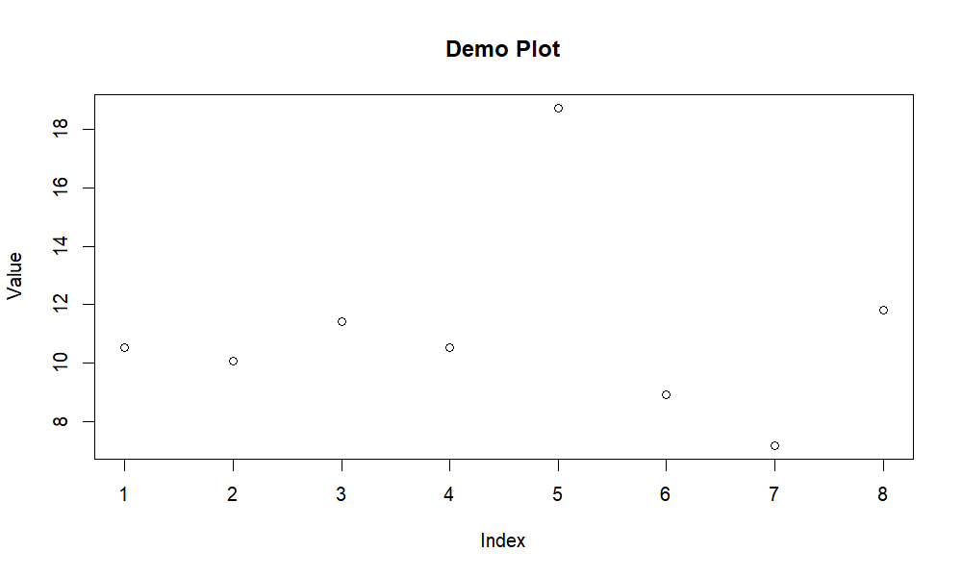

results/integration/consensus_clustering/annotation/plots/cc_hallmark_top5_heatmap.png

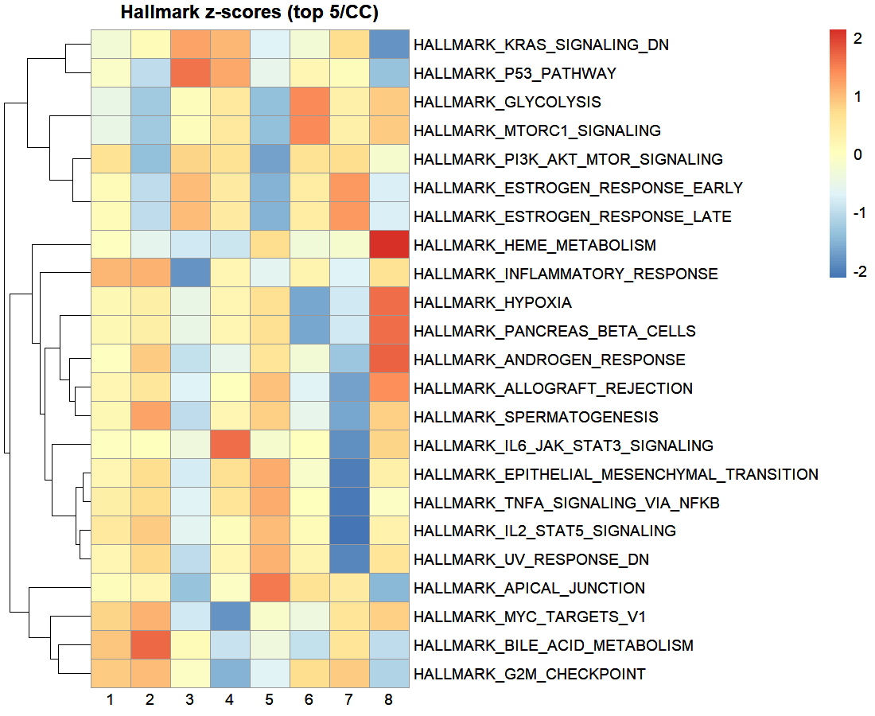

results/integration/consensus_clustering/annotation/plots/cc_progeny_heatmap.png

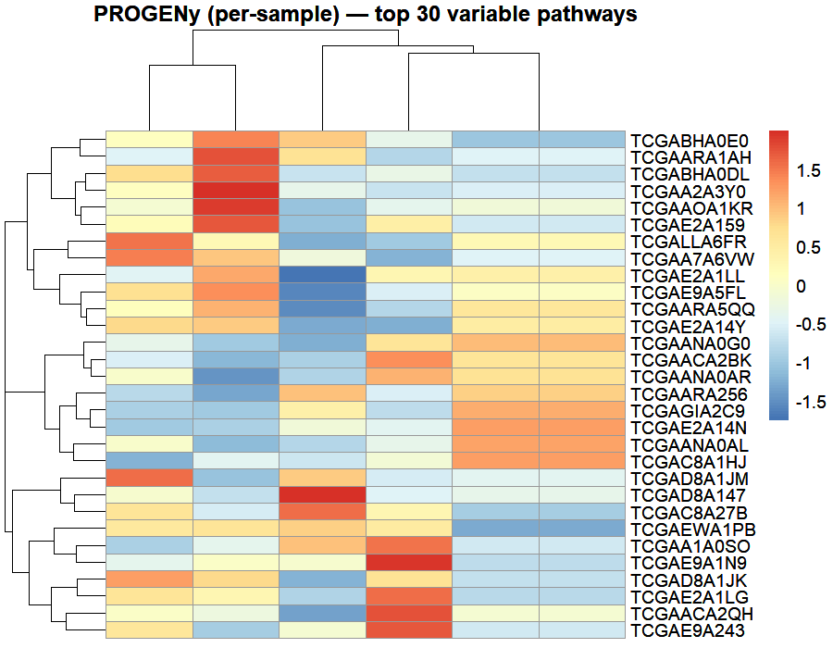

results/integration/consensus_clustering/annotation/plots/cc_top_hallmark_bars.png

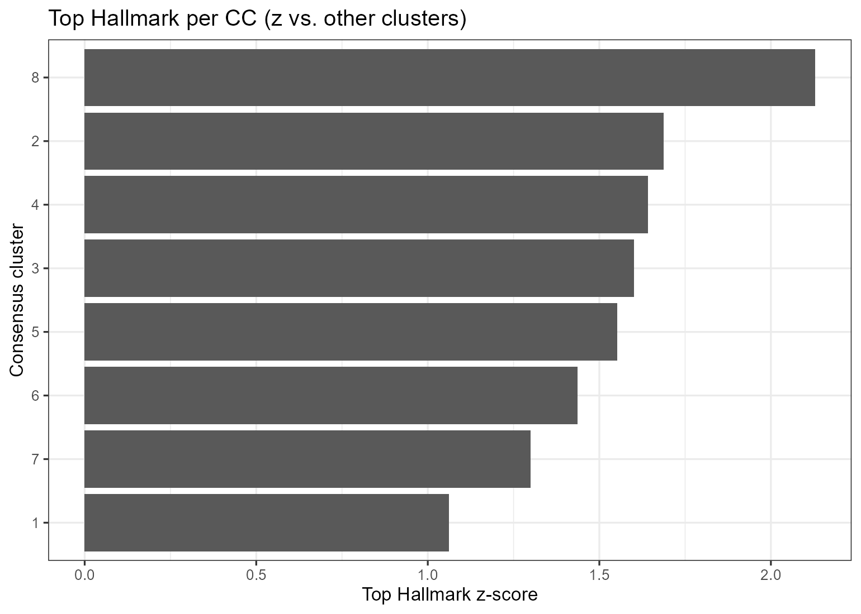

results/integration/consensus_clustering/classifier_cc/classifier_cc/plots/feature_importance_top25.png

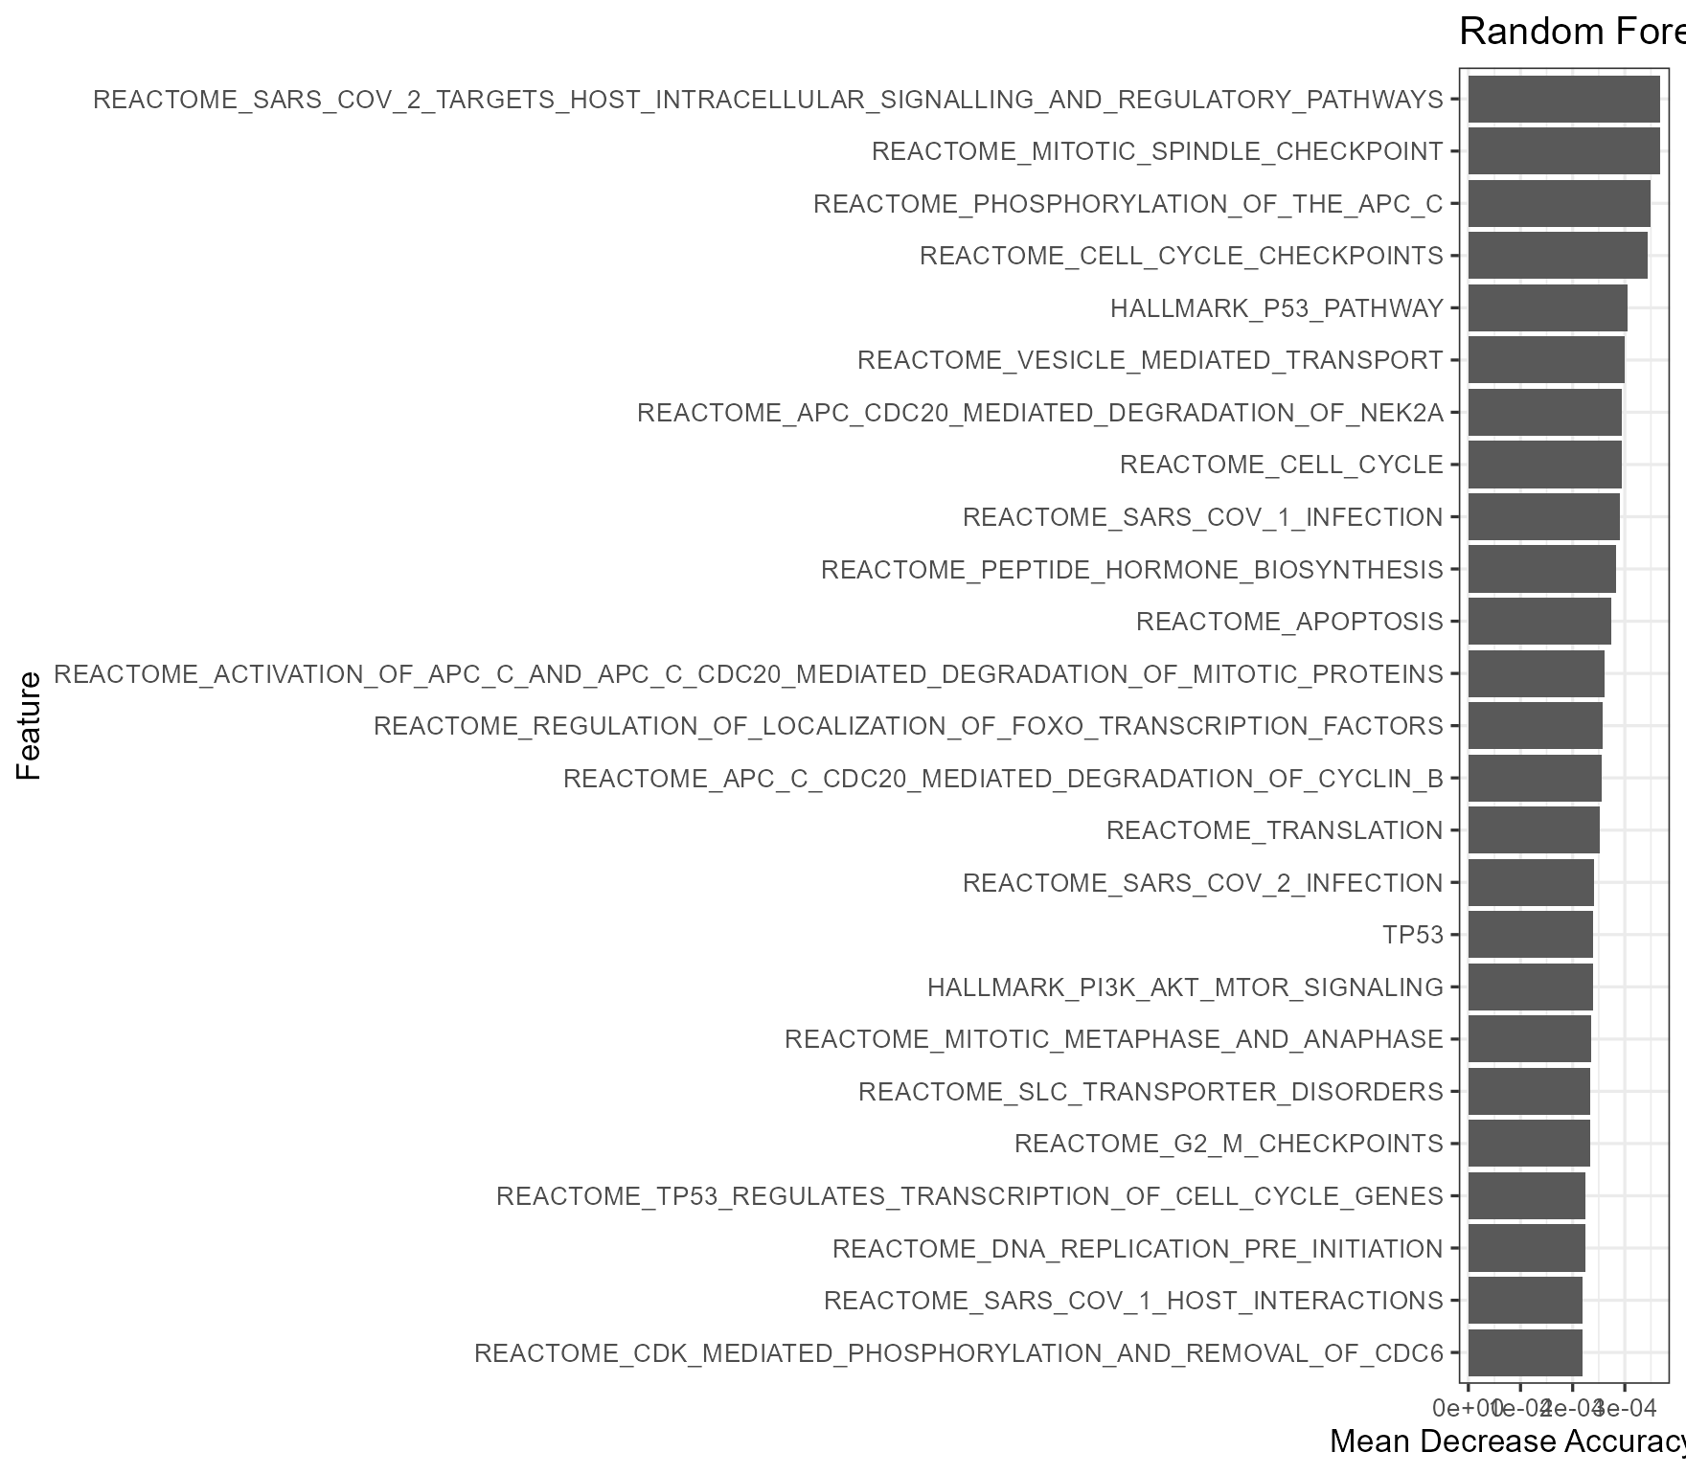

results/integration/consensus_clustering/classifier_cc/classifier_cc/plots/roc_curves/ROC_class_1.png

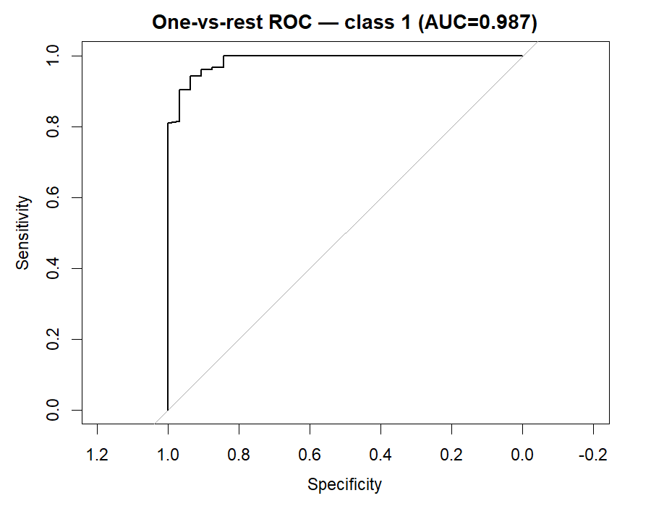

results/integration/consensus_clustering/classifier_cc/classifier_cc/plots/roc_curves/ROC_class_2.png

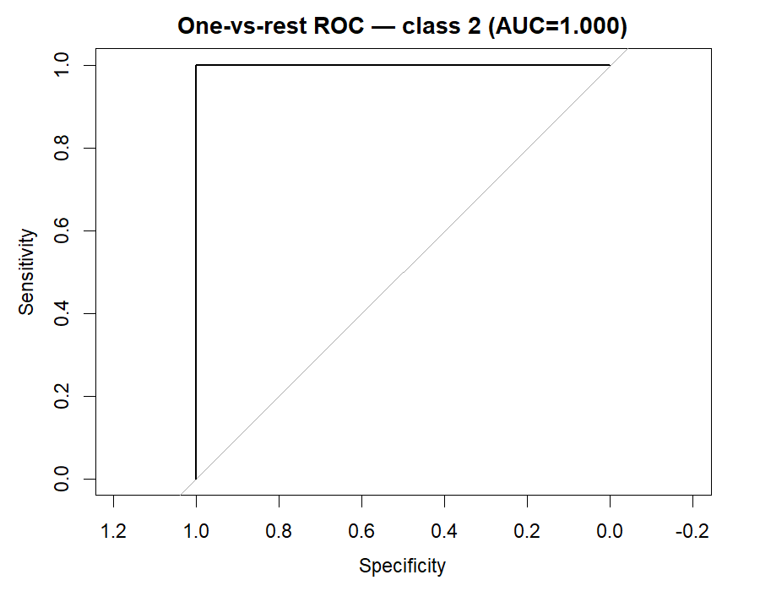

results/integration/consensus_clustering/classifier_cc/classifier_cc/plots/roc_curves/ROC_class_3.png

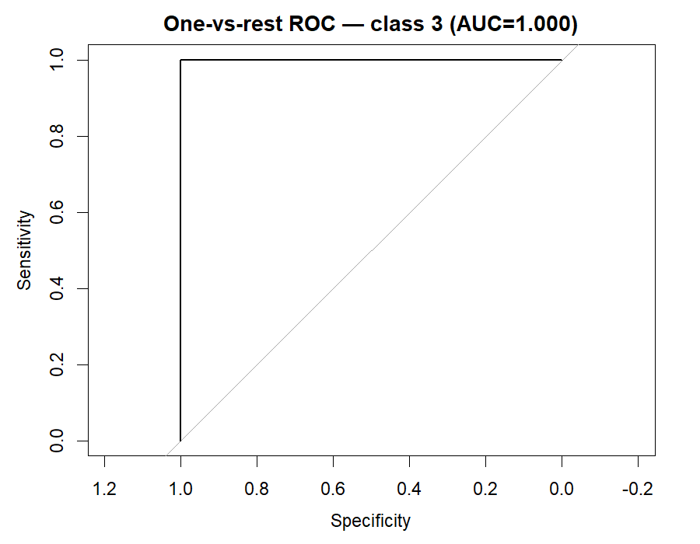

results/integration/consensus_clustering/classifier_cc/classifier_cc/plots/roc_curves/ROC_class_4.png

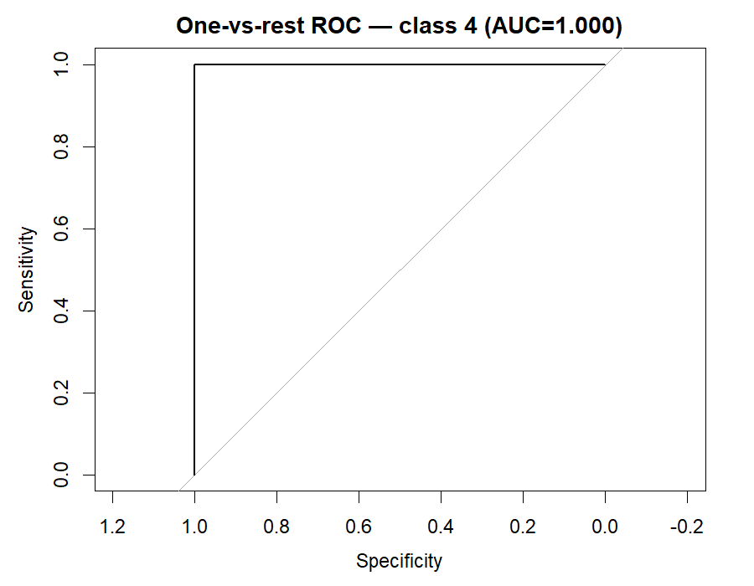

results/integration/consensus_clustering/classifier_cc/classifier_cc/plots/roc_curves/ROC_class_5.png

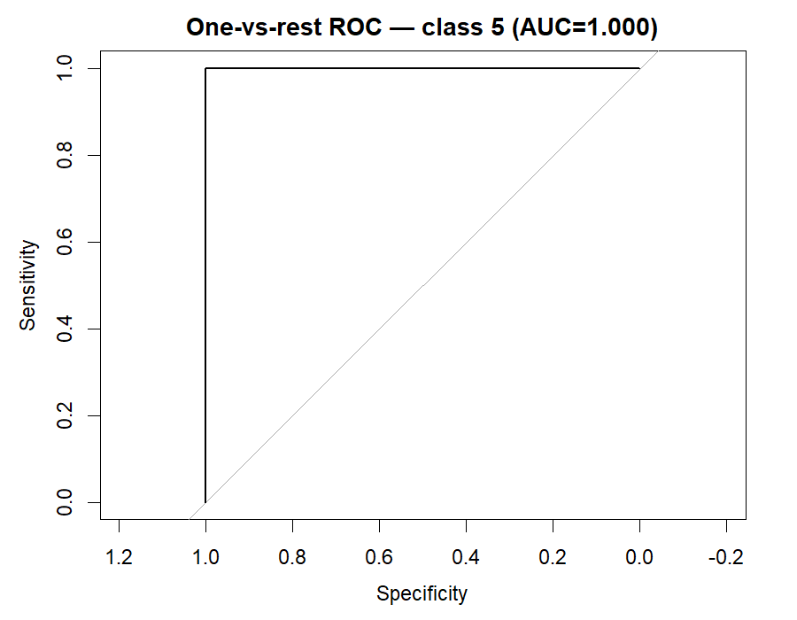

results/integration/consensus_clustering/classifier_cc/classifier_cc/plots/roc_curves/ROC_class_6.png

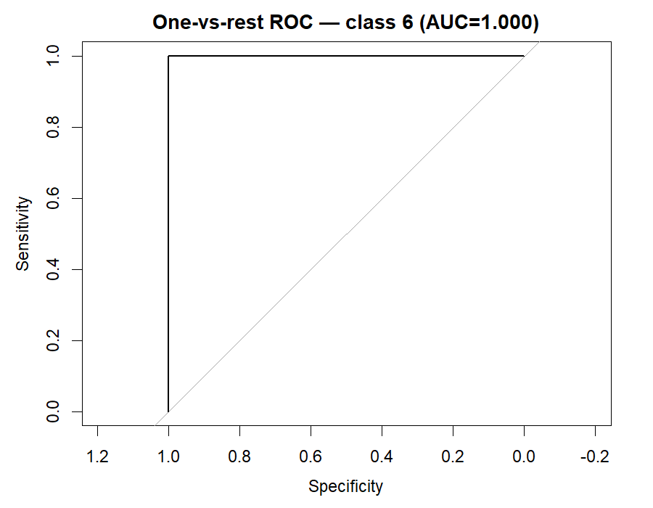

results/integration/consensus_clustering/classifier_cc/classifier_cc/plots/roc_curves/ROC_class_7.png

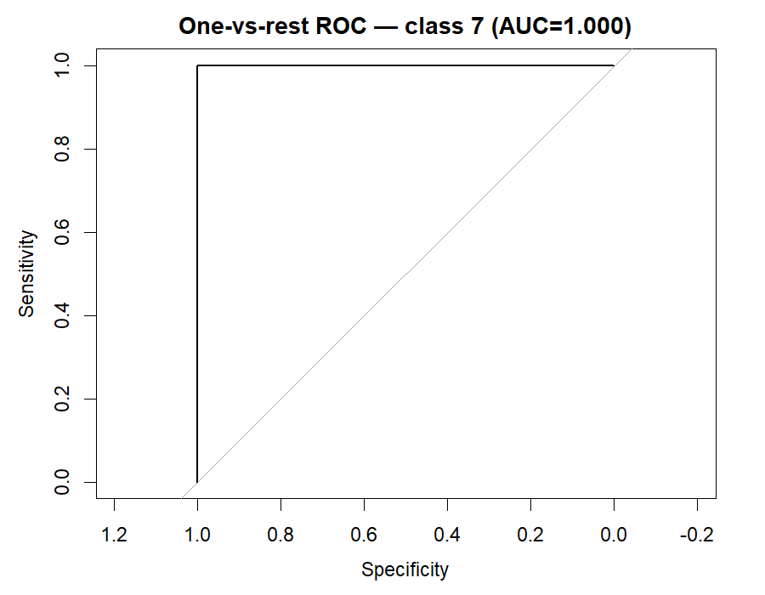

### Previews (first 12)

## Images

## Tables

## Summary

Root: C:/TNBC_project

Generated: 2025-08-22 06:32:42

# TNBC – Tables & Figures Dictionary