# Ohjelmistokehitys II

## Object Oriented Programming / Exam

Your name:

**Do the JavaScript code according to the class diagram. Copy your app.js code to the Moodle quizz.**

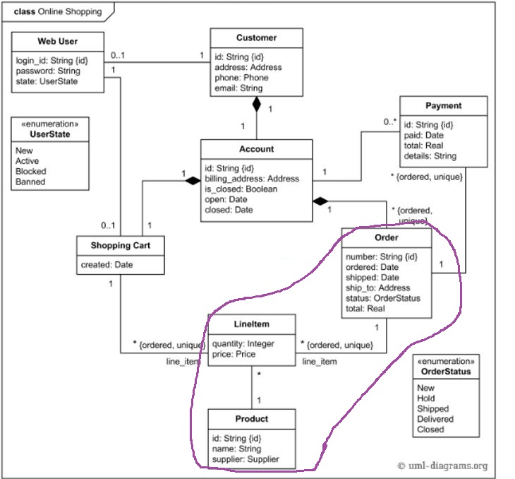

**1 (10 points)**

Code the constructor functions to Order, LineItem and Product objects. There is an object inside an object (Product object inside the LineItem) and an arraylist of objects inside an object (1 – n LineItems inside the Order).

|  |  |  |  |
| --- | --- | --- | --- |
| Object Type | Property Attributes | The Type of a Property Attribute | Notice |
| Order | number  ordered  shipped  ~~ship_to~~  status  total  lineItems | String  Date  Date  String  numeric  Array of LineItem objects | A string variable can consist of numbers like a postal code.  leave this away  status options: New, Hold, Shipped, Delivered, Closed  This is an array that has 0 -n pointers to LineItem objects |
| LineItem | quantity  price  product | Integer  numeric  Product object |  |
| Product | id  name  supplierName | String  String  String |  |

**2 (5 points)**

Do at least 2 of each: Order, LineItem and Product objects. In the Order –type object there have to be at least 2 line items.

**3 (5 points)**

EXTRA: Do methods:

|  |  |  |
| --- | --- | --- |
| To Object Type | Property Methods | Notice |
| Order | ChangeShipped() | Do the method so that it changes the date of shipped to todays date and changes status to ‘Shipped’ |
| LineItem | CountTheValue() | Do the method so that it multiplies quantity by price. |

Use Object.prototype method so, that the codes of methods will not be copied to every object but instead to the prototype of that object (only once to an object type).