Ryan Wiesenberg

rwies@umich.edu

Abstract

The goal of the smart mirror is to aggregate and present daily and upcoming tasks, aggregated for the user approaching the mirror based on supported, linked accounts.

Smart Mirror

CIS 553 Term Project

Contents

1 Introduction 1

1.1 Current System 1

2 Proposed System 1

2.1 Overview 1

2.2 Functional Requirements 2

2.3 Nonfunctional Requirements and Constraints 2

2.4 System Models 2

2.4.1 Object Model 3

# Introduction

The purpose of this document is to outline the software requirements and resultant system models for the **Smart Mirror** project. The goal of this project is to provide a centralized system for multiple users to interact with to see upcoming tasks for themselves and the group. This system is expected to contain a separate list of tasks for individual users and a list of tasks for the group. Additionally, the system should be able to differentiate users and present tasks and other information relevant to them.

The next section, Current System, details the current system state, based on user interviews. The Proposed System section then seeks to outline how the proposed system will seek to address the gaps in the current system, the system requirements, and any constraints on the system design. Finally, the Proposed System section will outline the resulting system models from the requirements specification and the goal user interface.

## Current System

Currently this system does not exist in an aggregated format and users must independently, manually view their upcoming tasks and mentally compare their deadlines and requirements. This creates undue stress for the user and detracts from making progress on the tasks themselves. Additionally, it is easy to forget one of the many systems used to track upcoming tasks and events and miss a task that is due or has been in the queue for an extended period without action.

# Software Requirements Specification (SRS)

## Overview

The primary goal of the **Smart Mirror** system will be to minimize the obstructions to the users as rephrased from the above:

* Multiple task tracking systems or applications
* Maintaining a mental model of task priority
* Obscured visibility of tasks due to infrequent access

This system is expected to run on low-end static hardware, affixed to a wall as a touch screen behind a mirror-like device. This document will not detail the physical element construction process but will aim to minimize computation overhead and design all UI elements and user interactions for a touch-screen device for ease of integration into the hardware.

## Functional Requirements

This section will organize itself now based on the goals listed above:

1. The system must be able to connect to multiple task tracking systems
   1. The systems should at least include access to a user’s Trello and Google Calendar
   2. All task systems linked should be shown adjacent in the same calendar and task list
   3. A user should be able to complete tasks by accessing the mirror
2. Mental model maintenance
   1. All tasks should optionally be able to store a due date or no due date
   2. All tasks should be able to signal the user if
      1. They have not been worked on in some time
      2. The due date is coming up
   3. A user should be able to check current individual tasks and group tasks
      1. Sort by due date and name
      2. Filter by source connection

## Nonfunctional Requirements and Constraints

* The system should minimally be supported by a RaspberryPi Zero or similar device that can support a touch screen monitor
* A user needs access at any hour of the day but uptime is not important this a non-critical component
* The product must be usable through a touchscreen and have a black background with primarily white text to promote the ability to use it as a physical mirror

# Software Design (SD)

In the identification step, two human actors were discovered:

* **MirrorUser**: Possesses the mirror and has connected to other allowed task services
* **TaskCreator***:* Creates tasks on an external system which are then retrieved by the **Smart Mirror**

Additionally, there are two non-human actors:

* **SmartMirror:** Responsible for collecting and organizing the tasks through the use of various user-centered connections to external task services
* **ExternalTaskService:** Collects and stores tasks for retrieval by the **SmartMirror.** Not regulated as a part of this design document but can be accessed directly by the **SmartMirror**

## Object Model

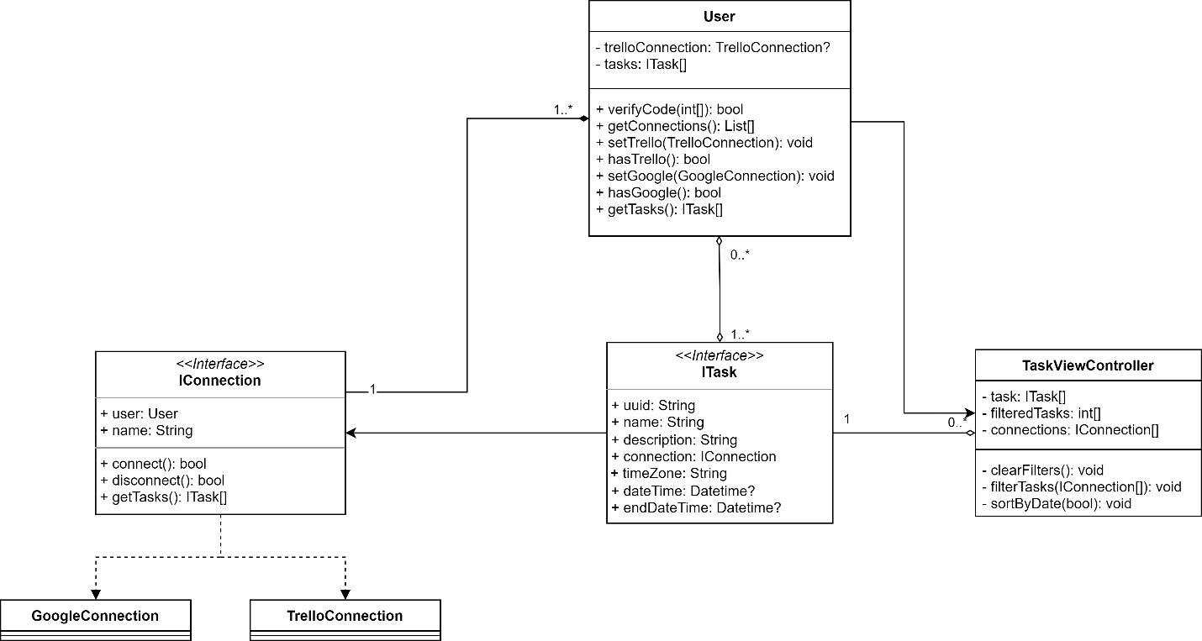

# Verification and Validation (V&V)