**PROJECT REPORT**

**ON**

**Face Recognition Based Attendance System**

**BY**

**Sanjeev Shekhar Naganur**

**Course: MCA 2nd Sem: III**

**Roll No.: 22093**

**Guide Name: Prof. Manish Patankar**



**PRATIBHA INSTITUTE OF BUSINESS MANAGEMENT**

**CHINCHWAD, PUNE-411019**

**2023-2024**

**DECLERATION**

I undersigned hereby declare that the project titled **Face Recognition Based Attendance System** has been completed by me under the guidance of **Prof. Manish Patankar** and is being submitted in partial fulfilment for the award of degree Master of Computer Application by **Savitribai** **Phule Pune University** during the Academic Year 2022-23.

This project work is original to the best of my knowledge and has not been submitted anywhere else.

**Date: ___________ Sanjeev Shekhar Naganur**

**ACKNOWLEDGEMENT**

We have made efforts in this project. However, it would not have been possible without the kind support and help of many individuals and organizations. We would like to extend our sincere thanks to all of them.

We highly in debted to **Prof.Manish Pathankar** for their guidance and constant supervision as well as for providing necessary information regarding the project & also for their support in completing the project.

We would like to express our special thanks of gratitude to our teacher as well as our **HOD Manish Pathankar** Sir and **Director Sachin Borgave** Sirwho gave us the golden opportunity to do this wonderful project on the topic Drowsiness Detection, which also helped us in doing a lot of Research and we came to know about so many new things we are thankful to them.

We would like to express our special gratitude and thanks to each other for giving me such attention and time and helping me learn new things to finish this project on time.

Our thanks and appreciation also go to us in developing the project and people who have willingly helped us out with their abilities.

**INDEX**

|  |  |  |
| --- | --- | --- |
| 1. | Introduction | 5 |
| 2. | Proposed System | 7 |
| 3. | Module Description | 11 |
| 4. | Analysis | 14 |
| 5. | Analysis & Design | 16 |
| 6. | Database Tables | 23 |
| 7. | Future Scope | 32 |
| 8. | Conclusion | 33 |

**CHAPTER 1: INTRODUCTION**

**1.1 Introduction:**

Attendance management is a critical aspect of organizational and educational efficiency. Traditional methods, such as manual attendance registers or card-based systems, have proven to be susceptible to inaccuracies and inefficiencies. In response to these challenges, the Face Recognition-Based Attendance System is introduced, leveraging innovative facial recognition technology to revolutionize the process of attendance tracking.

**1.2 Existing System and Need for System:**

1.2.1 Current State of Attendance Management:

Traditional methods of attendance management involve manual data entry or the use of physical identification cards. These methods are time-consuming, prone to errors, and often lack the level of security required in modern settings.

1.2.2 Need for a Modernized Approach:

The need for a more efficient and secure attendance management system has become imperative. With advancements in biometric technology, there is an opportunity to adopt a system that can offer precise identification, streamline processes, and enhance overall system reliability.

**1.3 Limitations of Existing System:**

1.3.1 Inaccuracy and Error-Prone:

Manual attendance systems are susceptible to human errors during data entry, leading to inaccuracies that impact the reliability of attendance records.

1.3.2 Time Inefficiency:

The time required for manual attendance recording can be significant, leading to inefficiencies and a potential misuse of valuable resources.

1.3.3 Security Concerns:

Physical identification methods, such as ID cards, are vulnerable to loss, theft, or misuse, compromising the security of attendance records.

1.3.4 Lack of Real-time Monitoring:

Traditional systems often lack the capability for real-time monitoring, hindering administrators' ability to make timely decisions based on attendance data.

1.3.5 Limited Scalability:

As organizations grow, manual systems become increasingly impractical, leading to scalability challenges and increased administrative burden.

**CHAPTER 2: PROPOSED SYSTEM**

**2.1 Problem Statement/s:**

In the context of attendance management, the existing systems are plagued by inaccuracies, time inefficiencies, and security vulnerabilities. The Face Recognition-Based Attendance System aims to address these issues by introducing a modern and robust solution. The specific problems to be addressed include:

* Inaccurate attendance records due to manual data entry errors.
* Time inefficiencies associated with traditional attendance tracking methods.
* Security concerns related to the loss, theft, or misuse of physical identification cards.
* The lack of real-time monitoring capabilities in existing systems.
* Limited scalability as organizations grow, resulting in increased administrative burdens.

**2.2 Objectives of Proposed System:**

The objectives of the proposed Face Recognition-Based Attendance System are as follows:

* **Achieve High Accuracy:** Implement advanced face recognition algorithms to ensure precise attendance tracking, minimizing errors associated with manual methods.
* **Enhance Efficiency:** Streamline the attendance recording process, reducing administrative burdens and optimizing resource utilization.
* **Ensure Data Security:** Introduce a robust biometric authentication layer to enhance the security of attendance records, mitigating the risks of identity fraud.
* **Real-time Monitoring:** Provide administrators with instant access to attendance data for timely decision-making and intervention.
* **User-Friendly Interface:** Develop an intuitive and user-friendly system that encourages widespread acceptance among administrators, faculty, and students.

**2.3 Scope of the System:**

The Face Recognition-Based Attendance System is designed to be applicable in various environments, including educational institutions and corporate settings. The system can be deployed in scenarios where accurate attendance tracking, security, and efficiency are paramount. It is scalable to accommodate different organizational sizes and adaptable to diverse operational requirements.

**2.4 Module Specifications:**

The proposed system consists of the following key modules:

* **Face Detection Module:** Utilizes computer vision algorithms to identify and extract facial features from images or video streams.
* **Face Recognition Module:** Employs machine learning algorithms for precise comparison of facial features against pre-registered templates, ensuring accurate identification.
* **Database Management System:** Safely stores and manages biometric data, facilitating quick and efficient comparisons during the recognition process.
* **User Interface:** Provides an intuitive interface for administrators to manage attendance records, user profiles, and system configurations seamlessly.

**2.5 Detail Description of Technology Used:**

The Face Recognition-Based Attendance System leverages the following technologies:

* **Computer Vision:** Utilized for face detection, identifying facial features from images or video streams.
* **Machine Learning:** Applied for face recognition, enabling the system to learn and accurately identify individuals based on their facial features.
* **Database Management System:** Stores and manages biometric data securely, facilitating efficient comparisons during the recognition process.
* **User Interface Development Tools:** Used to create an intuitive and user-friendly interface for administrators to interact with the system.

**2.6 Operating Environment:**

The system is designed to operate in a standard computing environment, compatible with common operating systems such as Windows, Linux, or macOS. It requires hardware components such as high-resolution cameras for capturing facial images and a processing unit capable of running the face detection and recognition algorithms efficiently.

**MODULE DESCRIPTION**

1. **Flask App Initialization (app):**
   * The Flask application is created to serve as the foundation for the Face Recognition-Based Attendance System. It handles HTTP requests and responses.
2. **Initialization and Configuration:**
   * **nimgs**: Variable representing the number of images to capture for training the face recognition model.
   * **datetoday** and **datetoday2**: Variables storing the current date in different formats.
   * **face_detector**: Initializes a cascade classifier for face detection using the Haar Cascade.
3. **Directory and File Handling:**
   * Checks and creates directories ('Attendance', 'static', 'static/faces') required for the system.
   * Creates an attendance CSV file for the current date if it doesn't already exist.
4. **Face Recognition Model Functions:**
   * **train_model**: Trains the face recognition model using the K-Nearest Neighbors (KNN) algorithm based on images stored in the 'static/faces' directory.
   * **identify_face**: Uses the trained model to predict the identity of a detected face.
5. **Attendance Management Functions:**
   * **extract_attendance**: Extracts attendance information from the CSV file for the current date.
   * **add_attendance**: Adds the attendance record for a recognized face to the CSV file.
6. **User Management Functions:**
   * **getallusers**: Retrieves the names and roll numbers of all registered users.
   * **deletefolder**: Deletes the folder of a specific user, including associated images.
7. **Flask Routes and Web Pages:**
   * **/**: Displays the main page showing attendance records for the current date and provides functionality for taking attendance.
   * **/listusers**: Displays a page listing all registered users with options for user management.
   * **/deleteuser**: Deletes a user and their associated images.
   * **/start**: Initiates the face recognition process to capture attendance.
   * **/add**: Adds a new user to the system by capturing and storing their facial images.
8. **Web Camera and Image Processing:**
   * Uses OpenCV (**cv2**) to capture frames from the web camera.
   * Performs face detection and recognition on captured frames.
   * Updates the web interface with real-time attendance information.
9. **Model Training and Persistence:**
   * The face recognition model is trained and saved using joblib.
   * The trained model is loaded for real-time face recognition during attendance capture.
10. **Web Interface:**
    * The system provides a web-based interface built with Flask's templating engine (**render_template**).
    * HTML templates (**home.html** and **listusers.html**) are used for rendering dynamic content.

**ANALYSIS**

**System Initialization and Configuration:**

The code initializes necessary variables, directories, and files.

Haar Cascade classifier is employed for face detection.

Directories such as 'Attendance' and 'static' are created for storing attendance records and user data.

**Face Recognition Model:**

The system employs the K-Nearest Neighbors (KNN) algorithm for face recognition.

The **train_model** function is responsible for training the face recognition model using facial images stored in the 'static/faces' directory.

The **identify_face** function predicts the identity of a detected face using the trained model.

**Attendance Management:**

The system maintains attendance records in a CSV file for the current date.

The **extract_attendance** function retrieves attendance information from the CSV file.

The **add_attendance** function adds attendance records for recognized faces.

**User Management:**

The system allows for user registration by capturing and storing facial images.

User management functions include listing all registered users and deleting specific user folders.

**Flask Routes and Web Pages:**

The Flask application defines routes for different functionalities, such as displaying attendance, listing users, deleting users, starting face recognition, and adding new users.

HTML templates (**home.html** and **listusers.html**) are used for rendering dynamic content.

**Web Camera and Image Processing:**

OpenCV is utilized for capturing frames from the web camera.

Face detection and recognition are performed on the captured frames in real-time.

The web interface is updated with attendance information during the face recognition process.

**Model Training and Persistence:**

The face recognition model is trained using captured facial images and saved for later use.

Joblib is employed for model persistence, allowing the system to load the trained model efficiently.

**Web Interface:**

The system provides a user-friendly web interface for administrators to monitor attendance, list users, and perform user management tasks.

HTML templates enhance the presentation of information on the web pages.

**Run the Flask App:**

The main function runs the Flask application, starting the web server for handling HTTP requests.

**Conclusion:**

The code presents a comprehensive implementation of a Face Recognition-Based Attendance System. It leverages Flask for web functionality, OpenCV for image processing, and machine learning for face recognition. The system offers a modern and efficient alternative to traditional attendance tracking methods.

**Future Enhancements:**

Potential future enhancements could include:

Integration with a database for better scalability.

Improved user interface features.

Incorporation of additional security measures.

Implementation of more advanced face recognition algorithms.

**SYSTEM DESIGN**

**Class Diagram:**

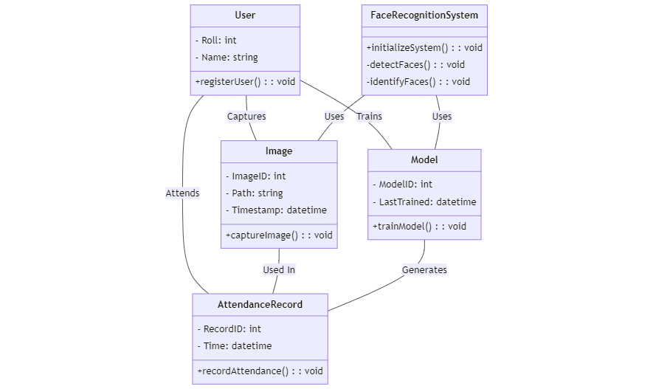

**Activity Diagram:**

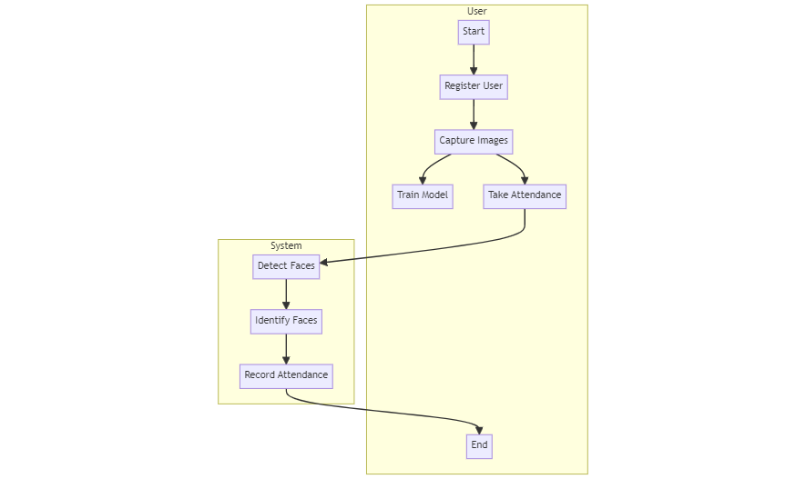

**Sequence Diagram:**

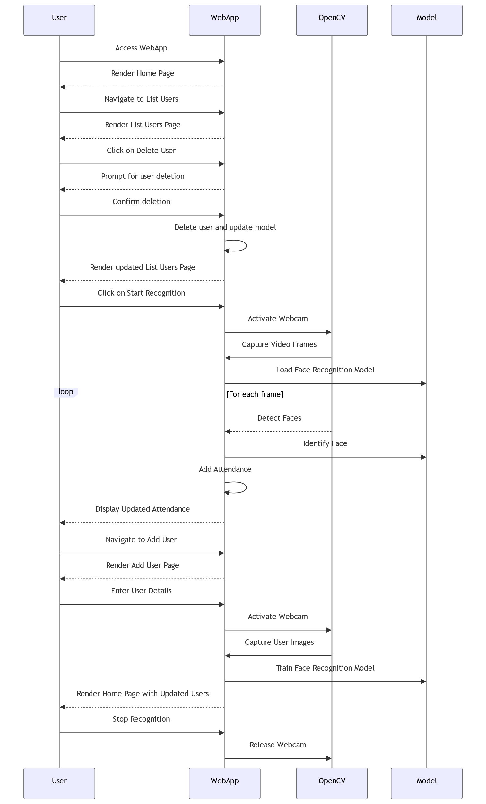

**Use-Case Diagram:**

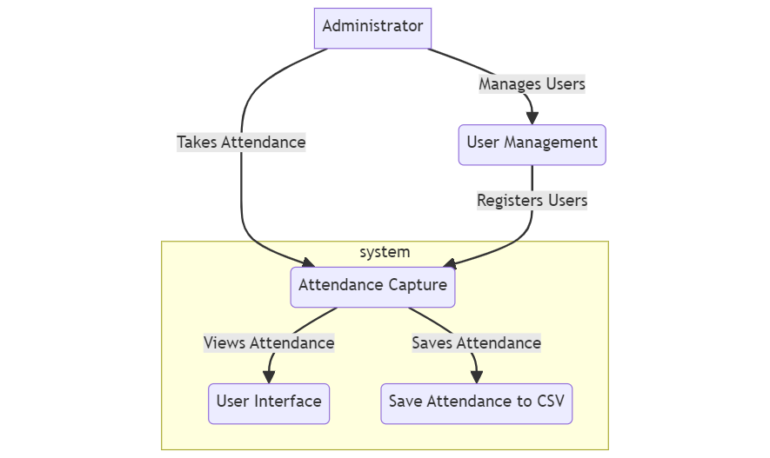

## **Chapter 4: User Manual**

### 4.1 User Manual

#### **4.1.1 Overview**

The Face Recognition-Based Attendance System is designed to automate the attendance process using facial recognition technology. This section provides a comprehensive user manual to guide users through various functionalities of the system.

#### **4.1.2 Accessing the System**

1. Open the web browser of your choice.
2. Enter the system's URL in the address bar.
3. The main page will be displayed, showing attendance information.

#### **4.1.3 Home Page**

* The home page provides an overview of attendance records for the current date.
* It displays the names, roll numbers, and times of attendance for all recognized individuals.

#### **4.1.4 List Users Page**

* Navigate to the "List Users" page to view a list of all registered users.
* This page provides details such as user names and roll numbers.

#### **4.1.5 Adding a New User**

1. Go to the "List Users" page.
2. Click on the "Add New User" button.
3. Enter the new user's name and roll number.
4. Capture multiple images of the user's face by following on-screen instructions.
5. The system will automatically train the model with the new user's data.

#### **4.1.6 Deleting a User**

1. Navigate to the "List Users" page.
2. Click on the "Delete User" button next to the user you want to remove.
3. Confirm the deletion.
4. The user's folder and associated data will be deleted.

#### **4.1.7 Taking Attendance**

1. Click on the "Take Attendance" button on the home page.
2. The system will use the webcam to identify faces and mark attendance.
3. The recognized person's name will be displayed on the screen.

#### **4.1.8 Viewing Attendance**

* The home page displays real-time attendance records.
* Users can view the names, roll numbers, and times of attendance for the current date.

### Drawbacks and Limitations

#### **4.1.9 Limitations**

1. **Dependence on Lighting Conditions:**
   * The system's accuracy may be affected by variations in lighting conditions.
2. **Single Camera Usage:**
   * The system relies on a single webcam, limiting its coverage in large environments.
3. **Training Sensitivity:**
   * The accuracy of the face recognition model is influenced by the quality and quantity of training data.
4. **Security Concerns:**
   * The system might be vulnerable to unauthorized access if proper security measures are not implemented.

### Proposed Enhancements

#### **4.1.10 Future Improvements**

1. **Multi-Camera Support:**
   * Implementing support for multiple cameras to enhance coverage and accuracy.
2. **Integration with Student Information System (SIS):**
   * Integrating the system with an SIS for automatic user registration and information updates.
3. **Enhanced Security Measures:**
   * Incorporating additional security features, such as user authentication and encryption, to ensure data integrity.
4. **Mobile Application:**
   * Developing a mobile application for remote access and monitoring.
5. **Machine Learning Model Updates:**
   * Periodically updating the face recognition model to improve accuracy and adapt to changes in user appearances.
6. **Real-time Notifications:**
   * Implementing real-time notifications for administrators and users regarding attendance updates.
7. **Performance Optimization:**
   * Continuously optimizing the system for better performance and responsiveness.

**Conclusion:**

The Face Recognition-Based Attendance System represents a significant advancement in automating the traditional attendance tracking process. Through the implementation of facial recognition technology, this system provides a seamless and efficient way to mark attendance, reducing the manual effort and potential errors associated with traditional methods.