EUROPEAN UNIVERSITY OF LEFKE

Faculty of Engineering

# Department of Computer Engineering



# COMP218

OBJECT-ORIENTED PROGRAMMING

## Lab Work No. 1

Prepared by Seward Richard Mupereri (20140175)

Submitted to Dr. Ferhun Yorgancıoğlu

### Task (1)

a.

#include <iostream>

int main() {

    std::cout << "Hello World";

    return 0;

}



b.

#include <iostream>

using std::cout;

int main() {

    cout << "Hello World";

    return 0;

}



**c.**

#include <iostream>

using namespace std;

int main() {

    cout << "Hello World";

    return 0;

}



### Task (2)

#include <iostream>

using namespace std;

int main() {

    int num1, num2, sum;

    cout << "Enter fisrt value:  ";

    cin >> num1;

    cout << "Enter second value:  ";

    cin >> num2;

    sum = num1 + num2;

    cout << "Addition of " << num1 << " and " << num2 << " is " << sum;

    return 0;

}

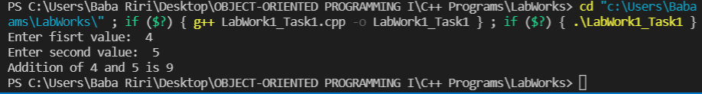

### Task (3)

#include <iostream>

#include <iomanip>

using namespace std;

int main() {

    cout << 4 << endl;

    cout << setw(3) << 4 << endl;

    cout << setw(3) << left << 4 << endl;

    cout << setprecision(7) << 3.141559 << endl;

    cout << setprecision(2) << fixed << 3.141559 << endl;

    cout << setw(6) << setprecision(2) << fixed << 3.141559 << endl;

    return 0;

}

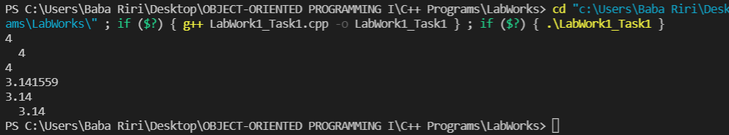

### Task (4)

#include <iostream>

#include <iomanip>

using namespace std;

int main() {

    int a = 2; //This line initialises an int value named a and assigns it the value 2

    char b = 'f'; //This line initialises a char variable named b and assigns it the value 'f'

    float c = 3.1415f; //This line initialises a floating point value named c and gives it the value 3.1415f

    double d = 3; //This line initialises a double value named d and gives it the value 3

    cout << setw(3) << a << endl; //This line prints the int value a in three spaces and goes to the next line

    cout << setw(3) << left << a << endl; //This line prints the int value a in three spaces adjusted left and goes to the next line

    cout << setw(3) << right << a << endl; //This line prints the int value a in three spaces adjusted right and goes to the next line

    cout << '\t' << a << '\t' << b << '\t' << c << endl; //This line prints the values a, b and c separated by tab and goes to the next line

    cout << setw(9) << a << setw(8) << b << setw(13) << c << endl; //This line prints variables a in 9 spaces, b in 8 spaces and c in 13 spaces

    cout << d << '\t' << setprecision(1) << d << '\t' << fixed << setprecision(1) << d << endl; //This line prints variable d then tab, prints one significant digit of value d, prints another tab then prints variable d with one significant digit after the point

    cout.unsetf( ios::fixed ); //This line formats the cout object to print a fixed number of values

    cout << d << endl; //This line prints the variable d and goes to the next line

    return 0;

}

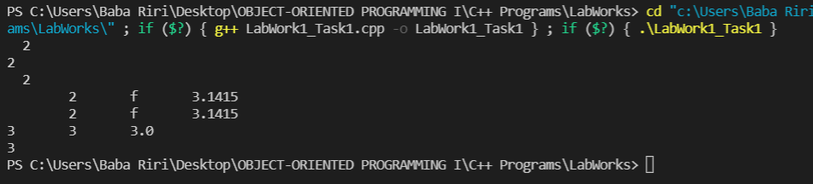

### Task (5)

#include <iostream>

#include <iomanip>

using namespace std;

int main() {

    int a = 3; //This line initialises an int value named a and assigns it the value 3

    char b = 'f'; //This line initialises an char value named b and assigns it the value 'f'

    cout << a << '\t' << static_cast<char>(a) << endl; //This line prints variable a, tab and the value of a again but converted to char data type and goes to the next line

    cout << b << '\t' << static_cast<int>(b) << endl; //This line prints variable b, tab and the value of b again but converted to int data type and goes to the next line

    cout << ( 2/3 ) << '\t' << ( static_cast<float>(2) / 3 ) << endl; //This line prints 2/3, tab and 2/3 again but converted to a floating data type

    return 0;

}

