EUROPEAN UNIVERSITY OF LEFKE

Faculty of Engineering

# Department of Computer Engineering



# COMP218

OBJECT-ORIENTED PROGRAMMING

## Lab Work No. 3

Prepared by Seward Richard Mupereri (20140175)

Submitted to Dr. Ferhun Yorgancıoğlu

### Task (1)

#include <iostream>

#include <cmath>

using namespace std;

template<class T>

T distance( T x1, T x2, T y1, T y2 )

{

    T d;

    d = sqrt( pow( ( y2 - y1 ), 2 ) + pow( ( x2 - x1 ), 2 ) );

    return d;

}

int main()

{

    int a1, a2, b1, b2;

    double c1, c2, d1, d2;

    cout << "---------------------------------------" << endl;

    cout << "DISTANCE CALCULATOR WITH INTEGER VALUES" << endl;

    cout << "---------------------------------------" << endl;

    cout << "FIRST POINT:" << endl;

    cout << "X-Cordinate = ";

    cin >> a1;

    cout << "Y-Cordinate = ";

    cin >> b1;

    cout << endl;

    cout << "SECOND POINT:" << endl;

    cout << "X-Cordinate = ";

    cin >> a2;

    cout << "Y-Cordinate = ";

    cin >> b2;

    cout << endl;

    cout << "Distance = " << distance( a1, a2, b1, b2) << endl;

    cout << "---------------------------------------" << endl;

    cout << "DISTANCE CALCULATOR WITH DOUBLE VALUES" << endl;

    cout << "---------------------------------------" << endl;

    cout << "FIRST POINT:" << endl;

    cout << "X-Cordinate = ";

    cin >> c1;

    cout << "Y-Cordinate = ";

    cin >> d1;

    cout << endl;

    cout << "SECOND POINT:" << endl;

    cout << "X-Cordinate = ";

    cin >> c2;

    cout << "Y-Cordinate = ";

    cin >> d2;

    cout << endl;

    cout << "Distance = " << distance( c1, d2, c1, d2);

    return 0;

}

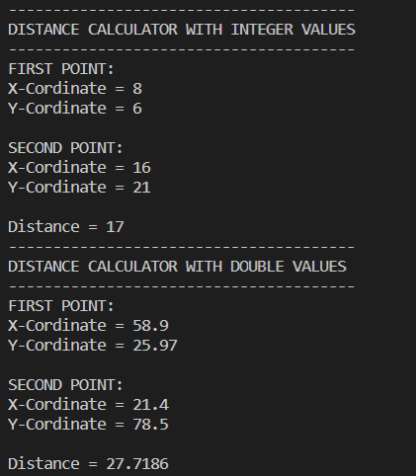

### Task (2)

#include <iostream>

using namespace std;

int volume( int a = 1, int b = 1, int c = 1 );

int main()

{

    cout << "-----------------------------------------" << endl;

    cout << "VOLUME CALCULATOR WITH DEFAULT ARGUMENTS" << endl;

    cout << "-----------------------------------------" << endl;

    cout << "Results with different function calls:" << endl;

    cout << volume() << endl;

    cout << volume(2) << endl;

    cout << volume(2, 3) << endl;

    cout << volume(2, 3, 4) << endl;

    return 0;

}

int volume( int a, int b, int c )

{

    return ( a * b * c );

}

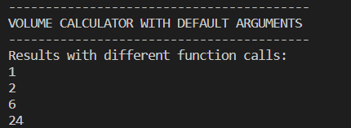

### Task (3)

#include <iostream>

using namespace std;

void swapCPP( char &a, char &b)

{

    char temp = a;

    a = b;

    b = temp;

}

void swapC( char *a, char *b)

{

    char temp = *a;

    *a = *b;

    *b = temp;

}

int main()

{

    char a = 'A', b = 'B';

    char x = 'X', y = 'Y';

    cout << "------------------------------------------------" << endl;

    cout << "PROGRAM TO SWAP 2 CHARACTERS PASSED BY REFERENCE" << endl;

    cout << "------------------------------------------------" << endl;

    cout << "TEST 1" << endl;

    cout << "-------" << endl;

    cout << "BEFORE SWAP: " << a << "   " << b << endl;

    swapCPP(a, b);

    cout << "AFTER SWAP: " << a << "   " << b << endl;

    cout << endl;

    cout << "TEST 2" << endl;

    cout << "-------" << endl;

    cout << "BEFORE SWAP: " << x << "   " << y << endl;

    swapCPP(x, y);

    cout << "AFTER SWAP: " << x << "   " << y << endl;

    cout << endl;

    cout << "----------------------------------------------------" << endl;

    cout << "VERSION USING C-STYLE CALL-BY-REFERENCE METHODOLOGY" << endl;

    cout << "----------------------------------------------------" << endl;

    cout << "BEFORE SWAP: " << a << "   " << b << endl;

    swapC(&a, &b);

    cout << "AFTER SWAP: " << a << "   " << b << endl;

    cout << endl;

    return 0;

}

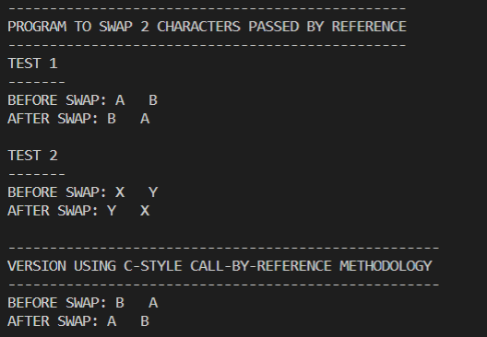

### Task (4)

#include <iostream>

#include<cmath>

using namespace std;

inline double area( double r )

{

    return ( M_PI* pow(r, 2) );

}

inline double volume( double r, double h )

{

    return ( area(r) * h );

}

int main()

{

    double radius, height;

    cout << "---------------------------------------------------------" << endl;

    cout << "PROGRAM TO CALCULATE AREA OF CIRCLE & VOLUME OF CYLINDER" << endl;

    cout << "---------------------------------------------------------" << endl;

    cout << "Enter the radius: ";

    cin >> radius;

    cout << "Enter the height: ";

    cin >> height;

    cout << "---------------------------------------------------------" << endl;

    cout << "AREA = " << area(radius) << endl;

    cout << "VOLUME = " << volume(radius, height) << endl;

    cout << "---------------------------------------------------------" << endl;

    return 0;

}

