EUROPEAN UNIVERSITY OF LEFKE

Faculty of Engineering

# Department of Computer Engineering



# COMP218

OBJECT-ORIENTED PROGRAMMING

## Lab Work No. 5

Prepared by Seward Richard Mupereri (20140175)

Submitted to Dr. Ferhun Yorgancıoğlu

### Task (1)

#include <iostream>  
#include <string>  
#include <iomanip>  
  
using namespace std;  
  
void printString(string s)  
{  
 int num = 30;  
  
 cout << setw(num) << "STRING: " << s << endl;  
 cout << endl;  
 cout << setw(num) << "IS IT EMPTY?: " << (s.empty() ? "Yes" : "No") << endl;  
 cout << setw(num) << "LENGTH?: " << s.length() << endl;  
 cout << setw(num) << "CAPACITY?: " << s.capacity() << endl;  
  
}  
  
void printMenu()  
{  
 int num = 30;  
  
 cout << endl << "|-----------------------------------------------------------|" << endl;  
 cout << "| STRING HANDLING PROGRAM |" << endl;  
 cout << "|-----------------------------------------------------------|" << endl;  
 cout << setw(num) << "1. " << "CREATE" << endl;  
 cout << setw(num) << "2. " << "INSERT" << endl;  
 cout << setw(num) << "3. " << "APPEND" << endl;  
 cout << setw(num) << "4. " << "DELETE" << endl;  
 cout << setw(num) << "5. " << "REVERSE" << endl;  
 cout << setw(num) << "6. " << "PRINT" << endl;  
 cout << setw(num) << "0. " << "QUIT" << endl;  
 cout << "|-----------------------------------------------------------|" << endl;  
}  
  
int main()  
{  
 int num;  
 string s0 = "DEFAULT STRING";  
 string s4 = "SOURCE";  
  
 printMenu();  
  
 cout << " ENTER A NUMBER FROM THE MENU:";  
  
 while ( (cin >> num) && (num != 0) )  
 {  
 if ( (num >= 0) && (num < 7) )  
 {  
 switch( num )  
 {  
 case 0:  
 {  
 cout << "QUITTING..." << endl;  
 break;  
 }  
 case 1:  
 {  
 cout << "|-----------------------------------------------------------|" << endl;  
 cout << " WE CREATE A STRING & ASSIGNED IT 'SOURCE' " << endl << endl;  
 string s1 = "SOURCE";  
 printString(s1);  
 break;  
 }  
 case 2:  
 {  
 cout << "|-----------------------------------------------------------|" << endl;  
 cout << " WE CAN INSERT A STRING 'CODE' TO STRING 'SOURCE' " << endl << endl;  
 char temp[] = " CODE";  
 s4.insert( s4.length(), temp);  
 printString(s4);  
 break;  
 }  
 case 3:  
 {  
 cout << "|-----------------------------------------------------------|" << endl;  
 cout << "WE ADD 3 LETTERS FROM 'Metaverse' TO 'Google' FROM THE 4th INDEX" << endl << endl;  
 string a = "Google";  
 string b = "Metaverse";  
 a.append( b, 4, 3);  
 printString(a);  
 break;  
 }  
 case 4:  
 {  
 cout << "|-----------------------------------------------------------|" << endl;  
 cout << " WE DELETE THE DEFAULT STRING" << endl << endl;  
 printString(s0);  
 s0.clear();  
 cout << endl;  
 printString(s0);  
 break;  
 }  
 case 5:  
 {  
 cout << "|-----------------------------------------------------------|" << endl;  
 cout << " WE PRINT THE REVERSE OF A STRING" << endl << endl;  
 printString(s4);  
 cout << endl;  
 cout << setw(27);  
  
 for (string::reverse_iterator i = s4.rbegin(); i < s4.rend(); i++)  
 {  
 cout << *i;  
 }  
 cout << endl;  
 break;  
 }  
 case 6:  
 {  
 cout << "|-----------------------------------------------------------|" << endl;  
 cout << " WE PRINT A STRING" << endl << endl;  
 string s3 = "NEW STRING";  
 printString(s3);  
 break;  
  
 }  
 }  
 }  
 else  
 {  
 cout << " INVALID CHOICE!";  
 }  
  
 printMenu();  
  
 cout << " ENTER A NUMBER FROM THE MENU: ";  
 }  
  
 return 0;  
}

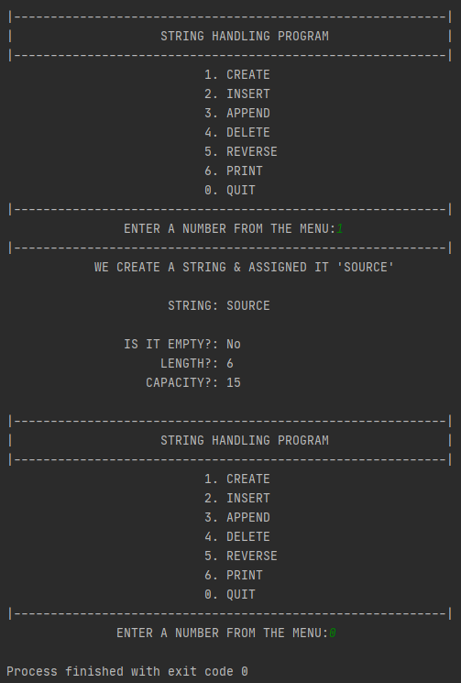

1