**Book Store Virtual Assistant Prototype**

**Section 1: Introduction**

*Introduction:* Welcome to the Book Store Chatbot Prototype, a cutting-edge solution designed to enhance user experience in the realm of online bookstores. Leveraging advanced technologies and a vast dataset, this chatbot offers personalized book recommendations, detailed information about books, and seamless interaction for users.

*Technologies Used:*

* Chromadb: A powerful vector database used for efficient data storage and retrieval, enabling seamless handling of book-related information.
* OpenAI: Utilized for Named Entity Recognition (NER), intention detection, summarization, and question answering, ensuring accurate and context-aware responses.
* FastAPI: A high-performance framework used to develop the chatbot's API, facilitating rapid communication between the user interface and backend processes.
* SQLite: Employed for data management, logging user interactions, and powering the recommendation engine.

*Dataset Overview:* Our chatbot prototype is fueled by a comprehensive dataset sourced from Kaggle, consisting of approximately 16,000 books. This dataset includes essential information such as book titles, genres, authors, and abstracts, providing a rich foundation for intelligent recommendation and information retrieval.

**Section 2: Data Management**

*Data Collection:* The book-related data is stored and managed using Chromadb, a versatile vector database. Upon initialization, the chatbot creates a dedicated collection named "book_store" within Chromadb to store detailed information about each book, including its title, genre, author, and abstract.

*General Information Collection:* In addition to book-specific data, the chatbot also maintains a collection named "general" within Chromadb. This collection stores essential information such as return policies and purchasing methods, generated using GPT-3.5 with knowledge distillation techniques. This ensures that users can easily access relevant general information during their interactions with the chatbot.

*User Activity Logging:* To enhance user experience and enable personalized recommendations, the chatbot logs user interactions using SQLite. This "Log_saver" database records user searches, purchases, and other activities, providing valuable insights for refining the recommendation engine and improving overall performance.

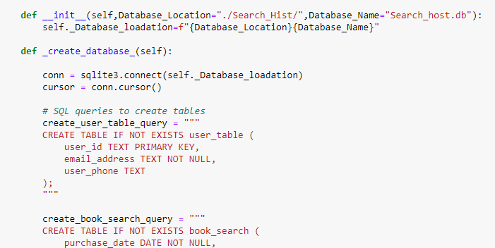

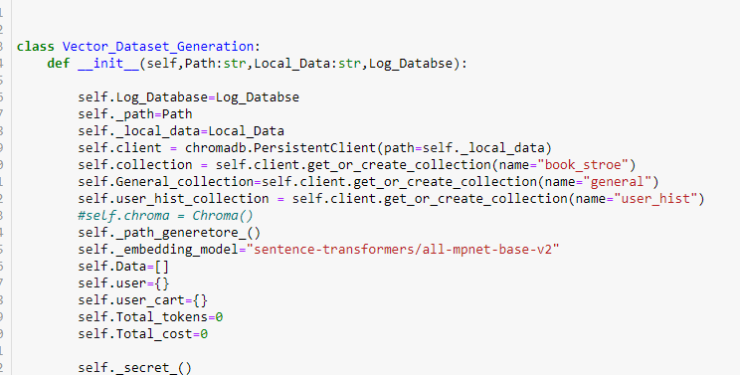

**Section 3: Chatbot Functionality** This section outlines the core functionalities of the chatbot, including NER, intention detection, summarization, and question answering, facilitated by OpenAI.

*Chatbot Operation:* Powered by OpenAI's advanced capabilities, our chatbot offers a seamless and intuitive user experience. Upon receiving a user query, the chatbot employs NER to extract relevant entities and intention detection to discern the user's objective.

*Few-Shot Learning:* Utilizing few-shot learning techniques, the chatbot continuously improves its understanding of user queries by analyzing a set of sample interactions provided in each query. This adaptive approach enables the chatbot to accurately interpret user intents and provide context-aware responses.

*Example Interactions:*

* User: "Can you recommend a book on Artificial Intelligence?"
  + Entities: "Artificial Intelligence"
  + Intention: "searching"
* User: "Tell me more about 'The Great Gatsby'."
  + Entities: "The Great Gatsby"
  + Intention: "information"

*Response Mechanisms:* Based on the user's intention, the chatbot leverages various response mechanisms such as OpenAI search, summarization, or retrieval of general information. This ensures that users receive relevant and informative responses tailored to their queries.

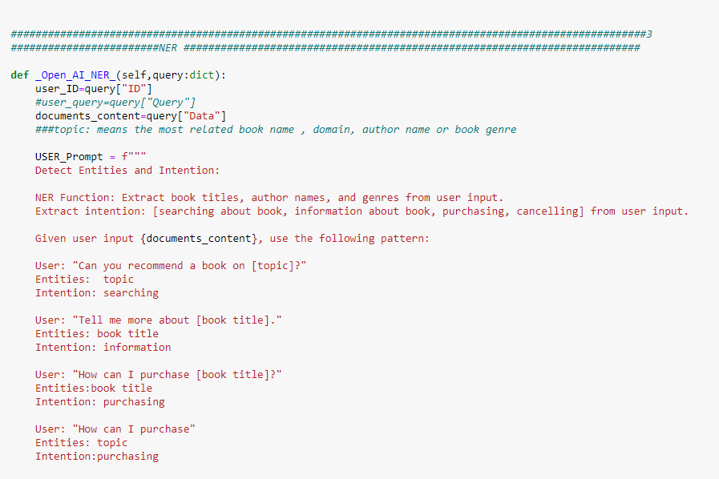

**Section 4: User Interaction Workflow** This section provides a detailed overview of the user interaction process with the chatbot, highlighting the seamless flow of communication and data management.

*User Interaction Flow:*

1. User initiates conversation with the chatbot via the API.
2. Chatbot applies NER and intention detection to interpret user query.
3. Depending on the intention, the chatbot retrieves relevant information from Chromadb or provides general information from the "general" collection.
4. User activity is logged in the SQLite database for future reference and recommendation.

*Handling Different Queries:*

* Recommendation Requests: The chatbot recommends books based on user interests and preferences derived from past interactions.
* Information Requests: Detailed information about books, authors, or genres is provided using summarization techniques.
* General Inquiries: Users can inquire about return policies, purchasing methods, and other general information stored in the "general" collection.

**Section 5: Recommendation Engine**

*Recommendation Process:*

1. The chatbot analyzes user search history to identify preferred genres.
2. Relevant books are retrieved from the Chromadb based on genre preferences.
3. Summarization techniques are applied to generate concise descriptions of recommended books.
4. Personalized recommendations are presented to the user, fostering engagement and facilitating book discovery.

*Enhancing User Experience:* By leveraging user activity data and advanced recommendation algorithms, the chatbot delivers tailored recommendations that align with the user's interests and preferences. This enhances user satisfaction and promotes continued engagement with the platform.

**Section 6: Conclusion**

*Summary:* The Book Store Chatbot Prototype represents a significant advancement in user interaction and recommendation systems within the online bookstore domain. By harnessing the power of advanced technologies such as Chromadb, OpenAI, and SQLite, our chatbot offers a seamless and personalized experience for users, enabling them to discover new books and access relevant information with ease.

*Future Directions:* As we continue to iterate and refine the chatbot, there are numerous opportunities for enhancement and expansion. This includes refining recommendation algorithms, integrating additional datasets, and exploring new ways to personalize the user experience further. We remain committed to delivering cutting-edge solutions that redefine the online bookstore experience and look forward to your feedback and collaboration in this journey.

**Section 7: Development Process**

*GUI Development with Streamlit:*

Streamlit is utilized to develop a user-friendly graphical interface that enables seamless communication with the chatbot. Through Streamlit's intuitive design and interactive elements, users can initiate conversations, input queries, and receive responses in real-time, enhancing the overall user experience.

*Chatbot Agent Integration with Rasa:* Rasa, an open-source conversational AI platform, is integrated into the chatbot architecture to facilitate natural language understanding and dialogue management. By leveraging Rasa's machine learning capabilities and pre-built components, the chatbot agent can interpret user intents, extract entities, and generate contextually relevant responses, thereby enabling more engaging and interactive conversations.

*Development Workflow:*

1. **Streamlit GUI Development:**
   * Designing the user interface layout and components using Streamlit's simple and declarative syntax.
   * Integrating backend APIs to enable seamless communication between the GUI and the chatbot engine.
   * Implementing user input forms, buttons, and interactive widgets to facilitate user interaction and query submission.
2. **Rasa Chatbot Agent Integration:**
   * Training the Rasa chatbot agent using conversational data and domain-specific knowledge to develop an understanding of user intents and entities.
   * Fine-tuning the chatbot's natural language understanding (NLU) and dialogue management models to improve accuracy and responsiveness.
   * Integrating the trained Rasa model into the chatbot architecture to enable real-time interaction and conversation handling.
   * Engaging Rasa with the book-store API and takes advantage of LLM technology on RASA Framework.

*Testing and Iteration:* Throughout the development process, rigorous testing and iteration are conducted to ensure the functionality, performance, and usability of the chatbot prototype. User feedback and testing results are collected and incorporated into the development cycle to refine the user experience and address any issues or limitations encountered.

*Future Development Directions:* As the chatbot prototype evolves, future development efforts may focus on enhancing the GUI interface, expanding the chatbot's capabilities and domain knowledge, and integrating additional features and functionalities to further enrich the user experience. Collaboration with stakeholders and end-users will continue to drive innovation and improvement in the chatbot's design and functionality.

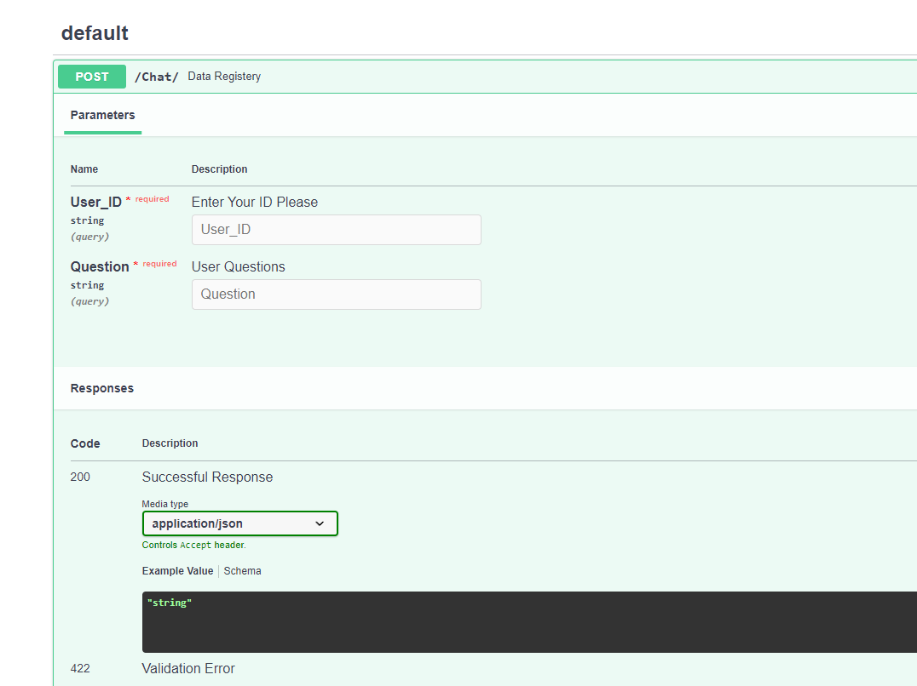

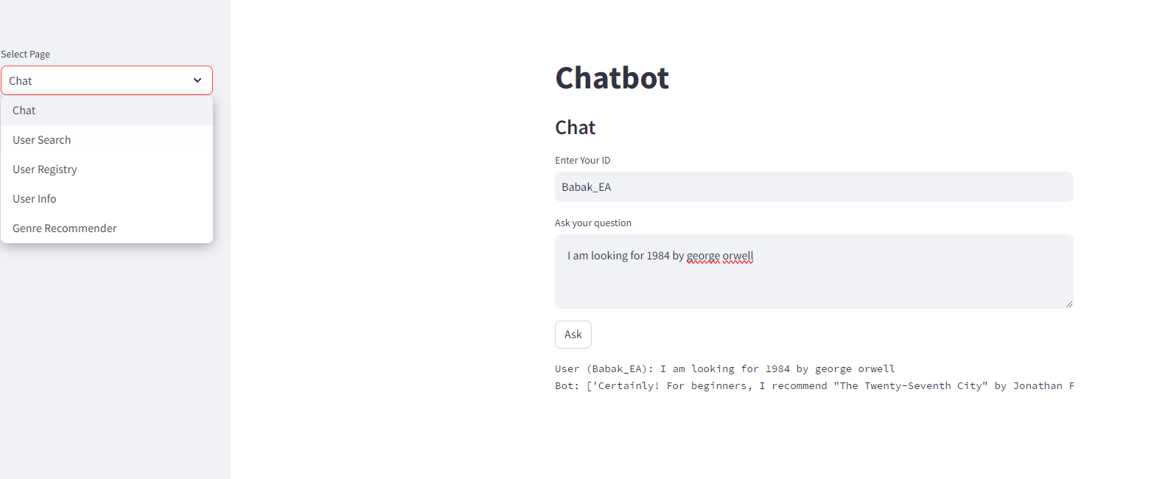

**End of Document**

This document provides a comprehensive overview of the Book Store Chatbot Prototype, covering its core functionalities, data management processes, and user interaction workflows. It serves as a valuable resource for communicating the project's scope, capabilities, and potential to stakeholders and clients.