
Games Engine Programming
Nathan Bowman
@00744684

Table of Contents
Project Plan 2
Introduction 2
Scope 2
Project Aims 2
Designs 3
UML Diagrams 3
Flowchart 5
Pseudocode 6
Design Challenges 9
Conclusion 14
What Went Well? 14
What Could Have Been Better? 14
Learnings From This Project 14
Bibliography 15

Project Plan

Introduction
I intend to produce a Unity 2D project which the main focus being the implementation of a Tetris inventory system also known as a grid inventory where items of different size and shapes are stored in a grid rather than more traditional styles such as the numerical weight limit(Wiktionary, 2023).

Scope
The inventory system will include:
- A main player inventory storage – The core storage for player items where players will be able to store, organise and utilise items.
- A special item slot - Exclusive slot that allows player to store special items, which adds an extra layer of inventory management for the player
- A hotbar - Exclusive slots that allows player to store item which can be keybinded and equipped without needing to open the main player inventory
- A nearby inventory - A dynamic inventory that display item in close proximity to the player
- Chest inventory – a generated inventory space allowing for the creation of items that a player can take into their own storage
To support this system, I will create additional supporting systems
- A player controller– a player controller which allows the player to interact with the inventory
- Enemies – entities for the player to interact with that allows the player to utilise items against
There will be 3 types of items for this project
Weapons | Food | Potions
 |  | 
Deal Damage | Heal Player | Player Effects

Project Aims
My aim is to create modular reusable components for a system that I haven’t created before which would improve my programming techniques as well as usage of programming paradigms and design patterns.
This document will contain my design process for the creation of this project and a detailed analysis of the final project.

Designs

UML Diagrams
Originally, I attempted to build my inventory using the observable pattern to update the UI every time it is changed which would allow me to make use of scriptable objects in unity and use less references in my project. Unfortunately, I found it too complex so I deemed it to be an unviable, unmaintainable solution for me although I felt gained sufficennt knowledge to develop the system using the singleton pattern.

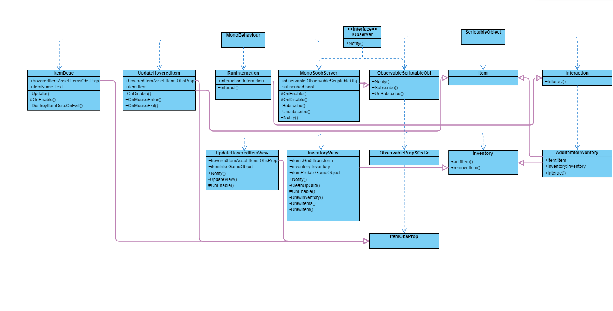
a UML diagram showing an older incomplete attempt at the creation of an inventory system using the observable pattern within unity
Instead of using the event driven observable pattern I opted for a more centralized control system that implemented the singleton pattern for an inventory manager.
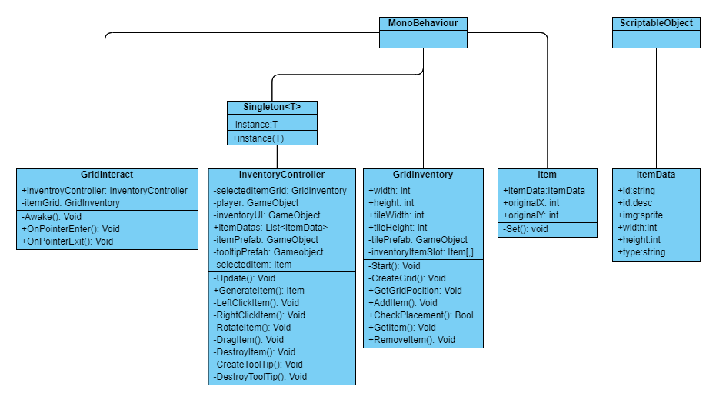
This is the UML diagram I created and used to design my pseudocode which I then used to develop my scripts. In this UML diagram items and inventories are given their own classes and then there is an inventory controller which links the items, inventories and player interactions together.
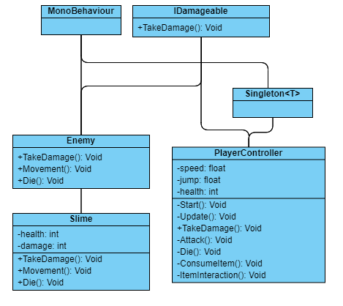
This UML diagram is designed for the supporting system and deals with the enemy and player entities, I also decided to create an interface for taking damage.

Flowchart
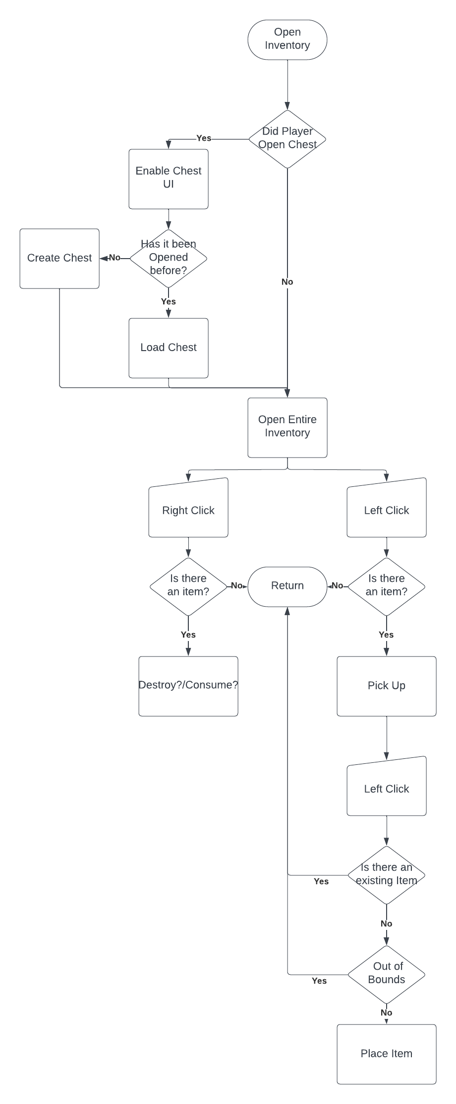
This flowchart illustrates how a player should interact with an inventory.

Pseudocode

Inventory Controller
UPDATE()
IF INPUT (e) THEN
IF inventoryUI == ACTIVE THEN
inventoryUI = !ACTIVE
ELSE
inventoryUI = ACTIVE
ENDIF
ENDIF

IF inventoryUI.ACTIVE THEN
RETURN
ENDIF

DRAGITEM()

IF INPUT(r) THEN
ROTATEITEM()
ELSE IF INPUT(LeftClick) THEN
LEFTCLICKITEM()
ELSE IF INPUTE(RightClick) THEN
RIGHTCLICKITEM()
ELSE
CREATETOOLTIP()
ENDIF

ENDUPDATE
CREATEITEM()

CREATE(Item item(itemData))
RETURN item

END CREATEITEM
LEFTCLICKITEM()

VECTOR2 pos = GridInventory.GetTilePositon()
IF pos == null THEN RETURN ENDIF

IF selectedItem == null THEN
selectedItem = GridInventory.GetItem(pos)
GridInventory.RemoveItem(pos)
ELSE
IF GridInventory.CheckPlacement(selectedItem, pos) THEN
GridInventory.AddItem(selectedItem, pos)
ENDIF
ENDIF

ENDLEFTCLICKITEM
RIGHTCLLCKITEM(pos)
selectedItem = GridInventory.GetItem(pos)
GridInventory.RemoveItem(pos)
DESTROYITEM(selectedItem)
ENDRIGHTCLLCKITEM
DESTROYITEM()
DESTROY(selectedItem)
selectedItem = null
ENDDESTROYITEM
ROTATEITEM()
INT temp = selectedItem.width
selectedItem.width = selectedItem.height
selectedItem.height = temp
ENDROTATEITEM
ICONDRAG()
selectedItem.position = mouse.position
ENDICONDRAG
CREATETOOLTIP()
INSTANTIATE(ToolTipPrefab)
ToolTipPrefab.data = selectedItem.data
ENDCREATETOOLTIP
DESTROYTOOLTIP()
DESTROY(ToolTipPrefab)
ENDDESTROYTOOLTIP

GridInteract
ONPOITNERENTER()
GridInventroy = this
ENDONPOITNERENTER
ONPOITNEREXIT()
GridInventroy = null
ENDONPOITNEREXIT

GridInventory
CREATEGRID(int W, int H)
FOR X=0, X < W, X++
FOR Y=0, Y < H, Y++
CREATE(tilePrefab)
ENDFOR
ENDFOR
ENDCREATGRID
GETITLEPOSITON(mousePosOnGrid)
Vector2 tileGirdPos = new vector2(mousePosOnGrid.x/tile.width, mousePosOnGrid.y/tile.height)
END GETITLEPOSITON
ADDITEM(item, x, y)
FOR w=0, w < item.width, w++
FOR h=0, h < item.height, h++
inventoryItemSlot[x + w, y + h] = item
ENDFOR
ENDFOR
item.originalX= x
item.originalY= y
ENDADDITEM
PLACEMENTCHECK(item, x, y)
BOOLEAN acceptable = true
FOR w=0, w < item.width, w++
FOR h=0, h < item.height, h++
IF inventoryItemSlot[x + w,y + h] != null OR OUTofBounds THEN
acceptable = FALSE
ENDIF
ENDFOR
ENDFOR
RETURN acceptable
ENDPLACEMENTCHECK
GETITEM (x, y)
Item item = inventoryItemSlot[x, y];
RETURN item;
ENDGETITEM
REMOVEITEM(item, x, y)
Item item = inventoryItemSlot[x,y]
x = item.originalX
y = item.originalY

FOR w=0, w < item.width, w++
FOR h=0, h < item.height, h++
inventoryItemSlot[x + w, y + h] = null
ENDFOR
ENDFOR
ENDREMOVEITEM

Itemdata
STRING id = ""
STRING desc = ""
SPRITE img
INT width = 1
INT height = 1;
STRING type = ""

Item
Itemdata itemdata
INT originalX
INT originalY
SET()
this.itemdata = itemdata
size = vector2(itemdata.width * tile.width, itemdata.height * tile.height)
transform.size = size
ENDSET

Design Challenges

The biggest challenge was that developing this project was both time-consuming and complex for that reason there are various inefficiencies that made it to the final project. In this section I will discuss the main challenges I faced, the creation of an inventory displayed to the player and the item management for these inventories.
Inventories
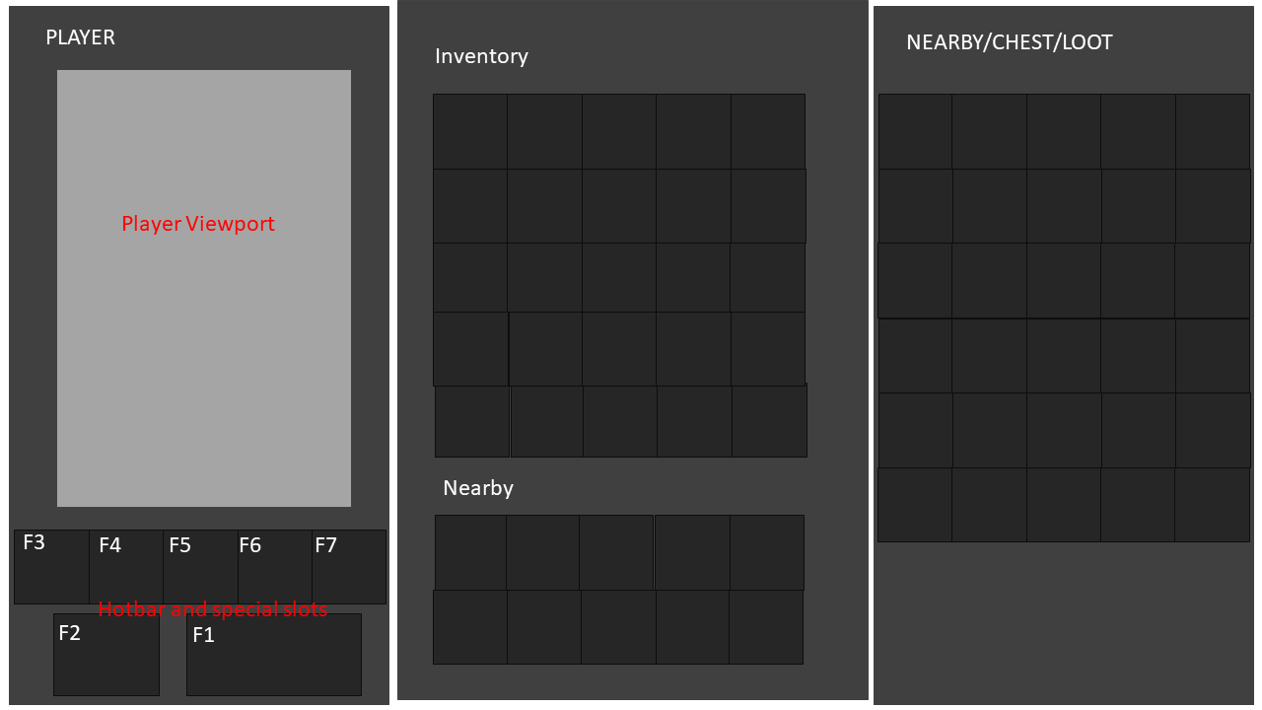
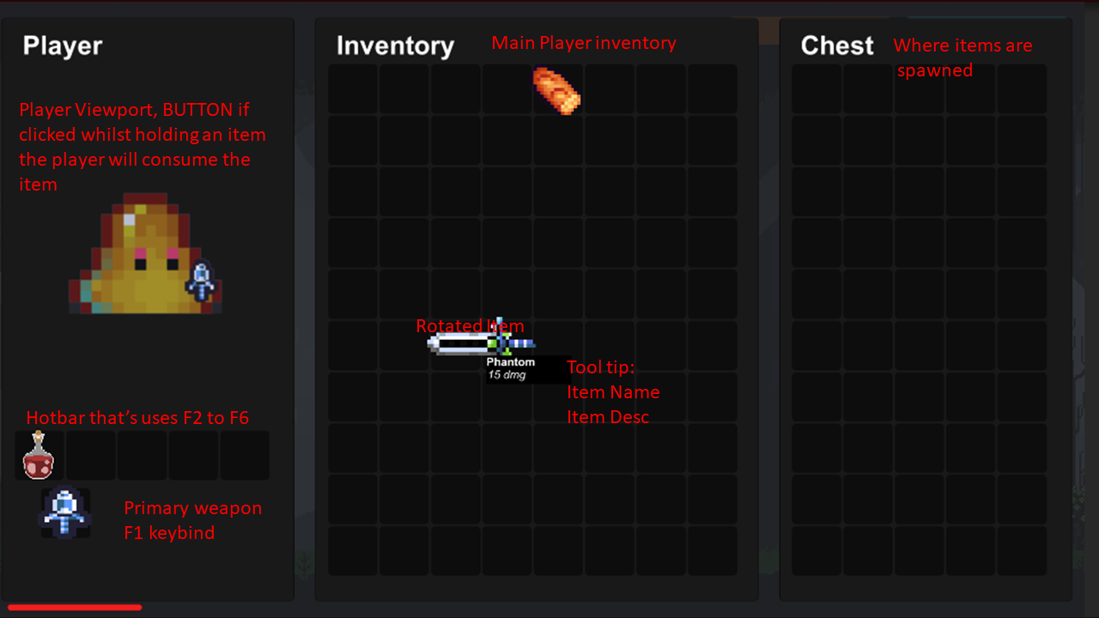
Initial concept art for the inventory
Final project inventory
Visually displaying the inventory to a user was a difficult concept to grasp as I needed to make interactable tiles that are also a visual guide, I decided to use the gridlayoutgroup component to so that I would not have to worry about anything visual in the scripts.
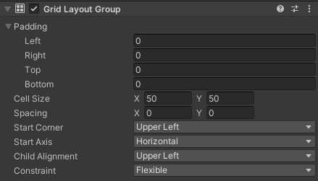
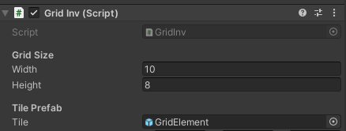
An example of how the system works:
- Cell Size 50x50
- W:2 H:2
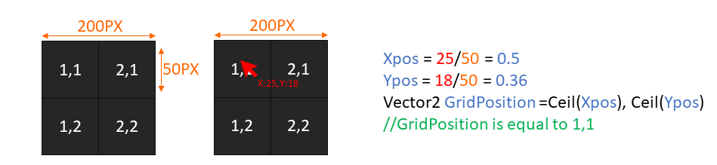
Note the tiles are all children of the inventory GameObject so the size is set to Vector2(WxCellSize,HxCellSize) for the calculations and so tiles are spawned correctly

Item Management
The next step was to implement items, for this I created a 2D array sized to the width and height of the array that stored items from an ITEM class, I also created scriptable objects with data that could be applied to the item class. An item prefab was created to be displayed on the inventory.
This item needed to be placeable, picked up and consumed. These functions were relatively easy to develop in the inventory by simply changing the values of the array to set/remove items from them. There were however other features to consider.
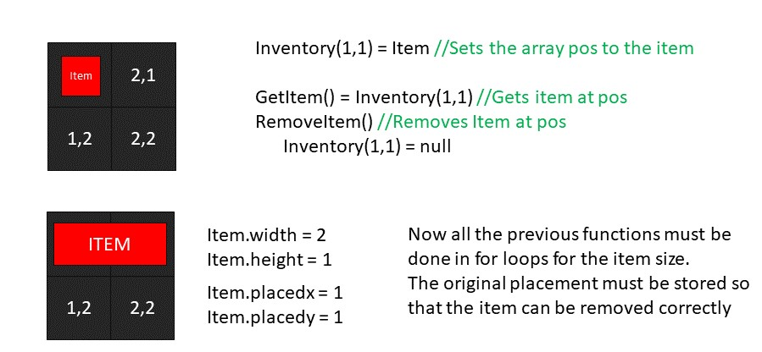
Different Sized Items:
Rotation:
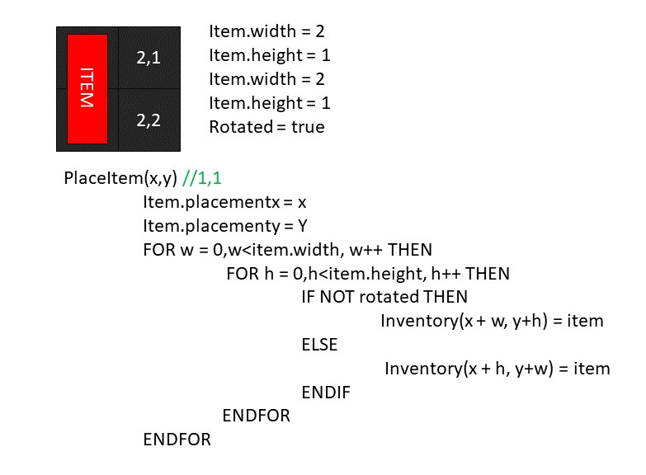
Originally I planned to swap the width and height of the item when it was rotated however this didn’t work as the width and height were based on the item data and would change it for all of the items in the scene, instead I created a rotated Boolean and swapped the width and height values within every function.

Placement Checks:
One issue was no items checks were performed meaning: 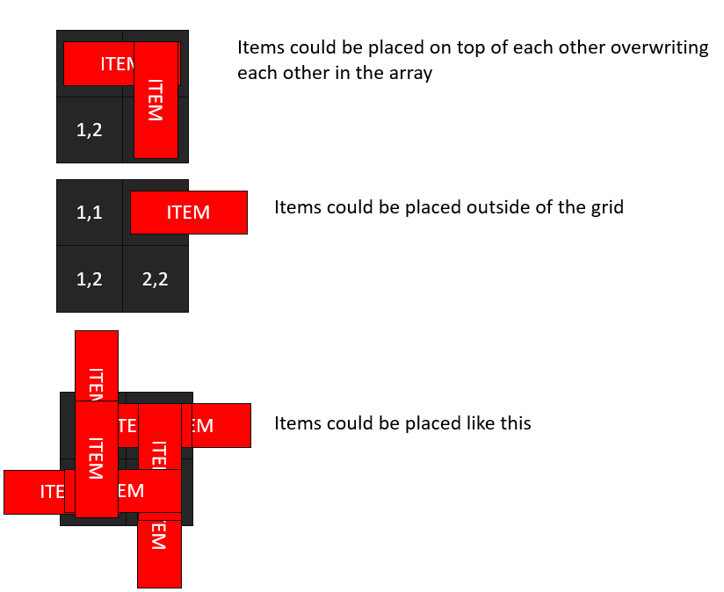
I created a function that is similar to placeitem but checks that the position is null and not bigger than the array size(out of bounds). This function returns a bool whether the item can be placed or not, if it can’t the item flashes red so the user knows the position is an invalid placement.
Generating Chest Inventories:
Creating inventories was another design challenge that I found difficult but luckily the algorithm ended up being a lot simpler than I expected.
Chest Algorithm
FOR n = 0, n<NumberOfItemsToSpawn++
Item = invcontroller.generateItem()
For x = 0, x<inventory.width, x++
For y = 0, y<inventory.height, y++
IF placementCheck == true Then
PlaceItem(x,y)
X = inventory.width
Y = inventory.height
ELSE
IF x == inventory.width AND y == inventory.height THEN
Fails++
ENDIF
IF Fails > 40 THEN
n = NumberOfItemsToSpawn
ENDIF
ENDIF
ENDFOR
ENDFOR
ENDFOR
Essentially, the algorithm attempts to place a certain amount of items, it procedurally places item by checking every tile to see if it can be placed there, it repeats this until the number of items are placed or if the fails exceed 30 which suggests the chest is full. It is very simple and will attempt to place items on tiles which items have already been placed however this logic was easy for me to implement and met my needs, so I am satisfied with the way this logic works.
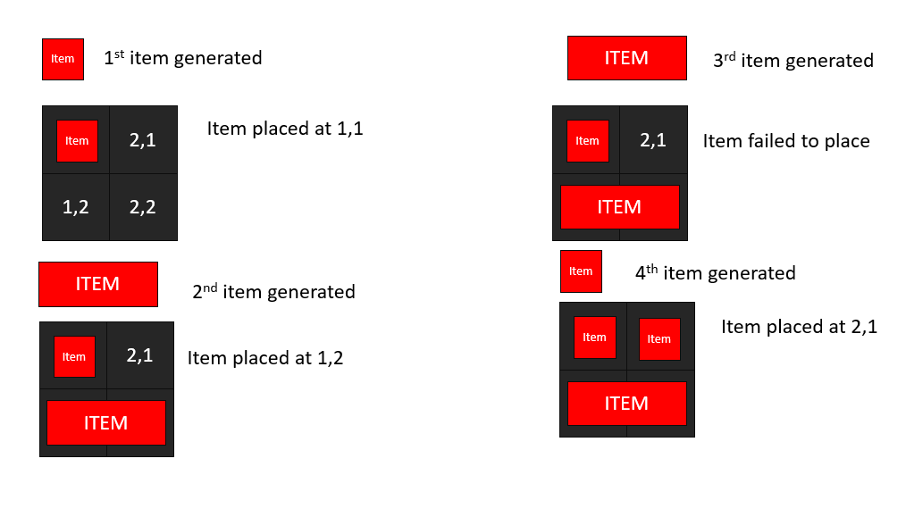
Tool Tips:
Implementing tool tips was hard as I could not use pointer enter and exit as the mouse raycast need to pass through all objects to hit the grid behind, the solution I used was calling the getItem function and when the player doesn’t leftclick, a tool tip is created at mouse position filled with item details. The tool tip variables only changed when the getItem function returns a different Item.

Conclusion
My aim was to create a tetris-inventory with various elements and supporting systems. This project has allowed me to expand my knowledge base and create game components I could use in future projects. In terms of project scope and module aims the final project outcome, I believe I have met these fairly well although there is much to be improved.

What Went Well?
I followed the design documentation I created and met almost all of the scope excluding the nearby inventory. I created the system I set out to design even with the time constraints, challenges and unexpected complexities that are based off my design documentation and make use of the singleton pattern and object oriented programming paradigm.
The project I have created is modular and relatively easy to understand with comments, with supporting documentation or even this document it would be easy to understand what each function is doing.

What Could Have Been Better?
I could have created pseudocode for the design of the supporting systems which would allow me to create these systems more efficiently. For example, the spawner scripts could have used a parent class or even been designed with a factory pattern if I had created some design documentation beforehand.
There is a lot of validation to ensure that the code does not crash, there are several try functions that exist, and I could have added validation that removes the need to catch erroneous code. Additionally, I would’ve liked to add the nearby inventory to complete my scope.
This project could have created to be more reusable as there are some hardcoded values such as canvas size which need to be updated to ensure the scripts can be reused at a later date or in different scenarios. Additionally, there are also a lot of serialized references which are required for the scripts to function as designed. If I was to redo the project I would create something similar but with the use of the observable pattern. Using my increased knowledge and understanding I could use it to reduce code and references by utilising scriptable objects. I am confident that I could now use the observable pattern in my own way for a simple sleek design of this system that could be reused in any future project.
I also could’ve use generics for interactions with items to reduce the functions that all do the same thing change a value, wait 10 seconds and change it back.

Learnings From This Project
- This project has helped me understand the various advantages and disadvantages of using the observable or singleton pattern including complexity and maintainability, for design of a Tetris-inventory.
- I have learnt to be adaptable during this project switching design patterns after a considerable amount of work already completed, finding solutions to complex or unforeseen design challenges and even removing some of my overall workload.
- One lesson was the importance of design documentation, the code developed with it is much higher quality than the code developed without it. It also taught me that there is a lot of room for code refinement.
- I have learned about and how to create grid inventories and items as well as a variety of implementations on how to add them into a game.
In conclusion, I would describe this project as a functional rigid first iteration of my system that meets what I set out to do but left a lot of room for improvement.

Bibliography
Gallant, M. (2009, February 1). Inventory Tetris. The Quixotic Engineer. http://gangles.ca/2009/02/01/inventory-tetris/
Glushenkov, A. (2023, May 12). Notifying the Masses: The Benefits and Challenges of the Observer Pattern in Software Development. Meduim. https://medium.com/@alexglushenkov/notifying-the-masses-the-benefits-and-challenges-of-the-observer-pattern-in-software-development-5decd1c008e3#:~:text=Benefits%20of%20the%20Observer%20Pattern&text=Loose%20Coupling%3A%20The%20observer%20pattern,observers%20without%20affecting%20the%20subject.
Jamelaumn(2023, June 2)). grid(tetris) inventory system.[Forum Post]. Stackexchange. https://gamedev.stackexchange.com/questions/205823/gridtetris-inventory-system
O’Connor, A. (2021, March 3). What’s better: inventory Tetris, or fishing minigames? Rockpapershotgun. https://www.rockpapershotgun.com/whats-better-inventory-tetris-or-fishing-minigames
tvtropes. (n.d.). Hyperspace Arsenal. Retrieved 29 November 2023, from https://tvtropes.org/pmwiki/pmwiki.php/Main/HyperspaceArsenal
Wiktionary. (2023, June 18). inventory Tetris. https://en.wiktionary.org/wiki/inventory_Tetris#:~:text=(video%20games)%20A%20system%20of,the%20space%20that%20they%20consume

