AI/ML Roadmap — Smart Noise Cancellation for Defence Communication
AI/ML workstream
The problem: A soldier speaks into a microphone while a rifle fires beside him and an engine roars underneath. The radio carries all of it, and the person listening cannot make out the words. Ordinary noise filters assume the background stays steady, so a gunshot defeats them completely. Our job is to train an AI model that can tell voice from noise moment by moment and keep only the voice — small enough to run on a chip inside a headset, and fast enough that nobody hears a delay.
1. Two jobs that sound the same but are not
The problem statement uses the phrase "noise cancellation" for two completely different technologies. Separating them is the first thing we should do, because only one of them is AI work.
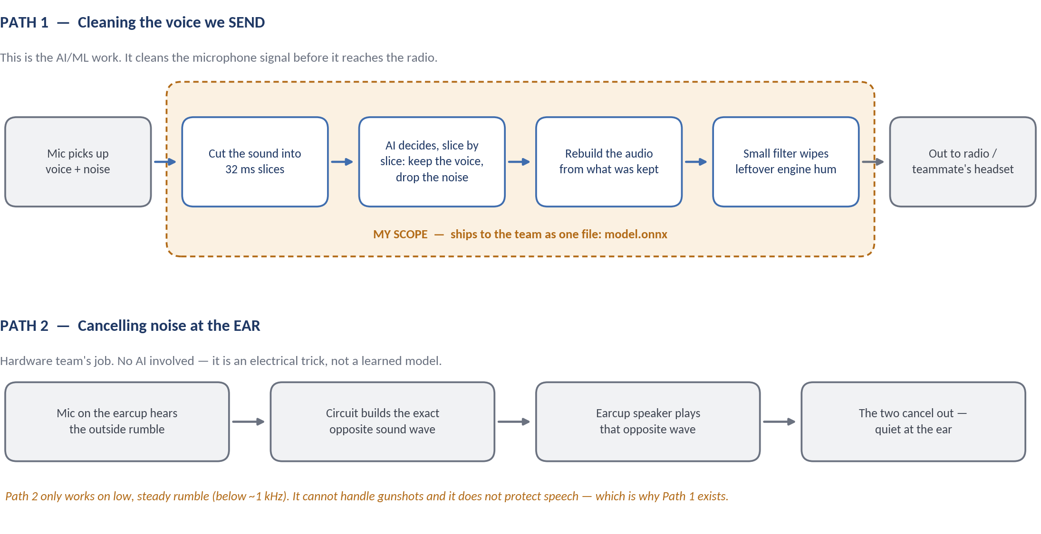
- My part: Path 1 — the AI model that cleans the outgoing voice. It handles the hard, sudden noises (gunshots, artillery) that no simple circuit can catch. Before the audio is even sliced into frames, a fast analog limiter sits between the mic preamp and the ADC — it clips a loud spike in microseconds purely by amplitude, with no notion of speech vs. noise, so the AI always receives an unclipped digital signal to work with instead of a saturated one.
- Hardware team's part: Path 2 — the circuit inside the earcup that cancels low rumble, plus everything after my model (converting to an electrical signal, driving the speaker), plus the analog limiter feeding my model's input.
- What we agree on Day 1: audio comes in at 16,000 samples per second in chunks of 16 milliseconds, and goes back out the same way, with under 32 ms of delay. I hand over a dummy pass-through file on Day 1 so the hardware team can start building while I train.
Path 1 signal chain in detail: primary and reference mics feed a shared ADC. Before that ADC, a fast analog limiter clips any spike above a set loudness in microseconds — pure amplitude protection, no notion of speech versus noise. In parallel, the digital samples go to the AI model, which outputs a mask or reconstructed waveform. That cleaned digital audio goes to the DAC and out through the driver.
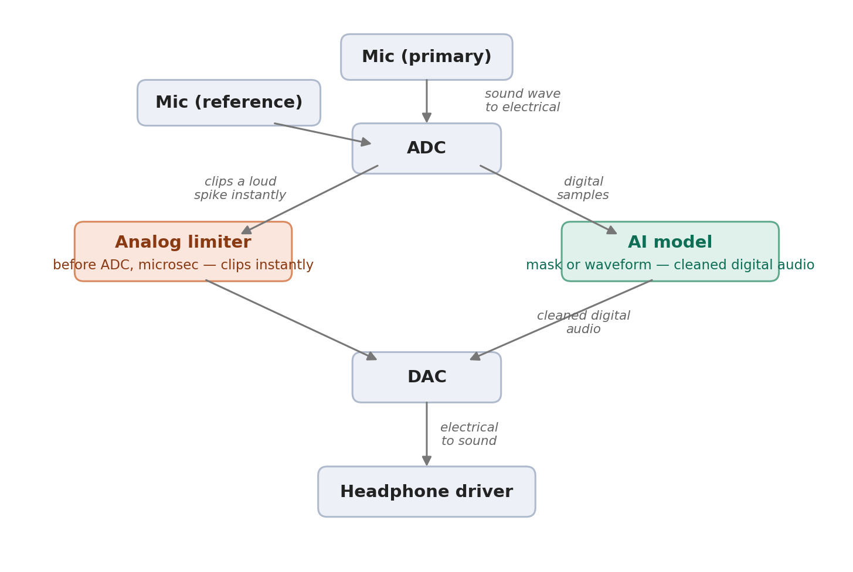
Figure — Path 1's front end. The limiter and the AI model act on the same ADC output in parallel; the limiter never talks to the AI, it only keeps the ADC from saturating.
2. Where the data comes from
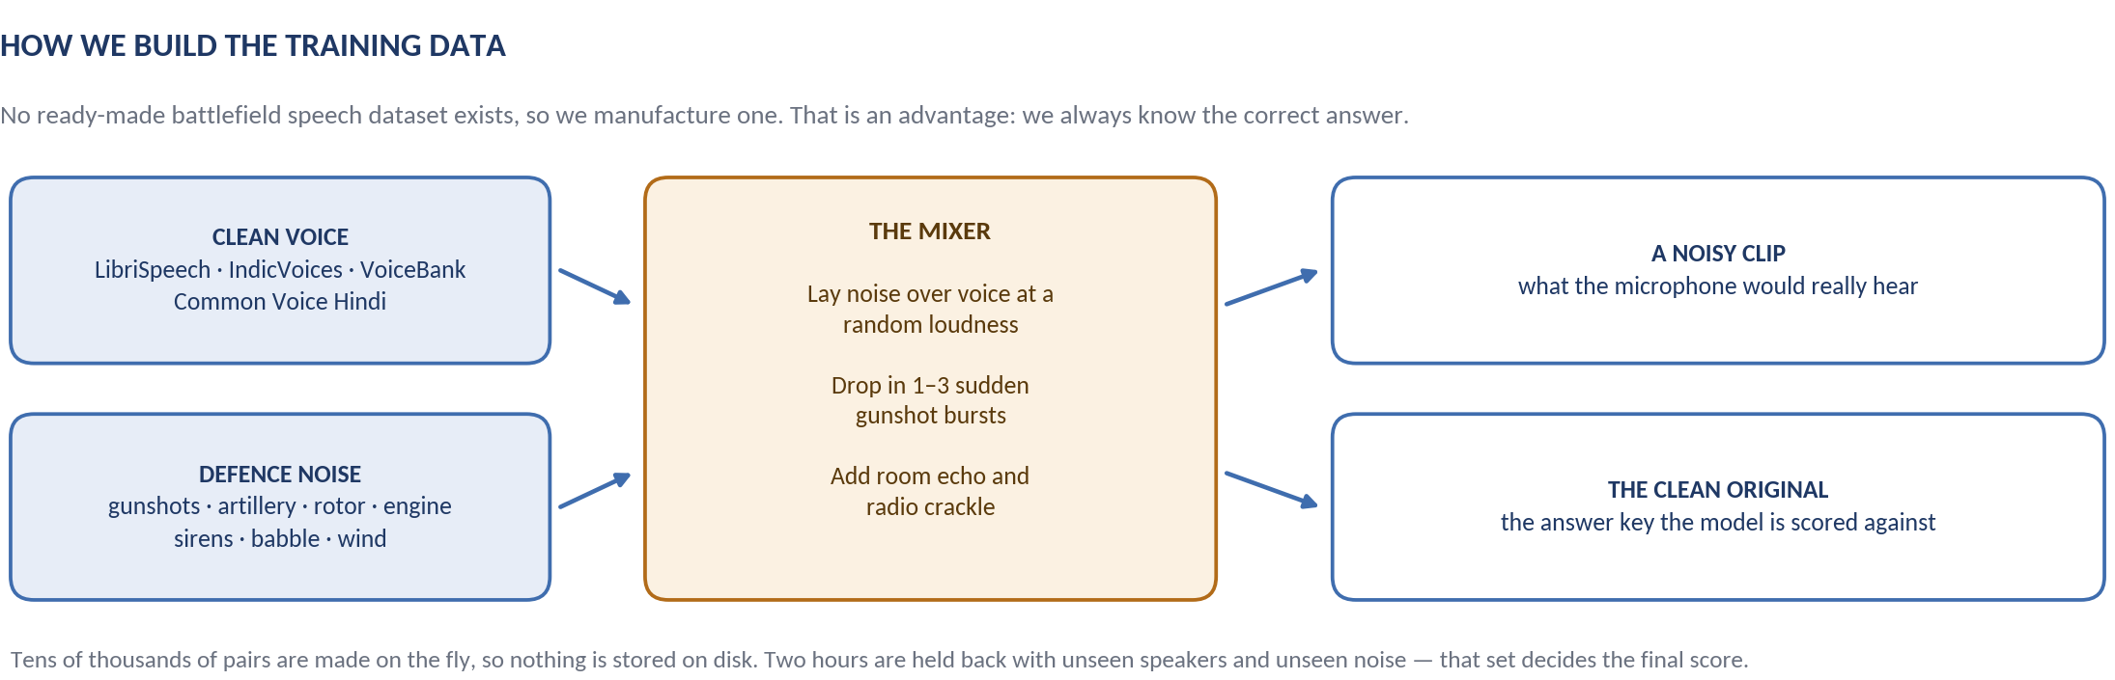
What we need | Where we take it from | Why this one
Clean voice (English) | LibriSpeech — openslr.org/12 | 100 hours, free, already at the sample rate we need.
Clean voice (Indian / Hindi) | AI4Bharat IndicVoices, Common Voice Hindi | Our actual users will not sound American. Judges notice this.
Ready-made test pairs | VoiceBank-DEMAND — datashare.ed.ac.uk/handle/10283/2791 | The standard set everyone publishes on, so our scores can be compared to real papers.
Gunfire, artillery, rotors | VGGSound, ORNL gunshot dataset, FSD50K, ESC-50, UrbanSound8K | The defence-specific sounds. We pull them out by label and keep the clean ones.
Engines, wind, babble | MUSAN — openslr.org/17 | The steady background layer that sits under everything.
Room echo | OpenSLR room impulse responses — openslr.org/28 | Makes clips sound like a vehicle cabin or a bunker instead of a studio.
One detail worth insisting on: gunshots must be dropped in as sudden, separate bursts — not blended evenly through the clip. Even blending teaches the model only the easy cases, and it will then fail on exactly the sound DRDO cares about most.
3. The model — what we use and why
We do not build a network from scratch. A week is not enough for that, and the result would be worse. We start from GTCRN, a published model that is already tiny — about 48,000 numbers, small enough to sit comfortably in an embedded chip — and already runs roughly 14× faster than real time on an ordinary laptop processor. On standard tests it already scores above the targets in the problem statement.
So our real work is retraining it so it holds up when the noise is gunfire instead of a café. Alongside it we run three older methods (Wiener filter, spectral subtraction, RNNoise) — not because we will use them, but because the report has to show exactly how much the AI adds over what already exists. That comparison is the argument for the whole project.
Training cost: about 6–8 hours on one free Colab GPU, saving progress every hour so a disconnect costs us nothing. If GTCRN stalls below target by Day 5, we switch to a bigger published model (DeepFilterNet3) rather than trying to invent something new.
4. How we prove it works
Measure | What it actually means | Target
SNR gain | How much louder the voice is than the noise after cleaning, compared to before. | above 15 dB
STOI | Out of 1 — how much of the words a listener can make out. | above 0.85
PESQ | Out of 4.5 — how natural and undistorted the cleaned voice sounds. | above 2.5
Speed (RTF) | How much faster than real time it runs. Below 1 means it keeps up with live audio. | below 0.5
Delay | The gap between someone speaking and the cleaned audio coming out. | under 32 ms
We report every one of these separately for each type of noise — gunshot, artillery, rotor, engine, siren, babble. An overall average can look perfectly healthy while gunshots quietly fail, and that is the one case we cannot afford to miss.
5. What it runs on
The board is not decided yet, so the plan works on all three. The model is the same in every case — only the export step changes.
Option | Train on | Demo on | Verdict
A — no budget | Free Colab / Kaggle GPU | A normal laptop CPU | Comfortably done in 7 days. This is what we demo on Day 7.
B — cheap board | Free Colab / Kaggle GPU | Raspberry Pi 5 | Realistic — the model is small enough. Needs about 2 extra days.
C — the spec in the PS | Own RTX-class GPU | NVIDIA Jetson Orin | Matches the wording exactly, but only worth it if the board is already with us. Buying one will not fit the timeline.
How we present it: demo on Option A, and show the measured speed numbers as proof that moving to the Jetson is a straightforward port, not a redesign.
6. The seven days
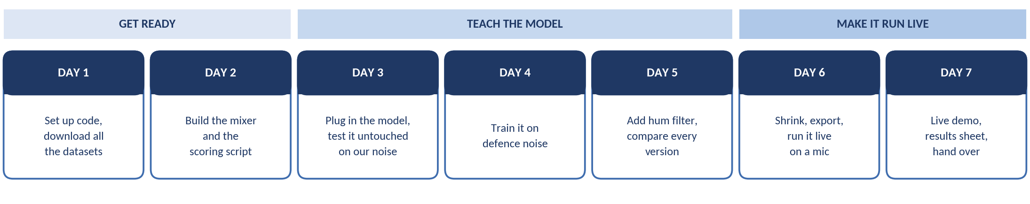
Three checkpoints tell us whether we are on track:
- End of Day 2 — we can automatically score any method on the same test set. Until this exists, no later number means anything.
- End of Day 5 — we know whether we hit the targets and by how much, with a table comparing every version we tried.
- End of Day 7 — it runs live from a microphone, and the hardware team has everything they need.
7. What could go wrong, and what we do about it
- Gunshots still get through. Make the bursts louder and more frequent in the training mix, and weight the training so sudden sounds count more. Do not just train for longer — that will not fix it.
- Scores stall below target. Switch to the larger DeepFilterNet3 model. Decide this on Day 5, not Day 7.
- Output is clean but the voice sounds robotic. This means we are cutting too aggressively. Ease off the suppression and lean more on the loss term that protects the voice.
- Colab disconnects, or downloads run long. Save progress every hour. Start all downloads on Day 1 morning — VoiceBank-DEMAND alone is enough to keep Days 2 and 3 moving if the big sets are still transferring.
8. What the hardware team gets on Day 7
The model as a single file (model.onnx) · a short spec sheet listing sample rate, chunk size, delay and speed · example code showing how to call it · a results sheet with all the scores · a 60-second before-and-after recording for the demo.
A note on sequencing: Days 1 and 2 produce nothing you can show anyone, and that is exactly why they get skipped and exactly why projects like this fail. A correct mixer and an honest scoring script make the rest of the week mechanical.

