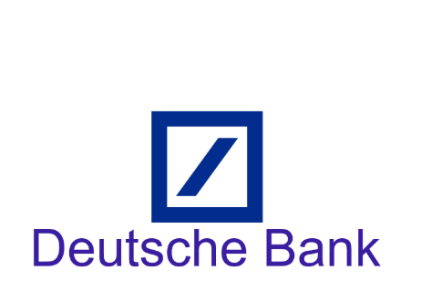

Round 1 Result:

Name | Status | Role
Tanmay Bhatt | Pass | UI/UX Designer
Kunal Kamra | Pass | SDE
Sheeja Chaturvedi | Pass | SDE
Devesh Shah | Fail | Business Analyst

