SALES / DEMAND FORECASTING SYSTEM

A Project Report Submitted in
the partial fulfillment of the requirements for the award of the degree of

BACHELOR OF TECHNOLOGY
In

DEPARTMENT OF COMPUTER SCIENCE AND ENGINEERING
By
J. Keerthana – 2420030423
Aaryyani – 2420030391
Snigdha – 2420030555
Under the Esteemed Guidance of
B Prathusha
Assistant Professor

Department of Computer Science and Engineering

AY-2026–2027

Semester: Odd




K L (Deemed to be) University
DEPARTMENT OF COMPUTER SCIENCE AND ENGINEERING

Declaration

The Project Report entitled “Sales / Demand Forecasting System” is a record of Bonafide work of J. Keerthana (2420030423), Aaryyani (2420030391), and Snigdha (2420030555), submitted in partial fulfillment for the award of B. Tech in Computer Science and Engineering to the K L University. The results embodied in this report have not been copied from any other departments/University/Institute.

J. Keerthana – 2420030423
Aaryyani – 2420030391
Snigdha – 2420030555

K L (Deemed to be) University
Department of Computer Science and Engineering

CERTIFICATE

This is certify that the mini project based report entitled “Sales / Demand Forecasting System” is a bonafide work done and submitted by J. Keerthana (2420030423), Aaryyani (2420030391), and Snigdha (2420030555), in partial fulfillment of the requirements for the award of the degree of BACHELOR OF TECHNOLOGY in Department of Computer Science and Engineering, K L (Deemed to be University), during the academic year 2026-2027.

_____________________  Signature of the Guide  B.Prathusha  Associate Professor, CSE | _____________________  Course Coordinator  Dr. N. Sunanda  Department of CSE | _____________________  Head of the Department  Dr. P. Venkateswara Rao  Department of CSE

ACKNOWLEDGEMENT
The success in this project would not have been possible but for the timely help and guidance rendered by many people. Our wish to express my sincere thanks to all those who has assisted us in one way or the other for the completion of my project.

Our greatest appreciation to my Course Coordinator and my guide Dr. N. Sunanda Associate Professor, Department of Computer Science and Engineering which cannot be expressed in words for her tremendous support, encouragement and guidance for this project.

We express our gratitude to Dr. P. Venkateswar Rao, Head of the Department of Computer Science and Engineering for providing us with adequate facilities, ways and means by which we are able to complete this project-based Lab.

We thank all the members of teaching and non-teaching staff members, and also who have assisted me directly or indirectly for successful completion of this project. Finally, I sincerely thank my parents, friends and classmates for their kind help and cooperation during my work.

J. Keerthana – 2420030423
Aaryyani – 2420030391
Snigdha – 2420030555

Abstract
Sales and demand forecasting is an important business analytics activity that estimates the quantity of products customers are likely to purchase in a future period. Accurate forecasts help organisations plan inventory, reduce stockouts and overstocking, schedule procurement, and make informed business decisions. Demand can vary due to seasonality, promotions, holidays, price changes, and changing customer behaviour.
The proposed Sales / Demand Forecasting System is designed as an interactive application that accepts historical sales data, validates and prepares the records, analyses demand patterns, and generates forecasts for selected products or categories. The system uses time-series features such as lagged sales, rolling averages, calendar information, and promotional indicators. A baseline forecasting method is compared with a machine-learning regression model so that users can review forecast behaviour and evaluation metrics.
The application is planned using Python, Pandas, NumPy, Scikit-learn, Matplotlib, and Streamlit. Users can upload a CSV file, select a product and forecast horizon, view historical trends and predicted demand, inspect model evaluation metrics, and export forecast results. The report describes the requirements, architecture, design, implementation approach, features, testing strategy, deployment steps, limitations, and future enhancements.
The charts and dashboard layout included in this report are illustrative examples created with synthetic demonstration data. They do not represent measured performance from a completed deployment. Actual accuracy values and test outcomes must be recorded after running the implementation on a verified dataset.
Keywords: Sales Forecasting, Demand Prediction, Time Series, Machine Learning, Inventory Planning, Regression, Streamlit, Python.
Index
S. No. | Chapters | Topics | Page.no
 |  | Acknowledgement | 4
 |  | Abstract | 5
1 | Introduction | 1.1 Background of the Project  1.2 Problem Statement  1.3 Scope of the Project  1.4 Objectives  1.5 Importance of the Application  1.6 Target Users/Audience
2 | System Requirements | 2.1 Hardware Requirements  2.2 Software Requirements  2.3 Development Tools and Frameworks
3 | Technology Stack | 3.1 Front-end – Streamlit  3.2 Application Logic – Python  3.3 Machine Learning – Scikit-learn  3.4 Image Processing – Pillow and NumPy  3.5 Data Visualization – Matplotlib  3.6 Model Storage – Joblib
4 | System Architecture | 4.1 High-Level Architecture Diagram  4.2 Description of System Modules  4.3 Application Execution Architecture
5 | Design | 5.1 User Interface Design and Screenshots  5.2 System Workflow / Data Flow Diagram
6 | Implementation | 6.1 Module-wise Implementation  6.2 User Input and Image Upload  6.3 Image Preprocessing  6.4 KNN Model Implementation  6.5 SVM Model Implementation  6.6 Prediction and Performance Analysis
7 | Features | 7.1 List of Main Features  7.2 Working of Each Feature  7.3 Interactive Drawing and Image Upload  7.4 Model Comparison Dashboard
8 | Testing | 8.1 Functional Testing  8.2 Integration Testing  8.3 Tools Used for Testing  8.4 Test Cases and Results  8.5 Model Performance Evaluation
9 | Deployment | 9.1 Steps to Run the Application  9.2 Python Environment Configuration  9.3 Local Application Execution
10 | Challenges & Limitations | 10.1 Issues Faced During Development  10.2 Solutions Applied  10.3 Current Limitations
11 | Future Enhancements | 11.1 Planned Features  11.2 Deep Learning Integration  11.3 Character Recognition and Cloud Deployment
12 | Conclusion | 12.1 Summary of the Project  12.2 Achievements  12.3 Skills Learned During Development
13 | References | Research Papers, Dataset and Technical Documentation
14 | Appendices | Application Screenshots  Sample Code Snippets  Installation and Setup Instructions  User Manual

CHAPTER 1
Introduction
1.1 Background of the Project
Businesses need to estimate future product demand before purchasing, manufacturing, storing, or distributing goods. Historical sales records provide useful evidence, but demand is not constant. It may change with weekdays, weekends, festivals, seasonal periods, discounts, marketing campaigns, product availability, and customer preferences.
Sales forecasting applies statistical and machine-learning techniques to historical observations to estimate future sales. A forecasting application makes this process repeatable and accessible by combining data preparation, model execution, visual analysis, and downloadable results in one place.
1.2 Problem Statement
Many small and medium-sized businesses rely on manual estimates or simple spreadsheets to plan stock. Such methods can be inconsistent, difficult to scale across many products, and unable to capture recurring patterns. Poor estimates may cause stockouts, excess inventory, increased storage costs, and missed sales.
The problem addressed by this project is to design and implement an interactive system that accepts historical sales data, prepares it for analysis, forecasts demand for a selected future period, and presents the results in a form that supports inventory and business planning.
1.3 Scope of the Project
- Upload historical sales records in CSV format.
- Validate required columns, date formats, missing values, and numeric quantities.
- Aggregate sales by day, week, product, or category.
- Explore historical sales trends and seasonality.
- Create lag, rolling-average, and calendar-based features.
- Generate forecasts for a selected product or category and forecast horizon.
- Compare a simple baseline with a machine-learning model.
- Evaluate forecasts using MAE, RMSE, and MAPE where suitable.
- Display charts, summary cards, and downloadable forecast tables.
The initial scope is limited to demand forecasting from historical sales data. It does not guarantee future sales, automatically place purchase orders, or replace business judgement.
1.4 Objectives
- Build a user-friendly sales forecasting application.
- Reduce repetitive manual calculations in demand estimation.
- Prepare sales data through validation, cleaning, and aggregation.
- Implement baseline and machine-learning forecasting approaches.
- Evaluate forecast quality using appropriate error metrics.
- Present forecast outputs through charts and tables.
- Support inventory planning through clear demand estimates.
1.5 Importance of the Application
Forecasts can help a business decide how much stock may be required, which products need attention, and when demand may increase or decrease.
The system also demonstrates the complete analytics workflow: collecting data, preparing features, training models, evaluating predictions, and communicating results.
1.6 Target Users/Audience
The intended users of the application include:
- Retail store owners and inventory managers.
- Sales and operations teams.
- Supply-chain and procurement planners.
- Small businesses maintaining digital sales records.
- Students and faculty learning data analytics and machine learning.
CHAPTER 2
System Requirements
2.1 Hardware Requirements
Component | Minimum / Recommended Configuration
Processor | Intel Core i3 / equivalent or higher
RAM | 4 GB minimum; 8 GB recommended
Storage | At least 1 GB free for code, data, and model files
Input | Keyboard and mouse / touchpad
Display | Laptop or desktop display
GPU | Not required for the baseline implementation

2.2 Software Requirements
Software | Purpose
Windows 10/11, Linux, or macOS | Operating system
Python 3.x | Application logic and modelling
Visual Studio Code / Jupyter | Development and experimentation
Streamlit | Interactive web interface
Pandas and NumPy | Data handling and numerical operations
Scikit-learn | Machine-learning model and evaluation
Matplotlib | Charts and visualizations
Joblib (optional) | Saving trained model objects

2.3 Development Tools and Frameworks
Python provides the main programming environment. Streamlit is used to create a browser-based interface without requiring a separate JavaScript frontend. Pandas handles tabular sales records, while NumPy supports numerical calculations. Scikit-learn provides regression algorithms and evaluation utilities. Matplotlib produces trend and forecast plots.
CHAPTER 3
Technology Stack
3.1 Front-end – Streamlit
Streamlit provides file upload controls, selection widgets, date or horizon inputs, metric cards, charts, tables, and export actions. It allows the application to be run locally and accessed through a browser.
3.2 Application Logic – Python
Python coordinates data loading, validation, preprocessing, feature generation, model training, forecasting, evaluation, and result display.
3.3 Machine Learning – Scikit-learn
Pandas reads CSV files, parses dates, groups sales by time period, handles missing values, and creates tabular features. NumPy supports numerical transformations and array operations.
3.4 Image Processing – Pillow and NumPy
A baseline such as a moving average or last-period value provides a reference. A regression model such as RandomForestRegressor can learn relationships between lagged demand, calendar variables, and sales.
The model must be trained and tested using time-ordered data.
3.5 Data Visualization – Matplotlib
Matplotlib displays historical sales, forecast trends, and actual-versus-predicted comparisons. Visualizations help users interpret changes over time.
3.6 Model Storage – Joblib
Joblib can serialize a trained model and preprocessing objects for reuse. If the application retrains on each uploaded dataset, persistent model storage may not be necessary.
CHAPTER 4
System Architecture
4.1 High-Level Architecture Diagram
The architecture begins with historical sales data supplied by the user. The ingestion layer checks the file and required fields. Valid records move to preprocessing and feature engineering. The forecasting layer generates future demand estimates. The results are evaluated and delivered to the dashboard for interpretation and export
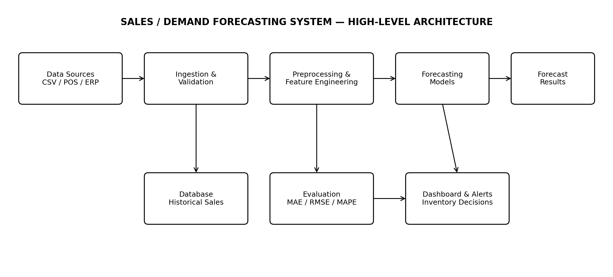
4.2 Description of System Modules

1. Data Input Layer
Accepts sales data from a CSV file. Typical fields include transaction date, product identifier, quantity sold, unit price, category, and promotion indicator.

2. Validation and Preprocessing Layer
Checks column names and data types, parses dates, removes or flags invalid rows, handles missing values, and aggregates transactions into a consistent time interval.

3. Feature Engineering Layer
Creates calendar features such as day of week and month, along with lagged demand and rolling averages. Features are generated without using future information.

4. Forecasting Layer
Fits a baseline and a selected forecasting model using historical training data. It predicts demand for the requested future horizon.

5. Evaluation Layer
Compares predictions with a time-based holdout set and calculates error metrics. It records the evaluation period and model configuration.

6. Presentation Layer
Displays charts, forecast tables, selected product details, metric summaries, and CSV download options.
4.3 Application Execution Architecture
The proposed prototype runs locally. The user starts the Streamlit application from the project directory. Streamlit launches a local web server and provides a browser URL. Python modules execute data processing and forecasting in the same application environment. A separate backend API or cloud database is optional for the first version.
.
CHAPTER 5
Design
5.1 User Interface Design and Screenshots
The interface is organised into a simple sequence: upload data, select a product or category, choose the forecast horizon, run the forecast, and inspect the results. Input validation messages should explain missing columns or invalid values instead of failing silently.
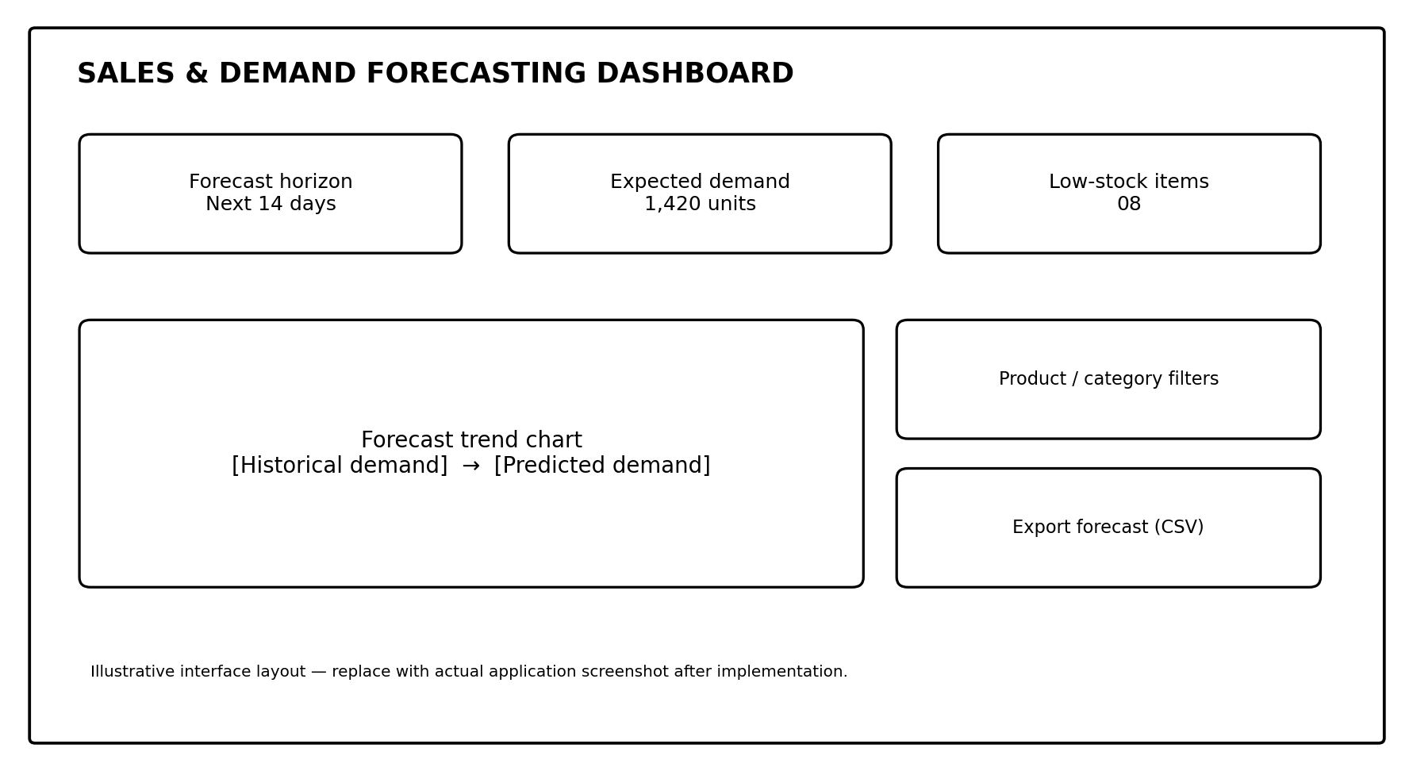
5.2 System Workflow / Data Flow Diagram
The workflow describes how information moves from the uploaded file to the final forecast. Each stage produces an output required by the next stage.
The overall data flow is:
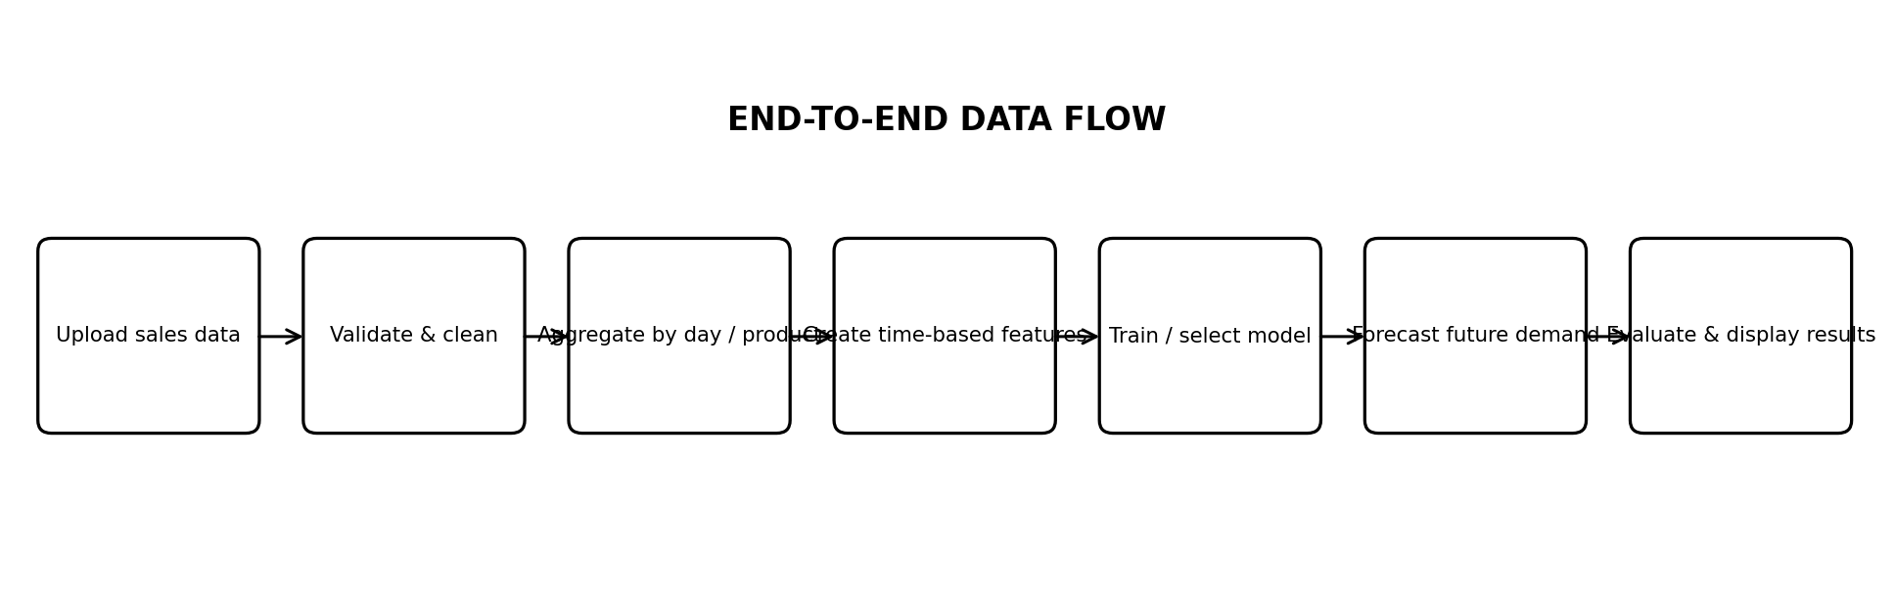

5.3 Data Design

Field | Description | Example
Date | Date of sale or transaction | 2026-01-15
Product_ID | Unique product identifier | P101
Category | Product category | Electronics
Units_Sold | Quantity sold | 12
Unit_Price | Selling price per unit | 499.00
Promotion | Whether a promotion was active | 0 / 1
Store_ID (optional) | Store or branch identifier | S01

The minimum required fields are Date, Product_ID, and Units_Sold. Additional columns can improve analysis if they are consistently populated. The exact schema should be documented and validated before model training.

CHAPTER 6
Implementation
6.1 Module-wise Implementation
Module | Input | Main Operations | Output
Data input | CSV file | Upload and read file | Raw sales table
Validation | Raw sales table | Check schema, dates, numeric fields | Validated records
Preprocessing | Validated records | Clean, aggregate, sort by date | Time series
Feature engineering | Time series | Lag, rolling, calendar features | Model-ready dataset
Forecasting | Model-ready data | Train baseline and regression model | Future demand estimates
Evaluation & display | Actual and predicted values | Calculate errors and plot results | Metrics, charts, export file

6.2 Data Ingestion Validation
The application reads the uploaded CSV file and verifies that the required columns are available. Date values are converted to a date-time format and quantity values are converted to numeric form.
Rows with invalid dates or non-numeric sales quantities are flagged for correction or excluded according to a documented rule. Duplicate transaction rows should be checked using the available transaction identifiers.
6.3 Data Preprocessing
- Convert date strings into a consistent date format.
- Convert units sold and price fields into numeric values.
- Inspect missing values and decide whether to fill, aggregate, or exclude them.
- Sort records chronologically.
- Aggregate transaction-level records by date and product.
- Represent dates with no recorded sales carefully; distinguish true zero sales from missing data.
6.4 Feature Engineering
Time-series forecasting models can use information derived from earlier observations.
Examples include lag_1 (sales in the previous period), lag_7 (sales seven periods earlier), rolling_mean_7 (average sales over the previous seven periods), day_of_week, month, and promotion status.
Lag and rolling features must be shifted so that they contain only information available at the forecast origin.
6.5 Baseline Forecasting
A baseline provides a simple reference against which a more complex model can be compared. Possible baselines include the last observed value, the average of the most recent periods, or the value from the same weekday in the previous week.
The chosen baseline should match the frequency and seasonal pattern of the dataset.
6.6 Machine Learning Forecasting
A supervised regression approach can be trained using lagged sales and calendar features. RandomForestRegressor is one possible model because it can represent nonlinear relationships and interactions.
The training data must be ordered by time; random shuffling is not appropriate for a time-series holdout evaluation. For multi-step forecasts, the implementation must define how predictions are generated recursively or directly for each horizon.

6.7 Forecast Generation

After selecting a product or category and forecast horizon, the application uses the latest available historical observations to create future feature rows. The trained model generates predicted quantities. Negative predictions, if produced by a regression model, should be handled using a documented business rule such as clipping at zero. Forecasts should be presented as estimates, not guaranteed sales.

6.8 Evaluation Metrics

Metric | Meaning | Interpretation
MAE | Mean Absolute Error | Average absolute difference between actual and predicted units; lower is better.
RMSE | Root Mean Squared Error | Penalises larger errors more strongly; lower is better.
MAPE | Mean Absolute Percentage Error | Percentage error; undefined or unstable when actual demand is zero or near zero.

Evaluation should use a chronological split: earlier dates for training and later dates for testing. The report should state the test window, forecast horizon, products evaluated, and metric values. Do not compare models using different test periods.

6.9 Sample Pseudocode

1. Read uploaded sales CSV
2. Validate required columns: Date, Product_ID, Units_Sold
3. Parse dates and convert sales quantity to numeric
4. Group records by date and product
5. Sort each product time series chronologically
6. Create lag and rolling-window features
7. Split each series into training and test periods by time
8. Fit baseline model and regression model
9. Predict the held-out period and calculate MAE / RMSE / MAPE
10. Refit selected model using all available history
11. Generate demand estimates for the requested future horizon
12. Display charts, metrics, and downloadable forecast CSV

CHAPTER 7
Features
7.1 CSV Sales Data upload
Users can upload historical sales records. The application checks file format, required columns, and data types before allowing forecasting.
7.2 Product and Category Selection
Users can focus on one product, a category, or an available store. Filtering helps avoid mixing unrelated demand patterns.
7.3 Forecast Horizon Selection
Users choose how many future days or weeks to estimate. The horizon should not exceed what the data history can reasonably support.

7.4 Historical Trend Analysis

Line charts show historical demand and help users identify growth, decline, recurring weekly patterns, and unusual spikes.

7.5 Demand Forecast Visualization

The forecast is plotted after the historical series, making the boundary between observed and estimated values clear.

7.6 Model Evaluation Dashboard

The dashboard reports MAE, RMSE, and MAPE where valid, along with the test period and selected model.

7.7 Export Forecast Results

Users can download forecast dates, product identifiers, predicted units, and optional lower/upper estimates if the implementation supports them.

7.8 Inventory Planning Support

Forecast quantities can inform replenishment discussions. A later version may combine forecasts with current stock, lead time, and safety stock to calculate reorder suggestions.
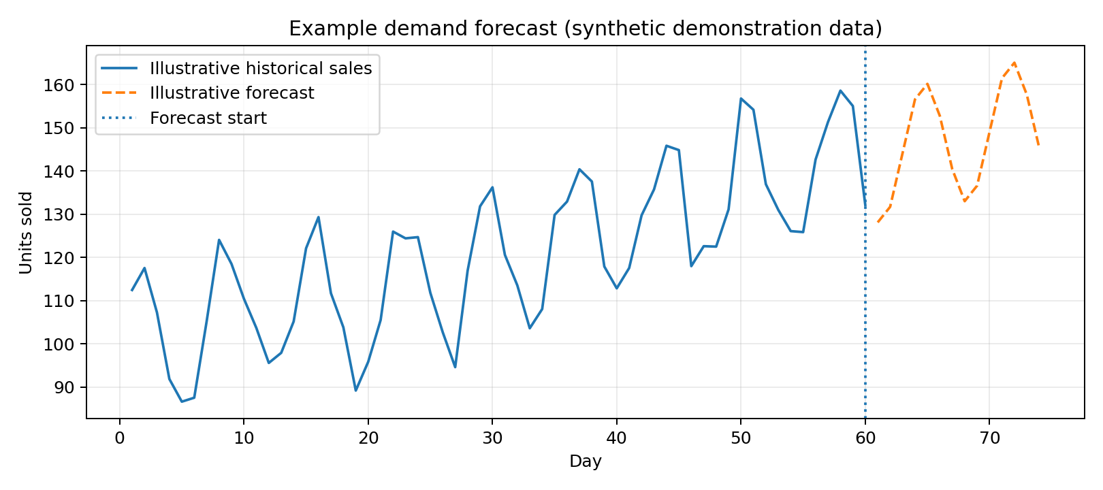

CHAPTER 8
Testing
8.1 Functional Testing
Functional testing verifies that the application accepts valid files, rejects invalid inputs with useful messages, applies filters correctly, generates forecast outputs, and exports results in the expected format.
8.2 Integration Testing
Integration testing checks the complete sequence from CSV upload through validation, preprocessing, feature creation, forecasting, evaluation, visualization, and export. It also checks that changing the selected product or horizon updates the displayed results
8.3 Tools Used for Testing
- Python test scripts or pytest for utility functions.
- Streamlit browser interface for user-flow checks.
- Pandas assertions for schema and aggregation checks.
- Scikit-learn metrics for evaluation calculations.
- VS Code for development and debugging.
8.4 Test Cases and Results
Test ID | Test Scenario | Expected Result | Status
TC-01 | Upload a valid CSV | File is read and preview is displayed | To be tested
TC-02 | Upload a file missing Date | Clear validation message is shown | To be tested
TC-03 | Upload non-numeric Units_Sold | Invalid rows are flagged or handled by rule | To be tested
TC-04 | Select a product | Only the selected product data is analysed | To be tested
TC-05 | Generate a 7-period forecast | Forecast table contains 7 future periods | To be tested

8.5 Model Performance Evaluation
The model evaluation must be completed using a real, documented dataset. The following table is intentionally left for actual results; values should be entered only after executing the system.
Evaluation Item | Baseline | Machine-Learning Model
Dataset name / source | To be recorded | To be recorded
Training period | To be recorded | To be recorded
Testing period | To be recorded | To be recorded
MAE | To be measured | To be measured

CHAPTER 9
Deployment
9.1 Steps to Run the Application
- Install Python 3.x and Visual Studio Code.
- Create a project folder and open it in VS Code.
- Create and activate a virtual environment.
- Install the required libraries.
- Place the application file and sample sales CSV in the project folder.
- Run the Streamlit application from the terminal.
- Open the local URL shown in the terminal.
9.2 Python Environment Configuration
python -m venv venv
# Windows PowerShell
.\venv\Scripts\Activate.ps1
pip install streamlit pandas numpy scikit-learn matplotlib joblib
9.3 Local Application Execution
streamlit run app.py
After the command runs successfully, Streamlit displays a local address (usually http://localhost:8501). Open that address in a web browser. The exact command and package list may change according to the final project files.
CHAPTER 10
Challenges and Limitations
10.1 Issues Faced During Development
- Incomplete or inconsistent sales records can reduce forecast reliability.
- Products may have short sales histories or newly introduced items.
- Promotions, holidays, stockouts, and price changes can create unusual demand patterns.
- Different products may require different forecasting strategies.
- Time-series data must be split chronologically to avoid information leakage.
- MAPE can be misleading when actual sales are zero or very small.
10.2 Solutions Applied
- Validate input files and show row-level data quality messages.
- Aggregate records consistently and document missing-date handling.
- Include calendar and promotion features when reliable data is available.
- Compare machine-learning forecasts against a simple baseline.
- Use time-based validation and keep future information out of training features.
- Report multiple error metrics and explain metric limitations.
10.3 Current Limitations
- Forecast quality depends on the quantity, quality, and representativeness of historical data.
- Unexpected events cannot be predicted reliably from historical sales alone.
- The initial prototype may process uploaded CSV files rather than connect to live POS or ERP systems.
- Forecasts do not automatically account for supplier lead times or inventory constraints unless those fields are added.
- A model that performs well for one product may not perform equally well for another.
CHAPTER 11
Future Enhancements

11.1 Advanced Forecasting Models

Add statistical and machine-learning methods such as exponential smoothing, ARIMA/SARIMA, gradient boosting, and sequence models. Model selection should be based on chronological validation.

11.2 External Demand Signals

Integrate holiday calendars, weather, marketing campaigns, price changes, and local events where the data is available and permitted.

11.3 Inventory Recommendation Module

Combine predicted demand with current inventory, supplier lead time, minimum order quantity, and safety-stock policy to generate reorder recommendations.

11.4 Real-Time Data Integration

Connect to point-of-sale, ERP, or inventory databases through secure APIs instead of relying only on manual CSV uploads.

11.5 Cloud Deployment and Access Control

Deploy the application to a cloud platform, add authentication and role-based access, and maintain audit logs for data and forecast changes.

11.6 Automated Monitoring

Track forecast errors over time, detect data drift, and notify users when model performance degrades.
CHAPTER 12
Conclusion

12.1 Summary of the Project
The Sales / Demand Forecasting System is designed to transform historical sales records into estimates of future product demand. It combines data ingestion, validation, preprocessing, feature engineering, forecasting, evaluation, and visualization in one interactive application.

12.2 Expected Project Outcomes

- A structured workflow for preparing historical sales data.
- A working prototype for generating product-level demand forecasts.
- A comparison between a baseline and a machine-learning forecasting approach.
- A dashboard for viewing trends, forecast values, and evaluation metrics.
- A downloadable forecast output that can support planning discussions.

12.3 Skills Learned During Development

- Python programming and application development.
- Data cleaning, aggregation, and exploratory analysis.
- Time-series concepts and feature engineering.
- Machine-learning model training and evaluation.
- Visualization, testing, debugging, and technical documentation.
- Team collaboration and project presentation.
CHAPTER 13
References
1. Pandas Documentation, “User Guide.” https://pandas.pydata.org/docs/user_guide/
2. NumPy Documentation. https://numpy.org/doc/
3. Scikit-learn Documentation, “Ensemble methods: Random Forests.” https://scikit-learn.org/stable/modules/ensemble.html#forest
4. Scikit-learn Documentation, “Model evaluation: quantifying the quality of predictions.” https://scikit-learn.org/stable/modules/model_evaluation.html
5. Streamlit Documentation. https://docs.streamlit.io/
6. Matplotlib Documentation. https://matplotlib.org/stable/
7. Rob J. Hyndman and George Athanasopoulos, Forecasting: Principles and Practice, 3rd edition. https://otexts.com/fpp3/
8. Joblib Documentation. https://joblib.readthedocs.io/
CHAPTER 14
Appendices
14.1 Suggested CSV Format
Date | Product_ID | Category | Units_Sold | Unit_Price | Promotion
2026-01-01 | P101 | Grocery | 18 | 25.00 | 0
2026-01-02 | P101 | Grocery | 22 | 25.00 | 1
2026-01-03 | P101 | Grocery | 16 | 25.00 | 0
2026-01-01 | P205 | Household | 7 | 120.00 | 0

The rows above are synthetic examples for explaining the expected format. They are not actual sales records.
14.2 Sample Code Snippets
import pandas as pd
from sklearn.ensemble import RandomForestRegressor
from sklearn.metrics import mean_absolute_error, mean_squared_error
df = pd.read_csv("sales.csv")
df["Date"] = pd.to_datetime(df["Date"])
df["Units_Sold"] = pd.to_numeric(df["Units_Sold"], errors="coerce")
df = df.dropna(subset=["Date", "Product_ID", "Units_Sold"])
daily = (df.groupby(["Date", "Product_ID"], as_index=False)
["Units_Sold"].sum())
daily = daily.sort_values(["Product_ID", "Date"])
# Example feature creation for one product series
g = daily[daily["Product_ID"] == "P101"].copy()
g["lag_1"] = g["Units_Sold"].shift(1)
g["lag_7"] = g["Units_Sold"].shift(7)
g["day_of_week"] = g["Date"].dt.dayofweek
g = g.dropna()
features = ["lag_1", "lag_7", "day_of_week"]
split = int(len(g) * 0.8) # chronological split
train, test = g.iloc[:split], g.iloc[split:]
model = RandomForestRegressor(n_estimators=200, random_state=42)
model.fit(train[features], train["Units_Sold"])
pred = model.predict(test[features])
mae = mean_absolute_error(test["Units_Sold"], pred)
rmse = mean_squared_error(test["Units_Sold"], pred) ** 0.5
print("MAE:", mae, "RMSE:", rmse)
Note: This is a teaching snippet for data preparation and holdout evaluation. A complete multi-step forecasting application must build future feature rows correctly, prevent leakage, handle each product series, and compare against a baseline.

14.3 Installation and Setup Instructions

- Install Python 3.x.
- Open the project folder in VS Code.
- Create a virtual environment using python -m venv venv.
- Activate the environment.
- Install packages using pip install streamlit pandas numpy scikit-learn matplotlib joblib.
- Keep the sales CSV in the expected project location or upload it through the interface.
- Run streamlit run app.py.

14.4 User Manual
- Open the application in a browser using the local URL.
- Upload a CSV file containing historical sales data.
- Check the data preview and correct any validation errors.
- Choose the product or category to forecast.
- Select the forecast horizon.
- Run the forecasting process.
- Review historical trends, forecast values, and evaluation metrics.
- Download the forecast table if required.

14.5 Important Submission Note

Before final academic submission, run the implemented application using a genuine dataset, insert actual application screenshots in Chapter 5 and Appendix 14.1, record the actual test outcomes in Chapter 8, and update the references and technology details to match the code that was finally developed.

