FEBRUARY 20, 2024

DevOps Classroom notes 20/Feb/2024

**DevOps CD Pipeline**

* Continuous Delivery  
  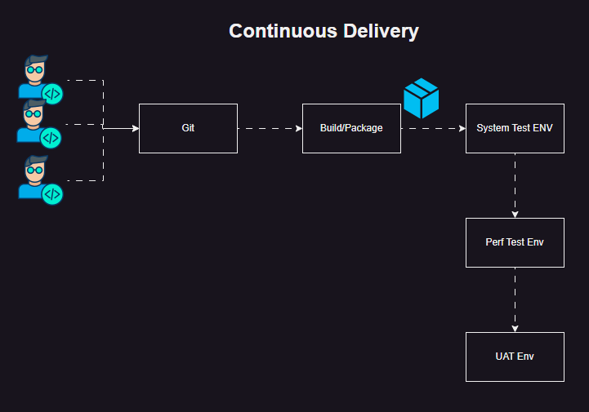
* Options to deploy the package to servers
  + Manual
  + Scripting
  + Configuration Management  
    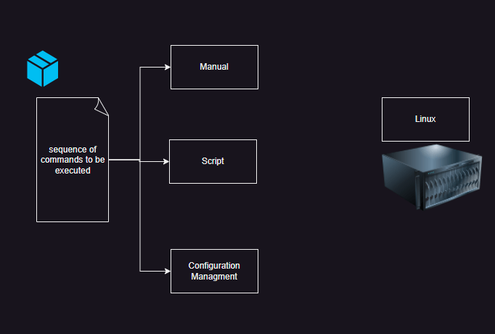
* Scripting:
  + This is as good as the knowledge of person writing it
  + This is procedural in nature
* Scripting vs CM  
  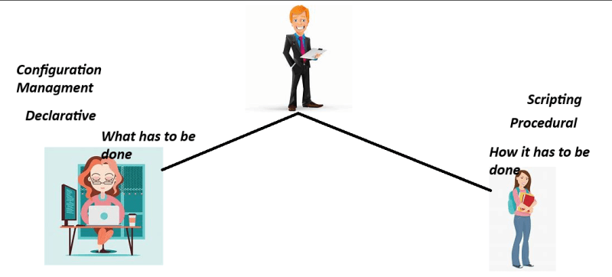

**Configuration Management (CM)**

* This a practice of configuring servers or hardware with a declarative approach.
* CM tools generally are idempotent
* CM architecture and choices
  + pull based CM:
    - Node will communicate with CM Server
    - Agents needs to be installed
    - Examples:
      * Chef
      * Puppet
  + push based CM
    - CM Server will communicate with node
    - node details and credentials will be stored, no agent installation required.
    - Examples:
      * Ansible
* Ansible job roles
  + DevOps
  + Network Infrastructure

**Softwares to be installed in your system**

* List:
  + git
  + visual studio code
  + aws cli
  + azure cli
* Mac

**Step 1: Review the Script:**

* First, open the URL in your web browser or use a command-line tool like curl to download the script content to review. This is important to ensure that the script is safe to execute.

curl https://raw.githubusercontent.com/ClassroomTraining/Setups/main/mac/setup.sh

**Step 2: Download the Script**

* Once you’ve reviewed the script and confirmed it’s safe, you can download it using curl with the -o option to specify the output filename, or you can directly execute it in the terminal (shown in Step 3).

curl https://raw.githubusercontent.com/ClassroomTraining/Setups/main/mac/setup.sh -o setup.sh

**Step 3: Make the Script Executable**

* Change the permissions of the downloaded script to make it executable.

chmod +x setup.sh

**Step 4: Execute the Script**

* Now, you can execute the script. Since it involves installing software, you might need to run it with sudo to provide the necessary permissions, depending on what the script does.

sudo ./setup.sh

**Steps to install on windows**

* Launch your Powershell or Windows Terminal as administrator
* Now copy the following script and run in powershell

cd ~/Downloads

Invoke-WebRequest -Uri "https://raw.githubusercontent.com/ClassroomTraining/Setups/main/Windows11/setup.ps1" -OutFile "setup.ps1"

./setup.ps1

* This script will install chocolatey, git, visual studio code, aws cli and azure cli into your system