ARCH 1, 2024

DevOps Classroom notes 01/Mar/2024

**Ansible contd**

**Activity 4: Install tomcat (contd)**

* Manual Steps:
  + Create tomcat application accounts
  + Allow remote host access to manager and hostmanager
  + Create a Systemd Service File
* [Refer Here](https://github.com/asquarezone/AnsibleZone/commit/0fd806a9c333669979cdc1af0bf2d418f3e88dd9?diff=split&w=0) for the changes done
* [Refer Here](https://github.com/asquarezone/AnsibleZone/commit/2a90768a51a83d03341d9b37e6ba551bd5bcf491) for the changes done to become at play level
* Now execute the playbook  
  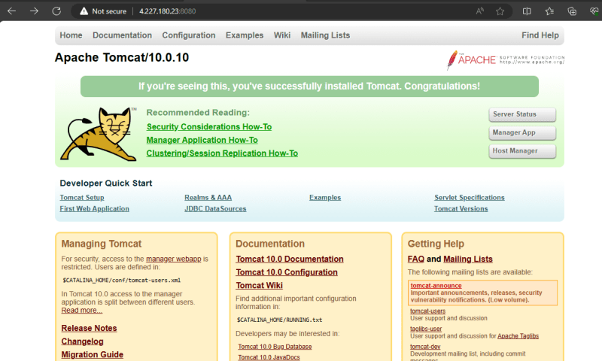
* Problems to be addressed:
  + avoid hardcoding in configuration files such as context.xml service etc.
  + make this playbook work on other distributions

**Templates**

* Templates help in bringing in dynamic content.
* Ansible adopts templating from popular jinja2 templating used in python [Refer Here](https://docs.ansible.com/ansible/latest/playbook_guide/playbooks_templating.html)
* We adopted template but didn’t implement any dynamic templating sofar in the following changeset [Refer Here](https://github.com/asquarezone/AnsibleZone/commit/ffee524a0c9e447bc235e7156418269bf9f1452f)
* [Refer Here](https://docs.ansible.com/ansible/2.9/user_guide/playbooks_templating.html) for jinja2 examples
* [Refer Here](https://github.com/asquarezone/AnsibleZone/commit/9f67bf5ee80e37aa6736ad7cc947ab049935858a) for the changes with templates

**Exercise**

* Use ansible to install nop commerce (skip mysql) [Refer Here](https://docs.nopcommerce.com/en/installation-and-upgrading/installing-nopcommerce/installing-on-linux.html)
* use ansible to install docker and add user to the docker group [Refer Here](https://docs.docker.com/engine/install/ubuntu/#install-using-the-repository)

sudo usermod -aG docker <username>

* Use the ansible to install postgresql