FEBRUARY 21, 2024

DevOps Classroom notes 21/Feb/2024

**Ansible Components At a high level**

* Nodes:
  + Ansible control node:
    - This is the system where we install ansible which is built on python
    - This has to be a linux instance
  + Node:
    - This is the system where we deploy applications
    - This can be linux as well as windows
    - On linux nodes ansible expects python
* Inventory: This is list of servers where we want to deploy applications
* Playbook: This is the deployment expressed in declarative format  
  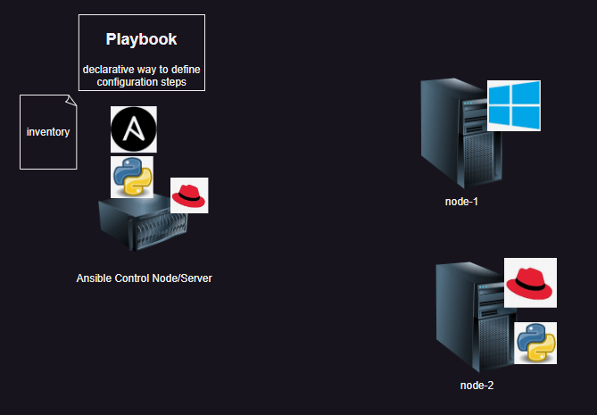

**Ways of working with Ansible**

* List out all the manual steps to install/configure your application
* Execute them manually and once they are working then
* Try converting each step into task.
* Then optimize.

**Setup Ansible**

* Launch two ubuntu 22.04 linux vms
* Ensure python is installed

python3 --version

* Now ssh (login) in to vm where we have to install ansible and [Refer Here](https://docs.ansible.com/ansible/latest/installation_guide/intro_installation.html) for the installation steps and use [Refer Here](https://docs.ansible.com/ansible/latest/installation_guide/installation_distros.html) for os specific installation and [Refer Here](https://docs.ansible.com/ansible/latest/installation_guide/installation_distros.html#installing-ansible-on-ubuntu) for ubuntu steps

sudo apt update

sudo apt install software-properties-common

sudo add-apt-repository --yes --update ppa:ansible/ansible

sudo apt install ansible --yes

* Lets check wheter ansible connect to node
* ansible will login into node and execute instructions and to check whether ansible can do this or not

ansible -i hosts -m ping all

* Lets create inventory with following ip into a file called as hosts

10.0.0.4

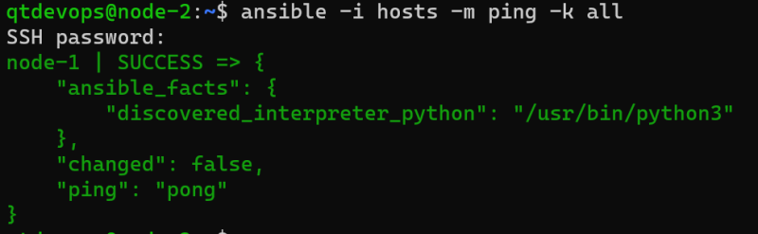

**Exercises**

* Find the differences between windows file system and linux filesystem
* What is package manager.

**Share this:**