FEBRUARY 22, 2024

DevOps Classroom notes 22/Feb/2024

**Ansible Setup – Recommended approach**

* User Setup:
  + Ensure password based authentication is setup temporarily atleast till we finish the next steps
  + edit /etc/ssh/sshd_config and ensure password authenication is set to yes. and restart ssh service
  + Create a common user devops on all nodes (including ansible control node)  
    sudo adduser devops
  + Grant administrative permissions for devops user for no password prompts  
    “`  
    sudo visudo

**add the following entry**

devops ALL=(ALL:ALL) NOPASSWD:ALL  
* create a key pair for `devops` user  
ssh-keygen  
* copy the public key of devops from ansible control node to other nodes  
ssh-copy-id  
“`  
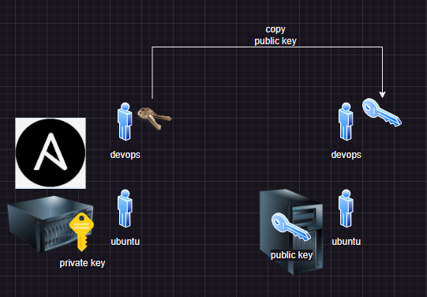

**Share this:**