FEBRUARY 23, 2024

DevOps Classroom notes 23/Feb/2024

**Ansible Contd**

**Writing Playbooks**

* [Refer Here](https://docs.ansible.com/ansible/latest/playbook_guide/playbooks_intro.html) for official docs of Ansible Playbook
* Playbook defines the configuration management expressed in desired state using YAML
* Ansible Playbook organization  
  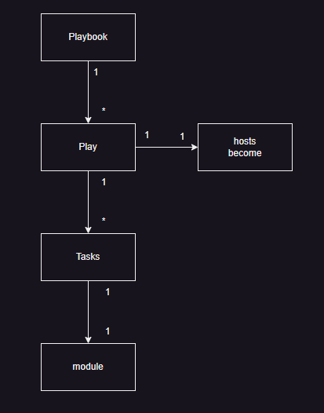
* In Ansible the smallest unit of execution is done by modules

**First Playbook: Install tree**

* Manual steps

sudo apt install tree -y

* Search for module for each step apt => ansible.builtin.apt  
  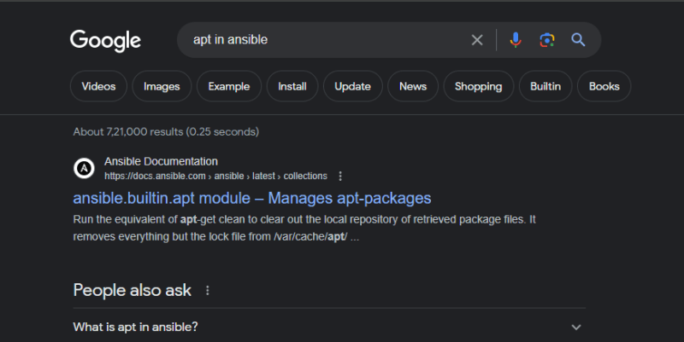
* [Refer Here](https://github.com/asquarezone/AnsibleZone/commit/a2d335d58f3060b2b06cc3ebdab3a5af342b2083) for the playbook and executed plabook  
  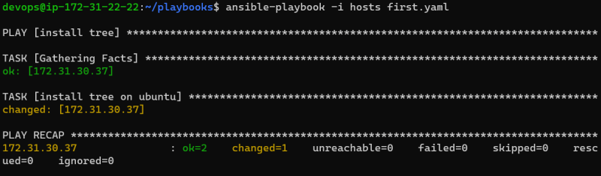

**Exercise**

* List out what are the areas which you need to fill in your resume

name

phone number

email

professional summary

skillset

work experience

education

* We have list out names/keys then we need fill values

name = text

phone number = text

email text

professional summar text

skillset

<skill name>: <skill values>

work experience:

experience list:

company name

duration

role and responsibilities: text array/list

**YAML**

* It is collection of name value or key value pair used to represent data.
* Generally it is stored in files with extension .yml or .yaml

<name>: <value>

* Values can be of different types
  + Simple
    - text: can be represented in single or double quotes tool: ansible
    - number: numbers in non quote format age: 10
    - boolean: true, false, yes, no online: yes
  + Complex
    - list: array  
      colors:  
      – black  
      – white
    - object/dictionary:  
        
      address:  
      flatno: 601  
      building: nilgiri  
      area: Ameerpet  
      city: Hyderabad
* [Refer Here](https://docs.ansible.com/ansible/latest/reference_appendices/YAMLSyntax.html) for YAML documentation from ansible
* Try to come up with a YAML format to describe your home town
* What does --- in yaml signify