FEBRUARY 24, 2024

DevOps Classroom notes 24/Feb/2024

**Ansible contd**

**using modules**

* Ansible has lots of modules [Refer Here](https://docs.ansible.com/ansible/2.9/modules/list_of_all_modules.html)
* Using Module

<module-name>:

<parameter-1-name>: <value>

...

<state>: <desired state>

* Refer paramters section in module documentation and fill the values

**Activity 1: Install Nginx**

* Finding Manual steps: [Refer Here](https://www.digitalocean.com/community/tutorials/how-to-install-nginx-on-ubuntu-22-04)

sudo apt update

sudo apt install nginx

* Testing manual steps
* Find module for every manual step
* Create a Playbook
* [Refer Here](https://github.com/asquarezone/AnsibleZone/commit/a20e62ece859cae458ca24e1a74498a8a84037a0) for the changes done
* Lets perform syntax check  
  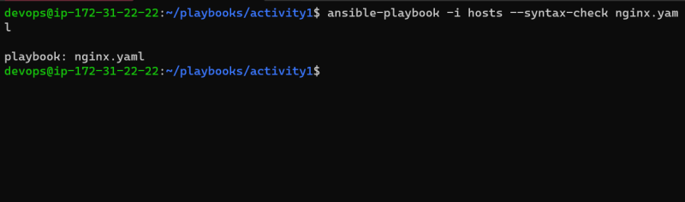
* Lets execute dry run (doesnot work in all cases)  
  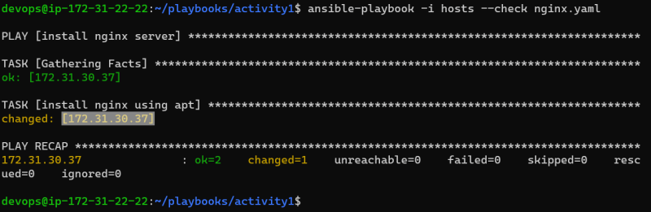
* Now lets execute the playbook  
  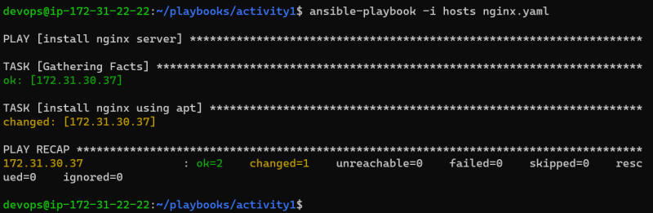
* Navigate to public ip  
  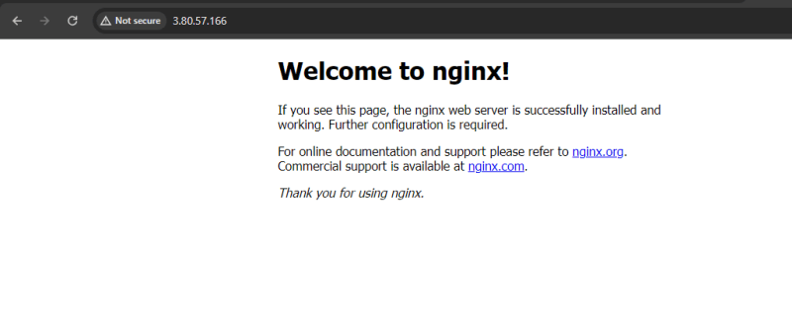

**Activity 2: Install Apache**

* Overview  
  
* Manual steps

# ubunu

sudo apt update

sudo apt install apache2 -y

sudo systemctl enable apache2

sudo systemctl start apache2

# redhat steps

sudo dnf install httpd

sudo systemctl enable httpd.service

sudo systemctl start httpd.service

* Daemon: This is an application designed to run in background. To ensure this application starts when your machine is started we have to enable the daemon/service

sudo systemctl => control daemons

sudo service => control daemons

* Daemon in ubuntu: generally after install softwares the daemon is mostly enabled
* Daemon in Redhat: we have to enable and start the daemon or service
* Execute the ansible playbook  
  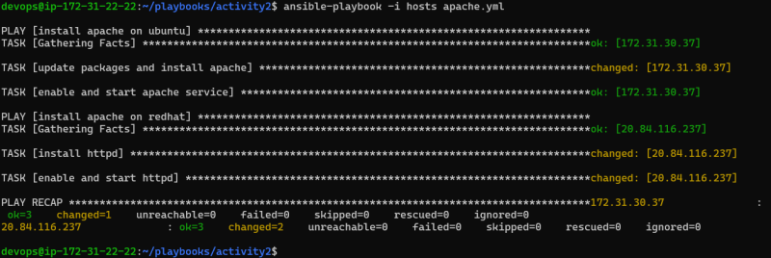
* Problems to be addressed:
  + redhat 9 issue
  + why check doesn’t work all the time

**adhoc command**

* Ansible automation can be executed using two approaches
  + imperative: using ansible commands (adhoc)
  + declrative: writing playbooks
* Adhoc command: [Refer Here](https://docs.ansible.com/ansible/latest/command_guide/intro_adhoc.html)

ansible -i <inventory> -m "<module name>" -a "parameter1=value1 parameter2=value2"

* Adhoc command for uninstallign ansible

ansible -i hosts -m apt -a "name=nginx purge=true state=absent"

**Share this:**