FEBRUARY 25, 2024

DevOps Classroom notes 25/Feb/2024

**Ansible contd**

**Ansible Facts**

* Facts are collected by ansible during playbook execution by default.
* This pull information about the node on which execution is happending
* Ansible has a module called setup which can pull facts. [Refer Here](https://docs.ansible.com/ansible/latest/playbook_guide/playbooks_vars_facts.html#ansible-facts) for facts & [Refer Here](https://docs.ansible.com/ansible/latest/collections/ansible/builtin/setup_module.html) for setup.

**Ansible conditionals**

* We can execute a task based on condition using when [Refer Here](https://docs.ansible.com/ansible/latest/playbook_guide/playbooks_conditionals.html)

**Ansible variables**

* Ansible allows to define variables and use them in playbook.
* First location where we will be adding variables is in inventory
* [Refer Here](https://docs.ansible.com/ansible/latest/playbook_guide/playbooks_variables.html) for official docs

**Ansible modules**

* [Refer Here](https://docs.ansible.com/ansible/2.8/modules/modules_by_category.html) for module index and [Refer Here](https://docs.ansible.com/ansible/2.8/modules/list_of_packaging_modules.html#os) for os package manager modules
* [Refer Here](https://docs.ansible.com/ansible/2.8/modules/package_module.html#package-module) for generic os package manager

**Lets change the Activity 1 to use conditionals and facts**

* [Refer Here](https://github.com/asquarezone/AnsibleZone/commit/d8c86c47f465dc343a1e0769117b3592d7519a54?diff=split&w=0) for the changes done.  
  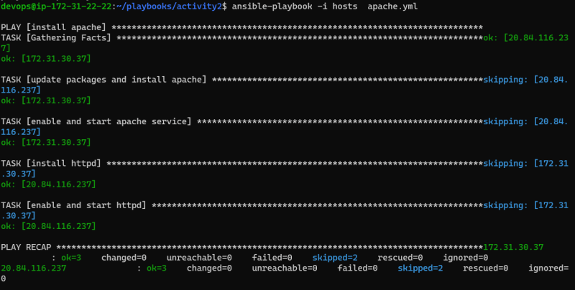
* [Refer Here](https://github.com/asquarezone/AnsibleZone/commit/5a2e79dd19f2c9288284d84745fbe1a178c4c407?diff=split&w=0) for the changes done to remove duplicate tasks  
  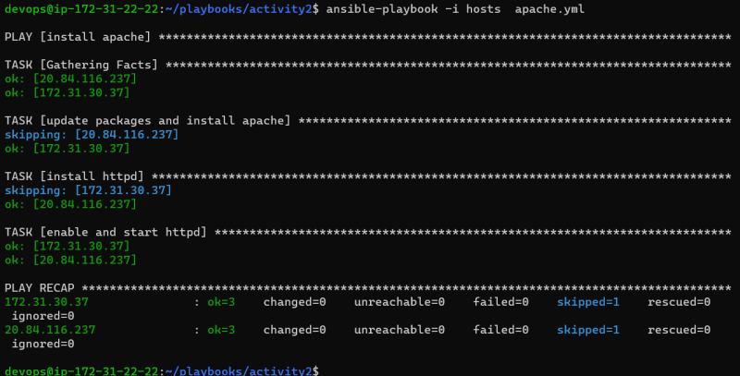
* Using generic modules for package [Refer Here](https://github.com/asquarezone/AnsibleZone/commit/6fa0f8d7db249883b9a710e88c5e09268bbe5b5a) for the changes done.  
  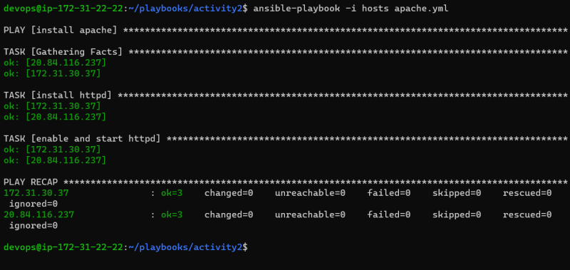
* Lets run this playbook only when os family is Debian or RedHat by using the fail module [Refer Here](https://docs.ansible.com/ansible/latest/collections/ansible/builtin/fail_module.html)
* [Refer Here](https://github.com/asquarezone/AnsibleZone/commit/428e1b28fa651ffebc102849e3867429ae5c17cd) for the changes done to fail playbook execution on unsupported os families

**Exercise**

* Ensure you have one ansible control node and one node
* ansible control node:
  + ubuntu 22.04
* node:
  + ubuntu 20.04
* Configure ansible by ensuring the common user name with sudo permissions is ansible

**Waiting for setup till 9:35 AM**

* Write a playbook to install git, tree, net-tools on both node and then adopt to run on ansible control node.

**Wait till 9:55 AM**