FEBRUARY 27, 2024

DevOps Classroom notes 27/Feb/2024

**Ansible contd**

**Activity 3 : Installing php on apache**

* [Refer Here](https://www.digitalocean.com/community/tutorials/how-to-install-linux-apache-mysql-php-lamp-stack-on-ubuntu-22-04) for manual steps
* Note: we will be skipping mysql.
* Manual steps for ubuntu

sudo apt update

sudo apt install apache2 -y

sudo systemctl enable apache2

sudo systemctl start apache2

sudo apt install php libapache2-mod-php php-mysql

sudo systemctl restart apache2

# create a file in /var/www/html/info.php with content <?php phpinfo(); ?>

sudo systemctl restart apache2

* Lets write a playbook for this.
* [Refer Here](https://github.com/asquarezone/AnsibleZone/commit/d38d22d3ef48e258f0529683f33cfa4180714273) for the first version of playbook with inventory and variables added.
* Ansible handlers [Refer Here](https://docs.ansible.com/ansible/latest/playbook_guide/playbooks_handlers.html)
* [Refer Here](https://github.com/asquarezone/AnsibleZone/commit/270199105a154ac2d291795943db3363a7af63a7) for the changes in inventory and variables  
  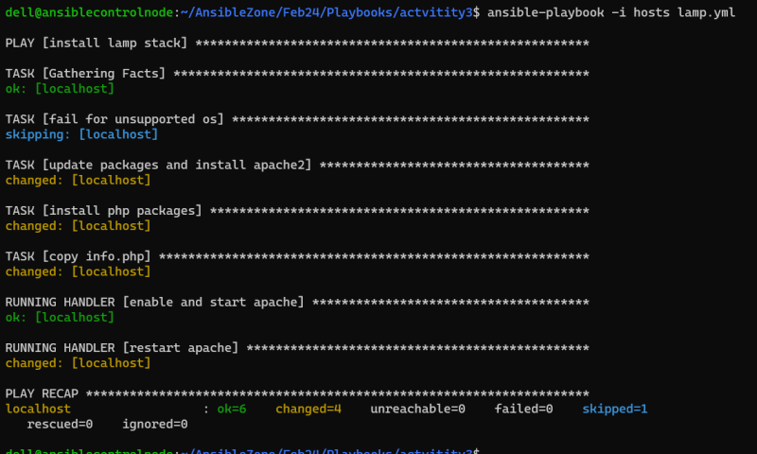  
  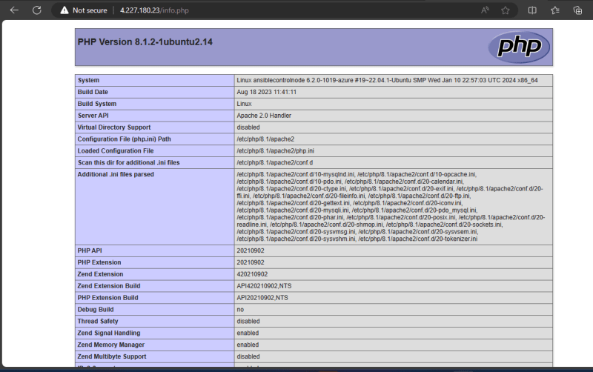

**Ansible inventory**

* Inventory is list of hosts
* Inventory consists of groups and hosts
* Inventory can be written in two formats
  + ini
  + yaml
* ini

[group-1]

host-1

host-2

[group-2]

host-3

host-4

[experiment-group]

host-1

host-3

* Yaml

---

group-1:

hosts:

host-1:

host-2

group-2

hosts:

host-3

host-4

experiment-group:

hosts:

host-1

host-3

* we have a host where we need to add a variable package with value apache2
* in ini format

[webservers]

192.168.0.11 package=apache2

* in yaml format

---

webservers:

hosts:

192.168.0.11:

package=apache2

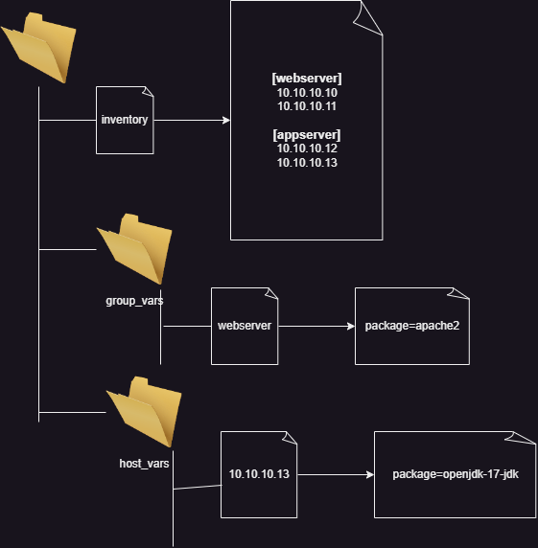  
*

**Ansible variables**

* Ansible variables can be created in different locations
  + inventory:
    - directly in inventory
    - relative to inventory
  + playbook
  + pass variables during execution

**Share this:**