EBRUARY 28, 2024

DevOps Classroom notes 28/Feb/2024

**Activity 4: Installing tomcat on ubuntu**

* [Refer Here](https://tecadmin.net/how-to-install-tomcat-on-ubuntu-22-04/) for manual steps

sudo apt update

sudo apt install openjdk-11-jdk -y

sudo useradd -r -m -U -d /opt/tomcat -s /bin/false tomcat

cd /tmp/

wget https://archive.apache.org/dist/tomcat/tomcat-10/v10.0.10/bin/apache-tomcat-10.0.10.tar.gz

* The command sudo useradd -r -m -U -d /opt/tomcat -s /bin/false tomcat means create a user tomcat with
  + home directory in /opt/tomcat
  + tomcat as a system user
  + ensure there is group called as tomcat
  + shell is /bin/false
* [Refer Here](https://github.com/asquarezone/AnsibleZone/commit/0a2c9ec3b22e6b98acfecb2bead67b286a450822) for the playbook to automate the above steps and execute the playbook  
  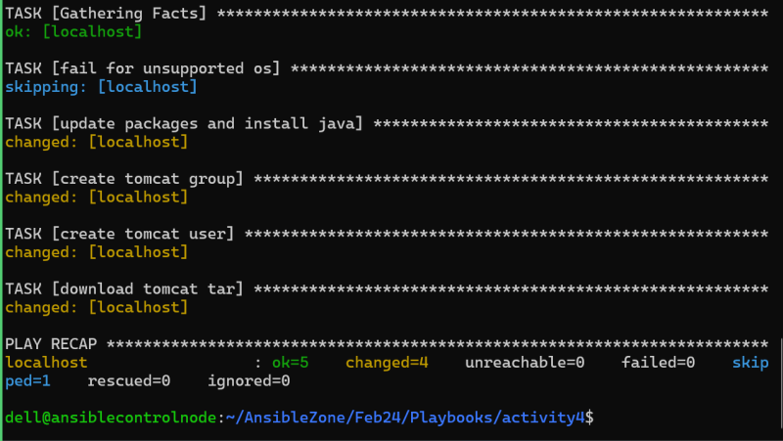
* [Refer Here](https://github.com/asquarezone/AnsibleZone/commit/319906147e818b20840205840d263136465b76b5) for debug messages added.  
  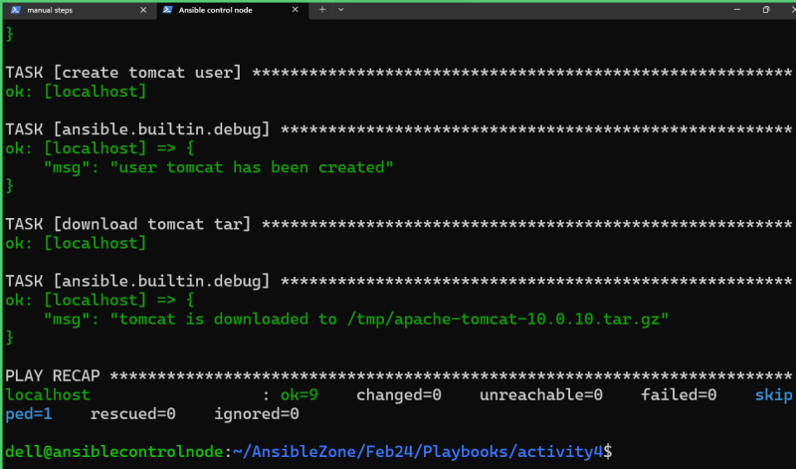
* Next set of steps

sudo tar xzf apache-tomcat-*.tar.gz -C /opt/tomcat

* [Refer Here](https://github.com/asquarezone/AnsibleZone/commit/02697626308eb571329023eada5030d4c4fc0de9) for the changes done to extract tomcat and [Refer Here](https://github.com/asquarezone/AnsibleZone/commit/fe297d3fb5266cc24c02a76b1b5097226abcb113) for the remote src to yes for downloading from external sources

**Exercise:**

* Make changes in the above playbook to work on centos 8
* Ensure /opt/tomcat/apache-tomcat-10.0.10 has tomcat user and tomcat group as owner.

**References**

* Understanding previlege escalation i.e. using become [Refer Here](https://docs.ansible.com/ansible/latest/playbook_guide/playbooks_privilege_escalation.html)
* printing messages during execution of playbook is considered to be a good ractice. we can use debug module [Refer Here](https://docs.ansible.com/ansible/latest/collections/ansible/builtin/debug_module.html)

**Share this:**