FEBRUARY 11, 2024

DevOps Classroom notes 11/Feb/2024

**Centralizing logs**

* Overview  
  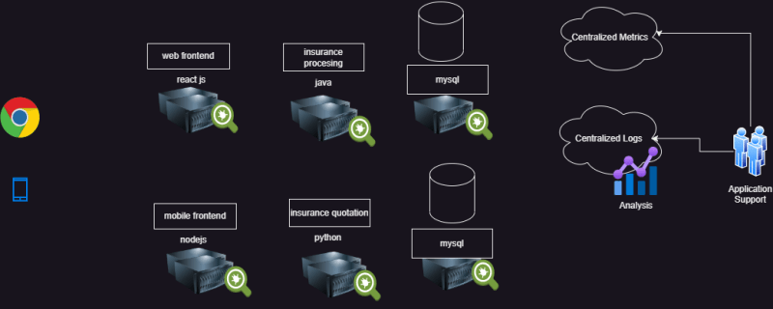
* Logs are generally centralized for
  + troubleshooting
  + Analytics and Predictions
  + Performance Bottlenecks
  + Convinience
* Challenges
  + Logs are text records which are not queryable
* Solutions
  + ETL
    - Elastic Search Log stash and Kibana
    - Kibana Search:
      * Kibana Query
      * Lucene Based Search
  + Advanced querying capabilities
    - AWS
      * Store Logs to S3 via cloud watch agent
      * Athena (Query for information)
    - Azure:
      * Stores logs into storage account (Log Analytics workspace/ Azure Monitor Logs)
      * KQL (Kusto Query Language) to query the logs

**SRE (Site Reliability Engineering)**

* I want to run a website on
  + AWS EC2
  + Azure VM
* My customer is asking me how much % of the time in a year site will be up and he wants me to sign a legal document with this % ?
* This is solved by Google when they published a book called Site Reliability Engineering [Refer Here](https://sre.google/books/)
* [Refer Here](https://directdevops.blog/2019/10/22/site-reliability-engineering-overview/)

**Observability**