JANUARY 31, 2024

DevOps Classroom notes 31/Jan/2024

**Tale of Food delivery application**

* Architecture  
  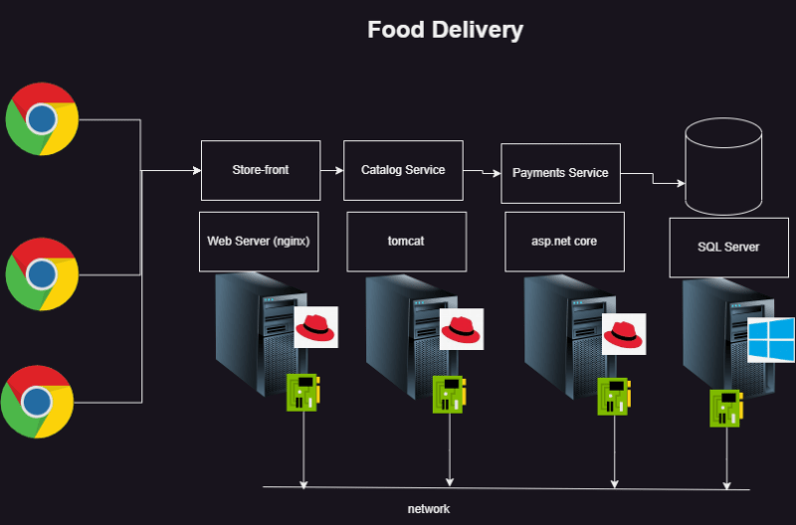
* Possible failures:
  + Connectivity issues
  + Hardware issues
  + OS issues
  + Web server/app server failures
  + applications
  + performance bottlenecks
    - cpu
    - RAM
    - disk
* Our idea is to ensure we have low MTTR (Mean time to recover) and high MTBF (Mean Time between failures) and MTTF (Mean time to fail)
* To do this we need to monitor
  + heart beat or alive
    - servers
    - applications
  + performance monitoring
    - cpu utilization
    - free disk space
    - free RAM
  + log monitoring
  + Trace monitoring / Profiling
* Centralized Monitoring: All the metrics, logs, trace should be centralized to analyse failure or predict failures without need to login into each server.

**Monitoring Types**

* There are two types of monitoring
  + Server Monitoring
  + Application Monitoring (logs, traces, metrics)
* Softwares to help here
  + Server Monitoring:
    - Nagios
    - Zabbix
  + Application Monitoring
    - New Relic
    - App dynamics
    - splunk
    - prometheus
  + Cloud Monitoring
    - AWS Cloudwatch
    - Azure Monitor
* Tools we will understand
  + Elastic Stack
  + Prometheus, Grafana (kubernetes)
* Technologies to watch out
  + eBPF
  + Open Telemetry

**Methodologies**

* ITIL
* Continuous Monitoring
* SRE

**Share this:**