FEBRUARY 1, 2024

DevOps Classroom notes 01/Feb/2024

**Checking for basic liveness of servers and applications**

* This monitoring typically involves
  + continuous checks for the alive state
  + raise a notification to team on the state

**Elastic Cloud**

* Elastic Stack: This is collection of different products such as
  + Elastic Search: A Text based search engine designed to scale horizontally
  + Logstash: This is used for log conversions and filtering
  + kibana: This is UI for the whole stack
  + Beats: There are different types of beats, at a very basic note they are agents who ship the data to elastic search or logstash
  + X-Pack: Additional features like usermanagement, notifications are added using x-pack  
    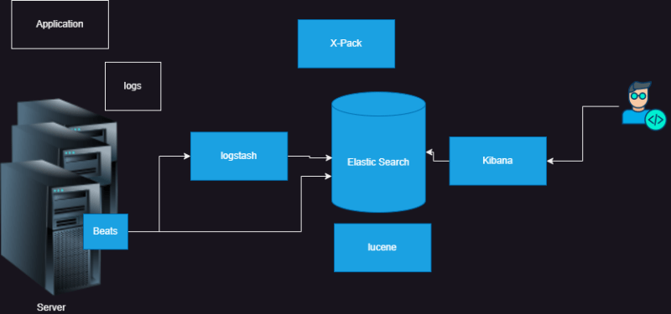
* Elastic stack is used for ETL (Extract transform and Load) for data of any shape into Elastic search
* Creating and Elastic Cloud Account
  + Create a new google or microsoft account
  + naviagate to elastic cloud [Refer Here](https://www.elastic.co/cloud/)  
    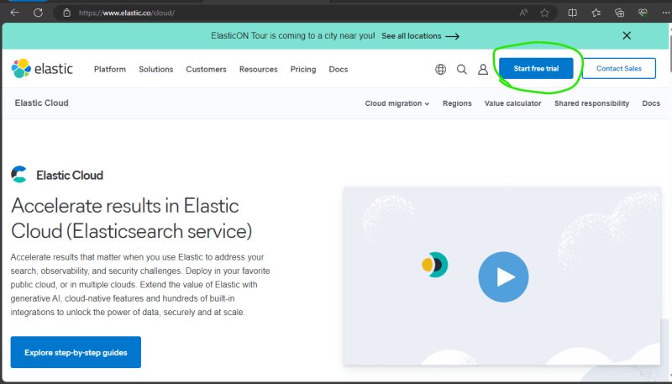

**Golden Signals**

* [Refer Here](https://sre.google/sre-book/monitoring-distributed-systems/) for four golden signals
* Latency
* Traffic
* Errors
* Saturation