FEBRUARY 2, 2024

DevOps Classroom notes 02/Feb/2024

**Creating an Elastic Cloud Account**

* Navigate to [Refer Here](https://www.elastic.co/cloud) and start free trail  
  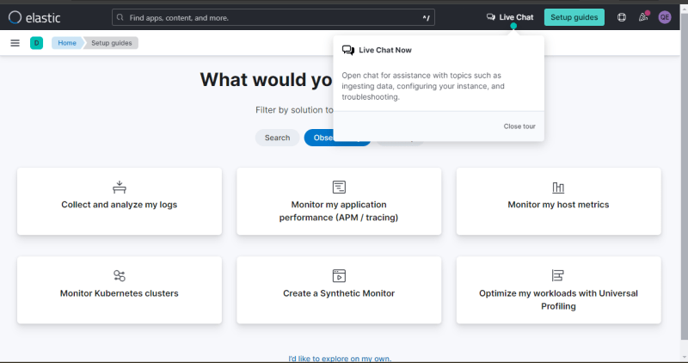  
  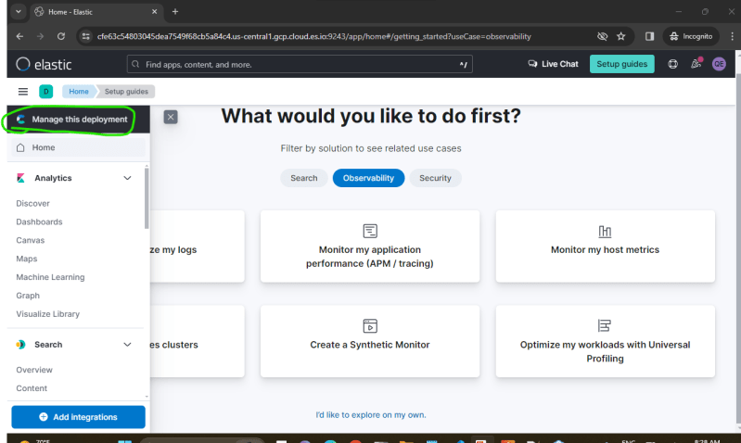  
  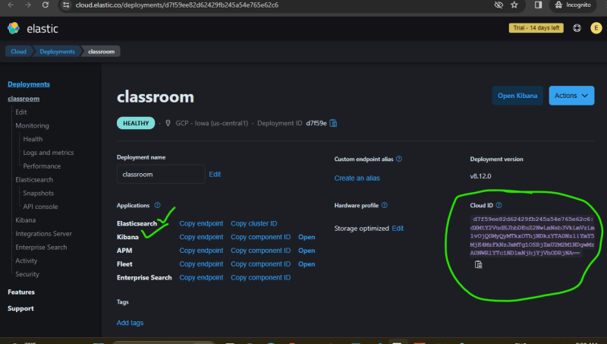

**Elastic Search**

* [Refer Here](https://www.elastic.co/elasticsearch) for the official page of elastic search
* Elastic Search stores documents.
* A document is a json data of a certain type in an index.
* Comparing relational Database with Elastic Search  
  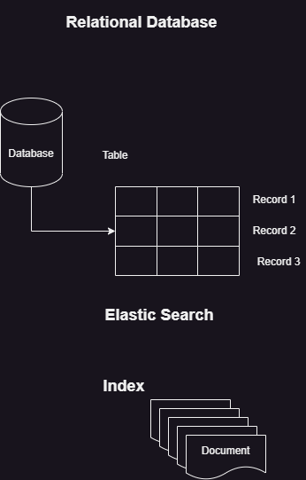  
  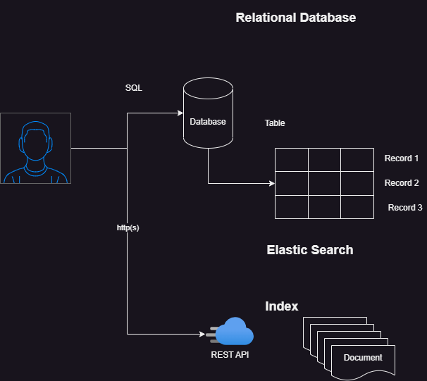
* How can elastic search scale ?  
  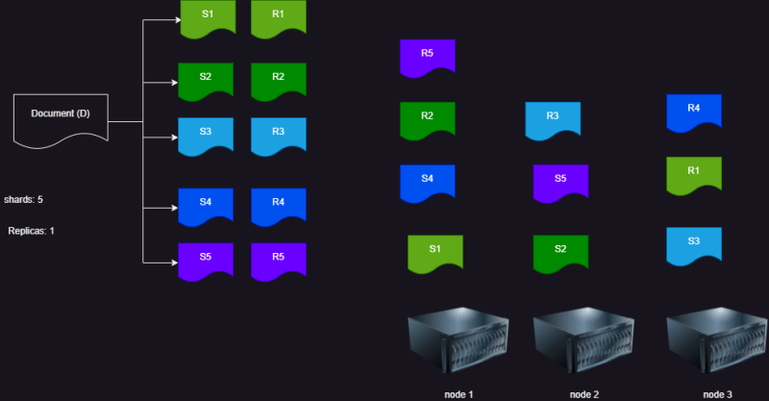
* [Refer Here](https://www.elastic.co/guide/en/elasticsearch/reference/current/rest-apis.html) for REST API