FEBRUARY 6, 2024

DevOps Classroom notes 06/Feb/2024

**Basic HeartBeat/Uptime Setup**

* Basic Architecture  
  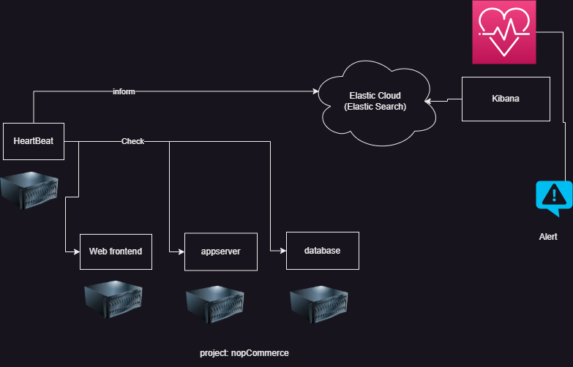
* Installing nopCommerce on Linux [Refer Here](https://docs.nopcommerce.com/en/installation-and-upgrading/installing-nopcommerce/installing-on-linux.html)
* Install mysql server [Refer Here](https://www.digitalocean.com/community/tutorials/how-to-install-mysql-on-ubuntu-22-04)
* Install nopCommerce [Refer Here](https://docs.nopcommerce.com/en/installation-and-upgrading/installing-nopcommerce/installing-on-linux.html)
* Note: Expose services on 0.0.0.0