FEBRUARY 8, 2024

DevOps Classroom notes 08/Feb/2024

**Heartbeat setup (contd)**

* Configuration file of beats /etc/<beat-name>/<beat-name>.yml
* Since we working on heartbeat /etc/heartbeat/heartbeat.yml
* To fill this file there are two references
  + /etc/heartbeat/heartbeat-reference.yml
  + [Refer Here](https://www.elastic.co/guide/en/beats/heartbeat/current/configuration-heartbeat-options.html)
* Cron: to schedule the monitor [Refer Here](https://crontab.guru/)

**Alerting setup**

* OVerview  
  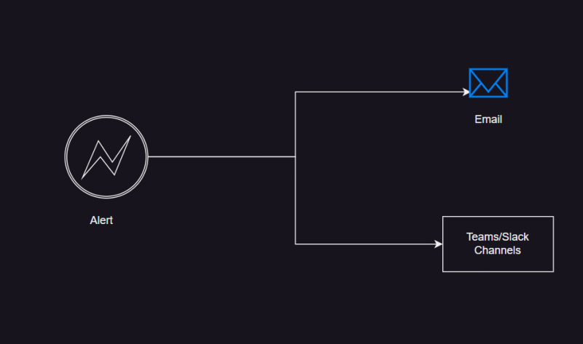
* For screenshots refer classroom video or [Refer Here](https://www.elastic.co/guide/en/kibana/current/alerting-getting-started.html)
* For fake smtp email server setup use https://mailtrap.io

**Metric Beat**

* This elastic beat is an agent that we would install on the servers  
  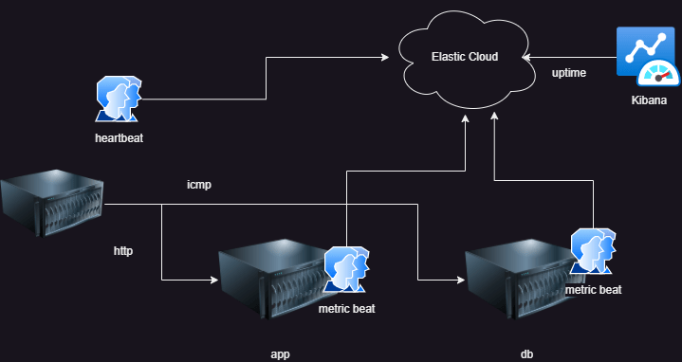
* [Refer Here](https://www.elastic.co/guide/en/beats/metricbeat/current/metricbeat-overview.html) for metric beat overview
* Installation:
  + Navigate through setup guides
  + Search for metric beat installation [Refer Here](https://www.elastic.co/guide/en/beats/metricbeat/current/metricbeat-installation-configuration.html)
* Metric beat comes with modules which collect metrics according to the application