FEBRUARY 9, 2024

DevOps Classroom notes 09/Feb/2024

**Metric Beats contd**

* Overview  
  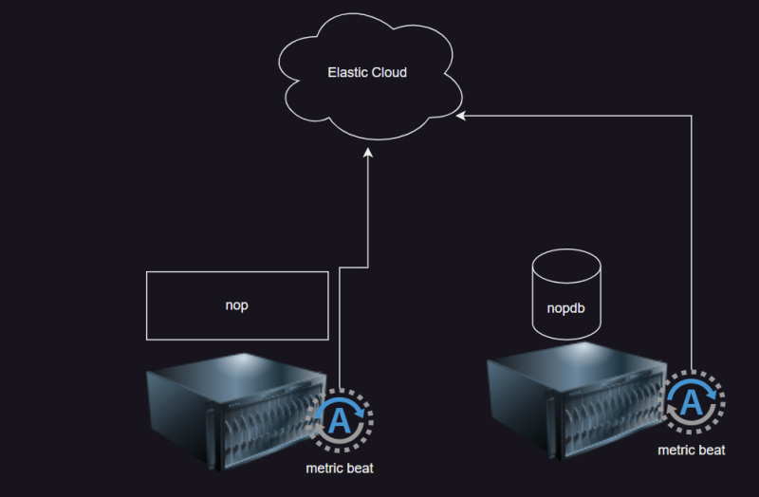
* We have already setup metrics beat on mysql vm
* In all the beat
  + configuration /etc/<beat-name>
  + binaries /usr/share/<beat-name>
* modules in metric beat: modules collect metrics about various system and application aspects
  + system => basic system metrics (cpu, memory, ram)
  + apache
  + mysql