**Milk Bank PH: A Website for Donating and Reserving Breastmilk for Infants**

|  |  |  |
| --- | --- | --- |
| Joshua Lois C. Paulino  National University Manila, Philippines  paulinojc@students.national-u.edu.ph  Jeline G. Go  National University Manila, Philippines  gojg@students.national-u.edu.ph  Von Gabriel C. Madrigal  National University Manila, Philippines  madrigalvc@students.national-u.edu.ph | Kent Alvin Gerald L. Aquino  National University Manila, Philippines  aquinokl@students.national-u.edu.ph  Kyla Dann Fadera  National University Manila, Philippines  faderakf@students.national-u.edu.ph  Paul Gabriel C. Pascual  National University Manila, Philippines  pascualpc@students.national-u.edu.ph | Dorothy Ann P. Bohulano  National University Manila, Philippines bohulanodp@students.national-u.edu.ph  Lexter Carl A. Almirol  National University Manila, Philippines  almirolla@students.national-u.edu.ph |

# ABSTRACT

A milk bank donation and reservation system are a service for individuals who would like to donate their breastmilk and for families in need of breastmilk. This paper will be exploring the whole functionality of the system developed as well as shed light on the need of a centralized, digitized, online system for Hospitals and Human Milk Bank Organizations

**Keywords:** Hospital, Milk bank, Donating, Breastmilk, Infants, Reserve

**ACKNOWLEDGMENT:**

We are grateful for the support and encouragement, extended for this project by our Dean Mrs. Arlene Trillanes and our professor Mr. Elcid A. Serrano for providing their invaluable guidance, comments, suggestions throughout the course of the project.

We are thankful to our college faculty staff and to the groupmates, classmates also for supporting and the motivation.

We have an immense pleasure in the successful completion of this project.

1. **Introduction**

Life comes in different shapes and forms. Plants for example come in varying colors and sizes. Living organisms have existed in our planet for millions of years but for living organisms to continue existing, it would require nutrients to sustain itself. Humans have life and as such, the species is no exception to the constant universal need that living organisms share - the need for food. With life there is death, it is also something that all living organisms share, the inevitable process that mortality brings. With that said, the objective now is to delay the unescapable end that all living organisms will eventually face.

While it is not guaranteed in cases of unnatural passing, an optimal solution that many employs in the attempt of delaying death would be to keep a healthy body. It is common knowledge that a healthy body would be the right path in the quest for longevity in life. However, a healthy lifestyle should start all way from infancy and even before birth. Infants and/or babies are especially prone to illness since their body is in the earliest stages of development after birth. According to the World Health Organization or WHO “Nearly 6.9 million children under the age of five died in 2011 – nearly 800 every hour – but most could survive threats and thrive with access to simple, affordable interventions.” And that the risk of death is at its peak in the first month of life [1]. Our attention is directed to the assurance of health in infants and/or babies.

According to the Center for Disease Control and Prevention – CDC, Breastfeeding is the way to go for early infant feeding the most health beneficial option for the baby and the mother [2]. There has also been a considerable amount of reduction of risks in varying infections and diseases such as respiratory infections, asthma, SIDS, and obesity, and etc among infants that have been breastfed. “In the United States, 84% of infants start out being breastfed, but only 25% get solely breast milk until they are 6 months old, as recommended by the American Academy of Pediatrics” [2]. It obvious that breastfeeding is one of the most effective ways to increase and ensure the survival rate and overall health of a child. However, according to the World Health Organization, “nearly 2 out of 3 infants are not exclusively breastfed for the recommended 6 months—a rate that has not improved in 2 decades” [3]. There are a lot of factors that may have cause this unfortunate situation. An example would be the inability of the mother to produce enough milk to satisfy the needs of the child. Breastmilk is the ideal food for infants for it is safe and clean and it also is a source of antibodies that will ensure the survival of the child when it comes to illnesses. It ensures that the child receives the nutrition it needs especially during the first half of the first year and up to the end of the second year. Not only that, breastfeed children have also been performing better in Intelligence Tests and are less likely to suffer in conditions such as diabetes and the like, later in life. So, what is the solution for mothers who have problems in producing breastmilk? The solution? By helping each other by way of milk bank.

A Human Milk Bank is where individuals can donate or be the recipient of donated breastfeeding milk. It is where human milk is collected, screened, stored, processed, and distributed [4]. Since we are living in the digital age where the internet is easily accessible by the masses, it is now possible to make milk banking.

an easy process. The developers have created a system where Milk Banks can easily manage data.

1. **Related Literature**

**2.1 The Importance and Benefits of Breastfeeding**

According to the Centers for Disease Control and Prevention “one of the most effective preventive measures a mother can take to protect the health of her infant” [5]. Breast Milk is the recommended choice when considering the health and safety of an infant. It is easily digested and provides all the nutrition that an infant need. Babies who have been breastfed apparently have better development in the mental area and emotional security aspect. They also develop better physiologically e.g., better jaw and tooth development and significantly stronger immune systems [6].

**Breast feeding reduces of [6]:**

* Obesity
* Type 1 diabetes
* Sudden Infant Death syndrome
* Pneumonia and other respiratory infections
* Coughs and colds
* Gastrointestinal illnesses
* Vomiting, diarrhea, constipation
* Urinary tract infections
* Ear infections that can damage hearing
* Meningitis
* Childhood cancers, including Leukemia and Lymphoma
* Crohn's disease, ulcerative colitis
* Celiac disease
* heart disease and liver disease in adulthood

Breastfeeding, apparently, not only helps the baby but it also helps the mother. It helps women heal post birth and even in cases of sever post-partum bleeding. Women also tend to return to pre pregnancy weight at a fast pace when breastfeeding. They also develop stronger bones later in life and they benefit from the strong emotional bond that they form when breastfeeding their children. Another physiological benefit from breastfeeding would be relaxation. Women get a surge of the bonding hormone called Oxytocin that produces a calming and relaxing effect. On a more practical standpoint, Mothers can save time and money since infant milk formula is expensive and time consuming to prepare. A problem that is so often overlooked in our modern world. Breast milk, on the other hand, is always ready and is always at the right temperature [6].

While Breastfeeding is a personal matter, being that it the choice differs from family to family, many medical experts recommend strongly recommend breastfeeding exclusively for up to 6 months. They also recommend that it’d be the choice for 6 months to a year as other foods are recommended after 6 months [7]. The breastfeeding milk itself changes its composition to suit the baby’s needs from time to time. “The milk changes in volume and composition according to the time of day, nursing frequency, and age of baby to promote healthy growth. Breast milk is the perfect food for your baby.” [8]

**2.2 Complications of Breastfeeding**

“A small percentage of women who want to breastfeed can’t be due to lactation failure or a true low breast milk supply” [9]. There are various reasons as to why a mother is producing insufficient milk for the baby.

The following reasons as listed by an article are as follows [10]:

* Insufficient glandular tissue
* Hormonal or endocrine problems
* Previous breast surgery
* Using hormonal birth control
* Taking certain medications or herbs
* Sucking difficulties or anatomical issues

With all of that in mind, a lot of mothers face the dread that is the inability to produce sufficient milk supply for the baby. The issues presented above creates a problem that we must address to ensure that we provide our children, the future of our world, the right to good health and well-being.

**2.3 Milk Banks – A Viable Solution**

“The first human milk bank was founded in 1909 in Vienna, Austria. Wet nursing was widely practiced in Europe during the 19th century to provide human milk for infants whose mothers were unable to provide milk for their infants. However, wet nurses were not always available or, when available, pursued unhealthy lifestyles or carried infections that could be transmitted through milk. An alternative to wet nursing was found in human milk banking.” [10]

Milk is the source the optimal source of nutrition for babies as shown by studies from all over the world and this it is an important resource that all should have access to. In India, “over 1.4 million children in India die under the age of five and almost fifty percent of those cases are babies under 28 days and this ‘liquid gold’ can save infants at Milk banks” [11]. These establishments offer infants a chance at living a healthy life. As Milk banks are proven to be a way to save infants all over the world.

Milk banks are establishment where mothers can donate or receive donated milk. It is where Human Milk is Collected, Processed, and Distributed. It is also where mothers are screened for their eligibility to donate milk. The Human Milk Bank, a milk banking establishment backed by the Dr. Jose Fabella Memorial Hospital or DJFMH, is only one of the many establishments that aims to distribute donated human milk to babies who need milk, whose mothers can’t provide milk on their own. Since its establishment, “the awareness and demand for the use of pasteurized donor milk has increased” [12]. According to its records, the Human Milk Bank has been providing milk for babies all over the country. Not just at normal circumstances but also in calamities. “It has donated 82 liters of pasteurized donor milk to victims of typhoon-stricken areas like Cagayan de Oro City, Iligan City and Davao Oriental, Compostela Valley and Tacloban “ [12] . But why is milk stored though? Well according to a published article on Human Milk Banking, “The main function of milk banks is to serve as repositories of donated milk, so it is available when needed.” [10].

**2.4 Relevance of Today**

While Milk Banks are readily available for mothers all over the country, a lot of mothers are still unaware that such establishments whose sole purpose is to provide milk for children, exists. As a result, they still opt for infant formulas which are not recommended by medical experts. Organizations such as “Save The Children”, whose aim is to “do whatever it takes for children, transforming their lives and the future we share” [13], aim to raise awareness in utilizing resources like milk banks.

Considering the COVID-19 outbreak, Atty. Alberto Muyot, Chief Executive Officer of Save the Children Philippines stated that nutrition and health support to children, pregnant and lactating mothers must be applied into the national and LG response during the COVID-19 pandemic including the promotion of breastfeeding. He also stated that “Children suffer the worst impact of the COVID-19 pandemic due to rising levels of poverty, ill-health, and malnutrition,” [14]

**2.5 Executive Order 51 of 1986**

Milk Code or Executive Order 51 of 1986, prohibits the donations of infant formula in times of disasters, calamities, and emergencies including a pandemic. [15]. This, in turn, resulted to Atty Muyot saying “We call on local governments to support parents and guardians by encouraging mothers to breastfeed, and provide access to affordable and healthy food” in light of the COVID-19 Pandemic [14]. Although DOH has allowed the distribution of milk formula during the pandemic, there is a limit [16]. As a result, mothers are left with the healthy choice and that is breastfeeding milk but about mothers who are unable to lactate properly? This is where Milk Banks come in.

**2.6 The Government’s Support**

Statistics say that only 34% of infants under 6 months are exclusively breastfed and only 34% continue to be breastfed until two years old in the Philippines [17]. Because of this, government agencies have decided that it was time to make a change towards a world where we can fix the problem with child malnutrition. Various Local Governments all over the country have already started moving to that goal.

In March 2013, the country established the first LGU-run milk bank – the Makati Human Milk Bank (MHMB). 7 years later, the Government run Milk Bank continues to help mothers and infants within and even beyond the city. The MHMB not only offers donor-recipient services, but they also educate the mothers in order to combat this problem with malnutrition that low milk supply creates [18].

In 2017, “The city government of Quezon City helps 165 premature and undernourished infants through its Quezon City Human Milk Bank (QCHMB)” [19]. The QCHMB aims to help undernourished children by providing them the milk that they should be consuming as part of Quezon City’s child and maternal health policy.

The National Government has moved to support this program and has installed facilities all around the country for donors to donate their milk so that it can be distributed to those in need. As of 201, there are 600 active members of breastfeeding support groups in 65 health centers [19].

**2.7 Milk Banking in the Digital Age**

We are currently in an age where the use of mobile phones is a phenomenon that has become so normal to us. With the state of technology that we have right now, there is an app for virtually everything. This has been a great aid to society and has provided convenience more than ever. While on the topic of technology and it is use in society, let us discuss how it has aided the Health care industry.

“The use of mobile devices by health care professionals (HCPs) has transformed many aspects of clinical practice.” Mobile devices have become extremely common in health care settings, this led to the development of medical software applications (apps) for these platforms. These applications are now able to help HCPs in doing jobs such as: information and time management; health record maintenance and access; communications and consulting; reference and information gathering; patient management and monitoring; clinical decision-making; and medical education and training [20].

In 2017, the first application to be of aid for milk banks in the Philippines came to surface. The application called “Milk track”, developed a group of undergraduate students, was of aid to Milk banks. It helped the community by providing an application where individuals can sell, buy, donate, and ask to receive breastfeeding milk. It was picked as one of the top five winners of Globe Future Makers Program [21]. The team of students visited different milk banks to learn the process and apply it to the application, helping the community support and avail the services of Milk Banking with ease and convenience.

* 1. **Centralization of Resources**

Since the creation of Milk Banks, mothers, and infants from all over the world have been aided with the services that MBs provide. Like with everything in society right now, including aspects in the Health Care Sector, the ease and convenience that technology so efficiently provides has only improved the reach and quality of the services that health care establishments offer. The researchers, as supporters of health and wellness, aim to provide a system where everything can be centralized. The researchers hope to contribute to building a world where ignorance regarding breastfeeding is eradicated.

A world where everyone can access the services that Milk banks offer with ease and convenience. The researchers aim to develop a system where all the information regarding Milk Banking, is centralized. From the donor to recipient to the management of milk supplies to the statistics that is needed for research and development. The aspects not covered in the research can and will be explored in further research so that may be of aid in the further development of Milk Banking.

1. **Methodology**

The developers have developed a system that will certainly fill the gap that the convenience of an application will fill in the field of Milk Banking. The different illustrations presented at various points in this section will describe the management of all the data that will be handled inside the system.

**3.1 System Architecture**

System Architecture of Milk Bank PH

The System Architecture of Milk Bank PH shows how the data passes through from the beginning until the end and shows the connection of other application program included.

To start it up, the Web Client is the user itself, wherein the user can use either mobile device or personal computer. The user will establish a connection to the Web Server of the Milk Bank PH to gain an access to it. After establishing a connection, the user can now use the Web Application, which is the Milk Bank PH. Every action made by the user in the Web Application, it will automatically create logs and will need a permission from the Company and the Master Administrator, to check first if the user is applicable to donate or reserve milks. If accepted obviously it will modify the database and if rejected it will not take an effect to the database itself. Both should agree to complete the request of the user.

For the Company Administrator side, their accesses are only limited to engaging with the client, updating the records in the database, and having a small knowledge when using the website. Obviously, they do not have a power to control the Web Server and delete the Master Administrator.

Lastly, the Master Administrator has all the access. Since it is their duty to maintain the welfare of the website. It can communicate with the client, change a server, modify the website, modify, and alter the database, and have the choice to choose its Company Administrator.

**3.2 Unified Modeling Language**

**UML – Admin**

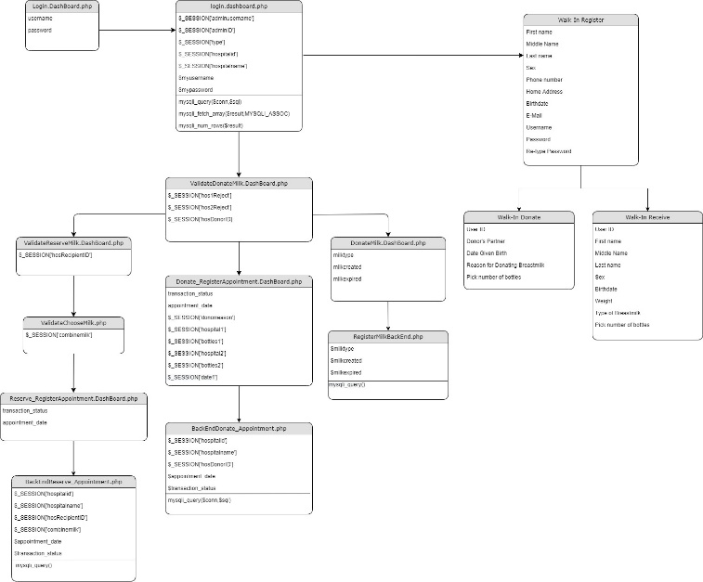

**UML – Website**

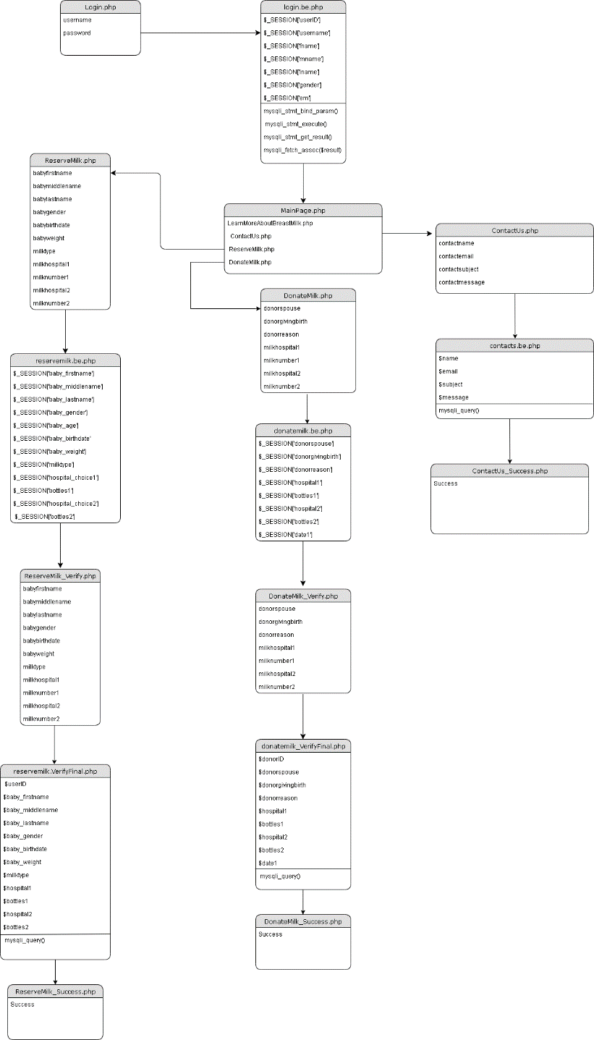

**3.3 System Map**

The following diagrams will further illustrate the flow of data in the system as well as the location of various aspects in the system.

**Website Map**

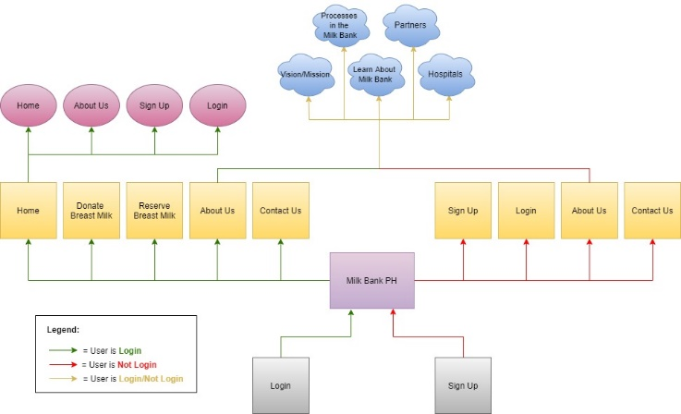

**Admin Dashboard Map**

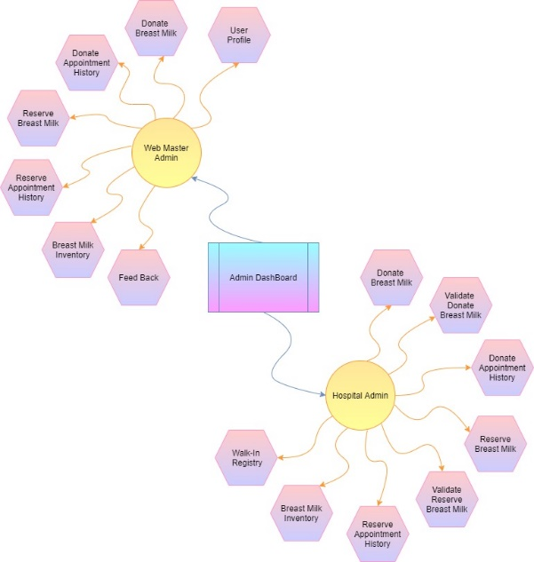

**Use Case – Admin**

**Use Case – Hospital**

**3.4 Database**

In accordance with industry standards, the developers have implemented a database in the third normal form while keeping the standard rules and possible issues that may affect the performance of the whole system, in mind. The next illustration presents the same third normal form Diagram but with semantics to further assist in comprehending the flow of data inside the database.

**3rd Normal Form of ERD**

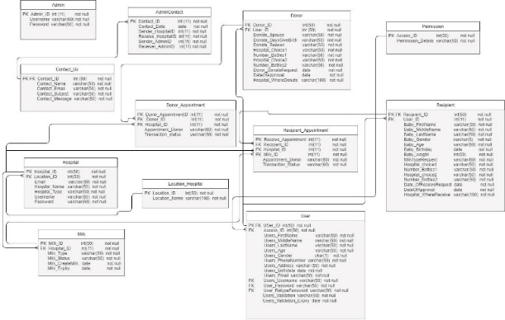

**3rd Normal Form of ERD with Semantic**

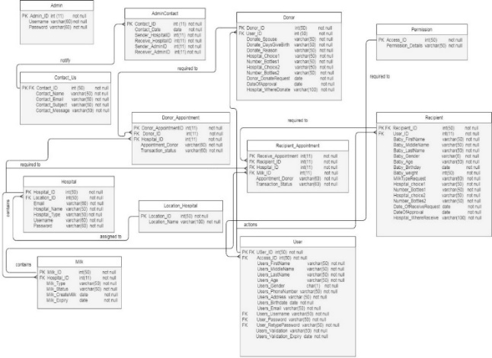

1. **Results and discussion**

We used User Acceptance Test method to test the Milk Bank PH Website to 3 respondents to test the functionalities and design of the system. They answered it in a excel file containing a scale from very poor, poor, moderate, good, and excellent (from lowest to highest), N/A will be given if the task and features was not applied in the system, it will be excluded in the scoring for the respondents. They scored the system based on the design specifications of the project.

**Summary of Results**

These are the general results of the evaluation given by our three respondents:

|  |  |  |
| --- | --- | --- |
| **Respondent Number** | **Score** | **Evaluation** |
| 1 | 77 | Good |
| 2 | 87 | Good |
| 3 | 90 | Excellent |
| **Average Score** | **84.67** | **Good** |

With the average score of 84.67, the system has fulfilled the functionalities and design of the website based on the respondent’s score on the UAT testing.

1. **Conclusion and Recommendations**

Technology, mobile and web applications to be more specific, has come a long way and now it has aided a lot of establishment across various fields and practices. Now, the time has come where it can be of use in the field of milk banking. The system essentially helps Milk Banks and its clients alike. The system provides a way in which Milk Banking services can easily be available. It has literally put the whole Milk Banking process in the palm of the society’s hands. The developers hope that this system will aid the field of Milk Banking here in the Philippines as such services are still not well known enough.

The developers aim to provide a system that can be used by anyone and everyone in all the different processes in Milk Banking. All the information obtained thus far while creating this paper will be used in the further development of the system. The findings that will be gathered after the launching of the system can and will be used in addressing various problems that may arise using the system. The developers are aware that Milk Banking applications in the Philippines are only getting started. With this “dawn” of Milk Banking applications in mind, the developers have become aware that there will be a lot to learn from after the launching of the system and as such, future issues that may arise in the launching of the system will be addressed in the future updates of the system. Features such as verification and notification (via email and text message) processes for both the admin and the milk bank clients shall be added in the future iterations of the application. These features will also aid in the security protocols that will be implemented in the future. Administrator security shall also be improved in the future such as password verification when manipulating the data inside the system.

This Milk Bank application project has been such an educational journey and the developers have been enlightened so much by the services that Milk Banking generously offers. All this information will be used effectively and efficiently by the developers in creating a safe environment for people availing themselves of the Milk Banking services to create a positive impression towards Milk Banking today.

# References

|  |  |  |
| --- | --- | --- |
| [1] | Organization, World Health, "What are the key health dangers for children?," 13 September 2012. [Online]. Available: https://www.who.int/news-room/q-a-detail/what-are-the-key-health-dangers-for-children. | |
| [2] | Central for Disease Control and Prevention, "Promoting Health for Infants," Central for Disease Control and Prevention, 19 August 2019. [Online]. Available: https://www.cdc.gov/chronicdisease/resources/publications/factsheets/infant-health.htm. [Accessed 14 May 2020]. | |
| [3] | World Health Organization, "Breastfeeding," [Online]. Available: https://www.who.int/health-topics/breastfeeding#tab=tab_1. | |
| [4] | Mothers Milk Bank Austin, "About Milk Banking," [Online]. Available: https://www.milkbank.org/milk-banking. | |
| [5] | Centers for Disease Control and Prevention, "Promoting Health for Infants," [Online]. Available: https://www.cdc.gov/chronicdisease/resources/publications/factsheets/infant-health.htm. | |
| [6] | HealthyFamilies BC, "Importance of Breastfeeding," [Online]. Available: https://www.healthyfamiliesbc.ca/home/articles/importance-breastfeeding. | |
| [7] | WebMD, "The Benefits of Breastfeeding," [Online]. Available: https://www.webmd.com/parenting/baby/nursing-basics#1. | |
| [8] | New York State Department of Health, "Why is Breastfeeding Important for your Baby?," [Online]. Available: https://www.health.ny.gov/prevention/nutrition/wic/breastfeeding/importance.htm. | |
| [9] | D. Murray, "Can All Women Breastfeed?," [Online]. Available: https://www.verywellfamily.com/why-some-women-cant-breastfeed-4153606. | |
| [10] | N. H. a. E. E. Ziegler, "Human Milk Banking". | |
| [11] | D. A. SRIVASTAVA, "IMPORTANCE OF HUMAN MILK BANK," [Online]. Available: http://amaara.org.in/index.php/2016/10/01/importance-of-human-milk-bank/. | |
| [12] | Dr. Jose Fabella Memorial Hospital, "HUMAN MILK BANK," [Online]. Available: http://fabella.doh.gov.ph/hospital-services/human-milk-bank. | |
| [13] | | Save the Children, "About Us," [Online]. Available: https://www.savethechildren.org.ph/about-us/. |
| [14] | | Save the Children, "No Milk Formula in the time of COVID-19," [Online]. Available: https://www.savethechildren.org.ph/our-work/our-stories/story/no-milk-formula-in-the-time-of-covid-19/. |
| [15] | | "Executive Order No. 51," [Online]. Available: https://pcw.gov.ph/law/executive-order-no-51. |
| [16] | | One News, "Milk Banks Pushed As DOH Allows Limited Infant Formula Donation Under ECQ," [Online]. Available: https://www.onenews.ph/milk-banks-pushed-as-doh-allows-limited-infant-formula-donation-under-ecq. |
| [17] | Rappler, "What's keeping the Philippines from exclusive breastfeeding?," [Online]. Available: https://www.rappler.com/move-ph/issues/hunger/specials/66233-exclusive-breastfeeding-philippines. | |
| [18] | Rappler, "Got milk? Makati says yes," [Online]. Available: https://www.rappler.com/move-ph/issues/hunger/59227-makati-human-milk-bank. | |
| [19] | Rappler, "Quezon City breast milk bank saves 165 infants," [Online]. Available: https://www.rappler.com/move-ph/181008-quezon-city-human-milk-bank-saves-infants. | |
| [20] | C. L. Ventola, "Mobile Devices and Apps for Health Care Professionals: Uses and Benefits," *Pharmacy and Therapeutics ,* 2014 . | |
| [21] | Globe, "MilkTrack: Solving the Problem of Breast Milk Scarcity, One Area at a Time," [Online]. Available: https://www.globe.com.ph/about-us/newsroom/citizenship/milktrack-solving-the-problem-of-breast-milk-scarcity.html. | |
| [22] | T. Pitman, "10 reasons for low milk supply when breastfeeding," [Online]. Available: https://www.todaysparent.com/baby/breastfeeding/10-reasons-for-low-milk-supply-when-breastfeeding/. | |