***SHRI GURU TEGH BAHADUR INSTITUTE OF MANAGEMENT AND INFORMATION TECHNOLOGY***

***MAJOR PROJECT***

***VIRTUAL VOICE ASSISTANT***



***Under Supervision of - Submitted by: -***

***Dr. HARSHITA TULI RAGHAV BABBAR***

***GURU GOBIND SINGH INDRAPRASTHA UNIVERSITY***

***(2018-2021)***

**INTRODUCTION**

In today’s era almost all tasks are digitalized. We have Smartphone in hands and it is nothing less than having world at your finger tips. These days we aren’t even using fingers. We just speak of the task and it is done. There exist systems where we can say Text Dad, “I’ll be late today.” And the text is sent. That is the task of a Virtual Assistant.

It also supports specialized task such as booking a flight, or finding cheapest book online from various e-commerce sites and then providing an interface to book an order are helping automate search, discovery and online order operations.

Virtual Assistants are software programs that help you ease your day to day tasks, such as showing weather report, creating reminders, making shopping lists etc. They can take commands via text (online chat bots) or by voice. Voice based intelligent assistants need an invoking word or wake word to activate the listener, followed by the command.

Formy project the wake word is DUDE. We have so many virtual assistants, such as Apple’s Siri, Amazon’s Alexa and Microsoft’s Cortana. For this project, wake word was chosen DUDE

* **OJECTIVE**

Main objective of building personal assistant software (a virtual assistant) is using semantic data sources available on the web, user generated content and providing knowledge. The main purpose of an intelligent virtual assistant is to answer questions that users may have. This may be done in a business environment, for example, other business website, with a chat interface. On the mobile platform, the intelligent virtual assistant is available as a call-button operated service where a voice asks the user “How can I help you?” and then responds to verbal input

* **HARDWARE REQUIREMENT**
* **Processor:** Pentium-4 class processor or Above
* **RAM:** 512 MB of RAM or Above
* **Operating System:** Windows XP or Above
* **SOFTWARE REQUIREMENT**
* **Front End:** Tkinter
* **Language:** Python v3.8.5

**USE CASE DIAGRAM**

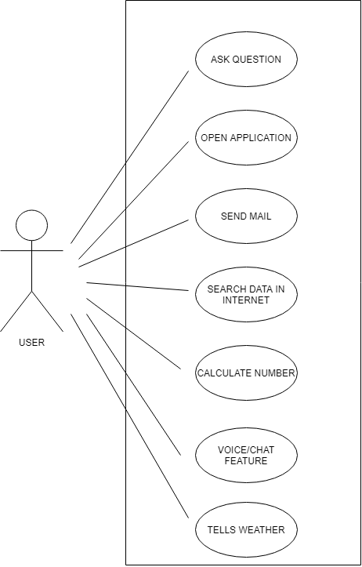

**DATA FLOW DIAGRAM**

1. **ZERO-LEVEL**

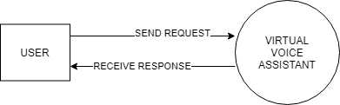

1. **FIRST-LEVEL**

