***SHRI GURU TEGH BAHADUR INSTITUTE OF MANAGEMENT AND INFORMATION TECHNOLOGY***

***MINOR PROJECT***

***FOOD ORDERING WEBSITE***



***Under Supervision of - Submitted by: - VAIBHAV AGGARWAL***

***RAGHAV BABBAR***

***GURU GOBIND SINGH INDRAPRASTHA UNIVERSITY***

***(2018-2021)***

**INTRODUCTION**

It is known globally that, in today’s market, it is extremely difficult to start a new small-scale business and live-through the competition from the well-established and settled owners. In fast pace time of today, when everyone is squeezed for time, the majority of people are finicky when it comes to placing a food order. The customers of today are not only attracted because placing an order online is very convenient but also because they have visibility into the items offered, price and extremely simplified navigation for the order.

Online ordering system that I am proposing here, greatly simplifies the ordering process for both customer and the restaurant. System presents an interactive and up-to-date menu with all available options in an easy to use manner. Customers can choose one or more items to place an order which will land in the cart. Customer can view all the order details in the cart before checking out. At the end, customer gets order confirmation details. Once the order is placed it is entered in the database and retrieved in pretty much real time. This allows Restaurant Employees to quickly go through the orders as they are received and process all orders efficiently with minimal delays and confusion.

* **OJECTIVE**

This study lays out a frame work for a new system to be developed and brought to the market for maximum use and to create an avenue through the web where users can log on to the sever and make a selection of whatever goods or food they like and subsequently pay via the internet. The following are the objectives this would bring:

* Time conversation where products and services offered would provide the customer with all the different categories of available products that they can choose and select from.
* Reduce cost effectiveness where the customer only has to make selection of what goods and they like.
* This will provide a user-friendly environment between the customer and employee thus increasing the efficiency of the food ordering system.
* It will also help for easy retrieval of orders made by the customers
* **HARDWARE REQUIREMENT**
* **Processor:** Pentium-4 class processor or Above
* **RAM:** 128 MB of RAM or Above
* **Operating System:** Windows XP or Above
* **SOFTWARE REQUIREMENT**
* **Front End:** HTML5, CSS, JAVASCRIPT, BOOTSTRAP v4.5.3
* **Language:** Python v3.71 with Django v2.0.13
* **Back End:** MySQL

**E-R DIAGRAM**

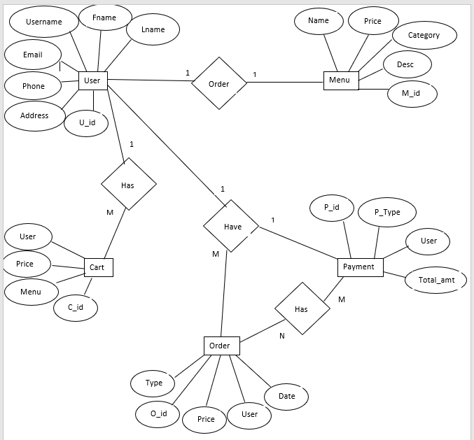

**USE CASE DIAGRAM**

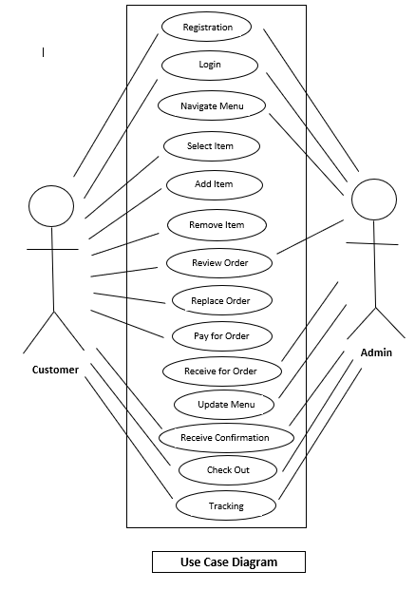

**DATA FLOW DIAGRAM**

1. **ZERO-LEVEL**

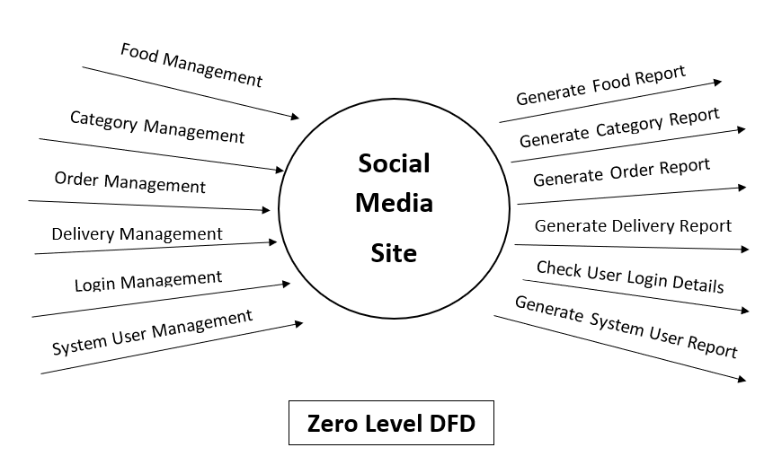

1. **FIRST-LEVEL**

