Channel fading model for indoor propagation in the 2.4GHz ISM band
BabbleSim 2.4GHz channel model

Copyright 2018 Oticon A/S

Licensed under the Apache License, Version 2.0 (the "License");
you may not use this file except in compliance with the License.
You may obtain a copy of the License at

http://www.apache.org/licenses/LICENSE-2.0

Unless required by applicable law or agreed to in writing, software
distributed under the License is distributed on an "AS IS" BASIS,
WITHOUT WARRANTIES OR CONDITIONS OF ANY KIND, either express or implied.
See the License for the specific language governing permissions and
limitations under the License.

---------------------------------------------------------

This license applies both to this component’s source code and documentation, including this file.

Model description
This document describes the expected channel multipath/fading in the 2.4GHz ISM band in indoors conditions, and how the 2G4_Indoorv1 models it, the parameters to tune in different typical scenarios, and simulation results derived from those parameters.
Note that for outdoor conditions, different models are necessary, as in those cases, reflections are farther apart in time, and, in many cases, the line of sight (LOS) path is dominant.
Section 3 provides a very quick introduction and background to the effects and parameters that affect the BLE physical layer performance.
Section 4 gives a description of the properties of the 2.4GHz physical channel.
In section 5, we describe the principles behind the model of the channel, and how it can be utilized to estimate the expected effect on the system (average fading and inter-symbol interference, ISI).
In section 6, we provide a few simulations results using this model and we elaborate a bit on the consequences.
A glossary (“dictionary of technical terms”) can be found in the last section.

Rationale
While designing complex wireless systems working on the ISM band (like BT smart/low energy), specially when the data transported has real time requirements, it is necessary to understand the effect the channel fast fading/multipath will have in the system. Both to understand how it will affect its performance but also as input for other design choices. For example: how wide and deep fading dips will be, what will be the coherence BW of the channel, how fast the channel would change over time, how big ISI it could create, etc.

2.4GHz indoors channel background
When transmitting from one device to another there are several effects to be considered that affect the physical layer performance for BT wearable devices (see Figure 1):
- The Tx modulation and Rx demodulation performance. In BabbleSim this are included in the modem models.
- The effects of the RF channel. These can be characterized with the following impairments:
  - The path loss
  - Fading/Multipath
  - Shadowing
  - Antenna gain/loss and body effect
Note that all these effects happen simultaneously.
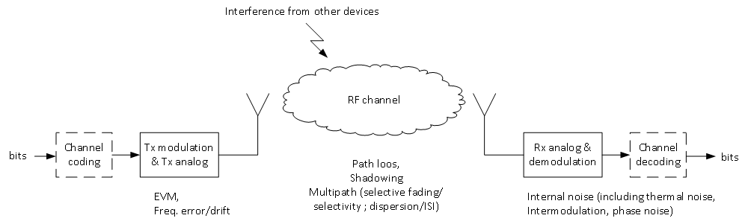Illustration 1: Very simplified diagram of the link layer and some of the parameters that define its performance
Path loss:
The path loss accounts for the average propagation power loss, from the transmitter to the receiver, for a given frequency and distance in a given type of environment.
The path loss indoors for the 2.4GHz band is relatively well understood. It can be modelled as a simple function of the distance. In [1], it is recommended to model it as
Ltotal = 20*log10( f ) + N * 10 * log10d + Lf(n) – 28 (dB),
where
- d is the distance in meters
- f is the frequency in MHz
- Lf(n) accounts for the attenuation when changing floor.
- N (the path loss exponent) would be:
  - 2 for big open rooms (indoors)
  - around 1.8 for corridors
  - around 2.8 as an average for residential buildings including the walls effect inside the same floor (=> Lf(n) = 0)

Fading/Multipath:
Fading accounts for the effects of the signal being reflected/diffracted/scattered multiple times in the medium and arriving with different amplitudes and phases to the receiver. This multiple reflections may contribute constructively or destructively to the received signal. That is, fading is an EM waves interference process, and therefore its effect changes significantly with small movements of the receiver (smaller than one wavelength), and with small variations of the carrier frequency.
In cases in which LOS (line of sight) is not present, or where the antenna is omnidirectional, and the environment allows for reflections of comparable power to the direct path, fading has a major influence in the link. This is the case in the 2.4GHz band, especially indoors.
In the Illustration 5 a realization of the fading process spectrum magnitude over time is depicted.

Shadowing:
Shadowing accounts for slow changing shadowing conditions (moving behind big obstacles). These obstacles are much bigger than the wavelength of the signal.
Shadowing is considered to change with large movements of the receiver/environment (movements much bigger than a wavelength).
Shadowing may be included in the path loss when the placement of the transmitter and receiver is fixed.
Walls may be considered as shadowing or included in the path loss. Their effect is described in [1].
For simulation purposes, shadowing due to walls or other big obstacles could be included as a relatively slow change of the path loss.

In case of the transmitter being placed close to the receiver (less than 3-4 meters), in its line of sight, a person walking in between both would block this line of sight, causing a wideband attenuation of the signal. This attenuation would correspond to removing the LOS (line of sight) component of the signal.
Therefore, the magnitude of this attenuation would be proportional to the ratio of the LOS component power to the scattered power. That is, to the channel Rice_K factor.
The effect of shadowing due to a passer-by in a LOS case, could be modelled both as an increase in the path loss proportional to the lost direct path power, and as a temporal change of the fading Rice_K factor (from a LOS to a NLOS case)

Antenna gain/loss and body effect:
The antenna gain and its matching play an important contribution to the link budget. In many cases, these are mostly constant and therefore can be just included as a part of the link budget.
The effect of the body, both by shadowing and by modifying the antenna radiation pattern is also significant.
From modelling point of view, the effect of the user body shadowing could be treated similarly to the effect described before for a passer-by.

Channel multipath characteristics
Fading is caused by the transmitted signal reaching the receiver via multiple paths through reflections, scattering and diffraction.
As each of these reflections travel through different paths, they will arrive with a slight different offset to the receiver. Similarly, if the receiver or environment are moving, each of these reflections will arrive with a slightly different Doppler shift due to their different incidence angles.
That is, the channel response can be described as a function of the delay (τ) and frequency shift (f_{s}):
Moreover, with movement, these reflections will change over time.
That is, in general, the channel response is a function that changes over time (t): .
A particular realization of the channel () will depend on the exact room shape and content, transmitter and receiver positions and antennas.
In general, one can consider a realization of the channel as a realization of a random process. In the following subsections, we describe the expected characteristics of this channel. That is, the characteristics of this random process.

Average impulse response
In line with the recommendation from [1] the average power delay profile of the channel is assumed to follow an exponential decay. This also fits with measurements as presented in [3] and [4].
That is, the average impulse response of the channel would be:

where
S = delay spread (defined here as the time for a reduction to 1/e in the channel response amplitude = -8.7dB)
τmax >> S
In dBs, this corresponds to:

That is, a straight line with a slope of -8.7dB per delay spread.

Expected delay spread (S)
In measurements done indoors specifically for the 2.4GHz band in [3] and [4], delay spreads between 7-31ns can be seen. Specifically:
([4]) room 3.6m * 5m (height 3.5m) : from 7-23ns
([4]) conference room of 25m*10m (height 3.5m) : 10-30ns
([3]) laboratory of approx. 8m * 10m: 22-31ns

On the other hand, following the ITU recommendation for indoors ([1]) for 1.9GHz, delay spreads of 30 and 70ns could be expected as “typical”. However, in the same document, for 3.7GHz this is reduced to 15 and 22ns. This would indicate the channel delay spread is highly dependent on the frequency in this frequency range.
In the same document, a model to calculate the delay spread from the room area for 2GHz is described. The calculations indicate delay spreads of approx. 25ns should be expected for a room of 25m2, and around 36ns for 100m2.

Therefore, it is chosen to base our expectation for the delay spread on the measurements from [3] and [4]. Based on these, we will consider realistic delay spreads of 10ns, 20ns and 30ns for rooms from medium to big/very big.
Note that this corresponds to the impulse response having tapered approx. 30dB at around 35ns, 70ns and 105ns respectively.

Expected Doppler shift and spread
If either the receiver or elements of the room move, some of the reflected paths would arrive with a slight Doppler shift. The maximum Doppler shift would be fd = v/c*fc. Therefore, a receiver moving at 4km/h (slow paced walking) would experience a maximum Doppler shift of 9Hz. That is, in an environment in which only the receiver moves at 4km/h, we could expect the Doppler spread of the channel to be bounded between ±9Hz.
Consequently, the impulse response could be assumed to be, in average, as depicted in Figure 3, assuming the Doppler spread of the channel is flat for all delays.
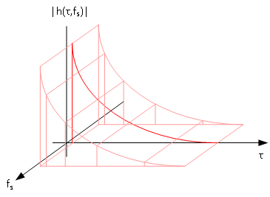Illustration 2: Approximation of the average channel impulse response including Doppler spread
Assuming the Doppler spread of the channel is flat for all delays is a simplification. Still, such an assumption is recommended by ITU for the channel modelling for IMT-2000 (1.9-2.1 GHz) indoors (see section 1.2.2 of [9][8]). Therefore, such a simplification could be considered good enough for our case also.

Note that this Doppler shift and spread would be irrelevant from the receiver performance, as they are anyway much lower than the expected carrier accuracy. In our case, they are only relevant to understand the variations of the channel over time.

Changes of the channel response over time
If the transmitter, receiver and environment were fully static, the channel response would not change over time.
However, given the very short λ of our carrier (approx. 12cm) even small movements of the receiver will cause very significant changes in the phases of the received signals, effectively varying the channel impulse response.
That means that, in general, our channel impulse response, h(τ), will vary over time: it will be h(t,τ).
That is, the channel has an impulse response over τ, but this impulse response varies with t.
In our case τ_{max} (in the order of 100 ns) is much smaller than the coherence time of the channel (in the order of 10ms). That is, in a given time t₀, a transmitted signal would see a static channel response h(t₀,τ).
How fast our channel changes depends on how fast the receiver moves relative to the wavelength of the signal, that is, the time to change our position by one wavelength = λ / v. As v / λ is equal to v*fc/c = Doppler frequency shift, the time to travel 1 wavelength is equal to = 1 / { maximum Doppler shift }.
Where v would be the relative speed of the receiver in m/s, c ≈ 3e8 m/s and fc ≈ 2.45e9.
Therefore, the coherence time of the channel will be inversely proportional to the maximum Doppler shift.
Note though that after we have travelled one full wavelength, the channel would be very uncorrelated. That is, the coherence time is NOT 1 / { Doppler spread }, but depending on the definition of “coherent”, it would be something in the order of 1 / ( 10*{ Doppler spread } ).

Notes on analog vs digital channel response
So far, we have discussed about the channel response as continuous / analog response in time and frequency.

In reality for any propagation environment, the actual channel response will be a set of delta’s, where each delta corresponds to a given propagation path.
In our case, these paths arrivals will be spaced in the order of a few picoseconds apart.

Any receiver will have a limited BW (its input filter will integrate / be convolved with the received signal over time), so the contribution from many paths will be added together.

For all practical purposes, when calculating the impulse response of the channel one can work with a sampled version of the channel impulse response, if the channel response is sampled fast enough compared to the receiver / signal BW.

For our calculations, we will discretize the channel response and sample it into taps.
This sampling of the channel response will need to be fast enough to contain all frequencies we care about. In this particular case (2.4GHz ISM band) as we want to analyze the response over the whole 80MHz band, the sampling frequency of the channel response should be at least 160MHz.
That is, our channel impulse response will be sampled at 1/160MHz = 6.25ns.

Each of this samples / taps of the channel response will therefore integrate the contribution from all the paths which fall into that 6.25ns integration bin.

Note that the channel response we will generate will be a baseband equivalent channel response. That is, we do not need to generate the channel response at the carrier frequency (and sample it therefore at 2*fc) as we can instead shift the response of the channel to baseband, reducing the computational complexity.

Statistical characteristics of the channel taps
Before, we have discussed the characteristics of an average profile/impulse response. In practice, realizations of the channel will have responses that will vary around that average (see the example in [6] and [7]).

Each tap of the channel impulse response will be the result of adding the received signal coming from different paths, which will reach the receiver with slight different phases. For all practical effects, all those contributions will add together so that the resulting signal magnitude can be modelled as a Rice statistical process:

When the received signal process is an offset complex Gaussian distribution:
Received signal = N(0,σ/√2) + 1j*N(0,σ/√2) + ν
the received signal magnitude follows a Rice distribution: Rice(ν,σ)
Where σ² is the accumulated power of all the received reflections (scattering), and ν² is the {power of the direct path}.

Throughout this document, we will refer to the ratio ν²/σ² as the Rice Κ factor, that is, the ratio between the power of the LOS (line of sight) component and the scattered power.
The higher the K factor, the lower the relative amount of received reflected power, and therefore, the lower the effect of the multipath.
When no LOS (direct path) component is present, the tap/bin can be modelled as a Rice with K factor = 0, that is, a Rayleigh distribution. This will be always the case for all but the first tap/bin of the impulse response. It will also be the case for the first bin when there is no LOS to the transmitter.
Illustration 3: Simulated magnitude of a channel realization of an exponentially decaying channel impulse response with S=30ns, where the received power of each bin/tap follows a Rayleigh distribution. And, where the receiver has a time resolution of 6.25ns.

Expected Rice Κ factor:
For the 2.4GHz channel indoors, with LOS conditions, measurements ([7]) seem to indicate the Κ factor tends to reduce quickly with the distance for normal rooms. In this same paper ([7]), the following expression is presented as an approximation for the Κ factor given the distance:

Where R is the distance from the transmitter, and Rd would be 1.6m and 2.78m, and n(f) would be 1.9 and 1.33, for small (4x3.5m) and big (9.5x6.5m) rooms respectively at 3GHz.
If this expression were correct and applicable for 2.4GHz, the K factor to be expected would be:
Big room at 1 m | Big room at 2 m | Big room at 3 m | Big room, at 5 m
K=3.9 | K=1.54 | K=0.9 | K=0.46
Small room, at 1m | Small room, at 2 m | Small room, at 3 m | Small room, at 4 m
K=2.44 | K=0.65 | K=0.3 | K=0.17

In another paper ([8]), K factors from 1.5 and up to 14 where measured (down to quite small distances)
In another paper ([9]), thru ray tracing simulations, in the 2.4GHz band, a Rice K factor of 1.4 was found as a good approximation for transmission in a corridor at 15meters from the transmitter (Note that corridors are known to have a tunnelling effect at this frequencies which also decreases the path loss with distance).
In this other paper ([10]) it is claimed a Rice K of 3dB (K=2) matched well for their LOS case in an office room at 2.4GHz without further explanation.

The conclusion from all these papers is that for LOS conditions, with very short distances (1.5m or less) relatively high K factors could be experienced by the user, mitigating the multipath/fading effects; while at bigger distances (3m or more) very low K factors (effectively 0) are to be expected.

Channel multipath/fast fading model
Based on what has been described in the previous sections a model of the channel fast fading was built in MATLAB, and then ported to C.
This model is based on a wideband tapped-delay line model of the channel impulse response for the whole 80MHz of the 2.4GHz ISM band.
To accelerate the calculations, several optimizations are done based on the characteristics with which it is meant to be used.

Tapped channel impulse response of the whole band:
The channel response is therefore modelled as:

Where Ts is 6.25ns (1/160MHz) to produce a response representing the 80MHz band (fs=160MHz => fs/2 = 80MHz).
Where ai,t are samples of a distribution (with Ricean magnitude) of the correct power and proper correlation over time t.
And where N, the number of taps in the channel impulse response, is so as to truncate the channel response at approximately 30dB of the first tap average level (or 3.5 times the delay spread S ). This corresponds to

This will produce a channel response that would be considered the “equivalent baseband channel response” for the whole band.
Note that we do not filter this channel impulse response by any equivalent receiver pulse shaping filter. This is not necessary as this response is not used for a physical layer simulation directly, but will be used to later generate responses for each individual channel in the band. Each of those channel responses would be the ones that would need to be filtered by the equivalent receiver pulse shaping if necessary.
The taps levels ai,t are generated using the Rice/Rayleigh generators depicted in the following figure:
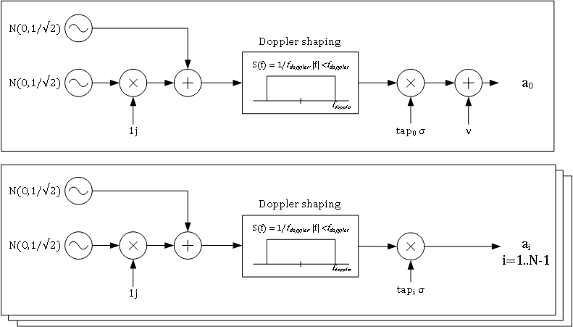Illustration 4: Rice/Rayleigh tap generators
Where the σ of each tap and ν of the first tap are generated as per the following equations:
(1)  Where R2 = Scattered power  ν2 = direct path power  (2)  (3)  S=r.m.s delay spread  (4) | 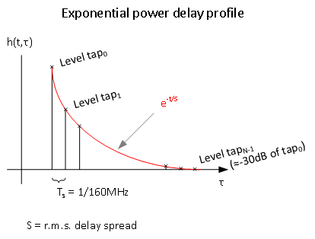

In short:
The taps are scaled (1) so that the total average power of the channel impulse response iso 1 (0 dB). That is, so that the fading process itself would not have any net gain.
The taps’ scattered power level (Level tapi ) follows an exponential power delay profile (3), and is scaled so that all scattered power adds to R2 (4).

What each of these Rice tap generators does, is to generate samples of a random process, which represent the instantaneous received signal level for that particular channel tap/bin. Where samples of this process are correlated over time by the Doppler shaping filter, in the same manner as in reality instantaneous samples of the channel taps response are correlated over time.

The model will generate a new instance of the channel impulse response every Recalc_time. Where Recalc_time is calculated as 1/(MaxDopplerSpread*Oversampling_recalc). And oversampling_recalc is typically set to 16.
That is, it will be recalculated every 7ms if the speed of the receiver is set to 4km/h.
Recalculating it 16 times per the coherence time of the channel (1/MaxDopplerSpread) allows producing a very smooth response in time (no big jumps), while still not having a too high computational load:
- Recalculating the channel response takes only generating 2N Gaussian random numbers, and running the N taps filters for 1 sample.
- These filters are designed as low pass equiriple FIR filters with sufficient length to allow a relatively flat passband (1dB ripple) and relatively big stop band attenuation (50dB) with a quick enough transition. Setting the oversampling factor as 16 sets the transition at fs=0.125π.

Derived results from this channel model

ISM band frequency response
The band frequency response can be then calculated as the Fourier transform (over τ) of our instantaneous channel impulse response. From this response, the first 80MHz are picked as the ISM band response (ChannelResp).
If we recalculated this ChannelResp each time a new channel impulse response is calculated (every Recalc_time), we would have the correspondent set of instantaneous representations of the channel fading over frequency. And example of this can be seen in the figure below.
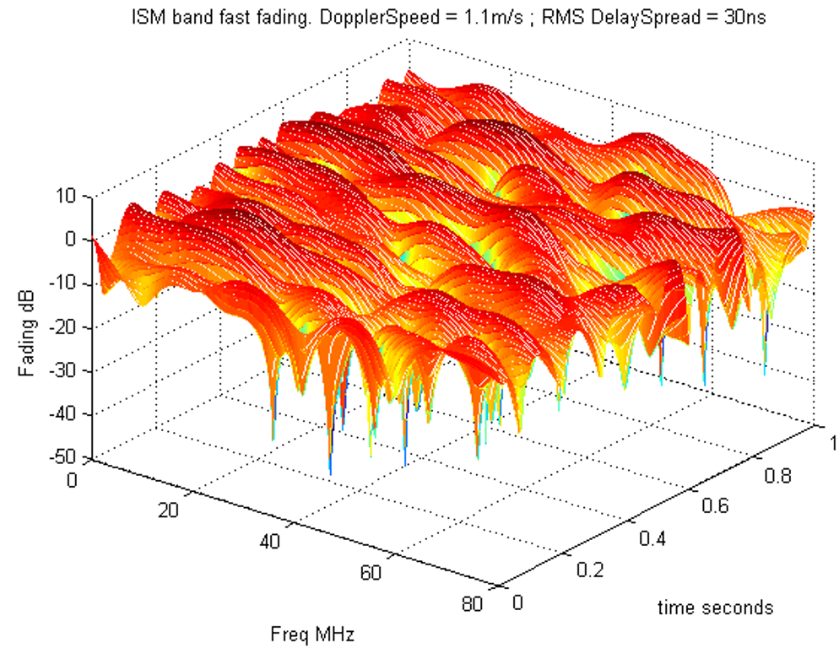Illustration 5: Example of the ISM band frequency response over time due to fast fading
Frequency and channel impulse response for each “channel”

BLE subdivides the 80MHz of the ISM band into multiple “channels”. The transmitter transmits one packet / series of packets in one of these “channels”, and after that, hops to another “channel”. This is done to mitigate the effects of interference and possible fading.
These “channels” can be roughly 1 or 2 MHz wide.
For simulation purposes, one could desire to:
- For physical layer simulations: Generate the equivalent baseband channel for the “channel” that is being used in each moment.
- For higher level/system simulations: Generate a few parameters that would abstract the “channel” response that could be used in simplistic models.

In the first case, to generate the equivalent baseband channel for a given “channel” one could, in time, frequency shift the band instantaneous channel impulse response, filter it with the equivalent pulse shaping of the receiver and sample it at the receivers’ (over)sampling rate. This would be the way to generate a realistic equivalent baseband channel for each given BLE “channel” number.
In the second case, at least the following 2 parameters are consider relevant for high level simulations:
- The equivalent power attenuation/gain due to fading for a channel in a given moment in time.
- The equivalent noise caused by the channel dispersion, that is, inter-symbol interference.
The first one would cause a decrease/increase in the received signal power, effectively lowering/raising the signal SNR by bringing it closer/further to the thermal noise and interference .
The second one would limit the SNR in itself by creating a noise floor relative to the received signal level.
Both of these could be estimated by modelling accurately the way the receiver physical layer works, but this would not be reasonable for a high-level simulation. Instead the following, rough, way to estimate them is used.

Equivalent power attenuation/gain of a given “channel”
Being precise, the transmitted signal would be filtered by the channel impulse response for that “channel”, then by the receiver filtering and pulse shaping, and afterwards sampled at the correct sampling rate in the correct sampling instants. The level of the desired signal after this processing would indicate what effective gain the channel had.
If the exact receiver filtering and pulse shaping are ignored, one could simply assume them to be equal to a perfect band pass filter in frequency (a rectangular filter in frequency, a sync filter in time) of bandwidth ±fs/2. Where fs = sampling rate of the receiver.
This can be done by just picking the carriers (FT taps) from the model ChannelResp from the channel center - fs/2 until the channel center + fs/2. For the sake of clarity, let’s call these frequency taps X[k], with k = 0..N-1, where N is the number of frequency taps between –fs/2 and fs/2.
Then the impulse response of the “channel”, x[n] could be calculated by doing an inverse Fourier transform (IFT) of those taps. The resulting impulse response would already be sampled at approximately the correct times, and the equivalent channel loss/gain could be calculated as the biggest tap amplitude squared.
In the model, this is done but with a couple of simplifications:
- The biggest tap will be in most of the cases the first tap of that resulting impulse response for that “channel”. When this is not the case, the channel is highly dispersive, and the ISI will limit the performance. In such a case, an overestimate of the power loss for that “channel” would not matter.
- One can calculate the power of this first time domain tap directly as

Without the need to calculate the IFT.
Results of the equivalent power attenuation/gain of the channels over time and frequency for different conditions can be found in the next section.

Equivalent noise caused by the channel dispersion (ISI):

To calculate precisely the ISI due to the channel dispersion, one would need to account for the exact shape of the receiver filters and the sampling mechanism. Calculating this accurately, would be out of the scope of a high-level simulation.

Instead, like before, we proceed by assuming that the receiver filtering and pulse shaping will be a perfect rectangular filter in frequency (sync in time), noting that this will underestimate the ISI the channel will create: Any added filtering will have a thicker main lobe in time (less flat response in frequency) than the ideal sync. Therefore spreading (dispersing) more over time the equivalent channel impulse response and increasing the ISI.

The ISI the channel will generate will be equal to the ratio of the strongest tap power to all other taps power. That is, the power spread into other symbols. This ISI can be treated as white noise of power equal to the combined power of those taps; and, therefore, it can be considered as white noise with power relative to the received signal power. That is, if the ISI is -15dB, the SNR is effectively limited to 15dB or less.

To calculate this.
- From the average attenuation calculation done in the previous section, we already have the time tap 0 power ().
- We pick the carriers (FT taps) from the model ChannelResp from the channel center - fs/2 until the channel center + fs/2: X[k], with k = 0..N-1.
- We calculate the average power of all these frequency taps as

- And following Parseval’s theorem

we can derive the power of all other time taps as

- The ISI power ratio is therefore estimated as

Again, with this method we assume the channel is not so dispersive like to significantly move the energy of the signal from the first time domain tap as otherwise we would overestimate it. If that would be the case, the ISI would, with very high likelihood, be higher than -10dB, and overestimating it would not matter, as the packet would be lost anyway.
Results of the equivalent ISI SNR of the channels over time and frequency for different conditions can be found in the next section.

A few simulation results

In this section, we present a few simulation results. These simulations were done with the channel model described in the previous section.
We will show the expected fading profiles, equivalent attenuation each channel would suffer and the equivalent inter-symbol interference (ISI) induced SNR. The last two have been calculated for channels centred each MHz.
Given the amount of parameters to tune and therefore figures that could be generated, just a few are presented here as examples.
More simulations / figures can be easily done by running the first 3 cells of:
matlab/trial_Generate_Multipath_fromFF.m
Note that all plots below, for a given delay spread, correspond to the same fading process realization.
Also, note that all these plots have been done for 4km/h (slow paced walking). Similar effects would be caused by other movements of the receiver or transmitter.

Fading realizations

These figures show a few realizations of the channel over frequency and time.
The channel changes over time due to the receiver moving at 4km/h relative to the transmitter.
The changes over frequency are caused by the multipath itself.
As can be appreciated in the figures, the higher the delay spread of the channel/room the faster the changes will be over frequency.
Note that these plots are for a Rice K of 0, which corresponds to a no line of sight scenario, or to the receiver being more than 3 meters away. A higher K factor will reduce the effect of multipath.
Illustration 6: Channel frequency response over time: Realization of the fading process for delay spreads of [10, 20, 30ns] with a receiver speed of 4km/h, and Rice K = 0 (no LOS to transmitter or far away, >3m )
Note that although the receiver is moving, we do not include here effects of the changing path loss. These plots could be understood as if the receiver was moving in circles around the transmitter.

Effective fading power gain/attenuation
In this subsection, we present the equivalent power attenuation (calculated as described in section 5.1.2.1) that each channel would see for the fading realizations presented in the previous subsection.
Note that when the “effective fading” is bigger than 0, that given “channel” has a net gain in that channel in that particular instant.
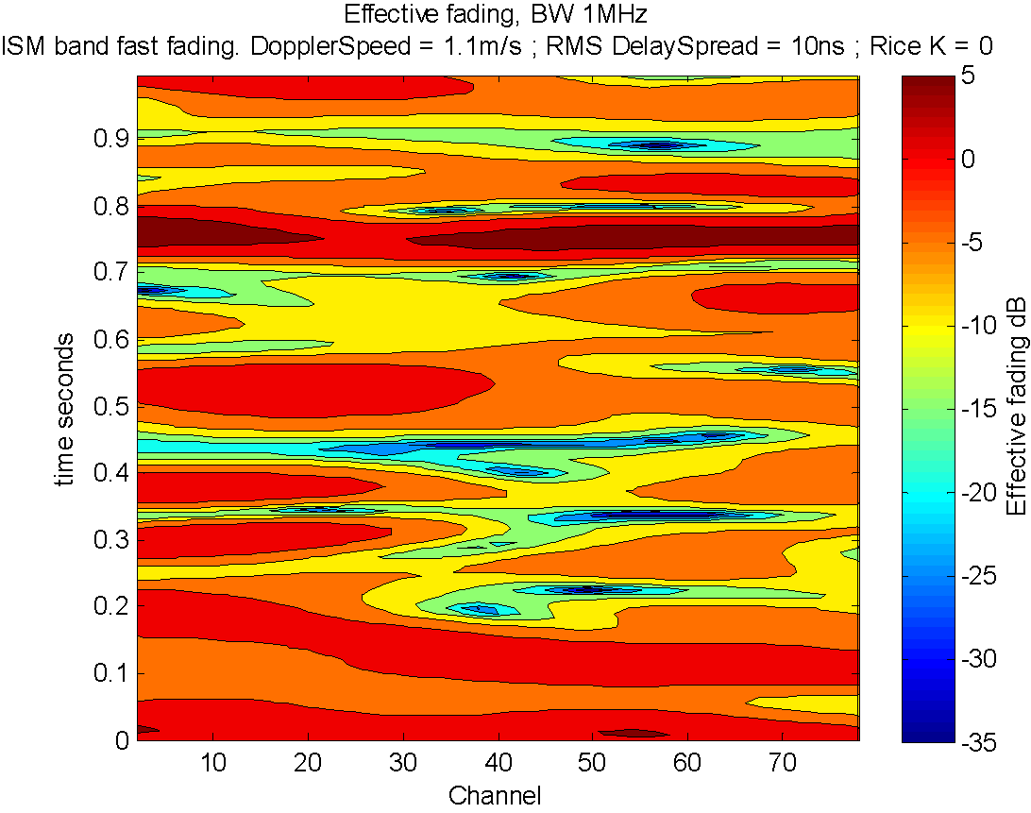
Note: all figures in this section are cropped at -35dB to ease comparison.
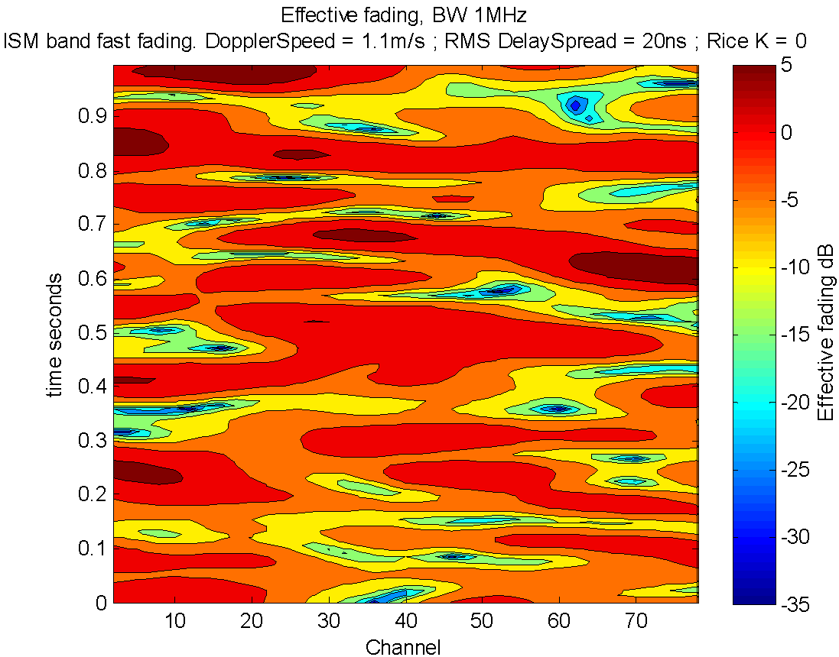
Illustration 7: Equivalent fading over time and channel: Realization of the fading process for delay spreads of [10, 20, 30]ns with a receiver speed of 4km/h, and Rice K = 0 (no LOS to transmitter or far away, >3m ), for BW of 1 MHz

To illustrate the effect of the Rice K factor, here we present the same as in the previous figure but with K=2 instead of K=0.
Illustration 8: Equivalent fading over time and channel: Realization of the fading process for delay spreads of 30ns with a receiver speed of 4km/h, and Rice K = 2 (transmitter in LOS of receiver, around 1 or 2 meters away), for BW of 1 MHz
Illustration 9: Probability of fading dip depth for Rice K factors from K= 0 (no LOS or 3+m from transmitter) to K = 5 (very close, ≈ 1m, with line of sight to transmitter)

Equivalent SNR due to channel induced ISI

For BLE modems, typically the receiver will not have a channel equalizer. In this case the inter-symbol interference effectively sets a limit to the signal quality at the receiver. This is due to each desired symbol arriving at the receiver with an overlapped noise due to the dispersion in time of all other transmitted symbols (bits) of the packet over that first symbol.
Therefore, it is relevant to calculate the relative noise the inter-symbol interference will cause. This noise will then be combined with the remaining noise sources in the system.
By analyzing the SNR caused by the inter-symbol interference alone, we can understand one of the limits set by the multipath in the system performance.
This SNR is defined as the power of a given symbol relative to the power of all neighbor symbols, which are dispersed into that first symbol (contributing effectively as white noise).
When this SNR is 10 dB or lower, a packet reception would not be possible independently of how good the reception would be otherwise. That is, in the figures below, no packets will make it thru in the cyan & blue areas.
In this section, we present the equivalent SNR caused by inter-symbol interference (ISI) for the same 30ns realization as presented in the previous subsections. In this case, we focus on the effect of the signal BW.
Note that in all this figures the SNR is capped to 30dB for ease of comparison.
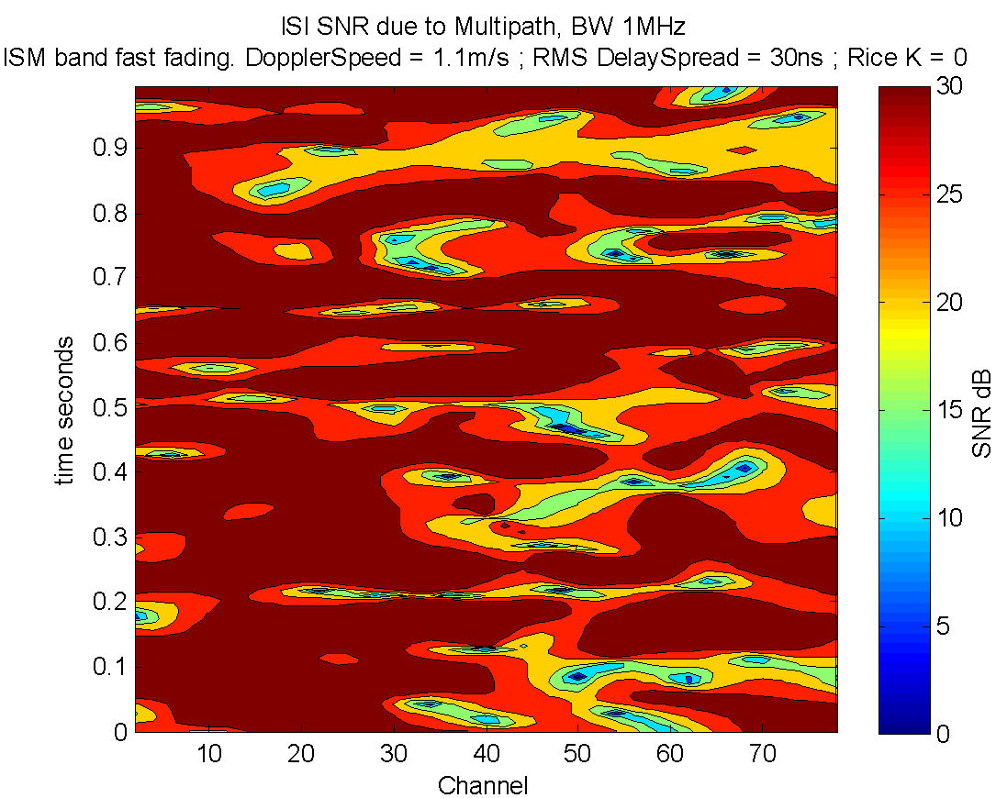
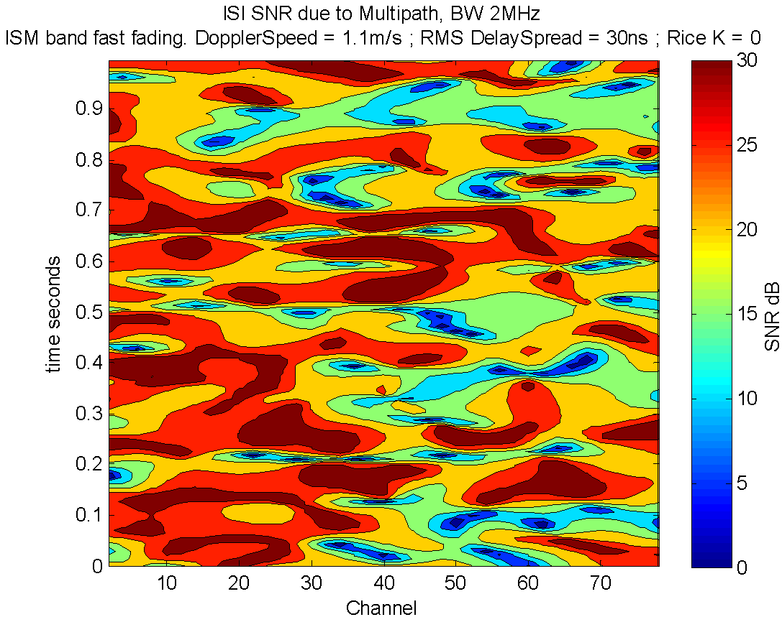
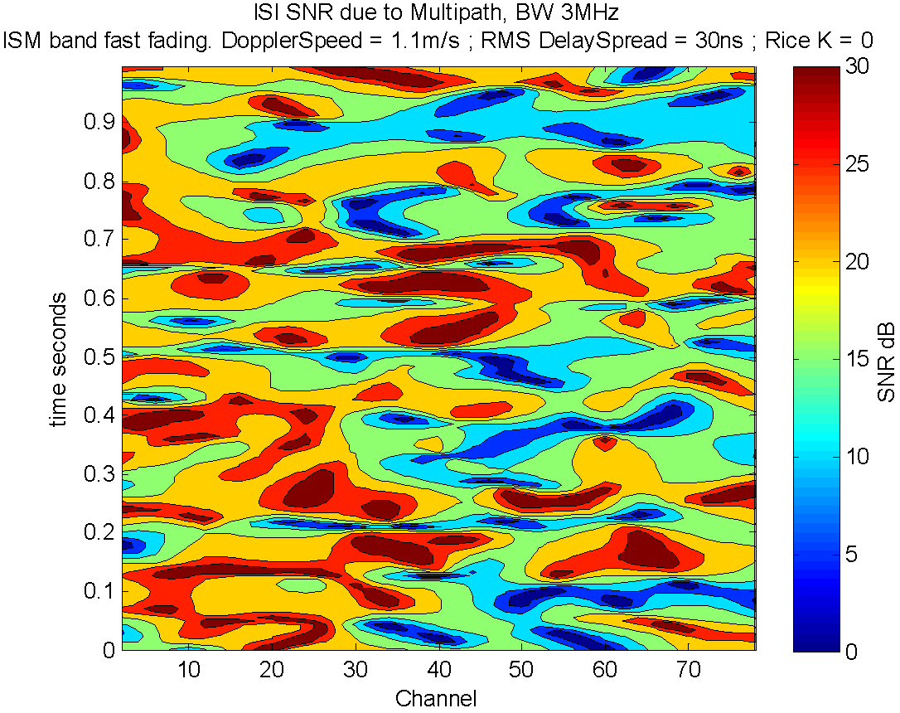Illustration 10: Equivalent ISI SNR limit over time and channel: Realization of the fading process for delay spreads of 30ns with a receiver speed of 4km/h, and Rice K = 0 (no LOS to transmitter or far away, >3m ), for BWs of [1,2,3] MHz

As expected, when everything else is equal, the higher the signal BW, the bigger the effect of dispersion will be.
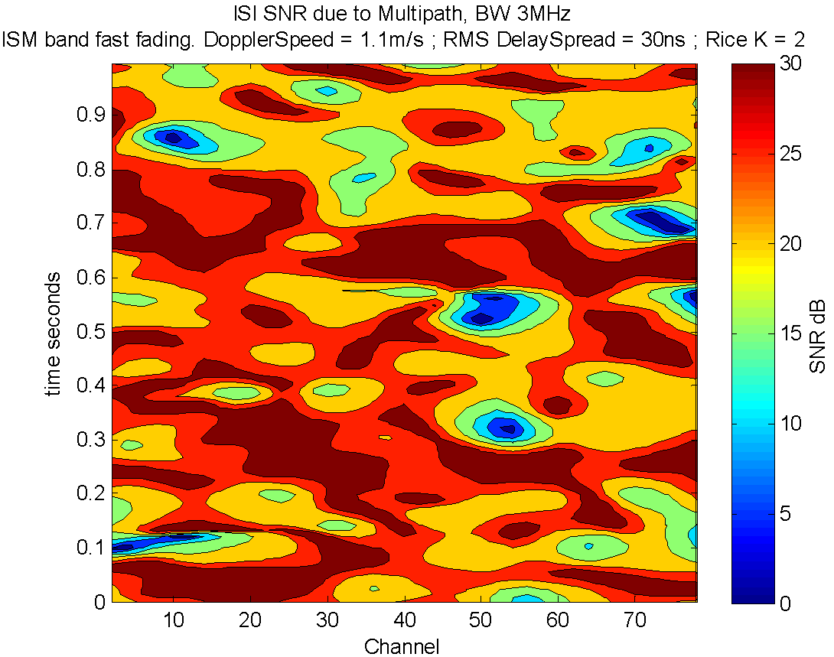Illustration 11: Equivalent ISI SNR limit over time and channel: Realization of the fading process for delay spreads of 30ns with a receiver speed of 4km/h, and Rice K = 2 (transmitter in LOS of receiver, around 1 or 2 meters away), for BW of 3 MHz

Probability of the SNR due to multipath induced ISI being less than X dBs

Based on the method described in the previous section, the probability of the SNR being limited by the multipath ISI to less than some given level is plotted below for different settings.
These plots can be understood as the area in the contour plots in section 6.3 above
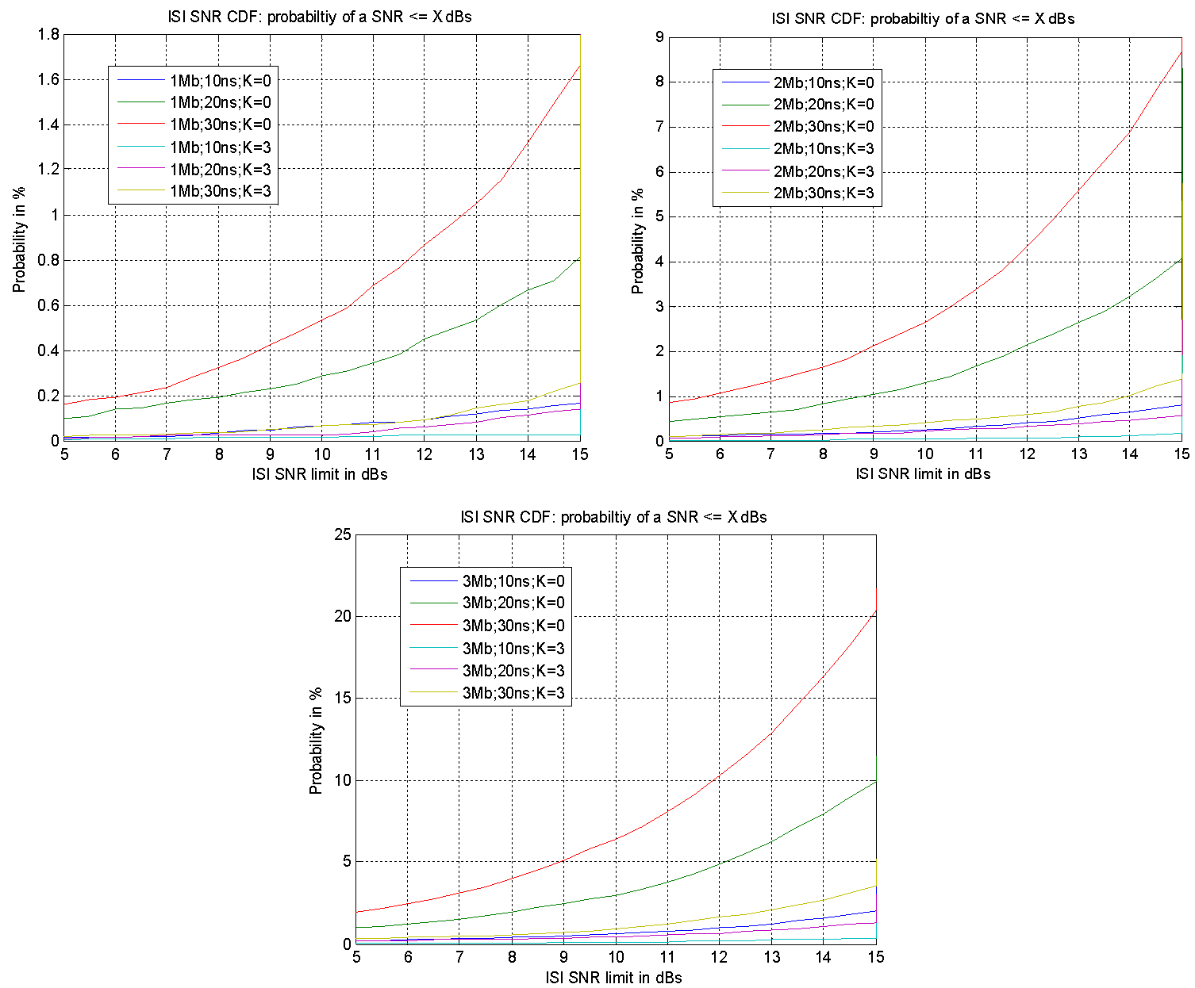Illustration 12: SNR limit due to ISI (intersymbol interference) from multipath. For 1,2 and 3MHz|Mbits/s|Msymbols/s , 10,20 and 30ns delay spread and direct line of sight (K=3) at approx.1.5m , or no line of sight (K=0) or more than 4 meters from transmitter
Note that roughly, the receiver will need a SNR of around 10-15dB to receive a packet (This depends on the exact modulation and receiver performance. 10dB corresponds approx. to a BER of 10⁻³ for an ideal coherent 2FSK receiver).
A quick calculation shows that this probability is approximately directly proportional to the square of the BW, and directly proportional the square of the delay spread.

( S= delay spread of the channel )
That is, for 2Mbps, we will lose 4 times more packets due to multipath than at 1Mbps. And for 3Mbps 9 times more than at 1Mbps.
Similarly, if the delay spread of the channel due to the room is doubled from 10ns to 20ns, we should expect 4 times higher packet loss due to multipath.
These plots are generated by generating a fading realization during enough time, applying the method described before to calculate the SNR due to the multipath induced ISI in a discrete grid of times and channels; and using these SNR values as samples for which to calculate the CDFs (cumulative distribution function) plotted above.
Note that for this calculation we assume that the receiver BW is equal to the bit rate and equal to the symbol rate; and that the receiver filter is an ideal rectangular filter.

References
- ITU recommendation P.1238-7, “Propagation data and prediction methods for the planning of indoor radiocommunication systems and radio local area networks in the frequency range 900MHz to 100GHz”, 2012
- “Multipath channel parameters for the indoor radio at 2.4GHz ISM band”, Hans-Jürgen Zepernick, Tadeusz A. Wysocki, 1999
- “Short range propagation measurements at 2.4, 4.5 and 11.5GHz in indoor and outdoor enviroments” (FEL-92-B154), G.J.M. Janssen, 1992
- “Channel models for TG8” IEEE P802.15
- ITU-R M.1125 “GUIDELINES FOR EVALUATION OF RADIO TRANSMISSION TECHNOLOGIES FOR IMT-2000”
- “Indoor Channel Spectral Statistics, K-factor and Reverberation Distance”, Yochay Lustmann and Dana Porrat
- “Channel Measurements of an Indoor Office Scenario for Wireless Sensor Applications”, Shurjeel Wyne, Telmo Santos, Fredrik Tufvesson, Andreas F. Molisch.
- “Assessment of Multipath Propagation for a 2.4 GHz Short-Range Wireless Communication System”, Tommy Hult, Abbas Mohammed, 2007
- “A comparative study of STBC transmissions at 2.4 GHz over indoor channels using a 2 × 2 MIMO testbed”
http://www.researchgate.net/profile/Jose_Garcia-Naya/publication/220098194_A_comparative_study_of_STBC_transmissions_at_2.4_GHz_over_indoor_channels_using_a_2__2_MIMO_testbed/links/09e41505c470e29050000000

Glossary

Coherence bandwidth of the channel: Bandwidth over which the channel frequency response is considered “flat”. This is a very vague term, which in some textbooks is defined as the width of the channel frequency response autocorrelation function main lobe (at some dBs). The coherence BW of the signal is inversely proportional to the delay spread of the channel.
Coherence time of the channel: Duration over which the channel can be considered static/non changing. This is also a very vague term, which in some textbooks is defined as the width of the channel time response autocorrelation function main lobe. The coherence time of the channel is inversely proportional to the Doppler spread.
Delay spread: Measure that indicates the duration of the channel impulse response. That is, how dispersive in time the channel is. In this document we use as delay spread (S), the time it takes (in average) for the channel amplitude to taper to 1/e.
Doppler shift: A propagating wave that is transmitted, received or reflected from a moving object will have its frequency shifted (Doppler effect). The Doppler frequency shift fs = v*fc/c. Where v = speed of the object, fc = frequency of the signal, and c = propagation speed of the wave.
Doppler spread: Measure that indicates the spread of the frequency shifts of the signal over the channel due to Doppler effect of the different reflections. In this document, it is arbitrarily defined as the maximum expected Doppler shift of all reflections.
Power delay profile: Gives the intensity of a signal received through a multipath channel as a function of time delay. The time delay is the difference in travel time between multipath arrivals.

Lf(n) refers to the walls / floors attenuation if the transmitter and receiver and not placed in the same room / floor.
The ITU recommended simulation channels for indoors for IMT-2000 (1.9-2.1GHz) has delay spreads of 50 and 100ns.
The Doppler shift of each reflection depends on the angle between the trajectory of the receiver and the reflection direction. In general, reflections would come from all possible directions, therefore having Doppler’s shifts in between ± the maximum Doppler shift.
It is known that depending on what moves, be it the receiver or objects in the environment, the Doppler spread shape will change significantly. Still what the Doppler spread shape changes is the manner in which the channel changes over time. However, nothing in a BLE like system is especially sensitive to the exact manner in which the channel changes over time (our packets are much shorter than the coherence time of the channel and reusing of the same channel will normally occur quite far apart, normally more than 1 coherence time of the channel apart). Therefore, a BLE like system performance is not expected to depend on the exact shape of the Doppler spread, that is, of the exact shape of the autocorrelation of the channel over time.
Or objects moving in the environment.
All filters have the same coefficients
The actual filter design choice is most likely an overkill. However, as the calculation time due to this filtering is quite small it wasn’t considered important. At the start, M-1 samples of the channel will be generated and discarded to feed the filter delay lines. Where M is the filters length.
The exact width of the channels depends on the exact modulation and filter configuration used.
This equivalent pulse shaping should include also relevant RF, IF and BB filtering effects.
This process could also be done partially in frequency domain by selecting the relevant part of the frequency response, multiplying it by the equivalent pulse shaping frequency response and doing an inverse Fourier transform at the correct sampling rate.
Note that for simulation purposes one should also consider that an equivalent but independent fading process applies to interferers.
An ideal rectangular filter would have gain 1 for those taps, and 0 for all others.
Assuming the FT / IFT gains had been properly compensated for
It has been confirmed that the properties of the noise created by the ISI match well enough Gaussian noise ( matlab/Check_ISI_propert.m ) by comparing this noise CDF with Gaussian noise of the same power even with no pulse shaping.

