WLAN channel activity model
BabbleSim 2.4GHz interference model

Copyright 2018 Oticon A/S

Licensed under the Apache License, Version 2.0 (the "License");
you may not use this file except in compliance with the License.
You may obtain a copy of the License at

http://www.apache.org/licenses/LICENSE-2.0

Unless required by applicable law or agreed to in writing, software
distributed under the License is distributed on an "AS IS" BASIS,
WITHOUT WARRANTIES OR CONDITIONS OF ANY KIND, either express or implied.
See the License for the specific language governing permissions and
limitations under the License.

---------------------------------------------------------

This license applies both to this component’s source code and documentation, including this file.

Introduction

This document describes the model behind the ext_2G4_device_WLAN_actmod component. This is a model of the channel activity generated by one WLAN network / access point.

This model, although very simplistic generates patterns of channel occupancy similar to what a real WLAN would generate while its underlying traffic pattern would remain static. That is, this model does not include variations of traffic workload. Instead, it generates realistic enough channel activity/occupancy for a given traffic workload.

For example if a VoIP application, or big file download would be running, its traffic pattern would be relatively constant and accurately modeled by this model. On the other hand, arrival and departure of applications / sessions / users are not modeled.

This model can be utilized to analyze the performance of 2.4GHz systems that will coexist with WLAN networks.

Note that this model is highly simplified: The whole link & MAC layer are reduced to a semi-Markov model with 2 states (active & idle). The time in each of these states is modeled statistically. Although highly simplistic, this generates occupancy patterns, which for the stated purposes should be representative enough.

Rationale and background

In the 2.4GHz band coexist many 802.11 WLAN systems. These systems transmit with high bandwidth ( ≈20MHz ) and high power ( 20dBm ) blocking a significant part of the band.

To design or analyze the performance of a system that will coexists in this band the interference caused by WLANs should be accounted for.

Although a WLANs transmitting in a channel causes severe interference for other systems, its average duty cycle is very low (see [5]). Therefore, other systems can normally coexist even in the same WLAN channel.

In [2] the duty cycle of an 802.11g WLAN in different conditions was measured when one node was running one particular application. This clearly indicated that for most WLAN networks the duty cycle will be under 5%, 90% of the time.

Model description

This model is based on the proposal for a channel occupancy model described in [1]. In short:

The WLAN physical layer is contention based. After a transmission has finished, and the ACK received, devices will wait for a predefined amount of time (DIFS). Once this time has passed, all devices willing to transmit will randomly select a slot inside the following contention window. Once the device reaches that slot, if no other device had already started transmitting it will start transmitting. If no collision occurs and the transmission succeeds, a predefined amount of time after the transmission finishes (SIFS), the receiver sends an ACK. If a collision occurs, the contention window size is increased and the devices draw a new slot and the contention process starts again.

In some cases, no new data will be available to transmit, and a silent period will follow.

This activity can be modeled with the semi-Markov chain on the figure below (left side).
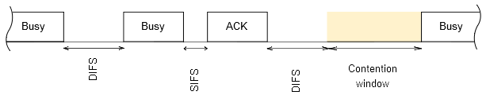Illustration 1: Modem access in a 802.11b WLAN
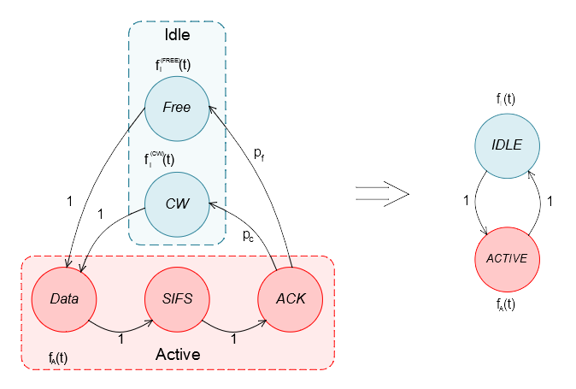

Where pc is the probability of a node having a new packet to transmit right after the previous transmission and pf = (1 - pc) being the probability of no node having anything to transmit right after.

Given that the SIFS time is very short (10-16µs depending on the 802.11 version), this chain can be further simplified as shown on the right side of that same figure.

The model will always transition from one state to the other (IDLE <-> ACTIVE). How long it will reside in each state ( fI(t) and fA(t) ) is drawn from a statistical distribution after each transition.
fA(t) is the distribution that represents the time spent in the active state, and is therefore:

where ,
and HeaderSize and ACKTime are constants (dependent on the data rate).
The PacketSize can be simplistically modeled as a uniform distribution in between a representative minimum and maximum packet sizes for the given traffic.

fI(t) is the time spent in the idle state, and is therefore split in 2 parts:
- with probability p, it will be fi(CW)(t) . That is, a new packet was ready to be transmitted right away in one of the nodes, and therefore we just wait for a contention window),
- and with probability (1-p), fi(FREE)(t). That is, no new packet was ready. fi(FREE)(t) being the wait time before any node in the network will have a new packet to transmit.
Where fi(CW)(t) can be modeled as a Uniform distribution between 0 and twice the average contention time.
And where fi(FREE)(t) (the arrival of new packets) is quite accurately modeled as a Generalized Pareto distribution ([1]). Where the parameters of this Pareto depend on the traffic density and type.

Note that the length of the SIFS and DIFS timings, contention window minimum and maximum sizes, and headers and ACK relative sizes depend on the version of the 802.11 standard used. The data rate used is also variable depending on the link conditions and version of the standard used. Therefore, all these are left as parameters for the model.

The probability of having a new packet to transmit right after (p), the packet minimum and maximum sizes, and parameters of the generalized Pareto distribution are also left as parameters of the model.

Parameter sets

As described in the previous section, the following parameters can be configured in the model:
- PacketMinSize: Minimum size of the packets (in bytes)
- PacketMaxSize: Maximum size of the packets (in bytes)
- p : probability of having a new packet right after finalizing transmitting a previous one.
- sigma : Generalized Pareto scale factor (in ms)
- kappa: Generalized Pareto shape factor.
- DataRate: One of the possible WLAN datarates {1,2,5.5,6,9,11,12,18,24,36,48,54} Mbps.
- PacketHeaderSize: Size of the packet header in “bits” for that datarate, including the preamble.
- SIFS: in µs, time between the data packet and ACK.
- AveCWSize : Average contention window size (in µs)
- ACKBe : ACK duration in bits at DataRate (will be added to ACKT)
- ACKT: ACK duration in µs (will be added to ACKBe)
- BeaconPeriod: in seconds, period of the WLAN beacons (fI(FREE)(t) will be capped to this value).

Effectively all red parameters above are given by the WLAN configuration and link state, while the blue parameters are given by the traffic type.

To simplify the use of the model several sets of parameters are provided. All are tuned for an 802.11g WLAN at 54Mbps with 1 user:
- ‘VoIP’ : Models a WLAN with one node having a VoIP call.
- ‘VideoConf’: Models a WLAN with one node having a Videoconference call.
- ‘FileDownload’: Models one node downloading a very big file (effectively saturating the WLAN connection).
- ‘50’ / ‘25’ / ‘10’ / ‘5’ : Cases modeling one node driving traffic at an average of 50% / 25% / 10% / 5% of the maximum WLAN capacity. Note that these parameters sets have been tuned for 54Mbps datarate, changing the datarate will alter significantly the “percentage” of the WLAN capacity which is used.

Note that decreasing the data rate, effectively increases the channel occupancy for the application / packet arrival pattern, as the same amount of data will take longer to be transmitted.

References

- “Dynamic Spectrum Access in WLAN Channels: Empirical Model and Its Stochastic Analysis”, Stefan Geirhofer, Lang Tong & Brian M. Sadler.
- “Determination of the duty cycle of WLAN for realistic radio frequency electromagnetic field exposure assessment”, Joseph W. et al.
- “Closing the gap between traffic workload and channel occupancy models for 802.11 networks”, I. Glaropoulos, A. Vizcaino Luna, V. Fodor, M. Papadopouli.
- “Cognitive Medium Access: Constraining Interference Based on Experimental Models”, Stefan G., Lang T., Brian M.
- “Dynamic spectrum access in the time domain: Modelling and exploiting white space”, Stefan Geirhofer, Lang Tong & Brian M. Sadler.

% of the time the channel is occupied by the WLAN
Note that in reality the contention time varies depending on the number of collisions / devices present willing to transmit. Nonetheless, a simple approach is just to consider all contentions equally distributed as U(0, 2*AverageCWSize). Where the AverageCWSize would be the average contention window size for a given traffic load.

