Brain MRI Classification
Using Regional Grey Matter Volumes
Xinsheng Liu (550314295) and Yue Xia (550500315)
ELEC5622 · Project 1
Abstract. Regional grey matter volumes were used to classify Alzheimer’s disease (AD) and normal control (NC) subjects from 50 T1-weighted MRI scans. Brain extraction, tissue segmentation and template-to-native registration produced grey matter volume features for the first 90 AAL regions. A StandardScaler and RBF support vector machine were evaluated using stratified five-fold cross-validation on 40 training subjects and then fitted to the complete training set. Mean cross-validation accuracy was 97.5%. On the 10 held-out subjects, accuracy was 90%, AD sensitivity was 83.3% and NC specificity was 100%. The small test set and residual preprocessing limitations restrict the conclusions and motivate further independent validation.

1. Aims and Background

1.1 Background and Rationale
Previous MRI studies have reported grey matter atrophy in multiple brain regions in patients with Alzheimer’s disease (AD) [1]. These findings provide evidence of an association between brain structure and AD. Other research has used structural MRI and support vector machines (SVMs) to distinguish patients with AD from normal controls (NC) [2]. Based on this background, this project uses regional grey matter volumes as numerical features to investigate their usefulness for classifying AD and NC subjects.
Using a predefined AAL parcellation [3] gives each volume feature a consistent anatomical identity across subjects, while reducing each scan to 90 numbers. This makes the relationship between preprocessing and classification explicit: extraction or registration errors can change the measured features. A 2024 systematic review describes diversity in MRI-based classifiers and validation procedures [4]. We therefore evaluate one specified pipeline on the supplied split, rather than claiming clinical diagnostic performance.

1.2 Project Aims
This project aims to develop a complete workflow from brain MRI processing to the classification of Alzheimer’s disease (AD) patients and normal controls (NC). First, brain extraction, tissue segmentation, image registration and volume measurement are performed to obtain grey matter volumes from the first 90 regions of the AAL atlas for each subject. Next, these features are used to train an SVM classifier using data from 40 training subjects, with feature standardization performed within each cross-validation fold to avoid data leakage. Finally, the trained model is used to predict the labels of 10 test subjects, and its predictive performance is evaluated. Through these tasks, the project integrates the brain image processing techniques from Lab 1 with the machine learning classification methods from Lab 2.

2. Contributions of Team Members
Table 1. Contributions of team members
Team member | Contributions | Share
Xinsheng Liu | Primarily responsible for code implementation and computational experiments, including completing the preprocessing scripts, adjusting BET parameters, extracting regional grey matter volumes, and implementing SVM training and evaluation. Also organized the code, execution records and output files. | 50%
Yue Xia | Primarily responsible for reviewing the processing workflow and representative results, selecting and explaining figures, reviewing relevant literature, and writing and organizing the report. Also checked the consistency of the reported methods and results with the project materials. | 50%
Both team members contributed equally to the project, with different primary responsibilities.

3. Methodology

3.1 Dataset and Experimental Design
In this project, we use T1-weighted MRI scans from 50 subjects. Data_00–Data_39 are used as the training set, and Data_40–Data_49 are used as the test set. The instructor provided the AD/NC labels. After feature extraction, we obtain grey matter volumes from the first 90 regions of the AAL atlas for each subject. These 90 values form the feature vector used for classification. We use the 40 training subjects to train the SVM classifier and perform five-fold cross-validation. This process is explained in Section 3.7. Finally, we evaluate the model using the 10 test subjects. Their labels are only used to check the predictions, not to train the model or select its parameters.

3.2 Overview of the Processing Pipeline
Figure 1 summarises the workflow from MRI preprocessing to regional grey matter volume extraction and SVM classification.
As shown in Figure 1, we first perform brain extraction and tissue segmentation on the original MRI scans to obtain grey matter masks and grey matter intensity images. Next, we use affine and nonlinear registration to determine the transformations needed to map the AAL atlas into each subject’s native space. We then intersect each ROI mask with the grey matter mask and measure the grey matter volumes in the first 90 regions of the AAL atlas. These volumes form the feature vector for each subject. Finally, we standardize the features and use an SVM classifier for model training, cross-validation and test set prediction.
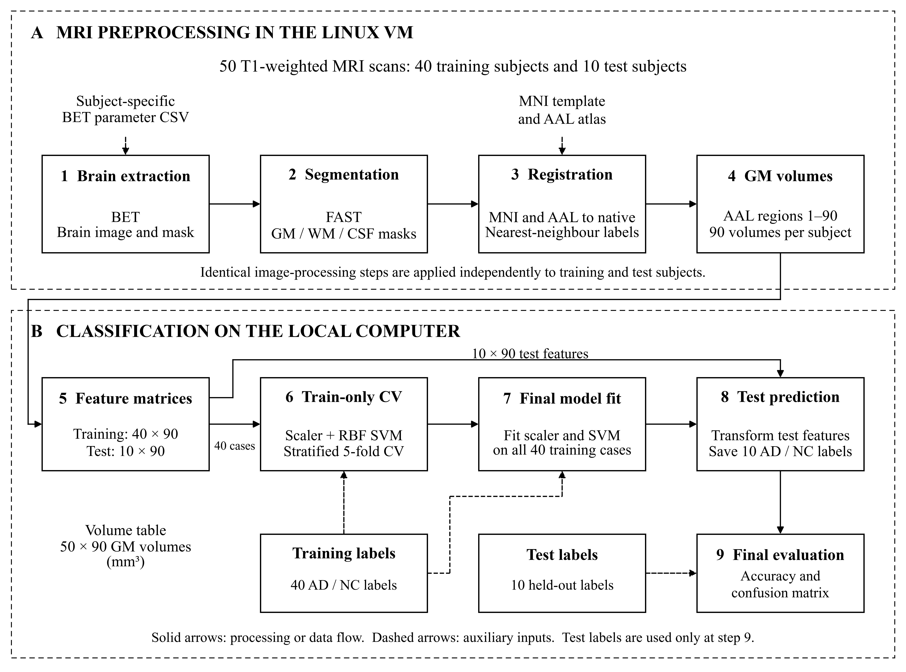
Figure 1. Processing and classification workflow. Dashed boundaries distinguish the Linux VM and local computer. Test features bypass model fitting; held-out test labels are used only after predictions have been saved.

3.3 Brain Extraction
The original T1-weighted MRI images contain both brain tissue and non-brain tissue. In this project, we use FSL’s Brain Extraction Tool (BET) to remove non-brain tissue and reduce its influence on subsequent tissue segmentation. The script reads the settings for each subject from the parameter table and processes the images in batches. This step produces brain-extracted images and binary brain masks. The brain-extracted images are then used for tissue segmentation in the next step. BET uses a deformable surface to separate brain from non-brain tissue [5].
Perform brain extraction and generate a binary brain mask for Data_00:
bet Data/train/Data_00.nii Output/train/Data_00_brain.nii.gz \
-f 0.3 -g 0 -c 109 165 82 -m
This command takes the original MRI of Data_00 as input and saves the brain-extracted image. The parameter -f sets the fractional intensity threshold to 0.3, while -g 0 applies no vertical threshold gradient. The parameter -c specifies the initial brain center at voxel coordinates (109, 165, 82). The option -m also produces a binary brain mask.
Moreover, this command shows the settings for Data_00. For batch processing, the Skull Stripping script reads the parameters for each subject from bet_parameters.csv and runs BET on the training and test images. The four main scripts run in the order SkullStripping, TissueSegmentation, Registration and Measurement; the last calls the supplied, unmodified CreateSeedMask helper. Representative commands are collected in Appendix A.

3.4 Tissue Segmentation and Grey Matter Image Generation
After completing brain extraction, we use FSL’s FAST to segment the brain images into three tissue classes: grey matter, white matter and cerebrospinal fluid. We also generate a binary mask for each tissue class. Next, we multiply the brain-extracted image by the grey matter mask to obtain the grey matter intensity image. This image retains the original MRI intensity values in the grey matter regions and sets the remaining voxels to zero. The grey matter masks are then used to measure regional grey matter volumes. FAST combines a hidden Markov random field model with expectation-maximization [6]. We use its binary GM mask for volume measurement, rather than summing tissue probabilities. Appendix A.1 gives the FAST and masking commands; Figure B2 shows the resulting GM intensity image.

3.5 Image Registration and AAL Atlas Transformation
To locate the AAL brain regions in each subject, we first register the MNI template to the subject’s native space. We use affine registration for global alignment, followed by nonlinear registration to account for local structural differences. We then apply the resulting transformation to the AAL atlas. During resampling, we use nearest-neighbor interpolation to preserve the discrete brain region labels. The transformed atlas is then used to define the regions for grey matter volume measurement. These operations use NiftyReg [7] and the supplied AAL atlas [3]. The subject brain is the reference image, and the original MNI template is the floating image in both registration stages. Appendix A.2 gives the commands.

3.6 Regional Grey Matter Volume Extraction
Inputs and ROI definition. Measurement uses the native-space AAL label image and binary GM mask produced by the preceding stages. Their voxel grids must match. The unchanged CreateSeedMask helper isolates each atlas label with thresholding and binarization; Measurement selects labels 1–90. Figure 2 illustrates label 1 for Data_00.
Restricting the GM mask. For each region, the binary ROI mask selects voxels from the binary GM mask. Only voxels that belong to both masks contribute to the measurement. This intersection excludes white matter and CSF from the regional count; image intensity is not summed.
Physical volume. We run fslstats on the GM mask, selecting the ROI with -k. Its -V output gives the non-zero voxel count followed by physical volume in mm³. Volume is the complete 3D intersection count multiplied by voxel volume from the image header. The displayed slice is illustrative; counting uses all slices. Appendix A.3 provides the command.
Feature export and checking. We save the second -V value and repeat for all 90 regions. Each CSV row contains one subject ID followed by ROI_1_mm3 through ROI_90_mm3, giving 40 × 90 training and 10 × 90 test matrices. For the illustrated case, 6109 GM voxels give 6523.223317 mm³, matching the stored ROI_1_mm3 value. IDs and disease labels are excluded from the feature matrix.
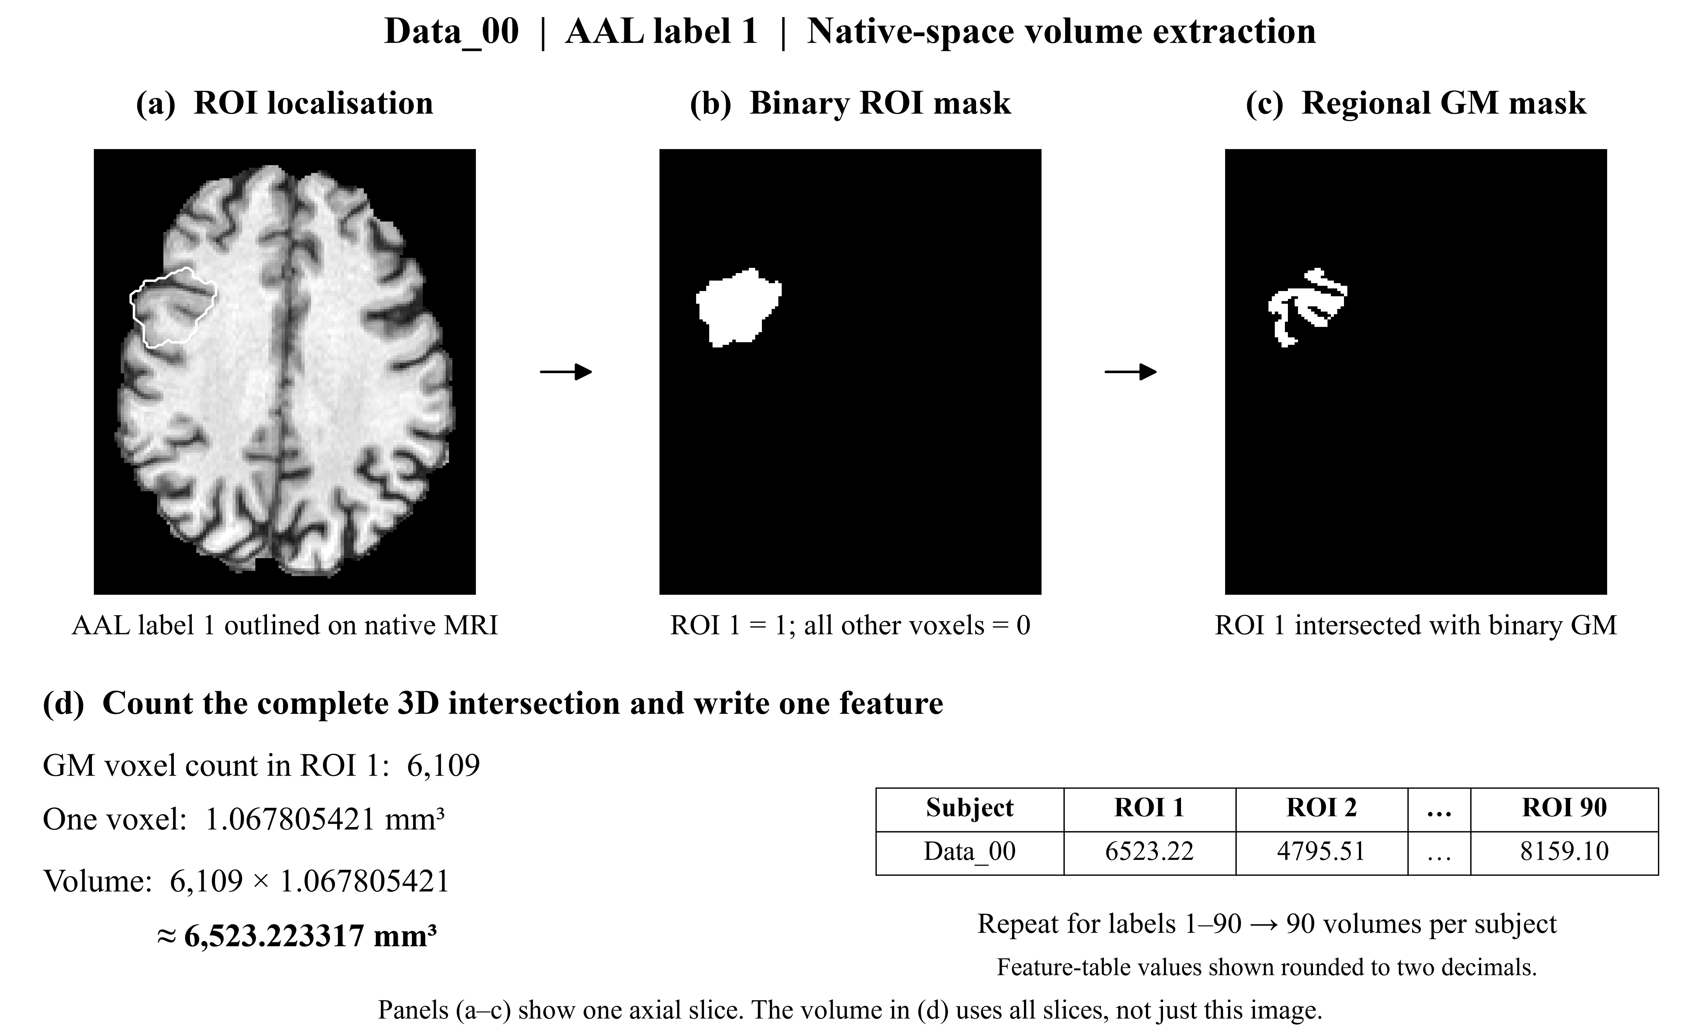
Figure 2. Regional GM volume extraction for Data_00, AAL label 1. (a) Native MRI with ROI boundary; (b) binary ROI mask; (c) its intersection with the binary GM mask; (d) full 3D voxel counting, conversion to mm³ and feature export. The slice is illustrative; volume uses all slices. Displayed feature-table values are rounded.

3.7 Feature Standardization and SVM Classification
Before classification, we standardise the 90 volume features using StandardScaler. For each feature, we subtract the mean and divide by the standard deviation calculated from the training data. This puts features with different numerical ranges on a comparable scale. We use an SVM classifier with a radial basis function (RBF) kernel, with C set to 1 and gamma set to ‘scale’.
The RBF kernel allows a nonlinear decision boundary in the volume-feature space. C controls the trade-off between regularization and fitting the training data; larger C penalizes training errors more strongly. Gamma controls the spatial reach of the RBF similarity function. In scikit-learn, gamma="scale" is calculated as 1 / (number of features × variance of the training matrix supplied to SVC), here after standardization [8]. These are fixed baseline settings, not parameters optimized on the test set.
We perform stratified five-fold cross-validation on the 40 training subjects. The data are divided into five folds with similar proportions of AD and NC subjects. In each round, four folds are used for training and one fold is used for validation. This process is repeated five times so that each fold is used once for validation. The scaler is fitted only on the training portion of each fold and then applied to the validation portion to avoid data leakage. We use fixed SVM parameters without a hyperparameter search. We use StratifiedKFold(n_splits=5, shuffle=True, random_state=73) and evaluate the complete scaler/SVM pipeline in each fold. Labels are encoded NC=0 and AD=1.
After cross-validation, we fit the scaler and train the final SVM classifier using all 40 training subjects. We then apply the fitted scaler to the features of the 10 test subjects and predict their labels using the final model. The test labels are only used to evaluate the predictions and are not used for model training or parameter selection.

4. Results

4.1 Brain Extraction Results
Figure 3 compares the brain extraction results for Data_00 using the default and selected BET parameters. With the default parameters, some neck and facial tissue remains in the sagittal and coronal slices. After adjusting the parameters, we can see that much of this non-brain tissue is removed, especially in Sagittal #84 and Coronal #104. The differences are smaller in the higher axial slice, Axial #167. Overall, the selected parameters improve the removal of non-brain tissue in the displayed slices. However, these slices alone cannot confirm that brain extraction is accurate throughout the whole image. Figure B1 provides larger views of the selected result at these three slice positions.
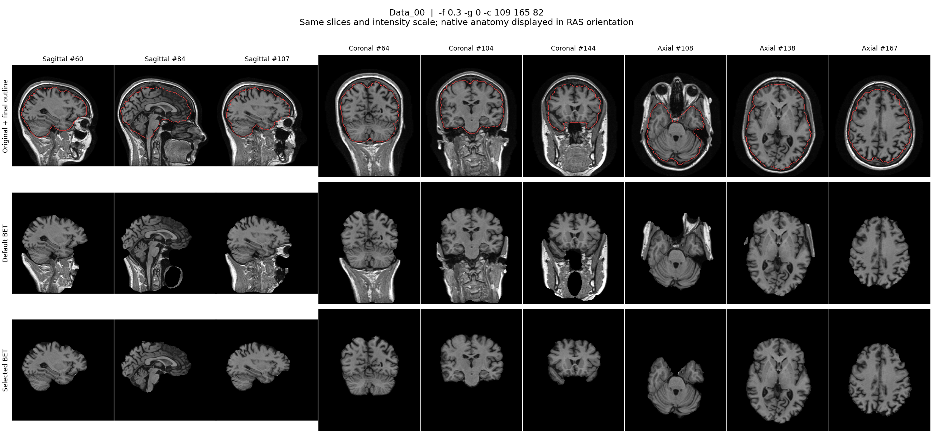
Figure 3. BET brain extraction for Data_00. Rows show the original image with the selected mask boundary, default BET extraction and selected-parameter BET extraction.

4.2 Tissue Segmentation and Grey Matter Images
Figure 4 shows the tissue segmentation results for Data_00. The red, cyan and yellow outlines represent the boundaries of the grey matter, white matter and cerebrospinal fluid masks, respectively. In the displayed slices, the outlines are relatively clear and generally follow the visible structures in the brain image. This allows us to visually inspect the distribution of the three tissue classes. However, these slices alone cannot confirm that all tissue boundaries are accurately segmented. Figure B2 separately displays the GM intensity image; a tissue-mask boundary and a masked intensity image represent different outputs.
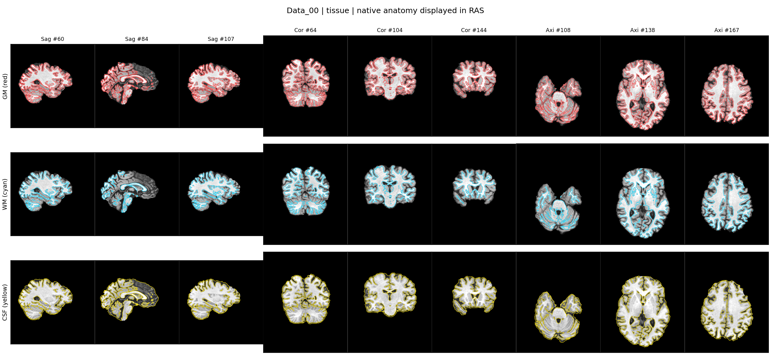
Figure 4. FAST tissue segmentation for Data_00. Rows show grey matter (red), white matter (cyan) and cerebrospinal fluid (yellow) binary-mask boundaries over the anatomical image.

4.3 Registration and Atlas Alignment Results
Figure 5 shows the affine registration, nonlinear registration and transformed AAL atlas for Data_00. In the first row, we can see local misalignment in Sag #84 and Sag #107, where the template does not fully match the underlying brain outline. Similar differences are visible in Cor #64 and Cor #104, while Cor #144 and the axial slices appear better aligned. In the second row, the nonlinear registration appears to improve the alignment in these areas, and the template follows the brain outline more closely. In the third row, the AAL labels generally lie within the brain outline. However, a small area at the bottom of Cor #64 remains visible without a colored label. This alone does not confirm a registration error, as some areas may not be labelled by the atlas. These observations are based on the displayed slices rather than a quantitative assessment of registration accuracy. Larger views of Sagittal #84 and Coronal #104 are provided in Figure B3.
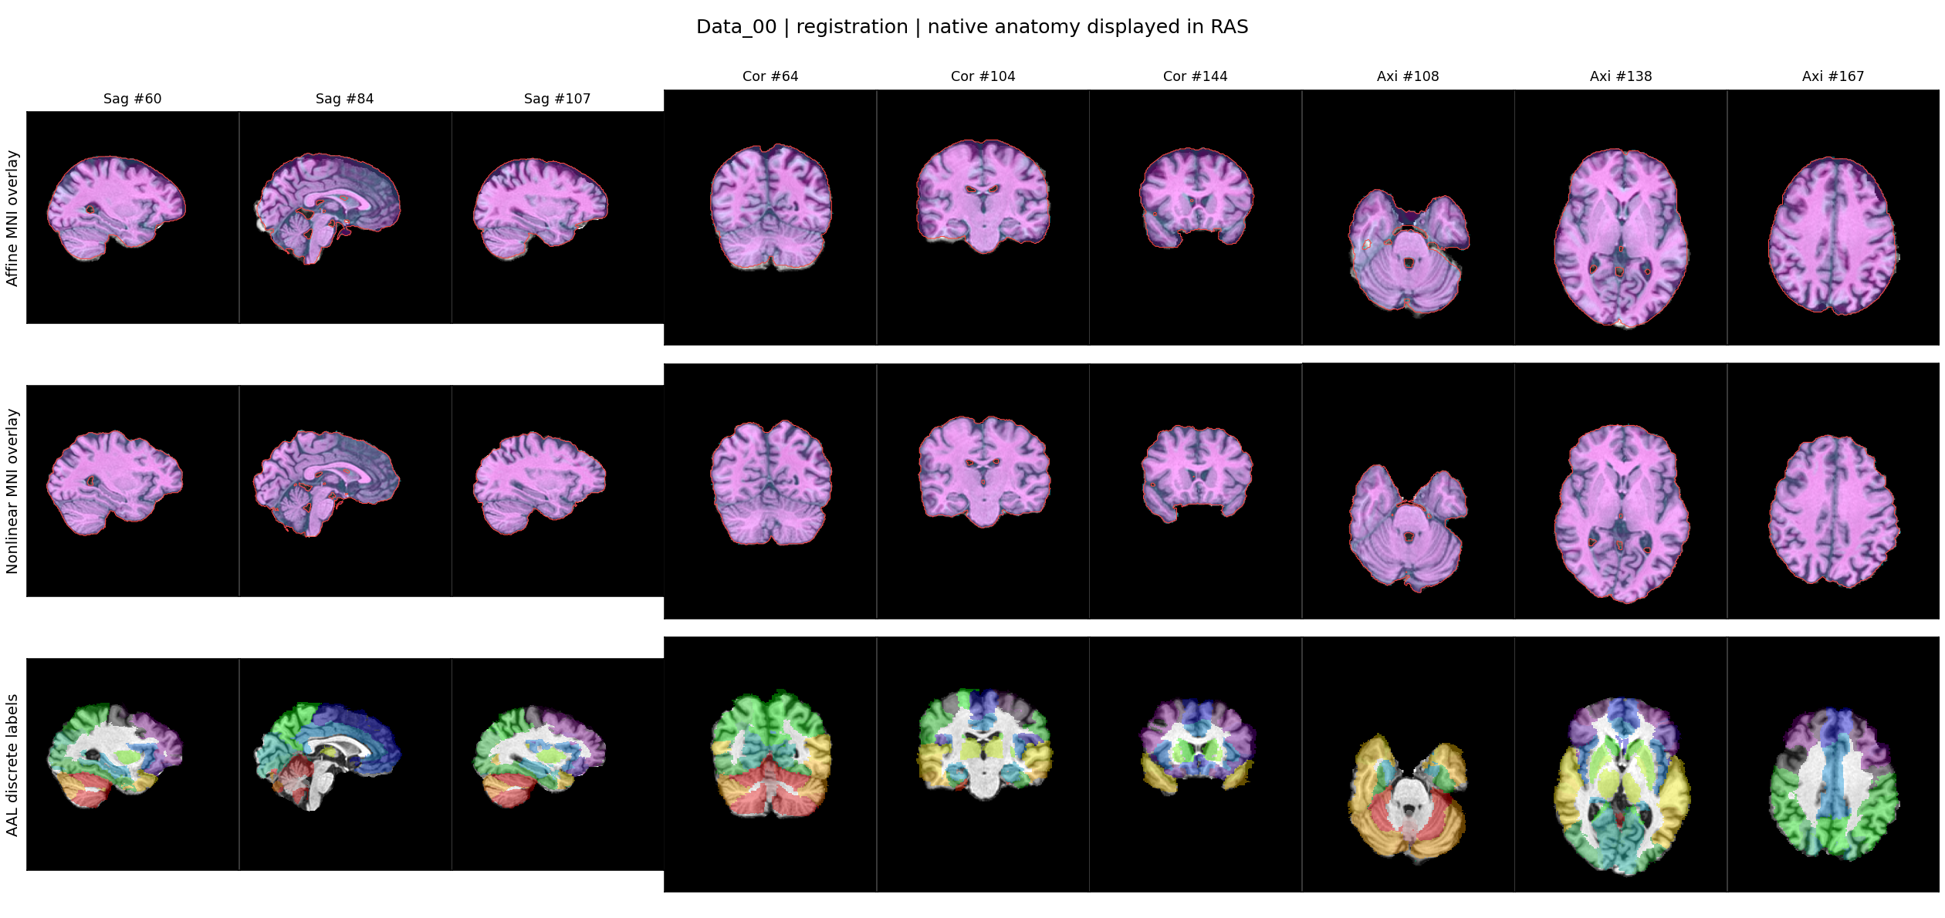
Figure 5. Registration and atlas alignment for Data_00. Rows show the affine template, nonlinear template and transformed AAL labels in native space, across sampled sagittal, coronal and axial slices.

4.4 Regional Grey Matter Volume Features
After regional grey matter volume extraction, we obtain 90 volume features for each subject, forming one feature vector. All volumes are measured in mm³. The training and test feature matrices have dimensions of 40 × 90 and 10 × 90, respectively, giving a total of 4,500 volume measurements. Table 2 shows the grey matter volumes of the first five AAL regions for three training subjects. The complete results are saved in the spreadsheet submitted with the report (Project01_90_ROI_GM_volumes.xlsx). These features are then used for standardization and SVM classification. Subject IDs are not included as input features.
Table 2. Example regional grey matter volumes for selected training subjects (mm³).
Subject ID | ROI 1 | ROI 2 | ROI 3 | ROI 4 | ROI 5
Data_00 | 6523.22 | 4795.51 | 6533.90 | 6715.43 | 1947.68
Data_01 | 7723.00 | 7983.00 | 9151.00 | 9135.00 | 2659.00
Data_02 | 8852.00 | 8397.00 | 5811.00 | 9491.00 | 2347.00
Values are rounded to two decimal places for display. The complete measurements for all 50 subjects and 90 regions are provided in the accompanying spreadsheet.

4.5 Cross-Validation Performance
Figure 6 shows the results of five-fold cross-validation on the 40 training subjects. The accuracies of the five folds are 100%, 100%, 100%, 87.5% and 100%, respectively. The mean accuracy is 97.5%. Four folds correctly classify all validation subjects, while one fold has a lower accuracy. These results show good classification performance during cross-validation. However, they are based on the training set, and the final test results are reported in Section 4.6. The standard deviation across the five fold accuracies is 5.0 percentage points; it describes variation across these folds, not a confidence interval.
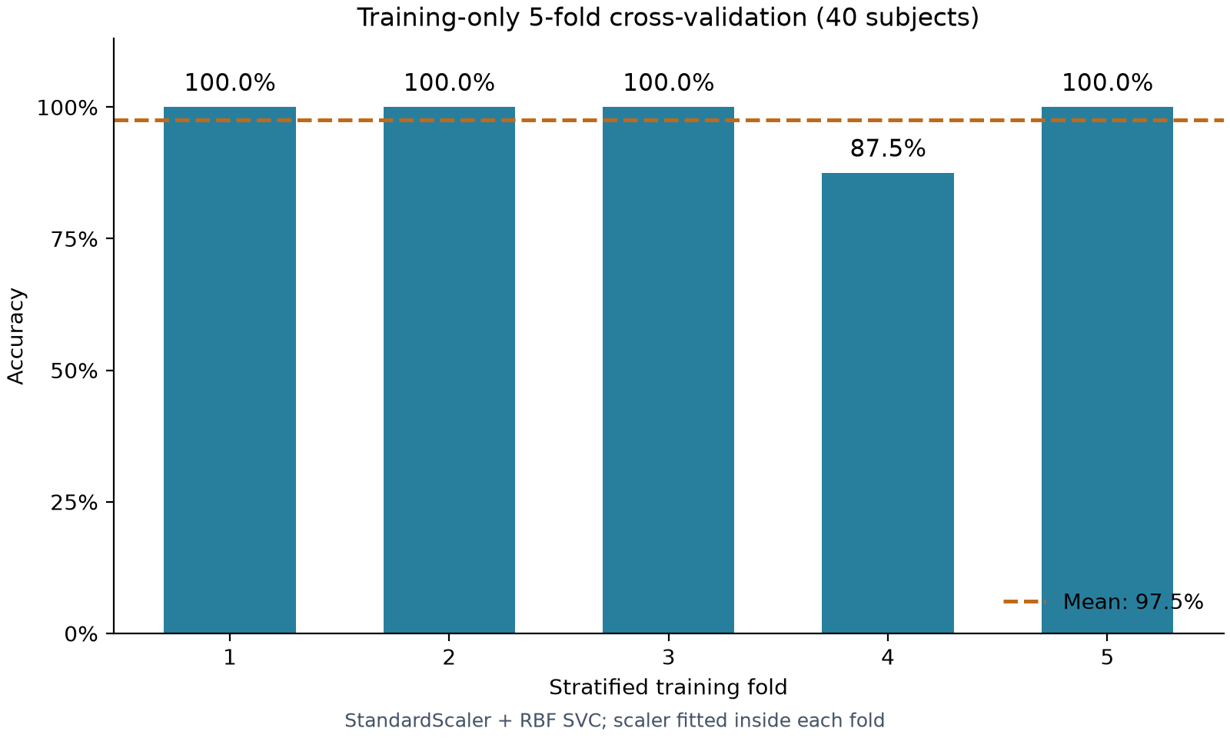
Figure 6. Five-fold cross-validation accuracy within the training set. The fold accuracies are 100%, 100%, 100%, 87.5% and 100%, with a mean of 97.5%.
These scores evaluate validation folds within the 40-subject training set. They are separate from the final held-out test result.

4.6 Test Set Predictions and Performance
Table 3 shows the predicted and true labels for the 10 test subjects, and Figure 7 shows the confusion matrix. The model correctly classifies 9 out of 10 subjects, giving a test accuracy of 90%. All four NC subjects are correctly classified, while five out of six AD subjects are correctly classified. This gives an AD sensitivity of 83.3% and an NC specificity of 100%. The only misclassified subject is Data_49, whose true label is AD but is predicted as NC. The test accuracy is lower than the mean cross-validation accuracy of 97.5%.
Table 3. Predicted and true labels for the test subjects.
File name | Predicted label | True label
Data_40.nii | NC | NC
Data_41.nii | NC | NC
Data_42.nii | AD | AD
Data_43.nii | NC | NC
Data_44.nii | AD | AD
Data_45.nii | NC | NC
Data_46.nii | AD | AD
Data_47.nii | AD | AD
Data_48.nii | AD | AD
Data_49.nii | NC | AD
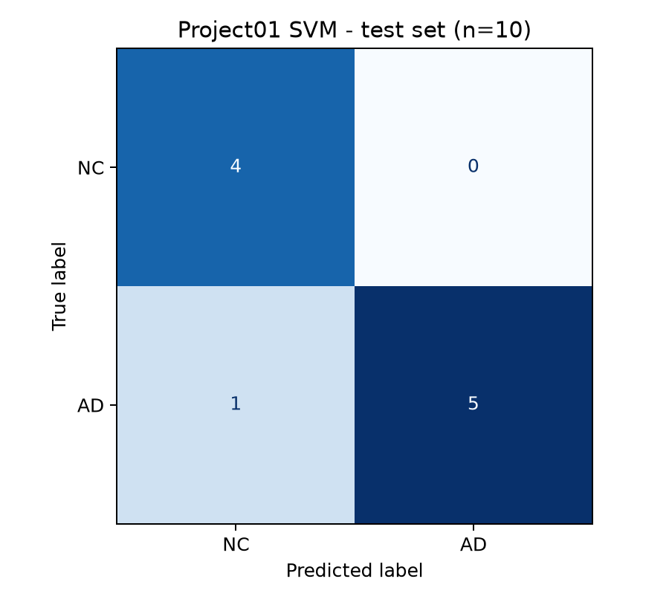
Figure 7. Held-out test confusion matrix. Rows indicate true labels and columns indicate predicted labels, ordered NC and AD. Four NC and five AD subjects were correctly classified; one AD subject was predicted as NC.

5. Discussion and Conclusion

5.1 Interpretation of the Findings
The results suggest that regional grey matter volumes provide useful information for distinguishing AD patients from normal controls in this dataset. Using these features, the SVM correctly classifies nine of the ten test subjects. This supports the use of regional grey matter volumes as classification features, although it does not show that all 90 regions contribute equally to the predictions. The findings are broadly consistent with previous research showing that structural MRI information can be used for AD classification [2]. However, that study used a different feature representation, so its results cannot be directly compared with ours.
The test accuracy of 90% is lower than the mean cross-validation accuracy of 97.5%. This shows that the performance observed during cross-validation is not fully maintained on the test set. However, this difference alone does not prove that the model is overfitted. Although all four NC subjects are correctly classified, one AD subject is predicted as NC. This shows that the model can still miss an AD case despite its high overall accuracy. The reason for the incorrect prediction of Data_49 cannot be determined from the current results. With 90 features and only 40 training subjects, further independent validation is particularly valuable.
Karas et al. [1] provide a biological rationale through their evidence of distributed grey matter loss, but our classification accuracy does not establish which individual ROIs are responsible for a prediction. Compared with the voxel-based representation used by Klöppel et al. [2], our AAL volumes aggregate information within predefined regions and may discard local detail. The 2024 review [4] also describes differences in datasets, classifiers and validation methods. Its reported performances therefore do not provide a directly comparable benchmark for this 50-subject experiment.
No intracranial-volume normalization or feature selection was applied. These remain possible improvements, together with validation on an independent cohort [4]. Any future parameter or feature selection should be confined to training-only nested validation, preserving a new independent test set.

5.2 Limitations and Potential Improvements
Figure 8 shows the brain extraction result for Data_44. Although subject-specific BET parameters are used, some boundary problems remain. In some upper frontal areas, the mask appears to exclude part of the brain tissue. The quality review also identifies residual non-brain tissue. These problems may affect the following tissue segmentation and regional grey matter volume measurements. Data_44 is correctly classified as AD, but this does not mean that its preprocessing is fully accurate. To improve the results, we could inspect more slices and further adjust the extraction settings for subjects with visible boundary problems. Figure B4 provides larger views of the retained mask boundary.
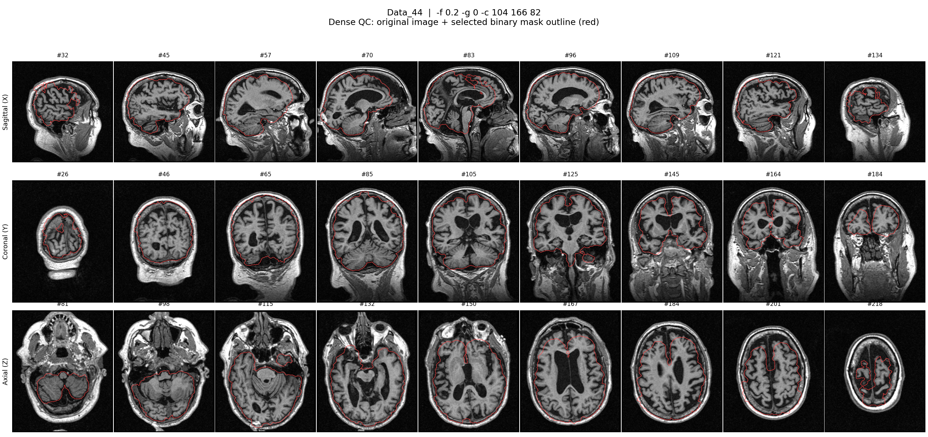
Figure 8. Multi-slice review of the retained BET result for Data_44. The repository quality review identifies suspected frontal boundary omission and residual non-brain tissue; this case illustrates a preprocessing limitation.
Another limitation is the small test set, which contains only 10 subjects. One additional incorrect prediction would reduce the accuracy by 10 percentage points. Therefore, a larger test set is needed to assess the model’s performance more reliably. The reason for the incorrect prediction of Data_49 remains unclear and cannot be directly linked to the preprocessing problems shown for Data_44.

5.3 Conclusion
In this project, we develop a complete workflow from brain MRI processing to AD and NC classification. We extract grey matter volumes from the first 90 regions of the AAL atlas and use the standardized features to train an SVM classifier. The model achieves a mean five-fold cross-validation accuracy of 97.5% and correctly classifies 9 out of 10 test subjects, giving a test accuracy of 90%. These results suggest that regional grey matter volumes provide useful information for AD and NC classification in this dataset. However, the small test set and the remaining preprocessing problems limit the conclusions we can draw. Further evaluation with more subjects and improved preprocessing quality checks is needed.

References
[1] G. B. Karas et al., “A comprehensive study of gray matter loss in patients with Alzheimer's disease using optimized voxel-based morphometry,” NeuroImage, vol. 18, no. 4, pp. 895–907, 2003. DOI: 10.1016/S1053-8119(03)00041-7.
[2] S. Klöppel et al., “Automatic classification of MR scans in Alzheimer's disease,” Brain, vol. 131, no. 3, pp. 681–689, 2008. DOI: 10.1093/brain/awm319.
[3] N. Tzourio-Mazoyer et al., “Automated anatomical labeling of activations in SPM using a macroscopic anatomical parcellation of the MNI MRI single-subject brain,” NeuroImage, vol. 15, no. 1, pp. 273–289, 2002. DOI: 10.1006/nimg.2001.0978.
[4] G. Battineni, N. Chintalapudi and F. Amenta, “Machine Learning Driven by Magnetic Resonance Imaging for the Classification of Alzheimer Disease Progression: Systematic Review and Meta-Analysis,” JMIR Aging, vol. 7, e59370, 2024. DOI: 10.2196/59370.
[5] S. M. Smith, “Fast robust automated brain extraction,” Human Brain Mapping, vol. 17, no. 3, pp. 143–155, 2002. DOI: 10.1002/hbm.10062.
[6] Y. Zhang, M. Brady and S. Smith, “Segmentation of brain MR images through a hidden Markov random field model and the expectation-maximization algorithm,” IEEE Transactions on Medical Imaging, vol. 20, no. 1, pp. 45–57, 2001. DOI: 10.1109/42.906424.
[7] M. Modat et al., “Fast free-form deformation using graphics processing units,” Computer Methods and Programs in Biomedicine, vol. 98, no. 3, pp. 278–284, 2010. DOI: 10.1016/j.cmpb.2009.09.002.
[8] scikit-learn developers, “SVC,” scikit-learn 1.9.1 documentation. Available: https://scikit-learn.org/stable/modules/generated/sklearn.svm.SVC.html (accessed 17 October 2026).

Appendix A Representative commands and settings
The commands below mirror the completed batch scripts for Data_00. Run them from the project root in the configured Linux VM with FSL and NiftyReg on PATH. They illustrate the existing processing; the four main scripts apply the same sequence to all subjects using their own BET parameters.

A.1 Tissue segmentation and grey matter masking
b=Output/train/Data_00
tpl=Packages/MNI152_T1_1mm_brain.nii.gz
aal=Packages/aal.nii.gz
fast -S 1 -n 3 -t 1 -g -v -o "${b}_brain" "${b}_brain.nii.gz"
mv "${b}_brain_seg_0.nii.gz" "${b}_csf_mask.nii.gz"
mv "${b}_brain_seg_1.nii.gz" "${b}_greymatter_mask.nii.gz"
mv "${b}_brain_seg_2.nii.gz" "${b}_whitematter_mask.nii.gz"
fslmaths "${b}_brain.nii.gz" -mul "${b}_greymatter_mask.nii.gz" \
"${b}_brain_greymatter.nii.gz"
The options specify one input channel (-S 1), three tissue classes (-n 3), a T1-weighted image (-t 1), binary masks (-g), diagnostic output (-v), and an output base name (-o). Class indices 0, 1 and 2 are renamed CSF, GM and WM. Multiplication retains brain intensities where the GM mask is one and sets all other voxels to zero.

A.2 Template registration and AAL label resampling
reg_aladin -ref "${b}_brain.nii.gz" -flo "$tpl" \
-aff "${b}_MNI_to_native_affine.txt" -res "${b}_MNI_affine.nii.gz"
reg_f3d -ref "${b}_brain.nii.gz" -flo "$tpl" \
-aff "${b}_MNI_to_native_affine.txt" \
-cpp "${b}_MNI_to_native_cpp.nii.gz" -res "${b}_MNI_warped.nii.gz"
reg_resample -ref "${b}_brain.nii.gz" -flo "$aal" \
-trans "${b}_MNI_to_native_cpp.nii.gz" -inter 0 \
-res Output/train/AAL_to_Data_00.nii.gz
The affine matrix initializes nonlinear refinement. The original template is used again, avoiding a second application of the affine transform to an already warped template. The AAL atlas is resampled with nearest-neighbour interpolation (-inter 0), which preserves integer region labels rather than averaging their IDs.

A.3 Measuring grey matter volume in one ROI
This example isolates AAL label 1 in native space. In the actual batch measurement, the supplied CreateSeedMask helper creates the ROI masks without modification, and Measurement iterates over labels 1–90.
fslmaths Output/train/AAL_to_Data_00.nii.gz -thr 1 -uthr 1 -bin \
Output/train/Data_00_ROI_1_example.nii.gz
fslstats Output/train/Data_00_greymatter_mask.nii.gz \
-k Output/train/Data_00_ROI_1_example.nii.gz -V
The -thr and -uthr thresholds retain only label 1; -bin makes the ROI binary. The -k mask restricts statistics to this ROI. Because the input image is the binary GM mask, -V measures GM voxels within the ROI, not the complete anatomical region. It returns voxel count and physical volume in mm³, in that order. The stored ROI_1_mm3 value for Data_00 is 6523.223317 mm³, rounded to 6523.22 in Table 2.

A.4 Reproducing the SVM validation settings
The notebook and project01_svm.py read the train/test CSV files, match labels by subject ID, and exclude IDs and labels from the 90 feature columns. The settings below show the fitted pipeline and validation procedure; X_train, y_train and X_test denote those loaded arrays.
from sklearn.pipeline import make_pipeline
from sklearn.preprocessing import StandardScaler
from sklearn.svm import SVC
from sklearn.model_selection import StratifiedKFold, cross_val_score
model = make_pipeline(StandardScaler(),
SVC(kernel="rbf", C=1, gamma="scale"))
cv = StratifiedKFold(n_splits=5, shuffle=True, random_state=73)
scores = cross_val_score(model, X_train, y_train,
cv=cv, scoring="accuracy")
model.fit(X_train, y_train)
y_pred = model.predict(X_test)
Cross-validation fits a separate copy of the complete pipeline in each fold, so validation values do not determine the scaler. The final fit uses all 40 training subjects, and the fitted pipeline transforms the 10 test subjects without refitting. Predictions are saved before comparing test labels. The recorded implementation and outputs are available at https://github.com/Babe153/Project01_5622 (repository snapshot 4859af6).

Appendix B Enlarged views of existing processing results
These views use the same final NIfTI outputs as the main figures. They enlarge selected slices without changing the processing. Slice indices refer to RAS-oriented display arrays.
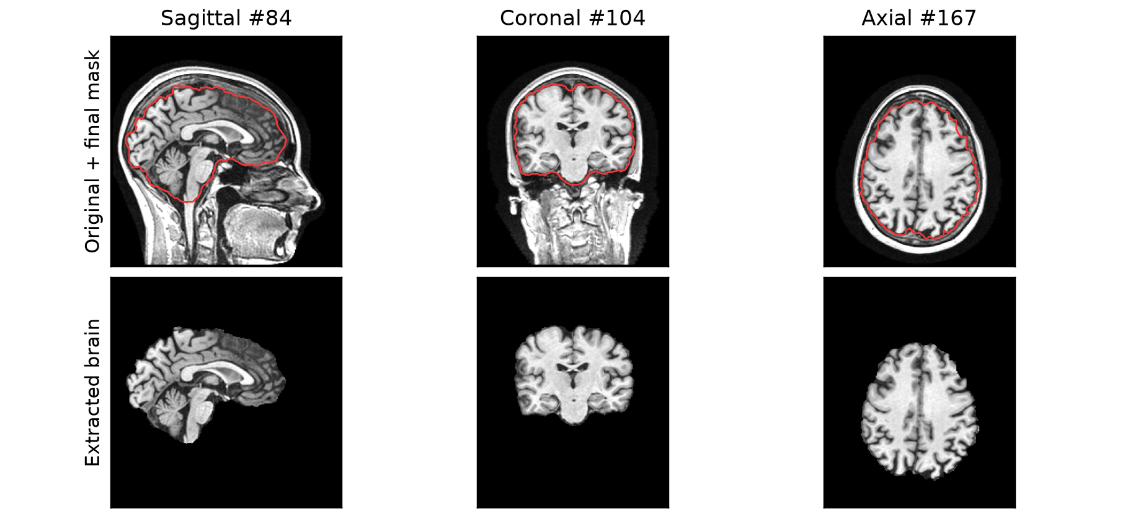
Figure B1. Selected BET result for Data_00 at the slice positions discussed in Section 4.1. Top: original MRI with final mask boundary in red. Bottom: extracted brain. These are the final settings, not the default BET result.
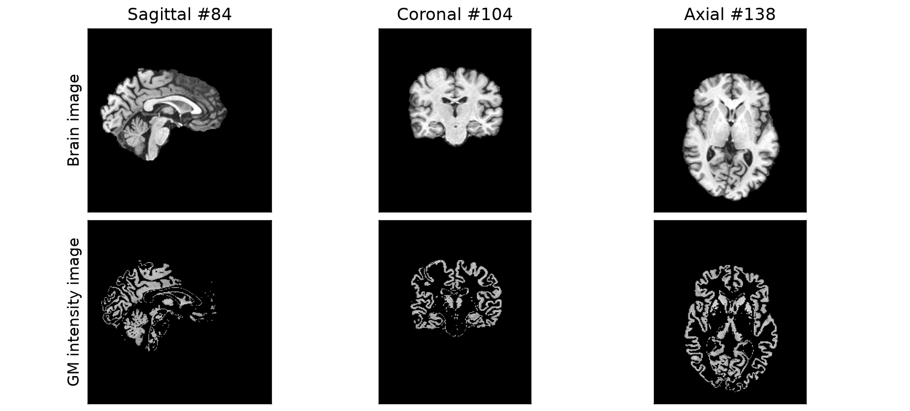
Figure B2. Data_00 brain image (top) and the GM intensity image obtained by multiplying it by the binary GM mask (bottom). The same intensity scale is used in both rows. The GM mask, rather than image brightness, defines the measured volume.

B.1 Registration and the retained BET limitation
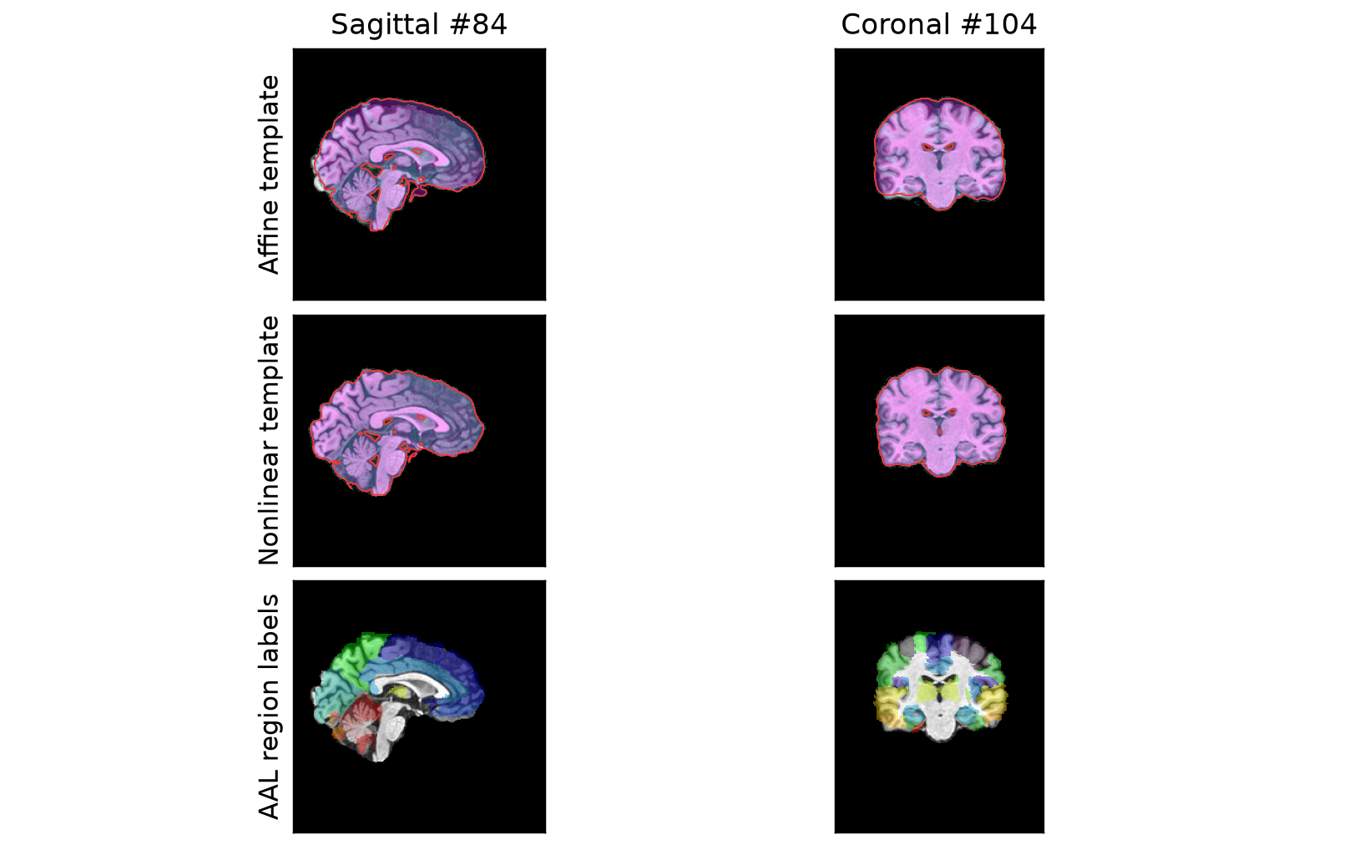
Figure B3. Larger views of Data_00 at Sagittal #84 and Coronal #104. Rows show affine template overlay, nonlinear template overlay and resampled AAL labels on the subject brain. This is a visual comparison, not a quantitative registration score.
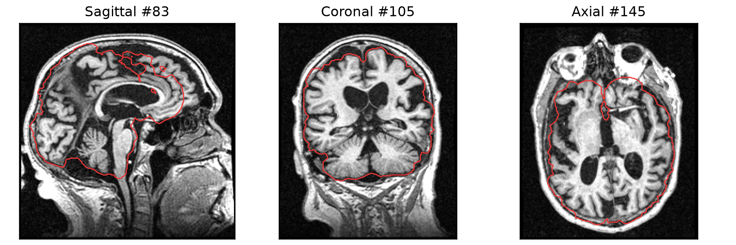
Figure B4. Retained Data_44 BET mask boundary (red) over the original MRI at three sampled positions. Suspected upper frontal tissue omission is visible in the sagittal view. These views illustrate the limitation discussed in Section 5.2; they do not establish its effect on classification.

