REPORT
Student Name: Phan Nguyễn Thảo Như
Student: 524V0007
Class: 24K50201

Introduction
The primary objective of this lab is to achieve the following technical milestones:
- Architectural Implementation: Constructing a school management system using two popular ASP.NET Core architectures—Razor Pages and Model-View-Controller (MVC)—to ensure high modularity and maintainability.
- Code First Development: Utilizing Entity Framework Core to define the database structure directly through C# classes (POCO classes), enabling schema management via Migrations instead of manual SQL scripts.
- Database Orchestration: Establishing a synchronization workflow between the source code and SQL Server, ensuring data is initialized and updated accurately based on application logic.
- Interface Scaffolding & Customization: Leveraging automated code generation (Scaffolding) to rapidly build CRUD interfaces while customizing display logic (e.g., combining ID and Name in dropdowns) to optimize user experience.

Exercises
- Implementation Steps:
  - Exercise 1: Integrated Entity Framework Core into the SchoolAppCoreRazor project to define a comprehensive set of Model classes including Student, Course, and Department. Leveraged the Package Manager Console to execute Code First migration commands (Add-Migration and Update-Database), programmatically generating the SQL Server database schema. Utilized the Razor Pages Scaffolding feature to automatically generate the underlying source code for CRUD interfaces, ensuring a consistent workflow within a page-centric architecture.

  - Exercise 2: Developed a parallel version using the MVC pattern to maintain a strict separation between Controllers, Views, and Models. Re-engineered the Model classes by incorporating the System.ComponentModel.DataAnnotations namespace and implemented attributes such as [Key] and [Required] to enforce data integrity. Leveraged Controller Scaffolding to establish a centralized navigation system, facilitating more efficient business logic management and a robust data management interface.

During the implementation process, I addressed the following technical challenges:
- Entity Key Requirement Error: The system triggered the error: "The entity type 'Student' requires a primary key to be defined" during Migration.
  - Resolution: Identified that Entity Framework failed to recognize the ID property due to naming conventions or typos. Resolved this by explicitly adding the [Key] attribute to the StudentID property.
- Migration Build Conflicts: The Add-Migration command failed because the project contained unresolved syntax errors.
  - Resolution: Performed a full Solution Rebuild (Ctrl + Shift + B), reviewed and fixed logical errors in the Model classes before re-running the commands in the Package Manager Console.
- Connection String Misconfiguration: The application failed to connect to SQL Server Express due to incorrect server naming or access permissions.
  - Resolution: Corrected the connection string in appsettings.json to Server=(local)\\SQLEXPRESS and enabled TrustServerCertificate=True to ensure a secure connection.
- Navigation Inconsistency: After Scaffolding, menu links were non-functional due to path discrepancies between Razor Pages (asp-page) and MVC (asp-controller/asp-action).
  - Resolution: Refactored the _Layout.cshtml file for each project type, ensuring navigation tags correctly targeted the corresponding Controller Actions or Page directories.

-Link GitHub: https://github.com/Babicute-29/SchoolAppCoreRazor, http://github.com/Babicute-29/SchoolAppCoreMVC_Lab8

-exc1:
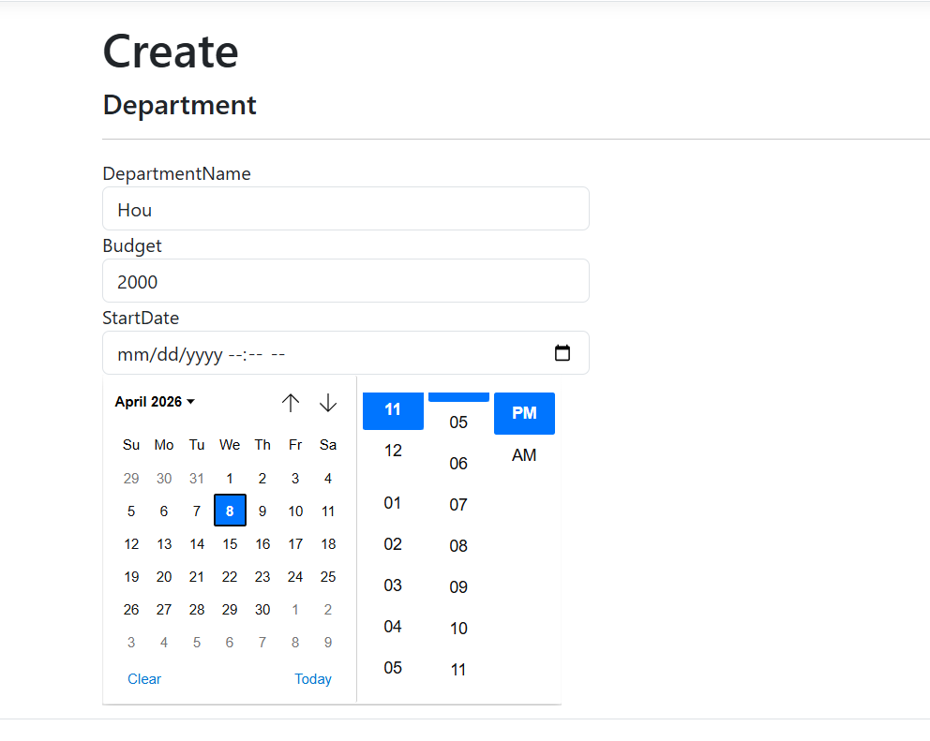
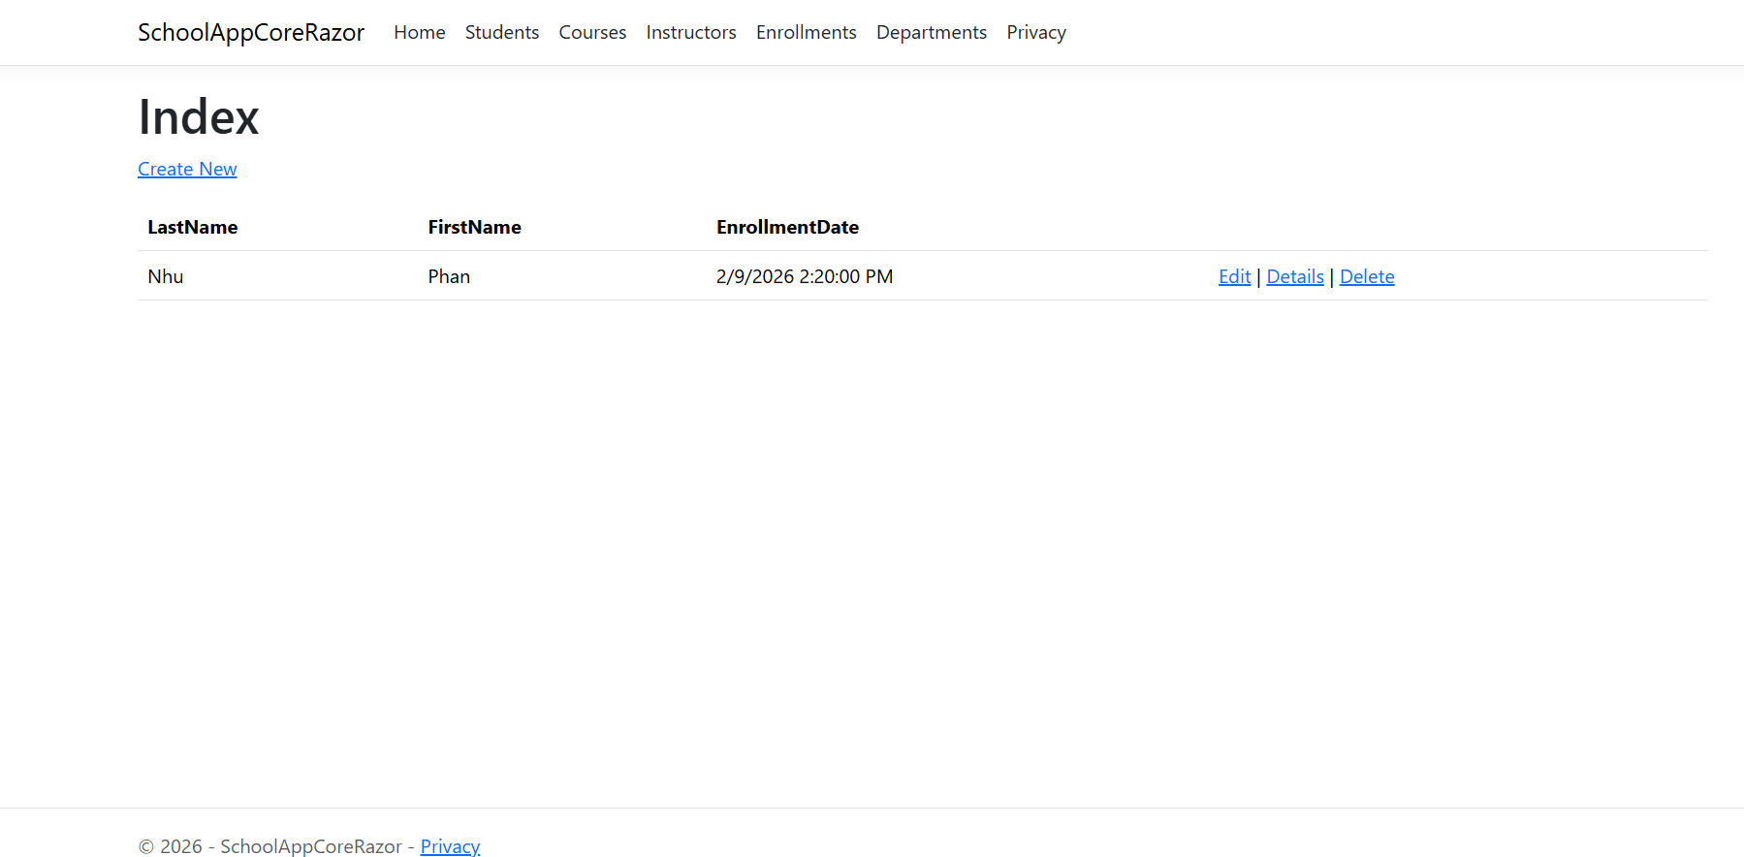
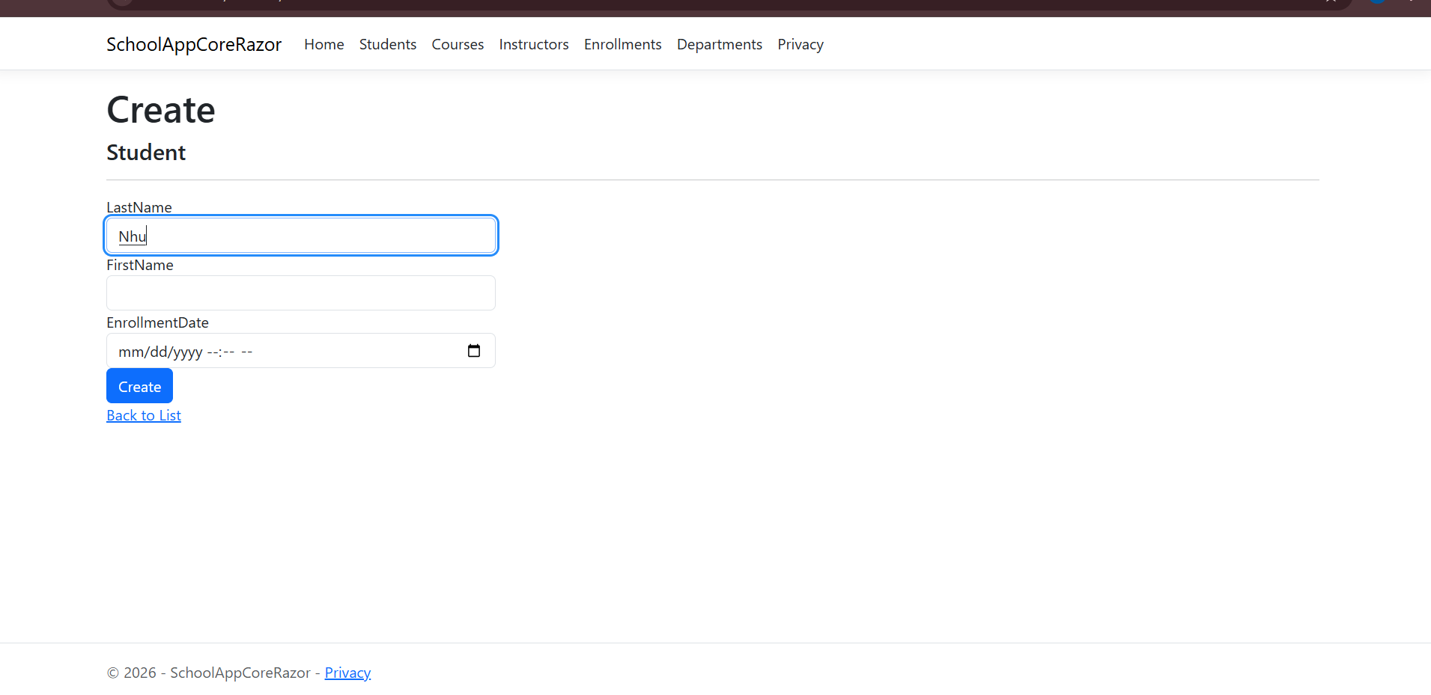
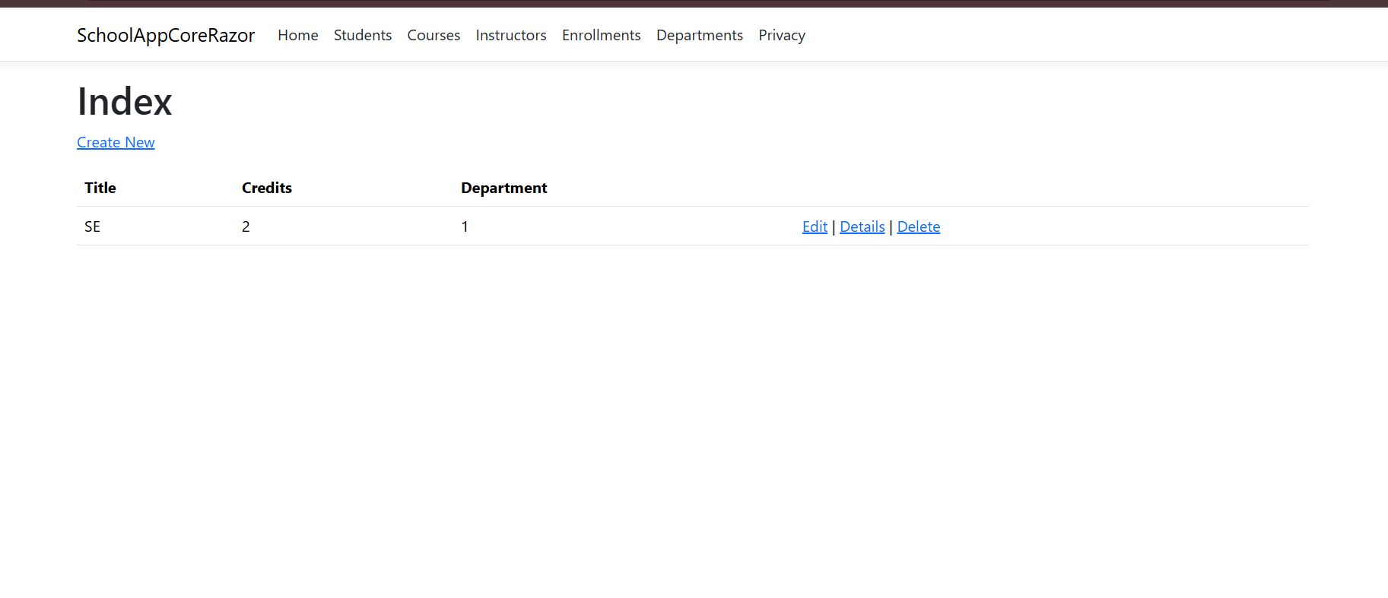

-exc2:

