REPORT
Student Name: Phan Nguyễn Thảo Như
Student: 524V0007
Class: 24K50201

Introduction
The primary objective of this lab is to achieve the following technical milestones: Architectural Implementation: To construct a robust Student Management web application by strictly adhering to the Model-View-Controller (MVC) design pattern, ensuring a clean separation of concerns. Data Persistence & Integration: To leverage Entity Framework Database First for seamless Object-Relational Mapping (ORM), facilitating efficient communication and data manipulation with the SQL Server backend. Core Functionality Deployment: To implement comprehensive CRUD (Create, Read, Update, Delete) operations, establishing a functional interface for data management. Feature Optimization: To enhance application usability and data integrity through the integration of advanced features, including Server-side Validation, dynamic Search Filters, and efficient Pagination for scalable data display.

Exercises
- Implementation Steps:
  - Exercise 1: Integrated the SQL Server database into the project via ADO.NET Entity Data Model. Leveraged the MVC 5 Controller with views, using Entity Framework scaffolding feature to automatically generate the underlying source code for the Index, Create, Edit, and Delete interfaces, ensuring a consistent CRUD workflow.
  - Exercise 2: Modified the tblStudent.cs model by incorporating the System.ComponentModel.DataAnnotations namespace. Implemented various attributes such as [Required], [StringLength], and [EmailAddress] to enforce strict data integrity and control user input at the model level.
  - Exercise 3: Refactored the Index action within the tblStudentsController to accept a searchString parameter. Utilized LINQ (Language Integrated Query) with the .Contains() method to filter the student records dynamically based on the input name. The user interface was enhanced with a search form constructed via the Html.BeginForm helper.
  - Exercise 4: Integrated the PagedList.Mvc library via the NuGet Package Manager. Recalibrated the Index action to handle an int? page parameter and utilized the .ToPagedList() extension method for efficient data segmentation. The pagination navigation was rendered on the View using the @Html.PagedListPager helper to optimize the display of large datasets.

- I have many problems in this lab:
  - Scaffolding Error:Failed to install the CodeGeneration.Design package due to version conflicts within the .NET Framework 4.7.2 environment. However, I detected an error in file config and initialized the scaffolding engine by creating an Empty Controller as a "template" before generating the final EF Controller.
  - Web.config Configuration Error: The system failed to recognize the DbContext because the XML tags were incorrectly ordered. I relocated the <configSections> tag to the primary position immediately following the opening <configuration> tag to ensure the Entity Framework configuration was parsed correctly..
- Exc1: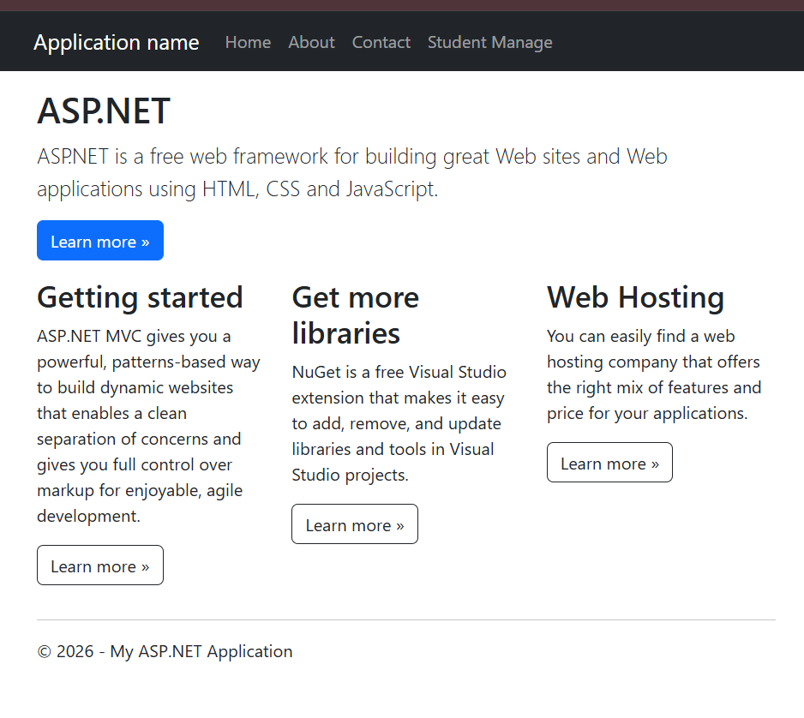
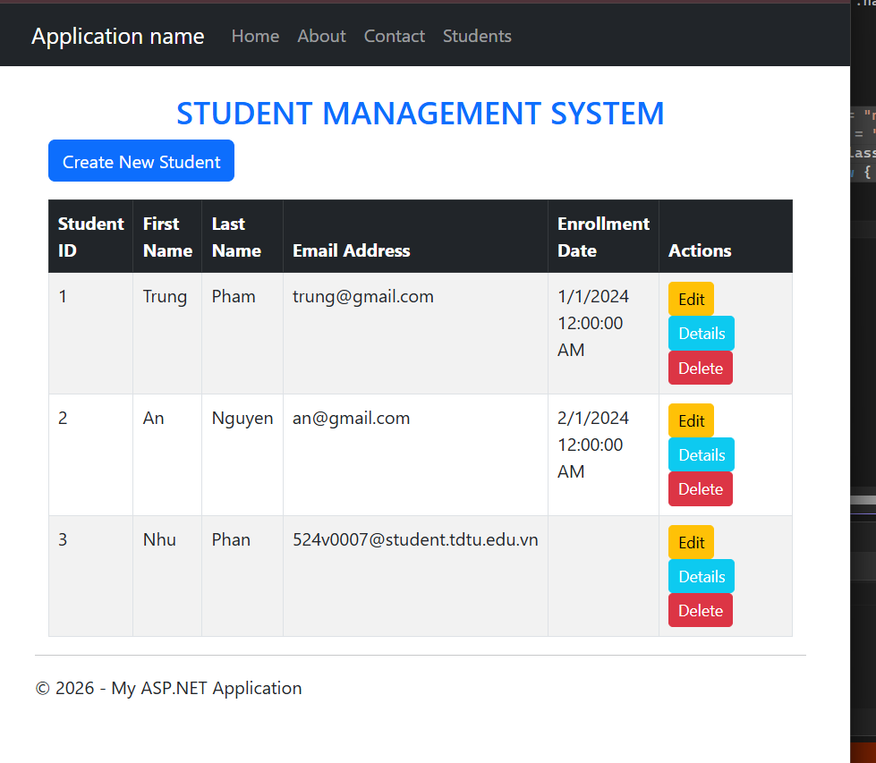

-Link GitHub: https://github.com/Babicute-29/Studentapps
- Exc2: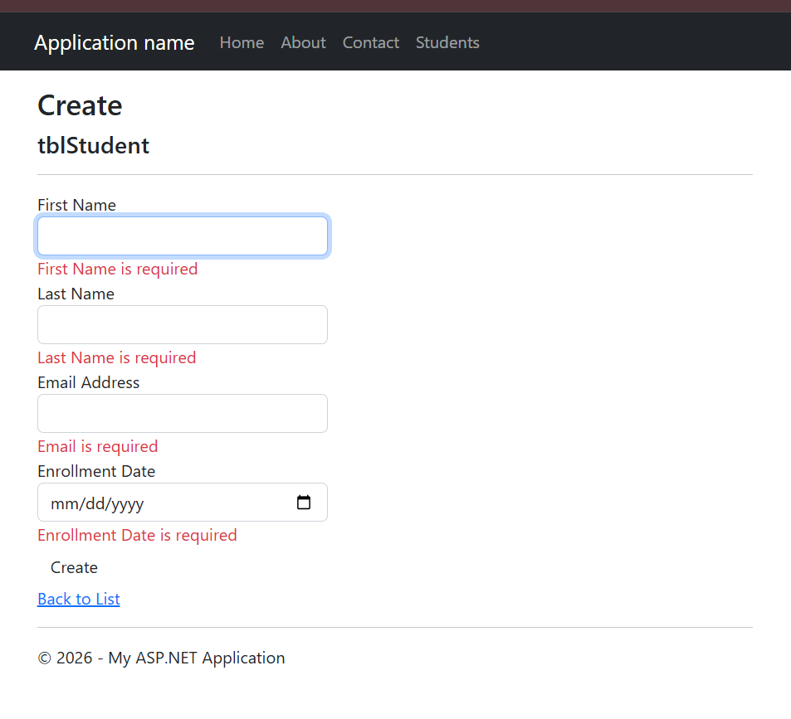
-Exc3: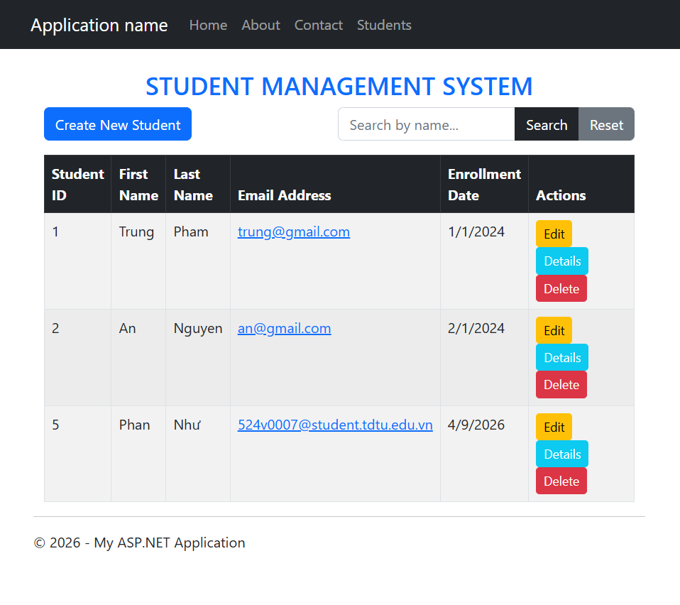
-Exc4: