World Happiness Visualised
570768
"I declare that, except where otherwise indicated, this mini-project is entirely my own work, and that it has not been previously submitted and/or assessed and is not due to be submitted on its entirety or inpart for any other course, module or assignment"

Overview

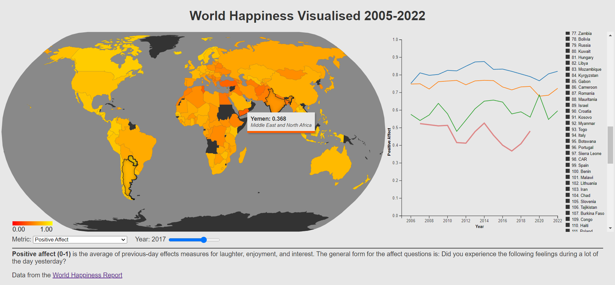
This project solves the problem of providing a rich, user-friendly platform to browse, explore and compare the happiness levels of countries through the 21st century. It uses various metrics that the World Happiness Report has deemed import factors in happiness. We address this problem through an intuitive webpage displaying a choropleth map of Earth that updates dependent on the chosen metric and year, an adaptive line chart that changes depending on the chosen metric and selected countries and a ranked legend of countries dependent on the chosen metric and year. The views use linked highlighting to show the connection between the views. The intended audience is the curious person who would enjoy learning about the quality of life in different countries.

Data

World Happiness Report CSV
The main data for this project is from the World Happiness Report between 2005 and 2022. It is a CSV using two keys and eleven attributes. Per country per year, it has various metrics. The dataset is incomplete as most countries do not have information for every metric every year.
 | Name | Type | Cardinality/Range
Keys | CountryName | Categorical | 165
Keys | Year | Quantitative | 2005-2022
Attributes | Region | Categorical | 10
Attributes | Life Ladder | Quantitative | 0-10
Attributes | Log GDP Per Capita | Quantitative | 5.5-11.7
Attributes | Social Support | Quantitative | 0-1
Attributes | Healthy Life Expectancy At Birth | Quantitative | 40-75
Attributes | Freedom To Make Life Choices | Quantitative | 0-1
Attributes | Generosity | Quantitative | -0.34-0.71
Attributes | Perceptions Of Corruption | Quantitative | 0-1
Attributes | Positive Affect | Quantitative | 0-1
Attributes | Negative Affect | Quantitative | 0-1
Attributes | Confidence In National Government | Quantitative | 0-1

Region is the region of the world that the country is situated in.
Life Ladder is the national average response to the question “Please imagine a ladder, with steps numbered from 0 at the bottom to 10 at the top. The top of the ladder represents the best possible life for you and the bottom of the ladder represents the worst possible life for you. On which step of the ladder would you say you personally feel you stand at this time?” This measure is also known as the Cantril life ladder.
Log GDP Per Capita is in terms of Purchasing Power Parity (PPP) adjusted to a constant 2017 international dollars. GDP data for 2022 is forecast. The equation uses the natural log of GDP per capita, as this form fits the data significantly better than GDP per capita.
Social Support is the national average of the binary responses (0=no, 1=yes) to the Gallup World Poll (GWP) question “If you were in trouble, do you have relatives or friends you can count on to help you whenever you need them, or not?”
Healthy Life Expectancy At Birth is constructed based on data from the World Health Organization (WHO) Global Health Observatory data repository, with data available for 2005, 2010, 2015, 2016, and 2019. To match this report’s sample period (2005-2022), interpolation and extrapolation are used.
Freedom To Make Life Choices is the national average of binary responses to the question “Are you satisfied or dissatisfied with your freedom to choose what you do with your life?
Generosity is the residual of regressing the national average of responses to the donation question “Have you donated money to a charity in the past month?” on log GDP per capita.
Perceptions Of Corruption is the average of binary answers to the questions: “Is corruption widespread throughout the government or not?” and “Is corruption widespread within businesses or not?
Positive Affect is the average of previous-day effects measures for laughter, enjoyment, and interest. The general form for the affect questions is: Did you experience the following feelings during a lot of the day yesterday?
Negative Affect is the average of previous-day effects measures for worry, sadness, and anger. The general form for the affect questions is: Did you experience the following feelings during a lot of the day yesterday?
Confidence In National Government is the national average of binary responses (0=no, 1=yes) to the question "Do you have confidence in your national government?"
The choropleth map and the interactive legend use the same subset of one selected metric in a selected year for all countries. The choropleth map also uses the countries TopoJSON data. The line chart uses the subset of one selected metric and some selected countries for all years.
The pre-processing involved renaming countries for consistency with the TopoJSON file. It also entailed filling in empty regional data and removing erroneous data.

Countries TopoJSON
The file `countries-110m.json` is a TopoJSON from tutorial 5 of the course. It represents the names, locations, and borders of the world's countries. Some of the countries were renamed for consistency with the CSV.

Goals & Tasks
The tasks I expect the intended audience to value are:
- Browsing the countries in search of the happiest extremes across various metrics.
- Exploring the distribution of happiness across geographic regions through various metrics.
- Exploring a country’s happiness trends over time through various metrics.
- Comparing countries’ features through time such as quick jumps and falls in happiness.

Visualisation

Choropleth Map
This view lets the user view a map of the world’s countries. Each country ranges in colour according to its score on a user selected metric in a user selected year. There is a key showing the colours possible as a gradient atop the metric-dependent domain extent. To get a closer look at smaller countries, it is possible to zoom and pan with the mouse. Hovering on an unselected country highlights it with a thicker border and highlights the country in the other two views as well. Further, a tooltip is shown displaying the country’s name, region and value under the selected metric and selected year. Clicking on a country will toggle whether it is selected. Selected countries have a noticeably thicker border on the map as well as a custom inset shadow. When a country is selected, it is also selected in other views. Countries that have no value for the selected metric and year are greyed out.
The marks are interlocking and are shape-, area-, and position-coded.
The channels used are:
- Colour hue was chosen for the value over luminance or saturation because the context of the happiness report made the red-to-yellow an intuitive gradient to map unhappy-to-happy. Values can pop-out if they are an outlier. This is accessible to the colour blind:
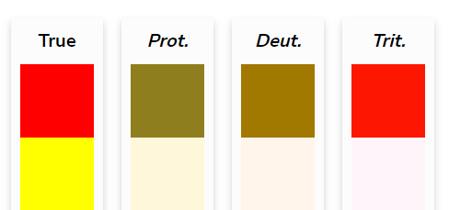
- Colour saturation/luminance was used in the greyed-out countries to show the lack of value. This is a common pattern and so is intuitive.
- A medium border indicated hovering over the country or one of its linked views indicating interactivity. There is also a thick border to indicate being part of the selected set. This pops out in the view.
- An inset shadow indicates membership of the selected set adding saliency to the thick border.
This idiom was chosen as choropleths are great for the exploration of happiness distribution across regions. They are easy to read and understand. To mitigate the limitation of smaller regions seeming less important, there is zoom functionality as to enlarge these regions.
The tooltip is useful for the fine grain detail on demand as the choropleth is not useful for reading absolute values. This is useful for exploring more subtle data features.

Multiple Line Chart
The line chart shows the selected countries’ values of the selected metric through time. When the metric is updated, the y-axis scale adjusts, and the lines reposition. The lines are coloured according to the interactive legend. When a country or legend value is hovered over, its plot in the line chart thickens and if the country is not selected then it is not fully opaque. The y-axis label also updates to match the selected metric.
The marks are the points and lines connecting them.
The channels used:
- Line colour indicates the country, which matches that of the legend. This was chosen as it allows around ten distinct lines.
- Line thickness indicates whether a country in a linked view is being hovered on. This pops out.
- Line opacity indicates whether the country is selected or not.
- Vertical point position indicates the value of the selected metric for the line’s country in that year.
This idiom was chosen as it facilitated exploring happiness trends over time. As well as trends, it is good for comparing features like big peaks and troughs in happiness. Due to the ordered nature of the x-axis being years and the granularity of the data, the line chart is a sensible way to visualise data. Superimposing lines on the same chart is use of local comparisons of features.

Interactive Legend/Bipartite Reorderable Checklist
The interactive legend lists all countries there is data for. The countries are divided into the selected and unselected. They are then sorted by the chosen metric in the selected year. The selected countries have coloured, ticked boxes that function as a key for the line chart. Countries also display their rank under the chosen metric in the selected year. When hovering on a checkbox, it has a larger stroke and highlights the country in the other views. Clicking on a checkbox selects the country as described in the Choropleth Map section.
The marks are the points and words.
The channels used:
- Vertical point position to indicate rank. This conveys order intuitively. It also conveys whether it is selected. This is made unambiguous by the other channels.
- Colour hue is used to let the list act as a legend for the line chart, making it easier for a user to identify country lines.
- Colour saturation and luminance, in keeping with the choropleth map, are used to indicate a lack of nullity, so unselected countries’ points are greyed out in the list.
- Areal size is used when hovering on a box or when hovering on a country in a linked view through an enlarged border around the box. As the boxes are a standard size, the difference is stark.
- Compounding this is the text toggling bold in the same scenario with similar reasoning.
The square shape is a standard design for checkboxes and the ticks are too, indicating interactivity. The tick indicates that the country is selected.
- The number plainly indicates the rank of the country. This is easy to discriminate.
- The name is a simple label.
Scrolling was used as a simple way to allow the user to access the hundreds of countries without filling the screen. The list is also searchable to help users find data for specific countries quickly.
This idiom was chosen as it allowed simple browsing to find extremes in happiness. Being sortable makes this more fruitful. Although non-standard, this view is very simple to understand as it combines elements of similar, common idioms. It is easy to look-up and is usefully linked to other views.

Linked Highlighting
There are three linked views. These three views show complementary data subsets, and all use the country name as a key and so can have meaningful linked highlighting.
The user has a slider to select the year which sorts the list and recolours the choropleth. They also have a dropdown menu to select a metric that affects all three views.
Hovering on checkboxes in the list and countries on the map will highlight the country across all three views. The country gets a medium border drawing attention to it while distinguishing it from the selected countries. The plot on the line chart thickens, making it pop compared to other countries. The checkbox grows and its text goes bold.
Clicking a country or a checkbox toggles whether the country is in the selection set. If it is, the country has a thick border and an inset shadow. The line is visible and opaque on the line chart. The checkbox is in the ‘selected’ area and has a coloured, ticked checkbox.

Text Display and Inputs
Due to the obscurity of the metrics used by the World Happiness Report, there is a description for the selected metric under the other views. This not directly interactive but updates with the selected metric.
There is a dropdown menu to select the metric as well as a slider to select the year.

Usage Scenario
This is the initial state:
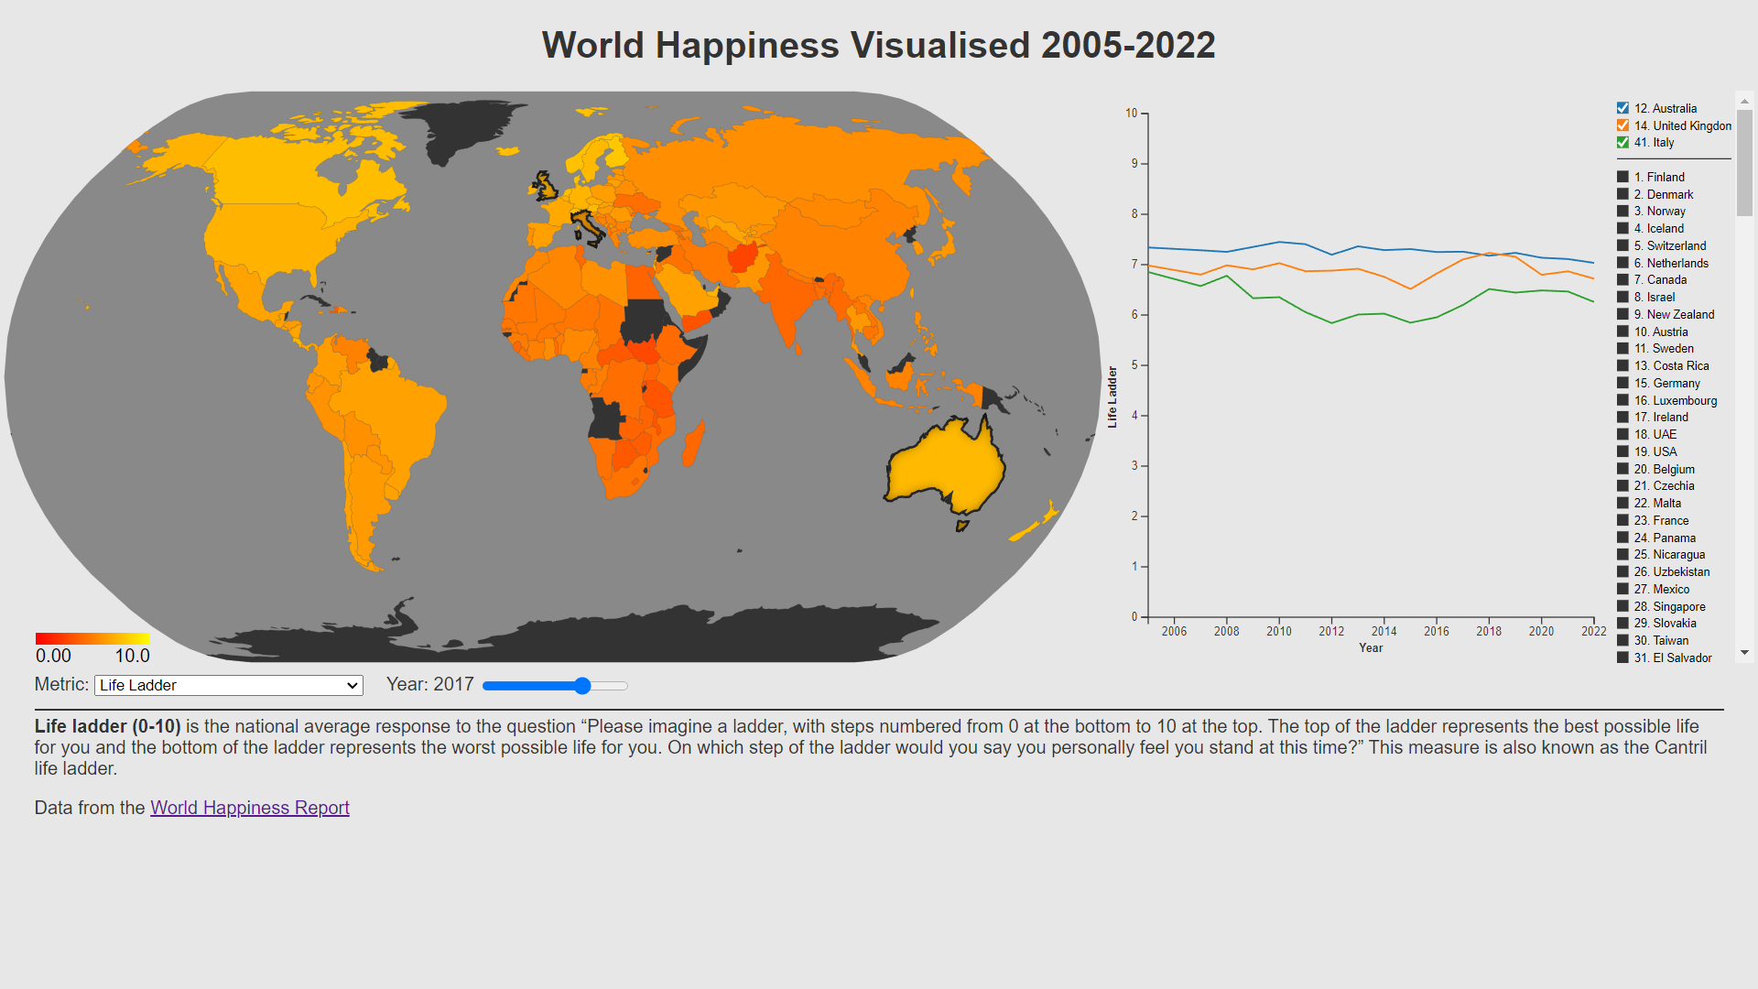
Below, a different metric and year have been selected with the dropdown menu and slider. The bold description title draws a user’s attention and explains how the metric is measured. The colour scale and values of the choropleth update, the lines, scale and label update on the line chart and the list reorders. What is the red country that pops out on the choropleth? Afghanistan. Hovering over the country displays a tooltip informing the user that the country is Afghanistan, and giving the value of Positive Affect for the country in 2021. This also highlights the country’s plot on the line chart, allowing the user to explore its very negative trend on the line chart.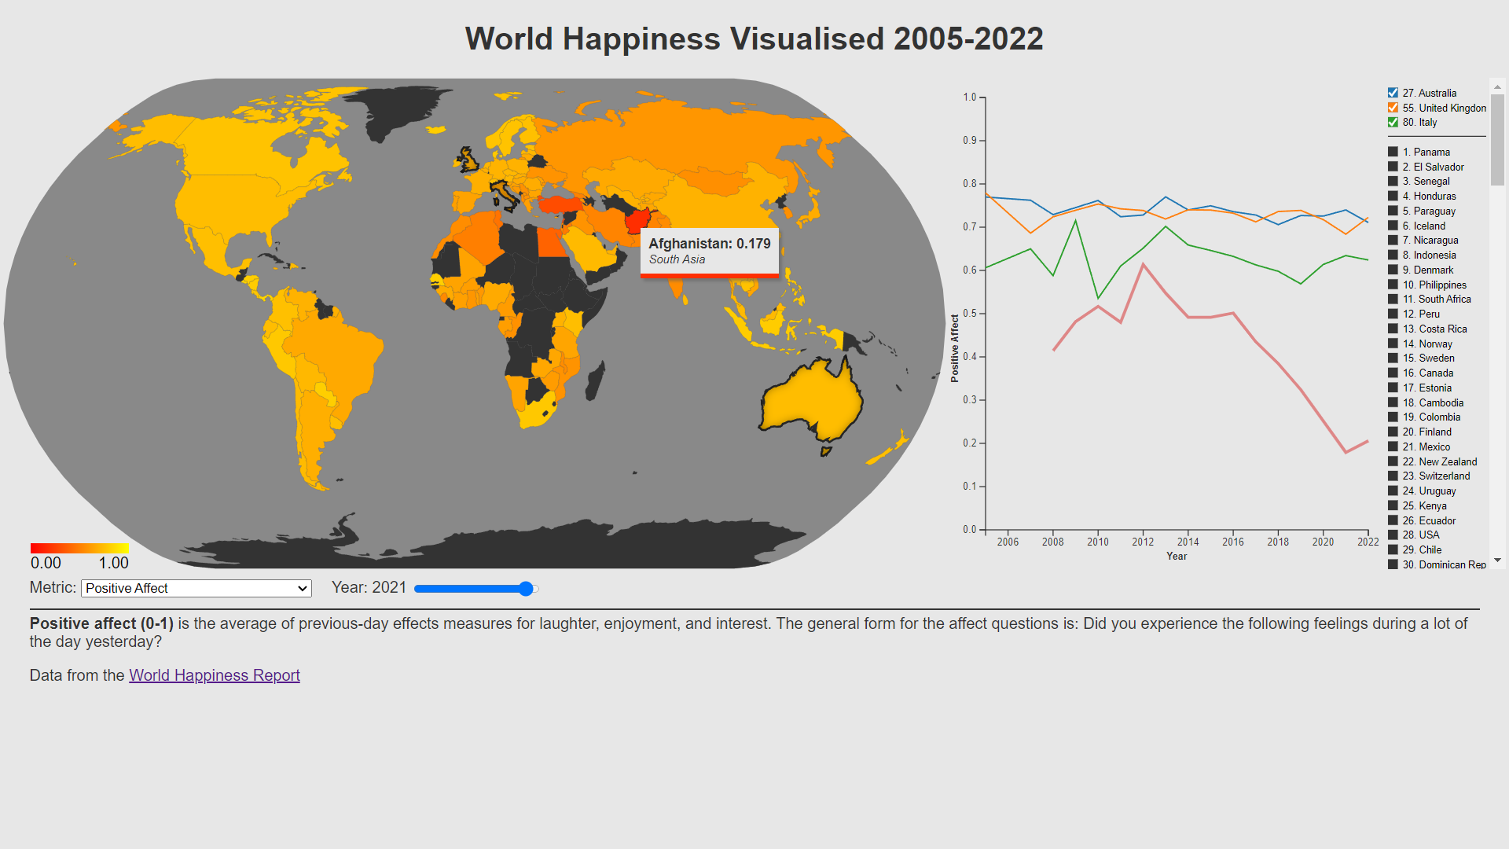
Following this, a natural question to explore is whether countries in the same region have had similar recent troughs. By clicking their ticked checkboxes, Australia, Italy, and UK may be unselected. I clicked countries on the map near Afghanistan. They seem to be similar until 2016 when Afghanistan’s big trough starts. The other local countries do not have the same feature.
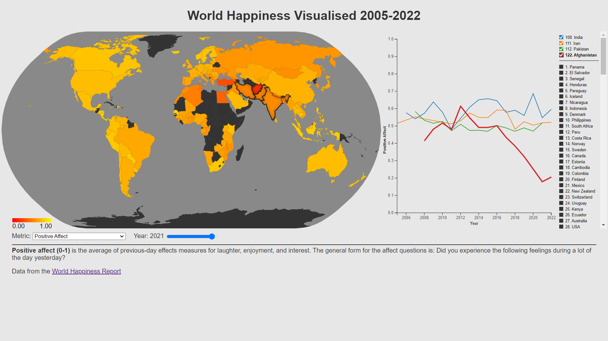I wonder what the top three countries are for Positive Affect? Fortunately they’re ranked on the right and ticking their boxes reveals more information about them. 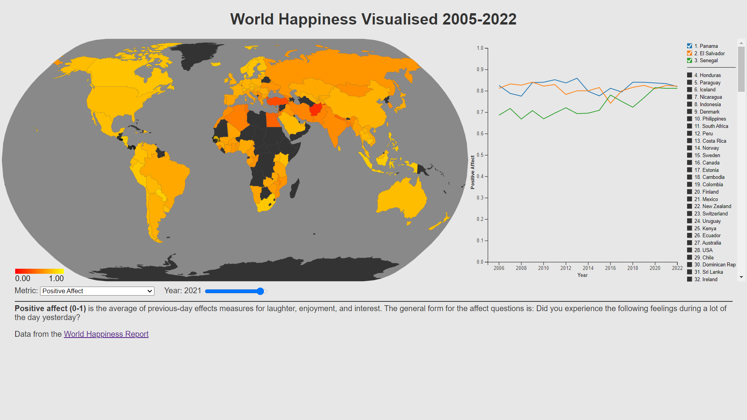
I wonder how perceptions of corruption look in different regions around the world in 2014? It seems Rwanda and the Nordic states are oases and have been for time.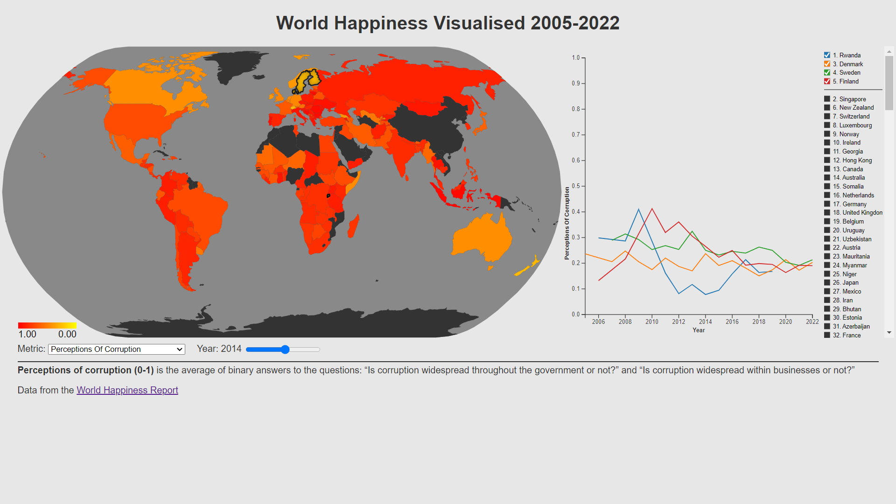

Credits

Code Consulted
The basis of the choropleth map was the geographic map from the Data Visualisation tutorial 5. It is in its own file for code reuse. I altered it so that it is a choropleth map by colouring countries based on a value associated with the country. I added more interaction through clicking and hovering. It has also had more visual changes such as a border and custom inset shadow on selected countries.
The dropdown box used for the metrics was based on that from Data Visualisation tutorial 4.4. I changed its contents and the styling as well as changing how it interacts with other dropdown menus in the same group as to not interfere with them through the introduction of an id.
The map's tooltip is based on the tooltip code from Data Visualisation tutorial 4.5. I restyled it and added the capacity for it to handle null values as well as follow the mouse pointer.
The interactive legend used a variation of a dynamic-sort from Stack Overflow: https://stackoverflow.com/questions/1129216/sort-array-of-objects-by-string-property-value. The changes I made specialised it to this scenario.
The inset shadow on the selected countries was based on the shadow at https://jsfiddle.net/w8r/yx0y1jLc/.
The gradient of the choropleth key was based on code from: https://www.visualcinnamon.com/2016/05/smooth-color-legend-d3-svg-gradient/.

Data & Media
- favicon: https://www.favicon.cc/?action=icon&file_id=837
- world happiness report dataset: https://www.kaggle.com/datasets/usamabuttar/world-happiness-report-2005-present

