**PROJECT TITLE:- FLIPKART**

**FIGURE:-**

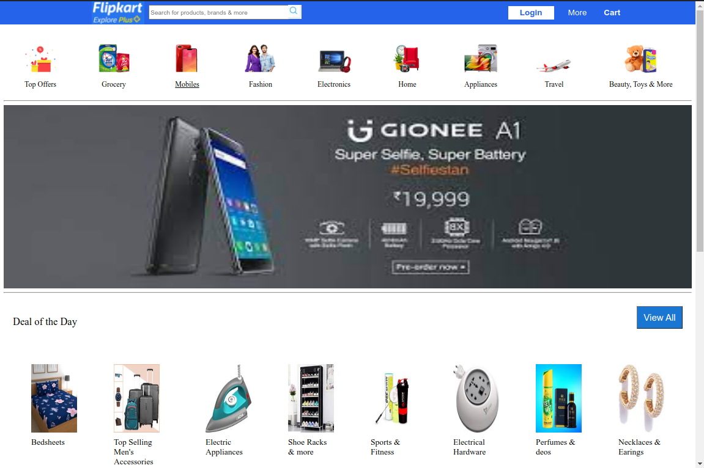

**GOALS:-**

* Login page

(Registration form- email id, date of birth, shopping reference)

(Sign in- user id, password)

* Home page
* Main page
* Detail page
* Payment page

(Address selection- fullname, mob no., house no, street/colony, area, district, state, pin code)

(Payment method- Phonepe, Bhim upi, Cod, Credit card, Debit card, Google pay etc.)

**OVERVIEW:-**

It’s an e-commerce website established in 2007 by Sachin Bansal and Binny Bansal. It extends to lifestyle products, electronics, home essentials,beauty products and groceries etc. Today, Flipkart is the biggest online Indian marketplace competing with the world leader Amazon

**HOME PAGE:-**

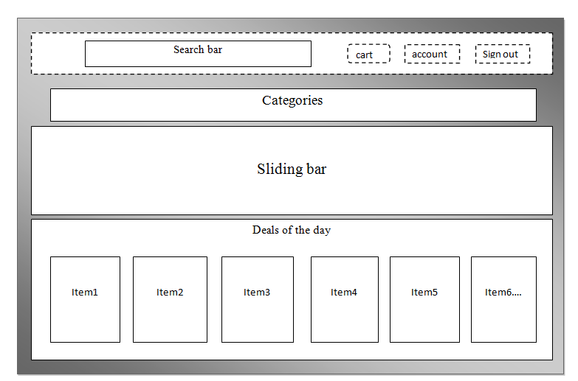

**MAIN PAGE:-**

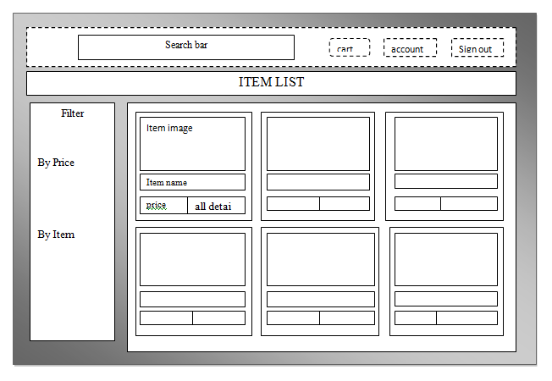

**DETAIL PAGE:-**

