**Approach 1: Greedy Approach**

1) Find all adjacent pairs that give a profit.

We will buy only when we definitely know that there will be an increase in the price next.

Therefore find all points where there is a growth

Time Complexity => O(n)

Space Complexity => O(1)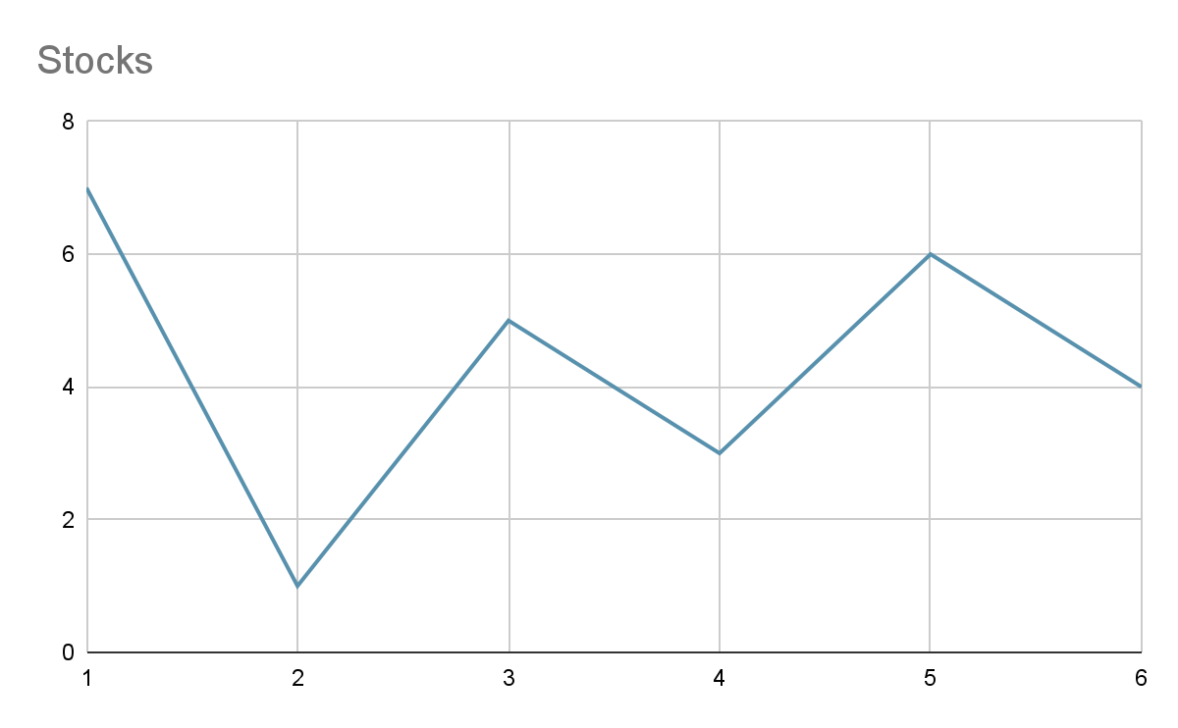

**Code:**

profit = 0

for i in range(1, len(prices)):

if prices[i] > prices[i-1]:

profit += prices[i]-prices[i-1]

return profit