**Evergreen Square**

**Smart Commercial Complex, Greater Noida**

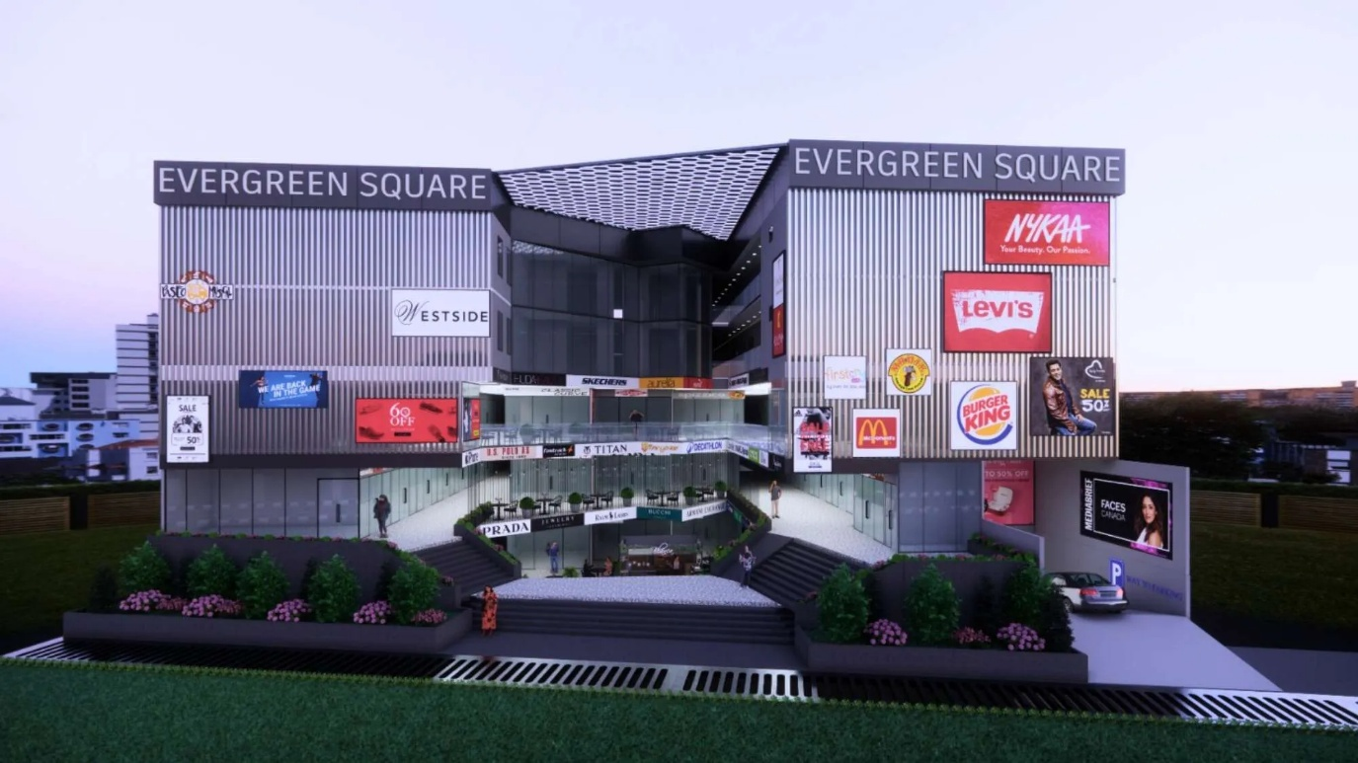

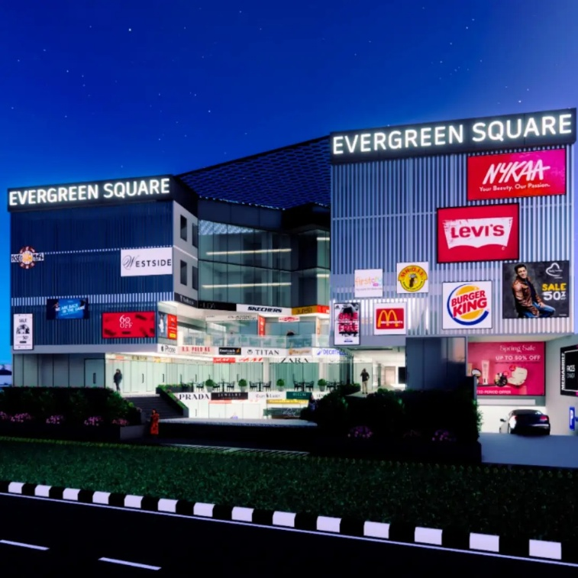

**🏢 Evergreen Square – Complete Project Overview (Updated)**

**Project Name:** Evergreen Square  
**Developer:** Goodmayes Builders & Developers Pvt. Ltd.  
**Type:** Smart Commercial Complex (Retail Shops + Office Spaces + Studio Apartments)  
**Location:** Near Tilapta Chowk, Greater Noida, Uttar Pradesh  
**RERA No.:** UPRERA Registered  
**Land Area:** Approx. 1.5 Acres  
**Structure:** Lower Ground + Ground + 4 Upper Floors

**🗺️ Location Advantage**

* Situated near **Tilapta Chowk**, Greater Noida
* **Easy access** to Surajpur Road and main Noida–Dadri route
* Surrounded by **developed residential hubs** and industrial areas
* Excellent connectivity to:
  + Pari Chowk – 15 mins
  + Noida Sector 78 – 20 mins
  + Yamuna Expressway – 10 mins
  + Eastern Peripheral Expressway – 12 mins
  + Proposed Metro Expansion – Nearby connectivity corridor

**🏗️ Floor-Wise Plan & Usage**

|  |  |  |
| --- | --- | --- |
| **Floor** | **Type of Unit** | **Ideal Use** |
| Lower Ground Floor (LGF) | Retail Shops (250–600 sq.ft.) | Grocery, salon, daily-need stores |
| Ground Floor (GF) | High-Street Retail (300–1200 sq.ft.) | Showrooms, branded outlets, cafes |
| First Floor (FF) | Retail & Restaurants (250–800 sq.ft.) | Boutique shops, fine-dine cafes |
| Second Floor (SF) | Food Court & Entertainment (300–900 sq.ft.) | Lounges, restaurants, gaming zones |
| Third Floor (TF) | Office Spaces (400–850 sq.ft.) | Startups, consultancies, clinics |
| Fourth Floor (4F) | Studio Apartments (450–650 sq.ft.) | Service apartments, Airbnb stays |

**💰 Price Details**

**🔹 Retail Shops**

|  |  |  |  |
| --- | --- | --- | --- |
| **Floor** | **Size Range** | **Price Range** | **Avg. Rate (₹/sq.ft.)** |
| LGF | 250–600 sq.ft. | ₹30 – ₹48 Lakh | ₹12,000 – ₹13,500 |
| GF | 300–1200 sq.ft. | ₹45 Lakh – ₹1.4 Crore | ₹13,500 – ₹15,500 |
| FF | 250–800 sq.ft. | ₹28 – ₹52 Lakh | ₹11,000 – ₹12,500 |

**🔹 Food Court & Entertainment (2nd Floor)**

|  |  |  |
| --- | --- | --- |
| **Size Range** | **Price Range** | **Avg. Rate (₹/sq.ft.)** |
| 300–900 sq.ft. | ₹40 – ₹85 Lakh | ₹10,500 – ₹12,000 |

**🔹 Office Spaces (3rd Floor)**

|  |  |  |
| --- | --- | --- |
| **Size Range** | **Price Range** | **Avg. Rate (₹/sq.ft.)** |
| 400–850 sq.ft. | ₹24 – ₹58 Lakh | ₹7,000 – ₹8,500 |

**🏨 Studio Apartments (4th Floor)**

**Type:** Fully Furnished / Semi-Furnished  
**Configuration:** 1 Room + Pantry + Washroom  
**Size Range:** 450 – 650 sq.ft.  
**Price Range:** ₹30 – ₹45 Lakh  
**Rate:** ₹7,000 – ₹8,500 per sq.ft.

**✳️ Features of Studio Apartments**

* Smart layout for single professionals and small business owners
* Modern fittings, attached pantry & washroom
* Fully furnished options available
* 24×7 power backup & security
* Access to retail, office & food court facilities
* Ideal for rental yield or corporate stay investments

**🌟 Project Highlights**

* **Smart Commercial Hub** combining retail, workspaces, and residences
* **Integrated design** offering all-in-one convenience
* **Wide road frontage** for high visibility and footfall
* **Double-height showrooms** on the ground floor
* **Assured returns** on select commercial units
* Sustainable design with **green building features**
* Construction in progress; **possession expected by 2026**

**📈 Investment Snapshot**

|  |  |  |  |
| --- | --- | --- | --- |
| **Segment** | **Rate (₹/sq.ft.)** | **Typical Ticket Size** | **ROI Potential (Annual)** |
| Retail Shops | ₹12,000–₹15,500 | ₹30 L – ₹1.4 Cr | 10–12% |
| Food Court | ₹10,500–₹12,000 | ₹40 – ₹85 L | 9–11% |
| Office Spaces | ₹7,000–₹8,500 | ₹24 – ₹58 L | 8–10% |
| Studio Apartments | ₹7,000–₹8,500 | ₹30 – ₹45 L | 9–10% |

**🏗️ Developer Profile – Goodmayes Builders & Developers Pvt. Ltd.**

* NCR-based developer focusing on **mixed-use and commercial projects**
* Emphasis on **smart infrastructure and affordable investment options**
* Track record of **timely delivery** and **transparent dealings**
* Vision: to create **sustainable smart spaces** combining business and lifestyle