**Vrinda Heritage Skyward**

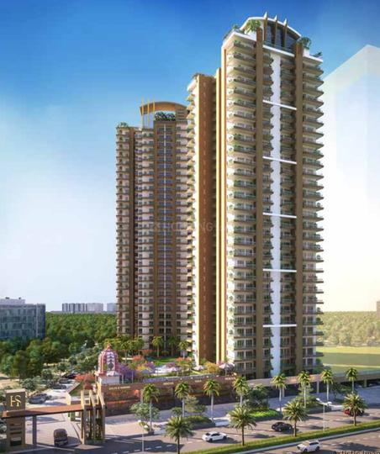

**Overview**

* **Developer:** Vrinda Group
* **Project Name:** Vrinda Heritage Skyward
* **RERA ID:** UPRERAPRJ848586
* **Location:** Sector 1, Greater Noida West (Noida Extension)
* **Project Area:** ~3 acres
* **Towers & Floors:** 2 Towers (30–32 floors)
* **Total Units:** ~370–374 apartments
* **Status:** Under Construction
* **Possession:** Expected by Dec 2027

**Architecture & Theme**

* Design: Contemporary high-rise with focus on ventilation and natural light.
* Construction: Mivan technology (aluminum formwork) for durability and precision.
* Open Space: ~80% open area landscaped with green zones.
* Interiors: Wide balconies (6 ft), 8 ft high doors, modular kitchen with hob & chimney, wardrobes included.
* Unique Feature: Air purifier system installed within the complex.

**Apartment Configurations & Pricing (as per price list provided)**

* 3 BHK Apartments:
  + Sizes range approx. 1,298 – 1,698 sq.ft
  + Pricing: ~₹1.25 Cr – ₹1.75 Cr
* 4 BHK Apartments:
  + Sizes approx. 2,018 sq.ft
  + Pricing: ~₹1.9 Cr – ₹2.2 Cr
* Average Rate: ~₹10,500 – ₹11,500 per sq.ft (depending on floor, view, facing, and tower)

**Amenities & Lifestyle Features**

* Recreational: Clubhouse, swimming pool, kids’ pool, rooftop restaurant.
* Sports: Tennis court, basketball court, indoor gym, jogging track.
* Community: Multipurpose hall, landscaped gardens, amphitheater, kids’ play areas.
* Facilities:
  + Modular kitchen fittings, wardrobes, glass partitions in toilets.
  + Power backup, 24×7 CCTV security, controlled entry.
  + High-speed lifts (4 in Tower 1, 3 in Tower 2).
  + Dedicated parking, water softener facility.

**Location & Connectivity**

* Address: Sector 1, Noida Extension (Greater Noida West)
* Nearby Infrastructure:
  + FNG Expressway, NH-24, DND Flyway within quick reach.
  + Proposed metro station within 2–3 minutes.
  + ~10 mins from Gaur Chowk.
  + Close to schools, malls, and healthcare centers.
* Airport Connectivity: ~40–45 mins drive to upcoming Jewar International Airport.

**Summary Table**

|  |  |
| --- | --- |
| Feature | Details |
| Developer | Vrinda Group |
| Project Area | ~3 acres |
| Towers | 2 (30–32 floors) |
| Units | ~370–374 |
| Configurations | 3 BHK (1298–1698 sq.ft), 4 BHK (2018 sq.ft) |
| Pricing | ₹1.25 Cr – ₹2.2 Cr |
| Avg. Rate | ~₹10,500–₹11,500 / sq.ft |
| Possession | Dec 2027 |
| Amenities | Clubhouse, pool, gym, courts, gardens, rooftop dining |
| Connectivity | FNG, Metro (proposed), Gaur Chowk, Jewar Airport |