**Madhav Kunj – CSB Infracon**

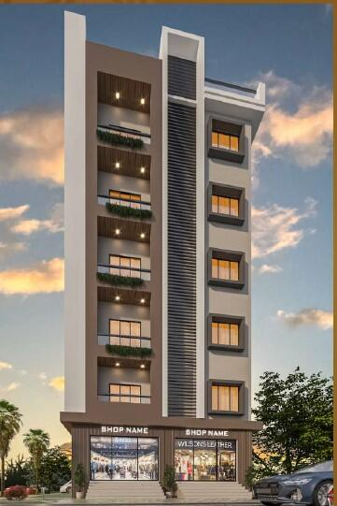

**Overview**

* **Developer:** CSB Infracon
* **Project Name:** Madhav Kunj
* **Location:** Milak Lachchhi, Greater Noida (Yamuna Expressway region)
* **Property Type:** Residential Plots
* **Project Status:** Ongoing (plots available with registry & possession options)

**Project Highlights**

* **Configuration:** Freehold residential plots
* **Plot Sizes:** 50 sq. yd. – 200 sq. yd. (approx.)
* **Ownership:** Registry & mutation available, ensuring clear title and legal security
* **Flexibility:** Buyers can construct homes as per their own design & budget
* **Community Setup:** Gated society with internal roads and boundary wall

**Price breakdown by apartment size**

* **2 BHK:** A 1,080 square-foot (super built-up area) 2 BHK apartment was listed for ₹59.4 lakhs, which comes out to ₹5,500 per square foot.
* **3 BHK:** A 1,450 square-foot (super built-up area) 3 BHK apartment was listed for ₹79.75 lakhs, also priced at ₹5,500 per square foot.

|  |  |  |  |
| --- | --- | --- | --- |
| Apartment Type | Super Built-up Area (Sq. Ft.) | Listed Price (₹) | Price per Sq. Ft. (₹) |
| 2 BHK | 1,080 | 59.4 Lakhs | 5,500 |
| 3 BHK | 1,450 | 79.75 Lakhs | 5,500 |

**Amenities & Features**

* Secure **gated entry** with boundary wall
* **24×7 security personnel**
* **Electricity & water provisions**
* Paved internal roads with street lighting
* Drainage & sewage systems
* Landscaped green zones

**Location Advantages**

* Strategically located along **Yamuna Expressway** for seamless connectivity.
* **Upcoming Jewar International Airport** – approx. 20–25 minutes away.
* Educational hubs & universities (Galgotias, Noida International University) nearby.
* Close to sports city, IT parks, and proposed industrial corridors.
* ~15 mins to Pari Chowk, Greater Noida.
* Excellent connectivity to Noida, Delhi, and Agra.

**Investment Perspective**

* **Affordable Entry:** Ideal for first-time buyers and investors seeking land in NCR.
* **Growth Zone:** Benefits from Jewar Airport, Film City, and Yamuna Expressway developments.
* **Flexibility:** Owners have freedom to design/construct per their preference.
* **Long-term Appreciation:** Expected rise in land value as infrastructure matures.

**Quick Takeaways**

* **Type:** Residential Plotted Development
* **Size Range:** 50–200 sq. yd.
* **Pricing:** ₹7.5 Lakhs – ₹30 Lakhs
* **Best For:** Affordable land buyers, long-term investors, and families seeking independent homes near Yamuna Expressway