**KDMG Central Plaza,**

**Greater Noida West**

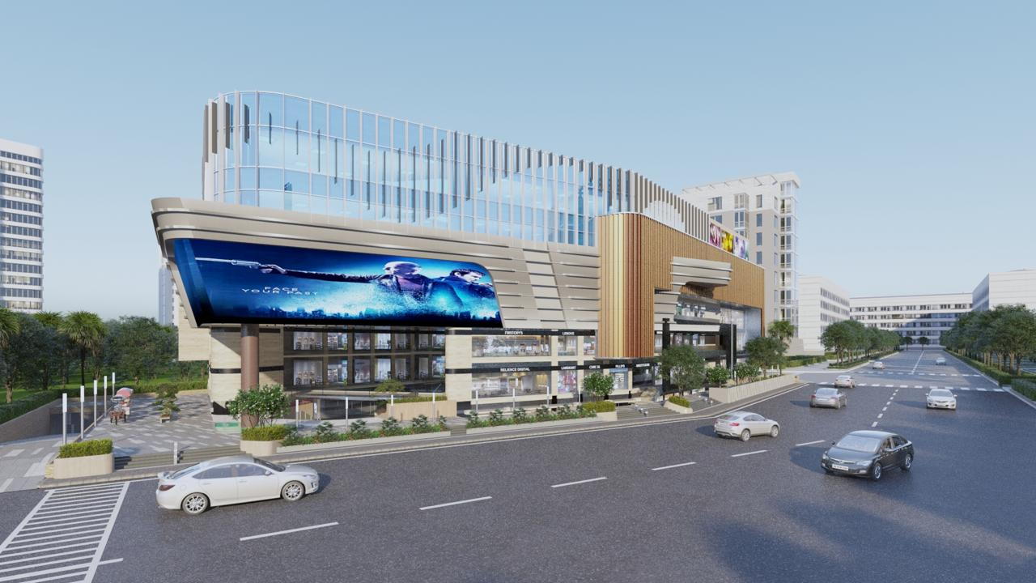

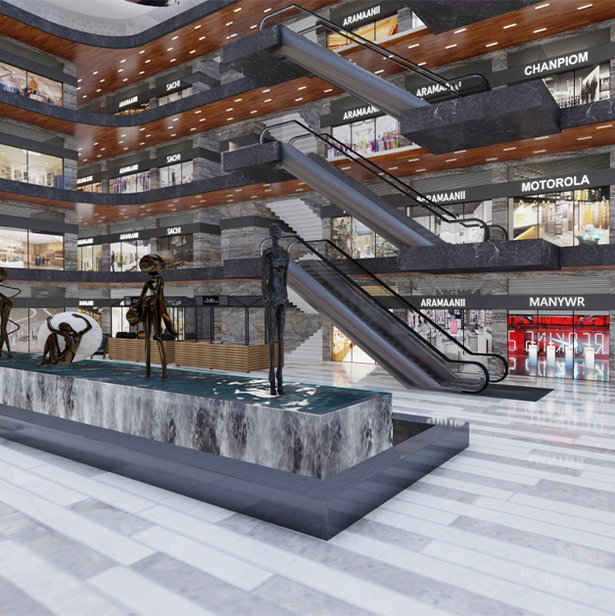

**🏢 KDMG Central Plaza – Complete Project Overview (Updated)**

**Project Name:** KDMG Central Plaza  
**Developer:** KDMG Group  
**Type:** High-Street Retail + Office Spaces + Food Court + Studio Apartments  
**Location:** Techzone 4, Greater Noida (West), Uttar Pradesh  
**RERA No.:** UPRERA Registered  
**Land Area:** ~1.5 Acres  
**Structure:** Lower Ground + Ground + 4 Upper Floors

**🗺️ Location Advantage**

* Located on **60-meter-wide main road**, prime frontage in **Techzone 4**
* Surrounded by high-density residential societies (30,000+ families)
* Close to major projects: *Gaur City, Ace City, Fusion Homes, Mahagun Mywoods, and Nirala Estate*
* **Accessibility:**
  + Gaur Chowk – 2 mins
  + Sector 78 Metro – 10 mins
  + NH-24 – 15 mins
  + FNG Expressway – 5 mins
  + Proposed Greater Noida West Metro Line nearby

**🏗️ Floor-Wise Plan & Usage**

|  |  |  |
| --- | --- | --- |
| **Floor** | **Type of Unit** | **Ideal Use** |
| **Lower Ground Floor (LGF)** | Retail Shops (250–600 sq.ft.) | Daily needs, salon, grocery |
| **Ground Floor (GF)** | High-Street Retail (250–1200 sq.ft.) | Showrooms, apparel, branded outlets |
| **First Floor (FF)** | Retail & Cafés (200–800 sq.ft.) | Boutique shops, small restaurants |
| **Second Floor (SF)** | Food Court & Entertainment Zone (300–900 sq.ft.) | Restaurants, lounges, gaming |
| **Third Floor (TF)** | Office Suites (400–900 sq.ft.) | Startups, clinics, consultancies |
| **Fourth Floor (FF)** | Studio Apartments (450–650 sq.ft.) | Service apartments, Airbnb, business stays |

**💰 Price Details**

**🔹 Retail Shops**

|  |  |  |  |
| --- | --- | --- | --- |
| **Floor** | **Size Range** | **Price Range** | **Avg. Rate (₹/sq.ft.)** |
| Lower Ground Floor | 250–600 sq.ft. | ₹32 – ₹50 Lakh | **₹12,500 – ₹14,500/sq.ft.** |
| Ground Floor | 250–1200 sq.ft. | ₹50 Lakh – ₹1.5 Crore+ | **₹14,500 – ₹17,000/sq.ft.** |
| First Floor | 200–800 sq.ft. | ₹28 – ₹55 Lakh | **₹11,000 – ₹13,000/sq.ft.** |

**🔹 Food Court & Entertainment (2nd Floor)**

|  |  |  |
| --- | --- | --- |
| **Size Range** | **Price Range** | **Avg. Rate (₹/sq.ft.)** |
| 300–900 sq.ft. | ₹45 – ₹90 Lakh | **₹10,500 – ₹12,500/sq.ft.** |

**🔹 Office Spaces (3rd Floor)**

|  |  |  |
| --- | --- | --- |
| **Size Range** | **Price Range** | **Avg. Rate (₹/sq.ft.)** |
| 400–900 sq.ft. | ₹25 – ₹60 Lakh | **₹7,000 – ₹9,000/sq.ft.** |

**🏨 Studio Apartments (4th Floor)**

**Type:** Fully Furnished / Semi-Furnished  
**Configuration:** 1 Room + Pantry + Washroom  
**Size Range:** 450 – 650 sq.ft.  
**Price Range:** ₹32 – ₹48 Lakh  
**Rate:** ₹7,500 – ₹8,500 per sq.ft.

**✳️ Features of Studio Apartments**

* Smart layout ideal for single professionals or business travelers
* Attached kitchenette and washroom
* Option for **fully furnished setup** (developer or investor choice)
* 24×7 security and power backup
* Access to commercial & food court amenities
* Suitable for **rental yield / Airbnb / corporate stay** investment

**🌟 Project Highlights**

* High-street retail with **daily footfall potential** from nearby residential zones
* **Corner plot** with dual road visibility
* **Double-height showrooms** on ground floor
* **Assured return schemes** on select retail units
* **Studio apartments** offer dual income — capital appreciation + monthly rent
* **Construction in advanced phase**, possession expected **by 2025–26**

**📈 Investment Snapshot**

|  |  |  |  |
| --- | --- | --- | --- |
| **Segment** | **Rate (₹/sq.ft.)** | **Typical Ticket Size** | **ROI Potential (Annual)** |
| Retail Shops | ₹12,000–₹17,000 | ₹35 L – ₹1.5 Cr | 10–12% |
| Food Court | ₹10,500–₹12,500 | ₹45 – ₹90 L | 9–11% |
| Office Spaces | ₹7,000–₹9,000 | ₹25 – ₹60 L | 8–10% |
| Studio Apartments | ₹7,500–₹8,500 | ₹32 – ₹48 L | 9–10% |

**🏗️ Developer Profile – KDMG Group**

* **Experienced NCR developer** with several small and mid-sized mixed-use projects
* Focus on **high-street commercial and affordable investment properties**
* Emphasis on **construction quality, delivery timeline**, and **investor returns**