**L&T GREEN RESERVE,**

**SECTOR 128, NOIDA**

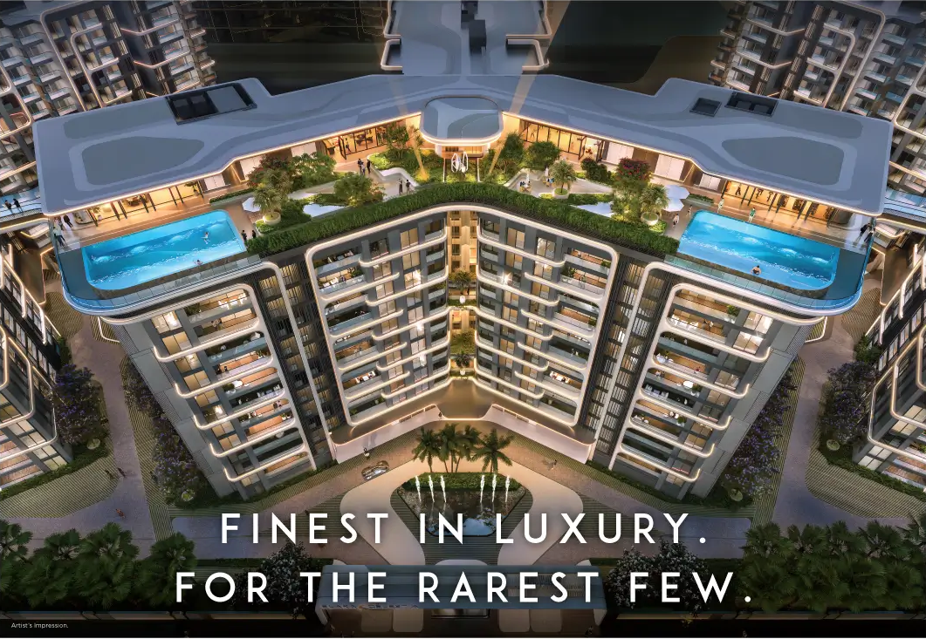

* **Overview of L&T Green Reserve (Sector 128, Noida)**
* **Project Overview**
* **Developer:** L&T Realty (real estate arm of Larsen & Toubro)
* **Project Name:** L&T Green Reserve
* **RERA Registration:** Registered (Allahabad High Court order in 2024 allowed sale & advertising after initial dispute)
* **Project Size:** ~6–6.3 acres, with 4 towers (G+45 floors)
* **Number of Units:** ~580–600 luxury residences

Possession is projected for **January 2027** ([Real Estate News Partner](https://www.landmarkloom.com/noida/lt-green-reserve-modern-lifestyle-in-sector-128-noida/?utm_source=chatgpt.com)).

* **Apartment Configurations & Pricing**
* **3 BHK:** 2,850–3,500 sq ft → ₹4.8 Cr – ₹6.3 Cr (~₹18,000–20,000/sq ft)
* **4 BHK:** 3,550–4,200 sq ft → ₹6.3 Cr – ₹8.25 Cr+
* **5 BHK:** 5,100–5,700 sq ft → ₹8.25 Cr – ₹11.44 Cr
* **Location & Connectivity**

Positioned right off the **Noida–Greater Noida Expressway**, the project offers exceptional connectivity:

* **1 km** to expressway ([Real Estate News Partner](https://www.landmarkloom.com/noida/lt-green-reserve-modern-lifestyle-in-sector-128-noida/?utm_source=chatgpt.com), [Team Cnut](https://teamcnut.com/invest-in-lt-green-reserve-prime-location-in-sector-128-noida/?utm_source=chatgpt.com)).
* Nearby landmarks:
  + **Amity University** (~3 km) ([Real Estate News Partner](https://www.landmarkloom.com/noida/lt-green-reserve-modern-lifestyle-in-sector-128-noida/?utm_source=chatgpt.com), [Team Cnut](https://teamcnut.com/invest-in-lt-green-reserve-prime-location-in-sector-128-noida/?utm_source=chatgpt.com)).
  + **Jaypee Hospital** (~2–4.5 km) ([lntrealtysector128noida.com](https://www.lntrealtysector128noida.com/?utm_source=chatgpt.com), [Real Estate News Partner](https://www.landmarkloom.com/noida/lt-green-reserve-modern-lifestyle-in-sector-128-noida/?utm_source=chatgpt.com), [realtytantra.com](https://www.realtytantra.com/listing/noida/lt-green-reserve/?utm_source=chatgpt.com)).
  + **DLF Mall of India** (~6 km) ([Real Estate News Partner](https://www.landmarkloom.com/noida/lt-green-reserve-modern-lifestyle-in-sector-128-noida/?utm_source=chatgpt.com), [Team Cnut](https://teamcnut.com/invest-in-lt-green-reserve-prime-location-in-sector-128-noida/?utm_source=chatgpt.com)).
  + **Botanical Garden Metro** (~7–8 km) ([Real Estate News Partner](https://www.landmarkloom.com/noida/lt-green-reserve-modern-lifestyle-in-sector-128-noida/?utm_source=chatgpt.com), [realtytantra.com](https://www.realtytantra.com/listing/noida/lt-green-reserve/?utm_source=chatgpt.com)).
  + **Sector 18 Market** (~6–7 km) ([Real Estate News Partner](https://www.landmarkloom.com/noida/lt-green-reserve-modern-lifestyle-in-sector-128-noida/?utm_source=chatgpt.com), [realtytantra.com](https://www.realtytantra.com/listing/noida/lt-green-reserve/?utm_source=chatgpt.com)).
* **Upcoming Jewar International Airport** is ~45 minutes away by road ([PropEstateNews](https://www.propesatatenews.com/noida/lnt-green-reserve-sector-128-noida-residential-bliss-at-green-reserve/?utm_source=chatgpt.com" \o "LnT Green Reserve Sector 128 Noida: Residential Bliss At Green Reserve - Propestate News - Your Real Estate News Partner), [Team Cnut](https://teamcnut.com/invest-in-lt-green-reserve-prime-location-in-sector-128-noida/?utm_source=chatgpt.com)).
* **Design, Architecture & Sustainability**
* **Premium Interiors**: Italian marble flooring, imported modular kitchens, designer bathroom fittings, double-height lobbies, floor-to-ceiling windows for panoramic golf views ([lntsector128.com](https://lntsector128.com/?utm_source=chatgpt.com), [propertyupdatehub.wixsite.com](https://propertyupdatehub.wixsite.com/real-estate/post/l-t-green-reserve-noida-premium-living-at-sector-128?utm_source=chatgpt.com), [realestateblog.co.in](https://realestateblog.co.in/lt-green-reserve-noida-sector-128-luxury-apartments/?utm_source=chatgpt.com)).
* **Smart Home Integration**: Home automation and other high-tech conveniences ([lntsector128.com](https://lntsector128.com/?utm_source=chatgpt.com)).
* **Green Living**: Features such as rainwater harvesting, solar panels, waste management systems, and energy-efficient architecture support eco-conscious living ([lntsector128.com](https://lntsector128.com/?utm_source=chatgpt.com), [PropEstateNews](https://www.propesatatenews.com/noida/lnt-green-reserve-sector-128-noida-residential-bliss-at-green-reserve/?utm_source=chatgpt.com), [Team Cnut](https://teamcnut.com/invest-in-lt-green-reserve-prime-location-in-sector-128-noida/?utm_source=chatgpt.com), [propertyupdatehub.wixsite.com](https://propertyupdatehub.wixsite.com/real-estate/post/l-t-green-reserve-noida-premium-living-at-sector-128?utm_source=chatgpt.com)).
* The development backs its sustainability credentials with mention of energy cost reductions of up to 30% ([lntsector128.com](https://lntsector128.com/?utm_source=chatgpt.com)).
* **Amenities & Lifestyle Experience**
* **Clubhouse**: Ultra-luxury, ~50,000–65,000 sq ft, includes spa, gym, lounges, community halls, etc. ([propertyupdatehub.wixsite.com](https://propertyupdatehub.wixsite.com/real-estate/post/l-t-green-reserve-noida-premium-living-at-sector-128?utm_source=chatgpt.com), [lntsector128.com](https://lntsector128.com/?utm_source=chatgpt.com), [lntgreenreserve.com](https://lntgreenreserve.com/?utm_source=chatgpt.com)).
* **Outdoor Leisure**:
  + Swimming pool (temperature-controlled/infinity edge) ([propertyupdatehub.wixsite.com](https://propertyupdatehub.wixsite.com/real-estate/post/l-t-green-reserve-noida-premium-living-at-sector-128?utm_source=chatgpt.com), [lntsector128.com](https://lntsector128.com/?utm_source=chatgpt.com), [realestateblog.co.in](https://realestateblog.co.in/lt-green-reserve-noida-sector-128-luxury-apartments/?utm_source=chatgpt.com)).
  + Reflexology parks, meditation gardens, jogging & cycling tracks ([lntrealtysector128noida.com](https://www.lntrealtysector128noida.com/?utm_source=chatgpt.com), [propertyupdatehub.wixsite.com](https://propertyupdatehub.wixsite.com/real-estate/post/l-t-green-reserve-noida-premium-living-at-sector-128?utm_source=chatgpt.com), [PropEstateNews](https://www.propesatatenews.com/noida/lnt-green-reserve-sector-128-noida-residential-bliss-at-green-reserve/?utm_source=chatgpt.com)).
  + Sports facilities—tennis, basketball, badminton, amphitheater, kids’ play zones ([PropEstateNews](https://www.propesatatenews.com/noida/lnt-green-reserve-sector-128-noida-residential-bliss-at-green-reserve/?utm_source=chatgpt.com" \o "LnT Green Reserve Sector 128 Noida: Residential Bliss At Green Reserve - Propestate News - Your Real Estate News Partner), [propertyupdatehub.wixsite.com](https://propertyupdatehub.wixsite.com/real-estate/post/l-t-green-reserve-noida-premium-living-at-sector-128?utm_source=chatgpt.com), [realestateblog.co.in](https://realestateblog.co.in/lt-green-reserve-noida-sector-128-luxury-apartments/?utm_source=chatgpt.com)).
  + Indoor games room and cinema / multiplex areas ([lntgreenreserve.com](https://lntgreenreserve.com/?utm_source=chatgpt.com), [PropEstateNews](https://www.propesatatenews.com/noida/lnt-green-reserve-sector-128-noida-residential-bliss-at-green-reserve/?utm_source=chatgpt.com), [propertyupdatehub.wixsite.com](https://propertyupdatehub.wixsite.com/real-estate/post/l-t-green-reserve-noida-premium-living-at-sector-128?utm_source=chatgpt.com)).
* **Convenience & Security**: 24/7 security, CCTV, biometric access, access control, concierge, basement/visitor parking, convenience stores ([lntsector128.com](https://lntsector128.com/?utm_source=chatgpt.com), [Real Estate News Partner](https://www.landmarkloom.com/noida/lt-green-reserve-modern-lifestyle-in-sector-128-noida/?utm_source=chatgpt.com), [PropEstateNews](https://www.propesatatenews.com/noida/lnt-green-reserve-sector-128-noida-residential-bliss-at-green-reserve/?utm_source=chatgpt.com), [Team Cnut](https://teamcnut.com/invest-in-lt-green-reserve-prime-location-in-sector-128-noida/?utm_source=chatgpt.com)).
* **Legal & Investment Perspective**
* **RERA Clearance**: Initially challenged, but a 2024 Allahabad High Court order deemed the project registered by default under RERA rules, allowing L&T to continue sale and advertising of the project ([The Times of India](https://timesofindia.indiatimes.com/city/noida/high-court-overturns-rera-notice-allows-lt-to-sell-flats-in-green-reserve-project/articleshow/113993517.cms?utm_source=chatgpt.com)).
* **Investment Appeal**:
  + Sector 128 has seen **12–15% annual property appreciation**, with golf-facing residences commanding a premium (~30%) ([lntsector128.com](https://lntsector128.com/?utm_source=chatgpt.com)).
  + Ultra-luxury positioning, limited inventory, and notable connectivity make it a desirable and potentially high-yield investment ([PropEstateNews](https://www.propesatatenews.com/noida/lnt-green-reserve-sector-128-noida-residential-bliss-at-green-reserve/?utm_source=chatgpt.com" \o "LnT Green Reserve Sector 128 Noida: Residential Bliss At Green Reserve - Propestate News - Your Real Estate News Partner), [lntsector128.com](https://lntsector128.com/?utm_source=chatgpt.com)).
* **Brand Strength**: L&T Realty’s legacy of engineering excellence and large-scale project portfolio lend credibility and appeal to the development ([lntsector128.com](https://lntsector128.com/?utm_source=chatgpt.com), [PropEstateNews](https://www.propesatatenews.com/noida/lnt-green-reserve-sector-128-noida-residential-bliss-at-green-reserve/?utm_source=chatgpt.com)).
* **Resident Insights**

A reflection from a community forum underscores the project’s blend of luxury, location & sustainability:

“At **L&T Green Reserve**, the emphasis on luxury is seamlessly intertwined with sustainability … beautifully designed 3 BHK and 4 BHK apartments … each apartment is designed to offer stunning views of the surrounding green landscapes … open layouts, modern fittings, and smart home features…” ([Reddit](https://www.reddit.com/r/infraestate/comments/1fxaofc?utm_source=chatgpt.com))

* **Summary Table**

|  |  |
| --- | --- |
| **Element** | **Details** |
| **Location** | Sector 128, Noida; excellent expressway connectivity; proximate to metro, university, hospital, mall |
| **Developer** | L&T Realty – legacy brand with engineering excellence |
| **Area & Towers** | ~6–6.3 acres, 4 towers of G+45 |
| **Configurations** | 3/4/5 BHK; ~2,850–5,700 sq ft |
| **Pricing Range** | ₹4.8 Cr up to ₹11.44 Cr |
| **Possession** | Expected Jan 2027 |
| **Architectural Highlights** | Italian marble, smart features, floor-to-ceiling windows |
| **Amenities** | Clubhouse, pool, spa, sports facilities, jogging tracks, indoor games, cinema |
| **Sustainability** | Rainwater harvesting, solar power, waste management, energy-efficient design |
| **Investment View** | Legal clearance achieved; strong appreciation potential & exclusivity |
| **Security** | Smart access control, CCTV, 24/7 security, concierge services |

* **Per-Square-Foot Rate Analysis – L&T Green Reserve**

|  |  |  |  |
| --- | --- | --- | --- |
| **Configuration** | **Size (sq. ft.)** | **Price Range (₹ Cr)** | **Approx. Rate (₹/sq. ft.)** |
| **3 BHK** | 2,850–3,500 | 4.8 – 6.3 Cr | 18,000 – 20,000 |
| **4 BHK** | 3,550–4,200 | 6.3 – 8.25 Cr | 18,500 – 19,800 |
| **5 BHK** | 5,100–5,700 | 8.25 – 11.44 Cr | 18,200 – 20,000+ |

* **Market Comparison**

|  |  |  |  |
| --- | --- | --- | --- |
| **Project** | **Avg. Rate (₹/sq. ft.)** | **Ticket Size (₹ Cr)** | **Positioning** |
| **ATS Picturesque Reprieves** (Sec 152) | 11,500 – 15,000 | 2.3 – 4.3 Cr | Premium, Spanish architecture |
| **Godrej Nest / Prateek Canary** (Sec 150) | 10,500 – 14,000 | 1.8 – 3.5 Cr | Mid-to-premium, modern amenities |
| **L&T Green Reserve** (Sec 128) | 18,000 – 20,000 | 4.8 – 11.4 Cr | Ultra-luxury, golf-course facing |

* **Floor Preference in L&T Green Reserve**

**🔝 High Floors (30th–45th)**

**Preferred by**: NRIs, HNIs, young professionals, investors.

* ✅ Stunning panoramic **golf-course & skyline views**.
* ✅ Less noise & dust from the expressway.
* ✅ More sunlight, breezier atmosphere.
* ✅ Higher prestige → premium resale value.
* ⚠️ Heat exposure in peak summers (though glass façade is insulated).
* ⚠️ Dependency on lifts (though project has multiple high-speed lifts + full power backup).

**🏢 Middle Floors (15th–29th)**

**Preferred by**: Families with kids, working couples, elderly parents.

* ✅ Balanced sunlight & ventilation.
* ✅ Easy accessibility (not too dependent on lifts).
* ✅ Quieter than lower floors but more affordable than top floors.
* ⚠️ Not as exclusive as higher floors.

**🏡 Lower Floors (Ground–14th)**

**Preferred by**: Senior citizens, families with toddlers, pet owners.

* ✅ Quick access to gardens, clubhouse, and sports courts.
* ✅ Easier in emergencies (faster evacuation).
* ✅ Convenient for daily chores.
* ⚠️ Higher noise & dust from expressway.
* ⚠️ Less premium in resale compared to higher floors.

✅ **Quick Takeaways**

* **L&T Green Reserve** has the **highest per sq. ft. rate** in Noida currently → positioned as an *ultra-luxury golf-side address*.
* Buyers pay a **premium for exclusivity, brand trust (L&T), golf views, and luxury clubhouse**.
* **Top floors fetch maximum resale premium**, while **middle floors give best balance of price & practicality**.