Data:

Based in the nature of problem we will use segmentation and clustering algorithm to cluster similar kind of neighborhood. We will need few specific data from customer to have insight of their neighborhood.

1. Customer neighborhood name
2. Customer Pin code
3. Current Customer city
4. Relocation city name

If customer is relocating within a city, we will not include that customer as they have better insight of their city and can suggest themselves better one.

These customer data will be collected from customer requirement form.

Later we will use government open data source to import pin code and neighborhood names of relocating city. We will import the data from csv file downloaded from below government database.

[India postal code](https://data.gov.in/resources/all-india-pincode-directory) : <https://data.gov.in/resources/all-india-pincode-directory>

A sample of data extracted from the government is as shown below:

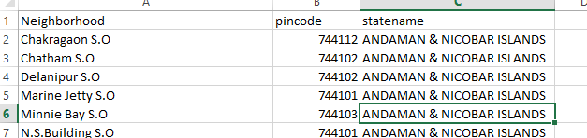

Based on the data obtained from government database, we will find out list of venues around the different neighborhood of both the cities and cluster them based on their similarity. We will use Foursquare API to obtain required venues details. Below are the list of venues that we will use to categories our neighborhood.

1. Building
2. Education
3. Nightlife
4. Food
5. Travel
6. Parks and Outdoors
7. Shops
8. Art and Entertainme