**Creating Microservices for account and loan**

1. **Account MicroService**

*AccountController.java*

package com.cognizant.account.controller;

import org.springframework.web.bind.annotation.GetMapping;

import org.springframework.web.bind.annotation.PathVariable;

import org.springframework.web.bind.annotation.RestController;

*@RestController*

public class AccountController {

*@GetMapping*("/accounts/{number}")

public Account getAccountByNumber(*@PathVariable* String number) {

return new Account(number,"savings",12345);

}

public static class Account{

private String number;

private String type;

private double balance;

public Account(String number, String type, double balance) {

super();

this.number = number;

this.type = type;

this.balance = balance;

}

public String getNumber() {

return number;

}

public void setNumber(String number) {

this.number = number;

}

public String getType() {

return type;

}

public void setType(String type) {

this.type = type;

}

public double getBalance() {

return balance;

}

public void setBalance(double balance) {

this.balance = balance;

}

}

}

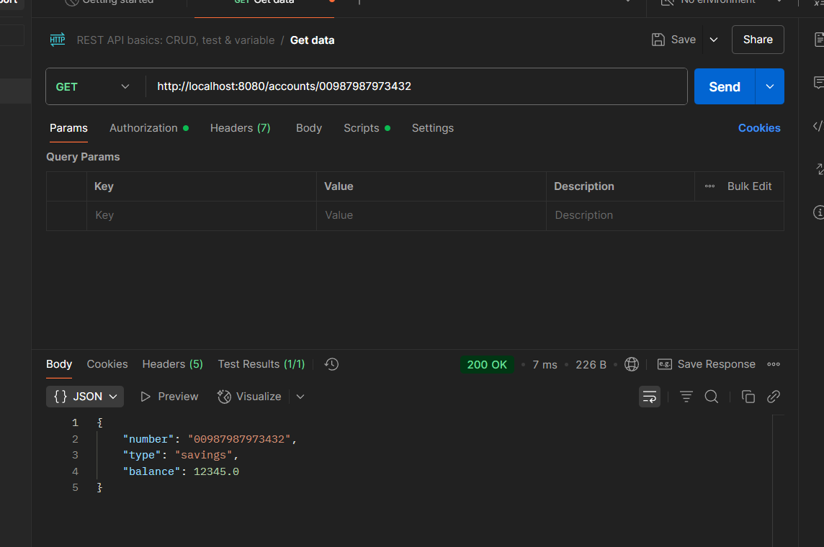

1. **Loan Service**

*LoanController.java*

package com.cognizant.loan.controller;

import org.springframework.web.bind.annotation.GetMapping;

import org.springframework.web.bind.annotation.PathVariable;

import org.springframework.web.bind.annotation.RestController;

*@RestController*

public class LoanController {

*@GetMapping*("/loans/{number}")

public Loan getLoanByNumber(*@PathVariable* String number) {

return new Loan(number,"school",800000,10000,12);

}

public static class Loan{

private String number;

private String type;

private double loan;

private double emi;//per month

private int tenure;//in years

public Loan(String number, String type, double loan, double emi, int tenure) {

super();

this.number = number;

this.type = type;

this.loan = loan;

this.emi = emi;

this.tenure = tenure;

}

public String getNumber() {

return number;

}

public void setNumber(String number) {

this.number = number;

}

public String getType() {

return type;

}

public void setType(String type) {

this.type = type;

}

public Double getLoan() {

return loan;

}

public void setLoan(double loan) {

this.loan = loan;

}

public double getEmi() {

return emi;

}

public void setEmi(double emi) {

this.emi = emi;

}

public int getTenure() {

return tenure;

}

public void setTenure(int tenure) {

this.tenure = tenure;

}

}

}

Added ***server.port=8081*** to application.properties to avoid the conflict among the services.

