**Week-07 Handson**

1. **Create a React Application named “cricketapp” with the following components:**

* ListofPlayers
* ListofIndianPlayers
* OddPlayers
* EvenPlayers
* ScoreBelow70

**ListOfPlayers.js**

*const ListOfPlayers = ({ players }) => {*

*return(*

*<>*

*{*

*players.map((item,index) => (*

*<div key={index}>*

*<li>Mr.{item.name}<span>  {item.score}</span></li>*

*</div>*

*)*

*)*

*}*

*</>*

*);*

*};*

*export default ListOfPlayers;*

**ScoreBelow70.js**

*const Scorebelow70 = ({ players }) => {*

*const players70 = players.filter(player => player.score < 70);*

*return(*

*<>*

*{*

*players70.map((item, index) => (*

*<div key={index}>*

*<li>{item.name}-{item.score}</li>*

*</div>*

*))*

*}*

*</>*

*);*

*};*

*export default Scorebelow70;*

**ListOfIndianPlayers.js**

*const ListofIndianPlayers = ({IndianPlayers})=>{*

*return(*

*<ul>*

*{*

*IndianPlayers.map((player, index) => (*

*<li key={index}>Mr.{player}</li>*

*))*

*}*

*</ul>*

*)*

*};*

*export default ListofIndianPlayers;*

**OddPlayers.js**

*function OddPlayers([first,third,fifth,seven,nine,eleven]) {*

*return (*

*<div>*

*<li>First:{first}</li>*

*<li>Third:{third}</li>*

*<li>Fifth:{fifth}</li>*

*<li>Seventh:{seven}</li>*

*<li>Ninth:{nine}</li>*

*<li>Eleventh:{eleven}</li>*

*</div>*

*);*

*}*

*export default OddPlayers;*

**ListOfPlayers.js**

*function EvenPlayers([second,fourth,sixth,eighth,tenth]) {*

*return (*

*<div>*

*<li>Second:{second}</li>*

*<li>Fourth:{fourth}</li>*

*<li>Sixth:{sixth}</li>*

*<li>Eighth:{eighth}</li>*

*<li>Tenth:{tenth}</li>*

*</div>*

*);*

*}*

*export default EvenPlayers;*

**App.js**

*import ListOfPlayers from "./ListOfPlayers";*

*import Scorebelow70 from "./Scorebelow70";*

*import ListofIndianPlayers from "./ListofIndianPlayers";*

*import OddPlayers from "./OddPlayers";*

*import EvenPlayers from "./EvenPlayers";*

*const App=() =>{*

*const flag =false;*

*const players = [*

*{ name: 'Virat', score: 85 },*

*{ name: 'Rohit', score: 90 },*

*{ name: 'Rahul', score: 65 },*

*{ name: 'Jadeja', score: 75 },*

*{ name: 'Pant', score: 60 },*

*{ name: 'Shami', score: 55 },*

*{ name: 'Bumrah', score: 85 },*

*{ name: 'Surya', score: 45 },*

*{ name: 'Gill', score: 95 },*

*{ name: 'Ashwin', score: 50 },*

*{ name: 'Ishan', score: 70 }*

*];*

*const IndianTeam = ['Virat', 'Rohit', 'Rahul', 'Jadeja', 'Pant', 'Shami', 'Bumrah', 'Surya', 'Gill', 'Ashwin', 'Ishan'];*

*const T20Players = ['First Player', 'Second Player', 'Third Player', 'Fourth Player', 'Fifth Player'];*

*const RanjiTrophyPlayers = ['Sixth Player', 'Seventh Player', 'Eighth Player', 'Ninth Player', 'Tenth Player', 'Eleventh Player'];*

*const IndianPlayers=[...T20Players, ...RanjiTrophyPlayers];*

*if(flag){*

*return(*

*<div>*

*<h1>List of Players</h1>*

*<ListOfPlayers players={players}/>*

*<hr/>*

*<h1>List of Players having Score Less than 70</h1>*

*<Scorebelow70 players={players}/>*

*</div>*

*);*

*}*

*else{*

*return(*

*<div>*

*<div>*

*<h1>Indian Team</h1>*

*<h1>Odd Players</h1>*

*{OddPlayers(IndianTeam)}*

*<hr/>*

*<h1>Even Players</h1>*

*{EvenPlayers(IndianTeam)}*

*<hr/>*

*</div>*

*<div>*

*<h1>List of Indian Players</h1>*

*<ListofIndianPlayers IndianPlayers={IndianPlayers}/>*

*</div>*

*</div>*

*);*

*}*

*};*

*export default App;*

**Output:**

*Flag=true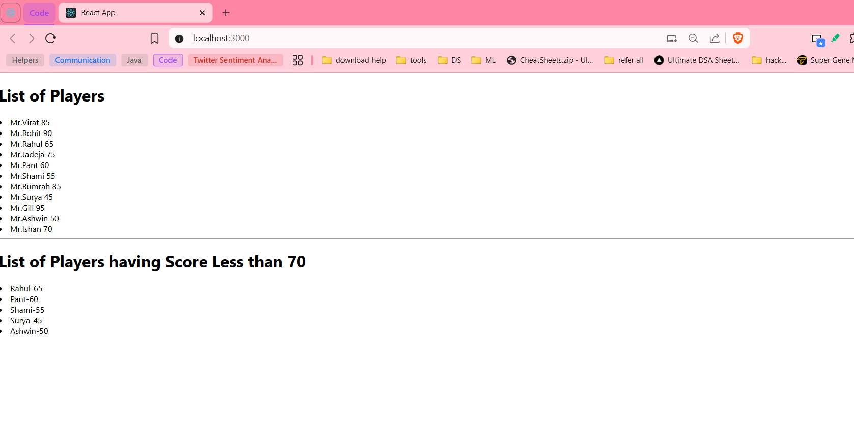*

*Flag=false*

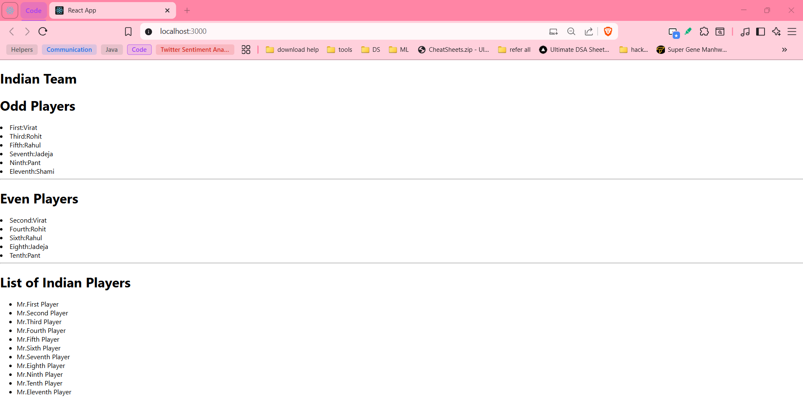

1. **Create a React Application named “officespacerentalapp” which uses React JSX to create elements, attributes and renders DOM to display the page.**

* OfficeCard.js
* Index.css
* App.js -where we define an element

**index.css**

*.textRed {*

*color: red;*

*}*

*.textGreen {*

*color: green;*

*}*

**OfficeCard.js**

*import './index.css';*

*const OfficeCard=({office})=>{*

*let colors=[];*

*if(office.Rent<60000){*

*colors.push('textRed');*

*}*

*else{*

*colors.push('textGreen');*

*}*

*return(*

*<div style={{border:'1px solid #ccc',padding:'10px',margin:"15px"}}>*

*<h2>Name: {office.Name}</h2>*

*<h3 className={colors.join(' ')}> Rent: Rs. {office.Rent}</h3>*

*<h3>Address: {office.Address}</h3>*

*</div>*

*);*

*}*

*export default OfficeCard;*

**App.js**

*import OfficeCard from "./OfficeCard";*

*import imageSrc from './space.jpeg';*

*function App(){*

*const element="Office Space";*

*const jsxatt = <img src={imageSrc} width="25%" height="25%" alt="Office Space" />;*

*const ItemName = {*

*Name: "DBS",*

*Rent: 50000,*

*Address: "Chennai"*

*};*

*const offices = [*

*{ Name: "WeWork", Rent: 45000, Address: "Mumbai" },*

*{ Name: "Reduks", Rent: 65000, Address: "Bangalore" },*

*{ Name: "Iinotion", Rent: 60000, Address: "Delhi" },*

*];*

*return(*

*<>*

*<h1>{element},at Affordable Range</h1>*

*{jsxatt}*

*<OfficeCard office={ItemName} />*

*<h1>More Available office Spaces:</h1>*

*{offices.map((office, index) => (*

*<OfficeCard key={index} office={office} />*

*))}*

*</>*

*);*

*}*

*export default App;*

**OUTPUT**:

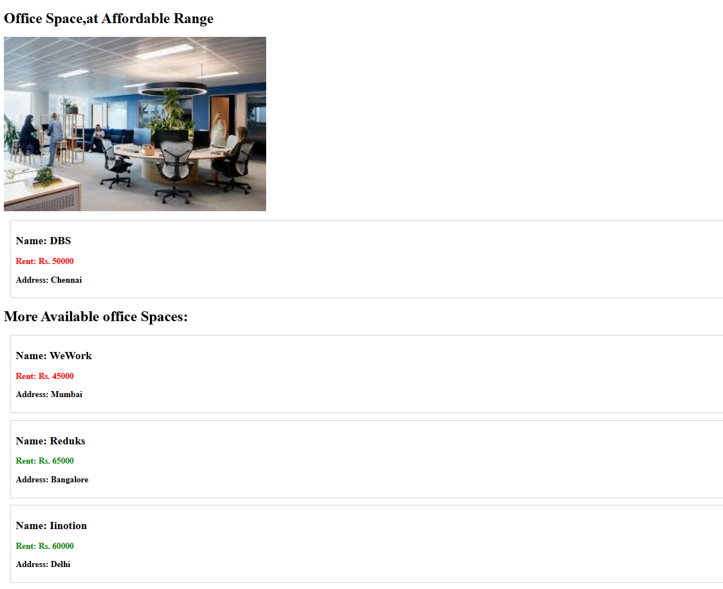

1. **Create a React Application “eventexamplesapp” to handle various events of the form elements in HTML.**

* CurrencyCounter.js
* App.js -where we do event handling

**CurrencyCounter.js**

*import { useState } from "react";*

*function CurrencyConverter() {*

*const [amount,setAmount]=useState(0);*

*const [currency,setCurrency]=useState("");*

*const handleSubmit = () => {*

*if(amount<0||currency===""){*

*alert("Please enter valid amount and currency");*

*return;*

*}*

*let symbol='';*

*let ans=0;*

*switch(currency.toUpperCase()){*

*case 'USD':*

*symbol='$';*

*ans=(amount/87.20).toFixed(2);*

*break;*

*case 'EUR':*

*symbol='€';*

*ans=(amount/101.09).toFixed(2);*

*break;*

*default:*

*alert("Currency not supported");*

*break;*

*}*

*alert(`Converted Amount: ${symbol}${ans}`);*

*setAmount(0);*

*};*

*return(*

*<>*

*<h2 style={{color:"green"}}>Currency Converter from INR to USD / EURO</h2>*

*Amount:<input type="number" value={amount} onChange={(e)=>{setAmount(e.target.value)}}></input>*

*<br/>*

*Currency:<input type="text" value={currency} onChange={(e)=>setCurrency(e.target.value)}></input>*

*<br/>*

*<button onClick={handleSubmit}>submit</button>*

*</>*

*);*

*};*

*export default CurrencyConverter;*

**App.js**

*import React,{useState } from "react";*

*import CurrencyConverter from "./CurrencyConvertor";*

*function App() {*

*const [count,setCount] = useState(0);*

*const increment = () => setCount(count + 1);*

*const decrement = () => setCount(count - 1);*

*const sayHello = ({count}) => alert(`Hello, Member ${count}`);*

*const handleIncrement = () => {*

*increment();*

*sayHello({count:count+1});*

*}*

*const sayWelcome = () => alert("!!!Welcome!!!");*

*return(*

*<>*

*{count}*

*<br/>*

*<button onClick={handleIncrement}>Increment</button>*

*<br></br>*

*<button onClick={decrement}>Decrement</button>*

*<br></br>*

*<button onClick={() => sayWelcome()}>Say Welcome!</button>*

*<br></br>*

*<button onClick={()=>{alert("You clicked me!")}}>Click Me!</button>*

*<br></br>*

*<CurrencyConverter />*

*<br></br>*

*</>*

*);*

*}*

*export default App;*

**OUTPUT:***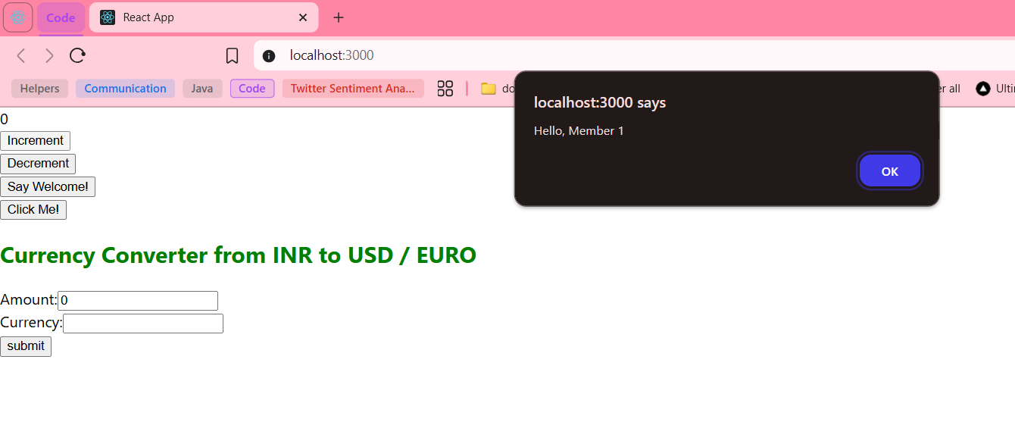* 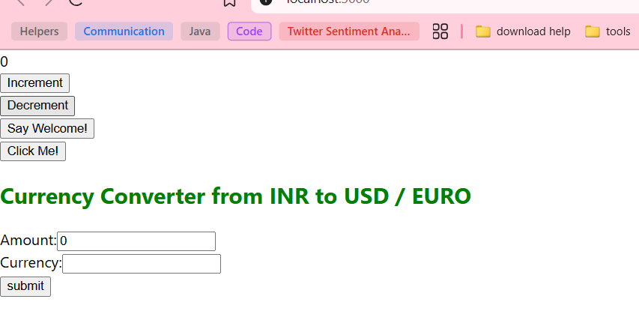 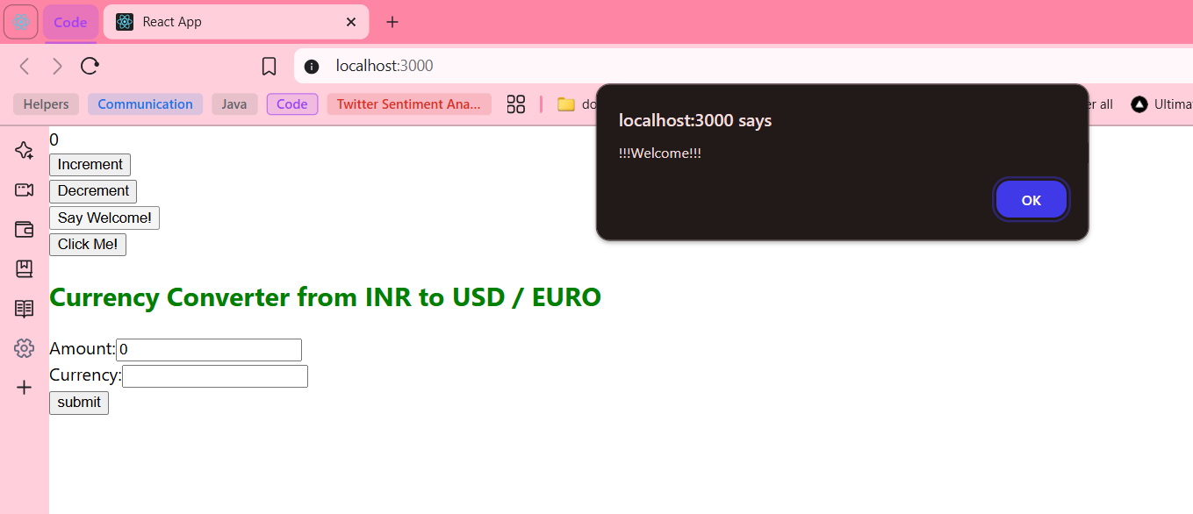 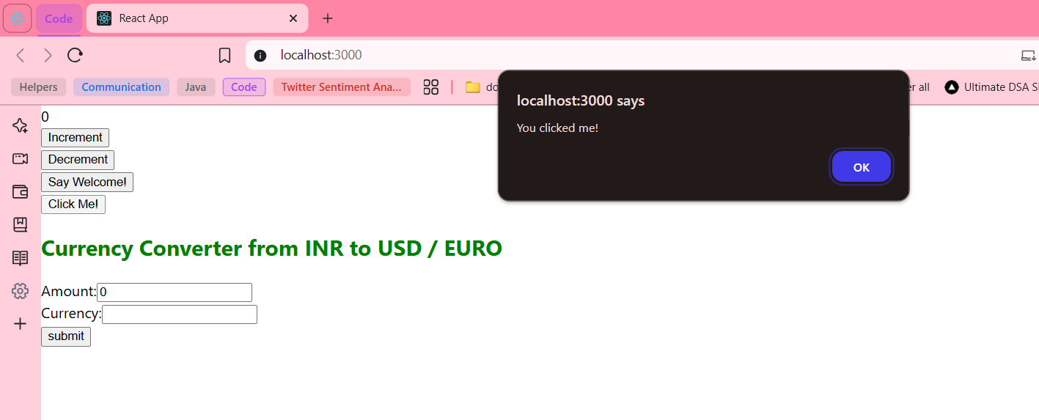 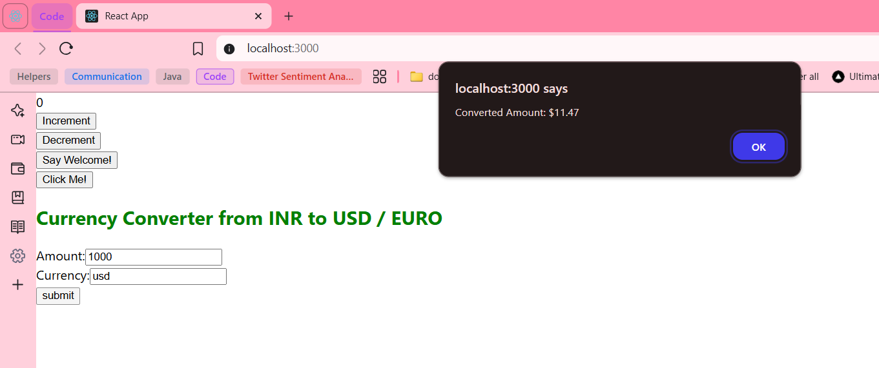

1. **Create a React Application named “ticketbookingapp” where the guest user can browse the page where the flight details are displayed whereas the logged in user only can book tickets.**

* Greeting.js
* App.js – Flight booking

**Greeting.js**

*function UserGreeting() {*

*return <h1>Welcome user.Now you can book your flights...</h1>;*

*}*

*function GuestGreeting() {*

*return <h1>Please sign up to book your flights...</h1>;*

*}*

*function Greeting({isLoggedIn}) {*

*if (isLoggedIn) {*

*return <UserGreeting />;*

*}*

*return <GuestGreeting />;*

*}*

*export default Greeting;*

**App.js**

*import React,{ useState } from 'react';*

*import Greeting from './Greeting';*

*function App() {*

*const [isLoggedIn, setIsLoggedIn] = useState(false);*

*const handleLogin=()=>setIsLoggedIn(true);*

*const handleLogout=()=>setIsLoggedIn(false);*

*const flights = [*

*{ id: 1, from: "Chennai", to: "Delhi", price: 4500 },*

*{ id: 2, from: "Mumbai", to: "Bangalore", price: 3500 },*

*{ id: 3, from: "Kolkata", to: "Hyderabad", price: 4000 },*

*];*

*return (*

*<>*

*<h1>Flight Booking App..</h1>*

*<Greeting isLoggedIn={isLoggedIn} />*

*{isLoggedIn?(*

*<button onClick={handleLogout}>Logout</button>*

*):(*

*<button onClick={handleLogin}>Login</button>*

*)}*

*<hr/>*

*<h2>Available Flights</h2>*

*<ul>*

*{flights.map(flight => (*

*<li key={flight.id}>*

*{flight.from} to {flight.to} : ₹{flight.price}*

*{isLoggedIn && <button>Book Now</button>}*

*</li>*

*))}*

*</ul>*

*<hr/>*

*</>*

*);*

*}*

*export default App;*

**OUTPUT:**

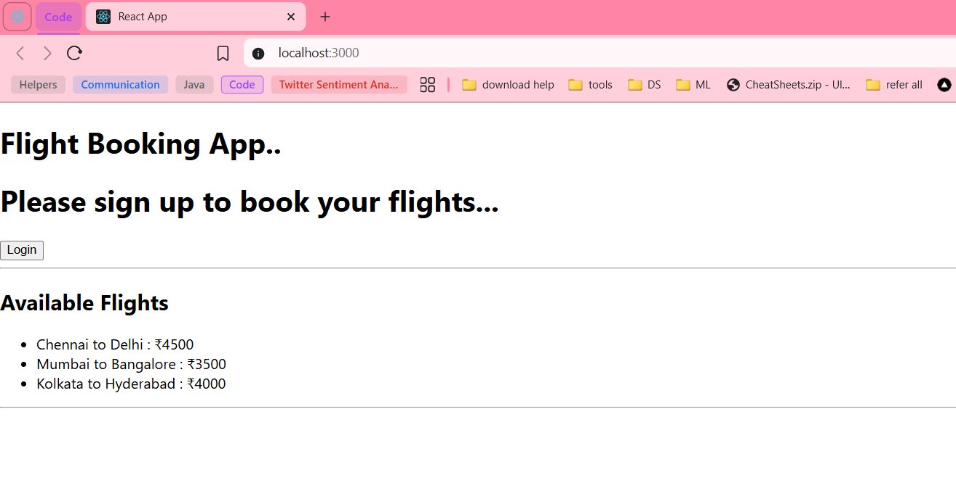

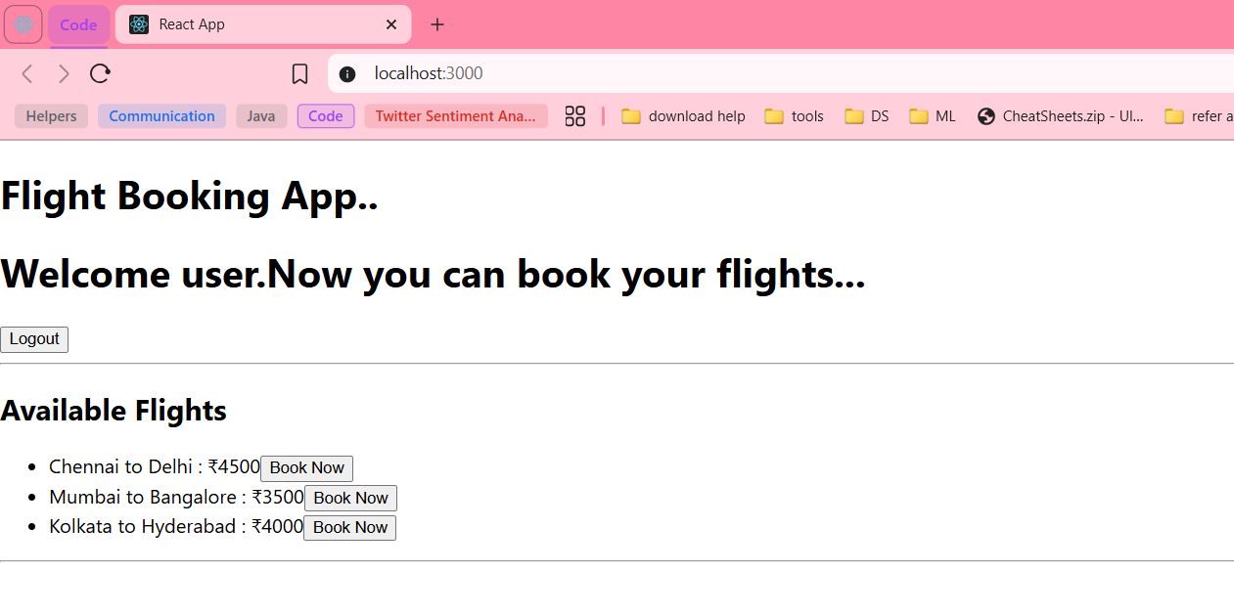

1. **Create a React App named “bloggerapp” in with 3 components.**
2. **Book Details**
3. **Blog Details**
4. **Course Details**

**BookDetails.js**

*const BookDetails = ({books})=>{*

*const bookdet=(*

*<ul>*

*{*

*books.map((book)=>*

*<div key={book.id}>*

*<h3>{book.name}</h3>*

*<h4>{book.price}</h4>*

*</div>*

*)*

*}*

*</ul>*

*);*

*return(*

*<div>*

*<h1>Book Details</h1>*

*{books.length>0 && bookdet}*

*</div>*

*);*

*};*

*export default BookDetails;*

**CourseDetails.js**

*const CourseDetails=({courses})=>{*

*if(courses.length===0){*

*return <p>No courses found</p>;*

*}*

*return (*

*<div>*

*<h2>Course Details</h2>*

*{*

*courses.map((course)=>(*

*<div key={course.id}>*

*<h3>{course.name}</h3>*

*<p><strong>startingDate: </strong>{course.startingDate}</p>*

*</div>*

*))*

*}*

*</div>*

*);*

*};*

*export default CourseDetails;*

**BlogDetails.js**

*const BlogDetails=({blogs})=>{*

*if (blogs.length > 0) {*

*return (*

*<div>*

*<h2>Blog Details</h2>*

*{blogs.map((blog) => (*

*<div key={blog.id}>*

*<h3>{blog.title}</h3>*

*<p><strong>Author:</strong>{blog.author}</p>*

*<p>{blog.intro}</p>*

*</div>*

*))}*

*</div>*

*);*

*} else {*

*return (*

*<div>*

*<h2>Blog Details</h2>*

*<p>No Blogs found</p>*

*</div>*

*);*

*}*

*};*

*export default BlogDetails;*

**App.js**

*import BookDetails from './BookDetails';*

*import BlogDetails from './BlogDetails';*

*import CourseDetails from './CourseDetails';*

*export const books=[*

*{ id: 101, bname: 'Master React', price: 670 },*

*{ id: 102, bname: 'Deep Dive into Angular 11', price: 800 },*

*{ id: 103, bname: 'Mongo Essentials', price: 450 }*

*];*

*export const blogs=[*

*{id:1,title:'Understanding Angular and React ',author:'Bob shawn',intro:"One is framework other is a library......."},*

*{id:2,title:'React Hooksin Depth ',author:'Marley Din',intro:"React Hooks simplify state and lifecycle management..."}*

*];*

*export const courses=[*

*{id:201,name:"Angular-Full Stack Bootcamp",startingDate:"2025-08-10"},*

*{id:201,name:"React - Complete Course",startingDate:"2025-08-15"}*

*];*

*const App=()=>{*

*return(*

*<div style={styles.container}>*

*<div style={styles.column}>*

*<BookDetails books={books}/>*

*</div>*

*<div style={styles.divider}></div>*

*<div style={styles.column}>*

*<CourseDetails courses={courses}></CourseDetails>*

*</div>*

*<div style={styles.divider}></div>*

*<div style={styles.column}>*

*<BlogDetails blogs={blogs}/>*

*</div>*

*</div>*

*);*

*};*

*const styles={*

*container:{*

*display:'flex',*

*flexDirection:'row',*

*padding:'20px',*

*gap:'20px',*

*justifyContent:'space-between',*

*alignItems:'flex-start'*

*},*

*column:{*

*flex:1,*

*padding:'10px',*

*},divider:{*

*width:'2px',*

*backgroundColor:'#ccc',*

*height:'100%'*

*}*

*};*

*export default App;*

**OUTPUT:**

